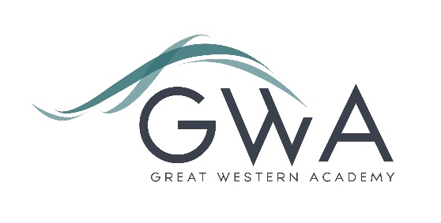

# Information for Applicants

**Teacher of Science**

Great Western Academy opened in September 2018 and now accommodates over 950 students in years 7 to 11 and the Sixth Form. The school is heavily oversubscribed in years 7 to 11 and the Sixth Form is flourishing. Our first GCSE results in summer 2023 showed that the progress made by the large majority of our first cohort of year 11 students has been excellent, particularly in English and Maths. The results of our first three A-level cohorts in summer 2021, 2022 and 2023 were excellent and enabled 98% of university applicants to take up their offers, including three to Oxford and Cambridge: students have also secured prestigious apprenticeships with companies such as Airbus and Rolls Royce. We believe firmly that strong outcomes follow from high expectations, high quality teaching, and strong support in terms of behaviour structures and targeted academic and pastoral interventions.

An applicant’s briefing pack with full information about Great Western Academy and the role is available on the GWA website at <https://www.gwacademy.co.uk/vacancies> If you have any questions prior to application, you are very welcome to contact us.

Application process

Please complete both the application form and equalities forms supplied and enclose a supporting letter, either in the space provided on the application form or as a separate document. The application form should be completed in full in black ink or type. A CV is not requiredand should not be submitted as part of the application.

Your supporting letter should be no more than 2 sides of A4 (with a font size no smaller than 11) and should enhance your application by providing further information, matched to the person specification, about your suitability for the post. This should include evidence of the impact on student outcomes you have made in your career to date.

Electronic applications should be returned via email to [**recruitment@gwacademy.co.uk**](mailto:recruitment@gwacademy.co.uk)

**Closing Date:** **9am Friday 23rd February 2024**

**Interviews:** will take place the following week. **We may interview before the closing date (and close the advert early) depending on the suitability, and number of, applicants.**

**References:** References will be taken up prior to interview.

The interview process will include observation of your teaching, and a variety of other tasks and activities.

*Great Western Academy is committed to safeguarding and promoting the welfare of children, young people and vulnerable adults and we expect all staff to share this commitment and undergo appropriate checks. All posts within the Trust are therefore subject to an Enhanced DBS and barred list check.*