Deputy Head of Curriculum and Achievement



Applicant Pack

Teacher of Science /
Teacher of Health and Social Care

Reimagine what’s possible

Headteacher’s Welcome
I am delighted to welcome you to this application pack and introduce you to our school.


Longcroft School and Sixth Form has a long tradition of being at the heart of the local community, and we are proud to serve the market town of Beverley and its surrounding areas. Our location and facilities are truly exceptional. Over 7.5 million pounds has been invested over recent years in our state-of-the-art learning spaces and with extensive grounds boasting fabulous views across the local Westwood Pastures and Beverley Racecourse, this really is a stunning place to be and learn.

Our school has a clear vision to provide an exceptional education founded on shared values and an absolute ambition for each and every child. We are a positive, welcoming and inclusive school, where every child is known and cared for as an individual, and where pupils take pride in their achievements.

Founded in 1951 Longcroft’s school motto celebrated the distinct education the school sought to provide. This motto remains an integral part of school life today and has helped to define who we are as a community.

“As free make I thee, as heart may think, or eye may see.”

In working to re-vision the school in recent years, we have distilled the meaning of these original words to articulate our core values:

Great Heart - The human qualities that define an individual. For example, demonstrating kindness, offering support or actively caring for the wider community and the environment we live in; acting with integrity and demonstrating character in serving the common good.

Great Thought - Academic success or excellence. For example, the production of a superb piece of classwork, homework, outstanding assessment and examination outcomes, or an impressive piece of thinking in class.

Great Vision - Showing our readiness for the future by developing the skills and qualities that will lead to success in life beyond school. For example, critical thinking, acting with initiative, team work, personal discipline, and understanding how to be safe and healthy as individuals, and in our relationships with others.


Through these core values we seek to articulate our commitment to educating the whole child and to preparing our young people for the challenges and opportunities that life beyond school will present. We work hard to provide an enriched and holistic school experience, which values the opportunities we are able to provide beyond what is taught in our classrooms. We seek to promote learning and personal development in many and varied ways including our extensive range of clubs, trips, visits and performances, charity and community work, our Duke of Edinburgh Scheme, or representing the school competitively through sport, the arts or literature.

This is an incredible time to be joining our school as demand for places continues to grow rapidly. We have enjoyed national profile, with the school being recognised for its achievements in recent years and have ambitious plans for the future. Alongside reading this application pack, I would encourage you to find out more about who we are by contacting us, and visiting our school to meet our fabulous staff and pupils.

We believe in the capacity for ordinary people to achieve extraordinary things, and welcome applications from those who wish to join us in ‘reimagining what’s possible’ as individuals and as a community.

Mr David Perry
Headteacher

About Us
Longcroft School and Sixth Form College

Age range: 11 – 18
Students on roll: 795
Gender: Mixed
Admissions policy: Non-selective
School Type: Local Authority Maintained
Situated in beautiful surroundings on the outskirts of the popular market town of Beverley, Longcroft offers motivated and well-behaved students, dedicated staff, a committed and experienced governing body and supportive parents.
With a growing school, colleagues have the opportunity to teach across the age and ability range including to A-Level. Our values of Great Heart, Thought and Vision, underpin all that we are and do, and we are committed to a holistic and enriched education that develops the whole child. Every member of our community is uniquely valued and is recognised for the important part they have to play.
This is a particularly exciting time to join Longcroft School and Sixth Form. Having undergone a transformational investment, Longcroft now enjoys state of the art facilities, set in exceptional grounds. Alongside the development of the estate, the leadership of the school has evolved, including the appointment of a new Headteacher and Deputy Headteachers in recent years. The role will be supported by an exceptional Curriculum Leader in Science who has sustained experience in leading a high performing team. The community share an ambitious vision for the school to provide a truly world class, holistic and inclusive education, serving to address social inequality and promote opportunity. This has been reflected in the school’s impressive trajectory and the national recognition it continues to receive. Longcroft has remained the most well attended secondary school in the region for consecutive years and is now ranked number one in the country by the Department for Education in the similar schools report 2026. Children enjoy coming to school and are proud to be a part of our community.
Colleagues describe an ambitious, collegiate and supportive school and this is a perfect opportunity for a dynamic and ambitious teacher to come and be a part of our exciting journey. We are committed to significant investment in our professional development programme and work collaboratively with other schools and organisations in the region, creating a range of professional opportunities and the chance to work alongside colleagues from an array of settings. For the right candidate, there will therefore be opportunities for further career progression moving forward. We recognise that great schools invest in great people.
Longcroft is committed to safeguarding and promoting the welfare of children and young people and expects all staff and volunteers to share this commitment. Appointment will be subject to an Enhanced DBS check.


Job Information
JOB DESCRIPTION

JOB TITLE: | Teacher of Science / Health and Social Care  Candidates with backgrounds in either discipline are encouraged to apply as you will be working as part of a wider team to meet curriculum requirements. Please note however, that some Science teaching will be required for any candidate.
REPORTS TO: | Curriculum Leader – Science
SALARY: | MPS / UPS
START DATE: | January 2027 – preferred (applications welcome from candidates who would be unable to start in January)
Purpose: | To effectively support and facilitate learning, enabling all pupils and students to meaningfully access their curriculum and to recognise and realise their potential.  To contribute to providing an exceptional educational experience for all pupils and students, removing barriers and supporting preparation for life beyond school.
Responsibilities as a classroom teacher (relates to pupils/students taught) | - To plan and deliver high quality and inclusive lessons which follow departmental schemes of learning and effectively meet the needs of all learners.  - To assess, monitor and report learner progress according to departmental and school policy.  - To record and use data to inform effective target setting and lesson planning and to enable learners to fulfil their potential.  - To ensure the curriculum is accessible to all learners through the use of effective, responsive and adaptive teaching.  - To contribute to all developmental and organisational priorities identified within the department/school development plan.  - Maintain good order and discipline among learners, upholding the Longcroft Standard, safeguarding their health and safety both in school and when engaged in authorised activities elsewhere.  - To share and support in our whole school commitment to the personal and social development of all learners.  - To follow departmental policy and procedures.  - To ensure that the curriculum leader is kept informed of any issues which could lead to learner under-performance.  - To ensure learning support staff are able to effectively fulfill their role in facilitating learning and progress within lessons.
Responsibilities as a form tutor (relates to students in the form group) | - Use all available data/information provided to monitor and promote overall progress, development and well-being of tutees.  - To monitor and respond to issues regarding behaviour and attendance following school policy and protocol.  - Communicate and consult with the parents/carers.  - Communicate and co-operate with external bodies or agencies as required in the interests of the wellbeing or care of individual tutees.  - To keep the Year Leader fully informed of issues which could affect pupil or student achievement and/or well being.  - To support the personal development of tutees including through the delivery of PSHE/Careers materials where appropriate.  - To follow pastoral policy and procedures.
Responsibilities as a member of staff: | - To uphold the school’s high expectations for safeguarding young people in all aspects of your role.  - To embrace professional development opportunities and demonstrate their impact on practice over time.  - To ensure an appropriate individual response to whole school priorities.  - To support the personal and social development of learners within the school.  - To engage actively in the Appraisal Process.  - To effectively implement all school policies with fidelity.  - To attend meetings / training events and engage with CPD provided.  - To pay due regard to Health and Safety in respect of all members of the school community and report any matters of concern appropriately.  - Reflect and promote the high expectations the school sets out for our community.
Personal Qualities  The postholder is expected to: | - Actively support and promote the values of the school.  - Be committed to team work and collective responsibility.  - Be prepared to teach across the age and ability range.  - Be pro-active in furthering professional knowledge and skills in service of children and the quality of their education.  - Act at all times with professionalism, promoting positive relationships with all members of the school community.  - Recognise that the most effective inclusion strategy begins with every day high quality inclusive teaching, which has most benefit for the pupils who find learning hardest and reduces the need for individual adaptations.

The above principal accountabilities are not exhaustive and may vary without changing the character of the job or level of responsibility. The Headteacher may from time to time ask the post holder to perform any other duties commensurate with the general level of responsibility of the post.

Person Specification

 | Ess | Des | MOA
KNOWLEDGE/QUALIFICATIONS
Graduate in related subject | * |  | A/C
Knowledge of relevant curriculum areas at KS3/4/5 | * |  | A/I
An excellent classroom practitioner | * |  | I/R
Other relevant qualifications that support curriculum delivery |  | * | A/C
EXPERIENCE
Qualified Teacher (suitable for ECT applicants) | * |  | A/I
Other relevant experience that support effective curriculum delivery |  | *
SKILLS
Ability to demand the highest standards of self and others, using research informed practice to engage, enthuse and challenge pupils of all abilities, needs and backgrounds | * |  | A/I/R
Strong communication skills and the ability to relate to stakeholders at all levels | * |  | A/I/R
Ability to apply highly effective behaviour management strategies | * |  | A/I/R
Ability and willingness to utilise ICT to facilitate learning and teaching | * |  | A/I
Effective organisational, personal management and time management skills | * |  | A/I/R
Work independently and be a team player | *
BEHAVIOUR AND OTHER RELATED CHARACTERISTICS
Alignment with the school’s vision and values | * |  | A/I
Commitment to continuing own professional development | * |  | A/I
Work in ways that promote equality of opportunity for all | * |  | A/I
Commitment to abide by and uphold the policies on Safeguarding, Equal Opportunities, Health and Safety and Child Protection at Longcroft School | * |  | A/I
Self-awareness, empathy, managing feelings, motivation, social skills | * |  | A/I
Key: A = Application | C = Certificate | I = Interview | R = Reference

N.B. We will require an enhanced CRB check for the successful candidate. This person specification is not necessarily a comprehensive definition of the post. It will be during the first year and will be subject to modification and amendment after consultation with the post-holder.

The school operates a safe recruitment process and appointment to the post will be subject to suitable references and an enhanced Disbarring and Barring Service check. The school is committed to safeguarding and promoting the welfare of children and expects all staff and volunteers to share this commitment.

The East Riding of Yorkshire Council is an equal opportunities employer.

All teaching staff are required to fulfil the duties described in the latest School Teachers’ Pay and Conditions document, including the appropriate Professional Standards.

Staff Information
Senior Leadership Team
Headteacher – Mr David Perry
Deputy Headteacher – Mr Leigh Haworth (Curriculum and Assessment)
Deputy Headteacher – Mr Jonathan Rogers (Care and Achievement / Safeguarding)
Assistant Headteacher – Ms Rachel Brooks (Head of Inclusion / SENCO)
School Business Manager – Mrs Nikki Smith
Assistant Headteacher – Mr Alan Worthington (Head of Upper School)
Assistant Headteacher – Mr Jonathan Chapman (Head of Lower School)

Key Contacts
School Business Manager | Mrs Nikki Smith | 01482 862171 | school@longcroft.eriding.net

Science Curriculum Leader | Mrs A Scott | 01482 862171 | anna.scott@longcroft.eriding.net

How to apply
If you would like to apply for this vacancy, please download a teaching staff application form from the school website or apply through the government’s teacher vacancies website: https://teaching-vacancies.service.gov.uk/
Applications should be returned to Mrs N Smith School Business Manager, Longcroft School and Sixth Form, Burton Road, Beverley, East Riding of Yorkshire, HU17 7EJ or via email to hr@longcroft.eriding.net

CLOSING DATE: Tuesday 20th October @ 12:30pm
Interviews are scheduled to take place Wednesday 21st – Friday 23rd October

How to Find Us
Longcroft School and Sixth Form
Burton Road, Beverley, East Riding of Yorkshire HU17 7EJ
Tel: 01482 862171

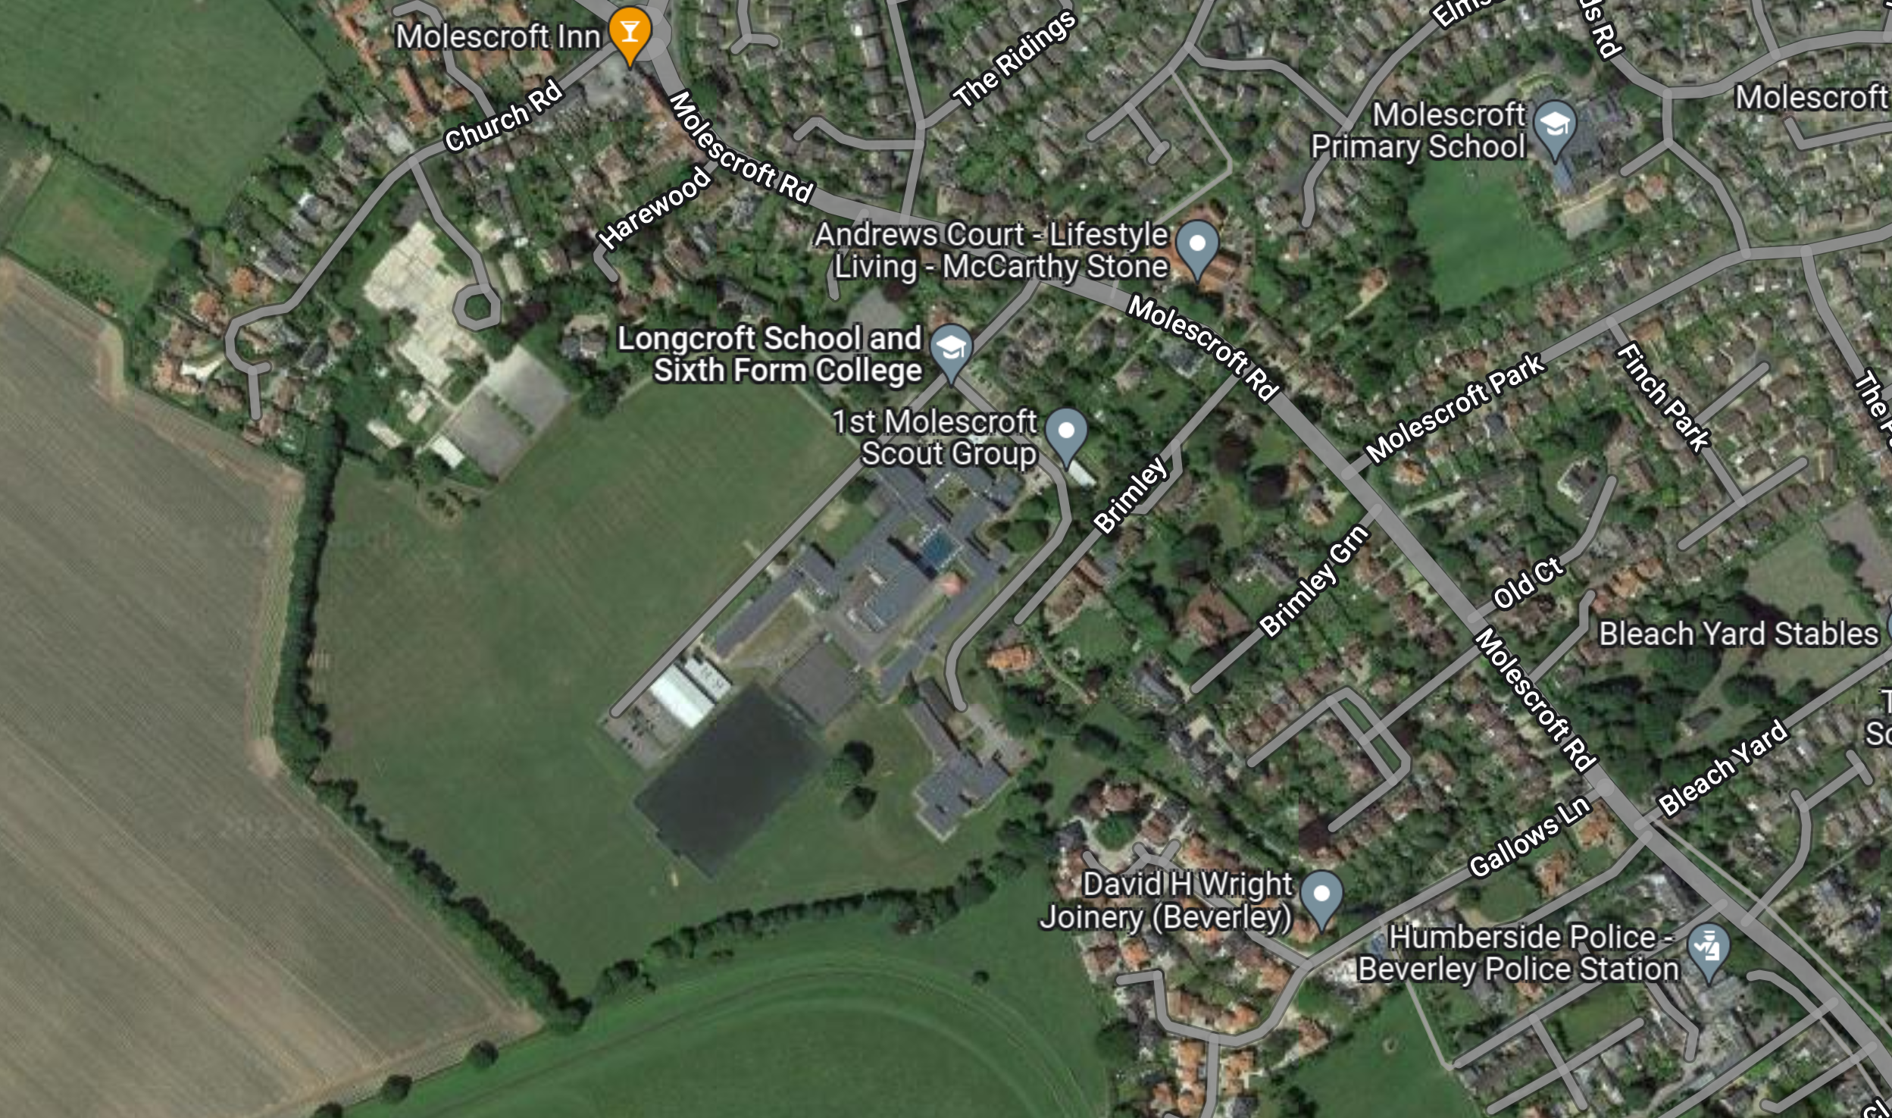

A. From Hull - Take the A1079 towards Beverley / York
- At the Killingwoldgraves roundabout turn right on to the A1174 (follow signs for Beverley Racecourse)
- Follow the road past Beverley Racecourse and across the Westwood Pasture to the cross roads at North Bar
- Turn left at the traffic lights (past the Rose & Crown Pub) on to Molescroft Road
- Continue past the Westwood Restaurant and Police Station
- After approx. 1.2km turn left on to Burton Road and drive in to Longcroft School and Sixth Form

B. From Humber Bridge - Take the Westward route towards Leeds along the A63
- Take the A164 towards Beverley
- Exit to A1079 towards York (follow signs for Beverley Racecourse)
- At the first roundabout turn right on to the A1174 (follow signs for Beverley Racecourse)
- Follow the road past Beverley Racecourse and across the Westwood Pasture to the cross roads at North Bar
- Turn left at the traffic lights (past the Rose & Crown Pub) on to Molescroft Road
- Continue past the Westwood Restaurant and Police Station
- After approx. 1.2km turn left on to Burton Road and drive in to Longcroft School and Sixth Form

C. From Leeds / York - Take A64, York by-pass towards Scarborough
- Leave A64 at Grimston Bar roundabout signposted York, Bridlington, Hull
- Exit from roundabout onto A1079 towards Hull
- At the Killingwoldgraves roundabout turn right on to the A1174 (follow signs for Beverley Racecourse)
- Follow the road past Beverley Racecourse and across the Westwood Pasture to the cross roads at North Bar
- Turn left at the traffic lights (past the Rose & Crown Pub) on to Molescroft Road
- Continue past the Westwood Restaurant and Police Station
- After approx. 1.2km turn left on to Burton Road and drive in to Longcroft School and Sixth Form

