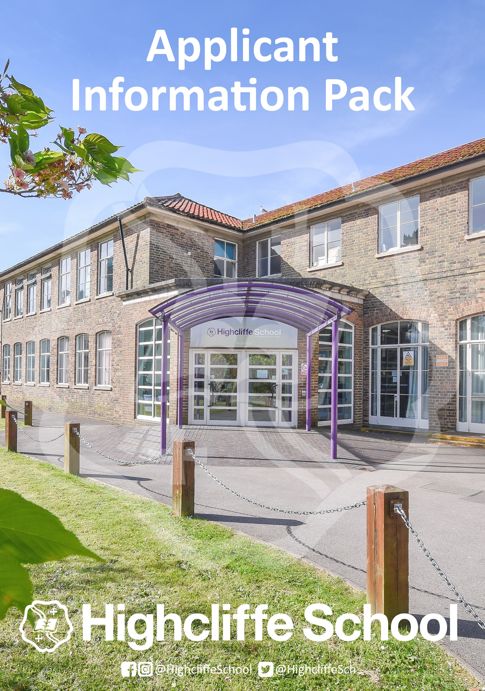
Science Teacher

Dear Colleague,

I am delighted you are considering applying for a post at Highcliffe School. Please find alongside this letter information, which, I hope, provides an insight to our school and the opportunities that await the successful candidate.

Highcliffe is a remarkable school with a special atmosphere. We are very highly respected in our community, with whole generations of families coming here for over 50 years from Christchurch and the New Forest. Former students, current students and their parents frequently speak of their powerful emotional bonds to our school lasting a lifetime. Always popular, and usually over-subscribed, in the last two years our identity and success has attracted a rapidly growing number of admissions requests for Year 7. Although we have raised our PAN twice in three years, demand for places still exceeds availability. This is a result of our caring and aspirational ethos combined with our engaging curriculum and excellent extra-curricular opportunities, although our track record of exam success is surely another factor. Our students are lovely young people to work with who respond enthusiastically to good teaching and are keen to learn.

Former students go on to work in international finance, law, education, politics, engineering, medicine, science, and in the Paris fashion houses, or as great chefs, carers, artists, musicians, mechanics, gardeners and much more – but not before they have thrived at Highcliffe academically, creatively and socially. We have an excellent record of success placing students into the top universities in their chosen field. Every year for the last 10 years at least one of our Sixth Form students have, for example, gone on to study at either Oxford or Cambridge universities. We have successful programmes for students accessing careers in medicine, the law and engineering. We are an outwardly focused community with extensive school links in Germany, France, Spain and Japan including a unique exchange programme with a school in Hiroshima.

Our teaching staff are highly experienced, knowledgeable professionals who work together superbly. Our SEND, pastoral, clerical, financial, technical and site staff, who form a good team, are also extremely good at their jobs and committed to the school’s success. We are a friendly, welcoming and supportive environment in which to work or learn, located in a great part of the country. Our strategic plan aims to improve examination results still further by developing more effective ways of supporting and challenging student progress, especially for disadvantaged pupil groups and more able boys; by further developing our teachers’ professional skills through our extensive in-house CPD programme and by deepening our distinctive Highcliffe teaching and learning pedagogy to promote oracy, recall and application of prior understanding to new learning. We work collaboratively within the Christchurch Learning Federation on a range of common school improvement issues and access support from our neighbouring Teaching Schools.

We welcome applicants who share our ethos, bring outstanding professional skills and personal qualities, and have an unshakeable drive to make a difference to young lives through education. Unfortunately, we will not be able to contact every applicant who applies and take this opportunity to thank you for considering our school.

I look forward to hearing from you if you apply, but whatever your decision, I wish you all the best for your professional future.

Patrick Earnshaw (BA) Hons, MA
HEADTEACHER

Application:

Submit a completed application form.

Submit a personal letter or statement of no more than 2 sides of A4, 11 point Calibri font, explaining your vision, skills and experience relevant to the post.

Please note that CVs only will not be accepted.

Application Form

The form must be completed in full and signed. Please use black ink or word processing as your form will be photocopied. Please complete all sections of the application form and ensure that your employment record is set out in full with an explanation of any gaps.

Please do not include photocopies of open testimonials. We will always write to your current or previous employer for a reference and to ask for a professional assessment of your suitability for the post. We reserve the right to approach any previous employer for a reference.

Please complete the application form carefully and ensure that you sign it at the end. You should use section 5 to set out your relevant skills, knowledge and experience.

Your completed application form and letter should be returned to Angie Parsons, PA to the Headteacher, Highcliffe School, Parkside, Highcliffe, BH23 4QD by email aparsons@highcliffeschool.com. Due to usually high volume, applications will not normally be acknowledged.

Information about the area
Highcliffe School is ideally situated minutes from Highcliffe and Avon beaches, Mudeford Quay and Christchurch Harbour. A few minutes’ drive or cycle away are the beaches of Bournemouth while Poole Harbour, a mecca for watersports, is approximately 12 miles away. As a result, sailing, kitesurfing, kayaking, paddle boarding, surfing and beach life are prominent parts of life in the area.

Highcliffe is also on the doorstep of the New Forest, meaning that equestrian sports, cycling, walking and running are also prominent features of local life. There is an extensive range of top-class pubs, cafes, clubs, theatres and cinemas throughout the area catering for people of all ages and tastes.

Highcliffe School is easily accessible from the urban centre of Bournemouth and Poole. With its large student population Bournemouth uniquely offers a multicultural city buzz combined with the relaxed South Coast surfing and holiday culture. London, the South East and the South West are easily reached by road or rail links. The European mainland is easily reached by ferry from Weymouth, Poole, and Portsmouth, while Bournemouth and Southampton airports offer continental and worldwide flights.

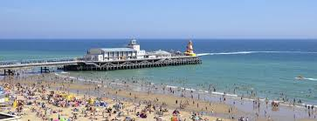
Information about the School
We encourage potential applicants to explore in depth the School’s website which includes recent publications and a prospectus. Potential applicants are also encouraged to read both the most recent Ofsted reports which are available via the school website or directly from www.ofsted.gov.uk and the published performance data available on the DfES performance tables site. www.education.gov.uk/schools/performance

SCIENCE CURRICULUM AREA

We deliver a 3 year KS3 course following a combination of in-house schemes and Exploring Science Texts. At KS3 all students study Science.
KS4 is delivered over 2 years from Year 10-11. Students who are high achievers at KS3 can opt to study separate sciences.
At KS5, the Science Team offer several courses including A Level Biology, A Level Chemistry and A Level Physics . Student retention at KS5 is very good.
Facilities and Resources
• 13 experienced, enthusiastic specialist science teachers and 3 technicians based in 4
technical areas.
• 11 fully equipped and laboratories.
• Science, STEM and Environmental clubs are available for enthusiastic students.
• Reference books issued to all students, plus in house reprographics.
• ICT and remote sensing available.
• An ICT Laboratory (Sc2) with extra ICT for data logging and processing, digital microscopy,
web browsing and interactive learning programs via school server.
• Enrichment activities include use of school grounds, with our environmental area including
school pond and garden, and local recreation areas – Steamer Point, Hengistbury Head
Learning Facility, trips to London museums and Intech at Winchester and various A level
outings and experiences including Biology Field work on the Dorset Heritage coast line, links
and visits with Southampton University Hospital and Southampton University Chemistry and
Physics Departments

Facilities and Resources
In addition to the facilities detailed above, these subjects all benefit from specialist accommodation with dedicated resources. Enrichment activities are an integral part of the delivery of each programme. These range from one to one tutorial support to trips and activities as well as extended vocational placements and visiting speakers.

Contact Person:
Ms S Cullen – Director of Learning, Science

Teacher Person Specification
CONTEXT: Before making an application candidates are asked to match their qualifications, experience, skills and abilities against the criteria listed below.
ATTRIBUTES | ESSENTIAL | DESIRABLE | EVIDENCE
QUALIFICATIONS | - Qualified teacher status.  - Good Honours degree (2:2 or above) or equivalent in relevant subject. | - 2:1 Honours degree or above.  - Further relevant qualifications and or In-Service training. | Application
EXPERIENCE | - Secondary School teaching experience of 12 months of more as at September 2020  - Evidence of outstanding teaching practice with a positive impact on student progress/outcomes. | - Using information technology in the classroom and for management.  - Working in partnership with parents.  - Experience of curriculum planning | Application  Reference
TRAINING AND  PROFESSIONAL  DEVELOPMENT | - Knowledge and understanding of excellent practice in learning, teaching and assessment.  - Knowledge and understanding of current issues relevant to the subject.  - Familiarity with & involvement with the National Curriculum, assessment, reporting & recording procedures at KS3 & KS4. | - Familiarity with & involvement with the National Curriculum, assessment, reporting & recording procedures. | Application  References  Interview.
PERSONAL QUALITIES AND SKILLS | - Energy and presence to lead by example, in terms of both departmental development, classroom management and organisation.  - Commitment to raising achievement.  - Commitment to staff development.  - Ensure that issues of equality are addressed in all aspects of work.  - Commitment to the success of an extra-curricular programme.  - IT Skills appropriate to the role.  - Ideas for implementing the School’s vision.  - The ability to develop good relationships with students, staff, colleagues & community members.  - Manage time effectively and be highly organised.  - Good interpersonal skills, communicate effectively (both orally and in writing) to a variety of audiences.  - Create a happy, challenging and effective learning environment.  - Plan for changing needs and circumstances and be able to adapt quickly.  - Report clearly and thoroughly on work completed.  - Have the drive, determination and enthusiasm to work effectively. | - Experience of partnership working and dissemination of ideas/materials.  - Experience of report writing | Application  References  Interview.
Academic Year 2022/23
Post Profile – Teacher

Name of Teacher:
Line Manager: Curriculum Leader/Assistant Director of Learning
Core Purpose
It is the role of the subject teacher to deliver high quality lessons to maximise students learning and contribute to the realisation of our mission statements:
- To provide a safe, nurturing environment that promotes happy confident learners possessing self-discipline, self-motivation and respect for others, who acknowledge their responsibilities toward each other and the wider community
- Through our teaching to allow students to develop into talented, ambitious young adults equipped with the intellectual and practical skills to enhance their own lives and of those around them
- To use our resources responsibly to secure maximum achievement in all aspects of our students’ education

Responsibilities
Assessment and Feedback:
- To complete KS3 Continuous Assessments and KS4/5 progress checks and profiles carefully and promptly
- To adhere to the school’s procedures for formal assessments and examinations

Attendance and Punctuality:
- To record attendance electronically in line with the school student information system
- To ensure that class registers are accurate and maintained on a timely basis
- To insist on punctuality and to lead by example in this respect
- To ensure that each lesson starts and ends in an orderly fashion

Preparation:
- To ensure that all lessons are thoroughly prepared and carefully structured in line with the scheme of work and that the work is appropriate to the needs and abilities of each student
- To ensure that assessment tasks are well planned, organised and hold value
- To utilise the most effective Learning and Teaching strategies in the planning of individual sequences of lessons.
- To use SEN profiles to inform learning, teaching and assessment practice
- To plan opportunities to utilise the expertise of support staff to aid all students in their learning on a 1:1 or small group basis within the classroom

Homestudy:
- To set homestudy that is relevant, meaningful and reasonable in length which extends the studies undertaken in school and provides students with valuable life-skills, experience in self-discipline and individual responsibility
- To set homestudy regularly on the night/s specified in the homestudy timetable in accordance with the school policy and record it online on the homestudy log
- To expect home study to be completed and handed in on time. If home study is not handed in then appropriate action should be taken (for example, issuing a demerit)

Marking:
- To ensure that over time marking and feedback reflects the purpose and principles of the school’s ‘Marking and Feedback’ policy – ‘Praise, Progress, Response’
- To mark work regularly using agreed strategies from the marking and feedback toolkit (i.e. in line with faculty practice)
- To maintain a secure overview of the starting points, progress and context of all students

Meetings:
- To attend and contribute to subject, faculty, year team and learning and teaching development group meetings as per the school’s calendar
- To attend parents’ evenings and any other meetings as directed by the Headteacher

Students:
- To praise students in line with school policy on rewards (for example rewarding individual or collective achievements using commendations (the basic currency of all rewards)
- To adhere to the schools Behaviour Management Policy and utilise effective behaviour management strategies.
- To ensure that any unacceptable behaviour is recorded using a demerit. Any further unacceptable behaviour should be followed up as set out in the school’s behaviour policy

Whole School Development:
- To assess, plan and teach to the same consistent high standard with common long-term goals in mind:
- To improve the impact of teaching and assessing on all our students, to improve their learning
- To improve the behaviour and learning skills of all our students, to improve their learning and improve the general learning ethos
- To improve the attendance of the lower attenders so they progress better
- To motivate a higher number of the brightest students from inside and outside Highcliffe School into joining our Sixth Form

Working Environment:
- To ensure that teaching areas are organised appropriately and provide a pleasant, stimulating and tidy working environment

General Conduct (including corridors and external areas):
- To work within the Code of Conduct and Guidelines for Safe Working Practices for the Protection of Children and Staff
- To be courteous to colleagues and students and provide a welcoming environment for visitors
- To maintain high expectations which inspire, motivate and challenge our students
- To ensure high standards of personal and professional conduct consistently displayed

Duties:
- To know when and where your weekly duties are. All teaching staff will have two duties on a set day of each week. Duties should be attended promptly
- To inform the Operations Manager (with as much advance notice as possible) if unable to attend a particular duty
- To be proactive whilst on duty, moving around the duty area and interacting with the students, maintaining a positive presence
- To promptly address any examples of inappropriate behaviour from students

Associated Responsibilities:
- To work collaboratively within and across teach to monitor, self-evaluate and improve the quality of teaching
- To engage in the learning and teaching strategy by fully participating in the activities of the Learning and Teaching Development Groups
- To follow subject specifications and schemes of work and contribute to their enhancement and development
- To contribute to and make good use of the relevant curricular performance and student progress data to inform Learning and Teaching
- To take responsibility to extend professional expertise by seeking, identifying and undertaking relevant personal professional development
- To contribute to and comply with agreed policy and priorities as per the Learning and Teaching policy
- To undertake any other reasonable duty, as required, and from time to time, by the Headteacher
- To undertake any other duty as specified by STRB (not already mentioned)

Professional Entitlements and Expectations:
- As set out in the schools 1265 time budget
- 44 teaching contact periods 10% PPA
- Gained time: Work programme - subject to direction and delegations of the Headteacher through Senior Curriculum Leaders/Directors of Learning
- Additional ‘non-contact’ (over 10%) will be assigned to priorities as outlined in the School Development Plan
- Rarely cover. Please note: Schools are required to ensure that teachers may be required to cover only rarely (paragraph 53.7 STPC 2016). This is consistent with current practice and therefore should not be interpreted as ‘if ever’ or ‘never’
- NQTs: 90% timetable ‘contact’ that is 40 periods per cycle
- We are strongly focused on investing in the best possible teaching in each subject in the curriculum to ensure lessons are stimulating and absorbing for students. As such we are heavily committed to the on-going professional development of our staff

Signed: ................................................................................ Teacher Date:……………………………..

Signed: .................................................................................. Headteacher Date:…………………………….

This job description may be subject to amendment or modification at any time after consultation with the post holder. It is not a comprehensive statement of procedures and tasks but sets out the main expectations of the School in relation to the post holder’s professional responsibilities and duties.
Whilst every effort has been made to explain the main duties and responsibilities of the post, each individual task undertaken may not be identified and the post holder will be expected to comply with any reasonable request to undertake work of a similar level that is not specified in this job description.

Equal Opportunities
This school is an equal opportunities employer. Our policy is to ensure that no job applicant or employee receives less favourable treatment because of race, colour or nationality, sex, marital status, religion or disabilities. Selection criteria and procedures will be frequently reviewed to ensure that individuals are selected or promoted on the basis of their individual relevant merits and abilities. All employees will be given equal opportunities and, where appropriate, further training to progress within and beyond the organisation.

Disclosure of Criminal Convictions
The post you have applied for is subject to a police check with the DBS. If you are offered the position you will be required to complete a Disclosure Form. The result of the police check will be sent to you.
The school will need to see and note some original documentation as part of the police check procedure. To speed up the process and avoid important documents getting lost in the post, if you are called to interview please can you bring the following documents which establish your identity and date of birth in addition to certificates of qualifications gained and in order to meet the requirements of the Asylum and Immigration Act, and a formal document showing your National Insurance Number.
- Pay slip, P45 or P60
- Passport or driving licence
- Birth certificate/marriage certificate
- Current Council tax bill
- Utility bill showing your current home address and dated within the last 3 months

Medical Fitness
In accordance with the Education (Teachers) Regulations 1999, all teachers are required to satisfy their employers of their medical fitness on entry to the teaching profession and also during the subsequent employment. In this connection, teachers will be required to complete a medical questionnaire, which is then considered by a Medical Officer. A medical questionnaire will also need to be completed by support staff.

No Smoking Statement
The School operates a No Smoking Policy.

