Teacher of Science
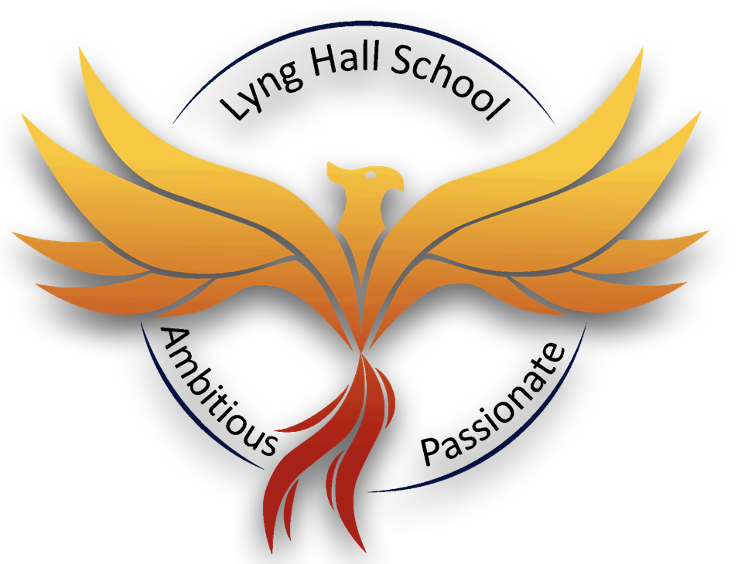
Starting ASAP
Grade TMS/UPS
Ly
Lyng Hall is a successful and inclusive school with good outcomes for pupils. We pride ourselves on removing barriers to learning through our core values: passion and ambition.
Our Ofsted Inspection said Lyng Hall was a place ‘where all teaching is consistently good or better’. ‘Pastoral care for pupils is exceptional’ and as a result, ‘the pupils feel very safe in school’. ‘Leaders have developed a highly personalised curriculum’ and ‘the school work to promote personal development and welfare is outstanding’. We are ambitious in our goal of delivering a world class education to all pupils.
The Trust is seeking to appoint an innovative and highly motivated Teacher of Science to join a strong and enthusiastic team where teachers are committed to delivering a high quality, lively and interesting curriculum to challenge and inspire all our students.

If you would like an informal conversation about the post, please contact Jane Wallace at jwallace@lynghallschool.co.uk or phone 024 7672 4960 ext 4103.
Lyng Hall is committed to the personal development of all of their staff and can offer:
- Outstanding professional development
- Supportive staff and a strong team ethos
- Supportive leadership
- Progression opportunities
- Opportunities to teach children aged 11 – 18 yrs
- Superb facilities

Closing Date: Monday 24th June 2024 at 9am
Interview Date: TBC

How to Apply
Applications are submitted through our Every Candidate Portal. Click the link below to take you directly to the site.
https://candidates.every.education/Vacancies/Details?advertKey=15b1cfe2-aaf4-42e5-9594-d991f7664f16
Alternatively, you can click on the ‘application form’ on our careers website which will direct you to the application page.
To request any of the documents in an accessible format, or to request an application form via email, please contact apply@finhampark.co.uk or call 02477 180000 and select option 2 for HR.
If you are a new user to our portal, you can click on ‘Register’ to complete your candidate profile. If you want to apply directly for this role and not save your data for any future vacancies, you can click on the ‘Apply Now’ button at the bottom of the Every page.
For further information on this role and other opportunities within the MAT, please visit https://careers.fpmat.co.uk

Safeguarding
Lyng Hall is committed to safeguarding and promoting the welfare of children and young people and expects all staff and volunteers to share this commitment. All successful applicants will be requested to undertake an Enhanced Disclosure and Barring Service Check.
Finham Park Multi Academy Trust requires all applicants to be eligible to work in the UK with no restrictions as we are unable to offer sponsorship/work visas. You will be required to provide proof of Right to Work at interview stage and if you are offered a job position with us.
Online Checks In line with KCSIE (Keeping Children Safe in Education) 2023. We will complete online searches as part of our due diligence on all shortlisted candidates. If anything is identified as part of these checks, they will be discussed with you at interview. If any safeguarding concerns are identified we reserve the right to withdraw your application.

