**RECRUITMENT PACK**

**Teacher of Science – Maternity Leave**

**Start Date: Easter 2024**

**1 Year 0.6 FTE**

**MPR/UPR**



**Introduction from the Headteacher**

The Henry Box School an exciting place to work and learn. We are committed to providing education that transforms lives and we are ambitious in our pursuit of excellence. We are the leading school in our ‘home grown’ Trust

This is a hugely exciting time for our family of schools as we are presented with a rare opportunity to make a real difference to the lives and life chances of so many young people. We believe that education can transform lives.

**Our approach**

To join The Henry Box School is to join a family – staff and pupils who have the courage to do things differently, if that’s what it takes.

Here we think deeply about how we can have the biggest impact on pupils. In a world where the algorithms of life give us more of the same, we believe education has the role to give children something different. We continually ask ourselves the following five questions:

* Are we securing equity?
* Is our leadership driving school improvement?
* Is our curriculum irresistible?
* Are we research informed?
* Are we deploying resources effectively?

All schools in our Trust have a culture of compassion underpinned by high expectations and understanding. We have three rules: ready, respectful and safe. We are a truly inclusive organization and passionately believe that every child has a right to mainstream education.

**Our curriculum principles**

We aim to ensure that all our children have access to a ‘box set’ knowledge curriculum that builds students’ schemata. We work on the understanding that the best type of feedback is in the moment and/or in the next lesson; feedback must be a medical, not a Post Mortem. We limit our interventions to the ones that are evidence based and enable our students to access the curriculum. Our curriculum is learnt, not experienced and we work hard to ensure a challenging curriculum is available for all. Our curriculum principles are clear: we aim to make sure our curriculum:

* Is ambitious and designed to give **all** learners, particularly the most disadvantaged, the knowledge and cultural capital they need to succeed in life.
* Extends beyond the academic by providing opportunities to develop and discover their interests and talents. Learners are supported to develop their character and help them
* To know how to keep physically and mentally healthy – including resilience, confidence and independence.
* Prepares learners for life in modern Britain, equipping them to be responsible, respectful, active citizens who contribute positively to society; developing their understanding of fundamental British values. All learners will develop their understanding and appreciation of diversity, celebrating what we have in common and promoting respect.
* Is coherently planned and sequenced towards cumulatively sufficient knowledge and skills for future learning. Assessment is used to help learners to embed and use knowledge fluently, to check understanding and to inform teaching.
* Has a rigorous approach to the teaching of reading, writing and oracy that develops learners’ confidence and enjoyment of learning.
* Provides a range of opportunities to ignite a passion for.

**Professional development**

We work hard to reduce bureaucracy and keep after school commitments and meetings to a minimum. Teachers in their second year of teaching are entitled to the OLEVI ‘Improving Teacher Programme’ and in their fourth year the ‘Outstanding Teacher Programme’, whilst leaders complete the ‘Outstanding Leadership of Education’ Programme. In a nutshell, whatever your career stage, you will have access to high quality professional development and a sensible approach to appraisal, based on action research and supporting each other to be even better. All staff also have access to our ever growing professional development library.

The Henry Box School is committed to promoting the welfare of children and young people and expects all staff and volunteers to share this commitment. The appointment will be subject to enhanced DBS clearance, satisfactory references and other relevant pre-employment checks.

All staff at The Henry Box School have a responsibility to co-operate with and follow all Health and Safety requirements in accordance with the school Health and Safety Policy.

If you are interested in working in a forward thinking organisation, then Henry Box could well be the place for you.

W J Hemmingsley

Headteacher

**The opportunity**

**Position: Teacher of Science (Maternity Cover Easter 2024)**

**Part time 1 Year 0.6 FTE**

**Required**

We are looking for a well-qualified, committed and enthusiastic Teacher of Science to join our successful 11-18 comprehensive school. This is an excellent opportunity for a talented teacher to join a strong Science Faculty. Applications are welcome from ECTs or experienced teachers. Visits to the school are welcome, by prior arrangement.

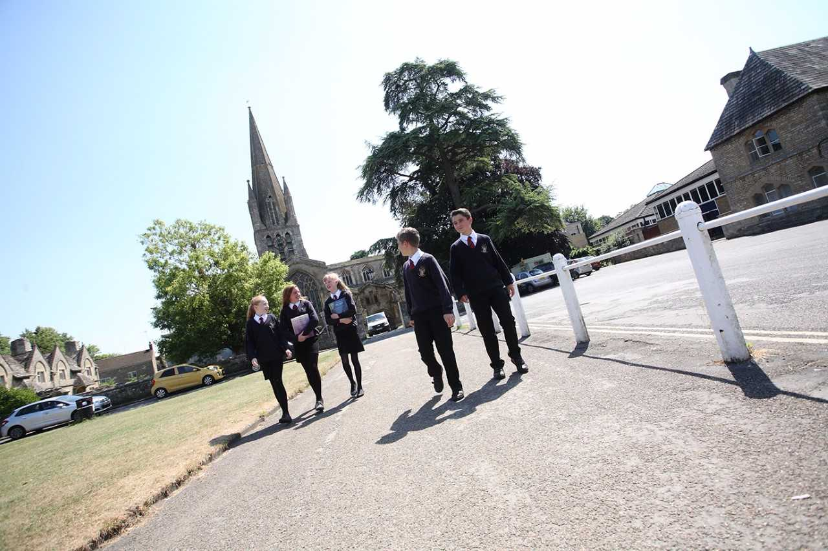

**The Science Faculty**

The Science Faculty is a strong team of committed specialist teachers. The team is managed by the Faculty Leader for Science.

Science across the Key Stages is taught in 9 well-equipped laboratories. The Science laboratories are served by 3 preparation rooms, one for each specialist area. There are 3 well-qualified and experienced laboratory Technicians who give invaluable support to Science teaching. There is also a greenhouse off one of the Biology laboratories and an established pond within a Science garden area. Schemes of learning, resources, course outlines and practical equipment are available for each year group and offer a broad and balanced curriculum for all students as well as maintaining flexibility for teachers. Every laboratory is equipped with a data projector and computer. In addition, six of the laboratories have interactive whiteboards. Teachers and students also have access to two banks of 15 laptops.

The new Key Stage 3 programme of study follows the national curriculum, using our own schemes of learning adapted from the Collins scheme. These schemes place a large emphasis on the skills required to successfully access the new GCSE courses in Key Stage 4. In Year 7, 8 and 9 students are taught in all ability groups and have 6 hours of Science per fortnight. Year 9 students complete the Key Stage 3 course by the end of term 2 and then begin the first GCSE modules.

All students in Years 10 and 11 follow the AQA GCSE specification. Teaching groups are not set by ability and many students choose to study Separate Biology, Chemistry and Physics GCSEs. The rest study the Combined Science (Trilogy) course, leading to a double award GCSE. Key Stage 4 Science groups are taught by subject specialists.

Science at Henry Box is a popular subject amongst students and attracts large numbers of candidates for A-level. The specifications followed are:

|  |  |
| --- | --- |
| * Biology: | Edexcel |
| * Chemistry: | Edexcel |
| * Physics: | AQA |

A level groups usually have around a dozen students.



**Selection Criteria**

**Essential**

* Qualified Teacher Status
* Ability to teach KS3, KS4 and KS5
* Effective behaviour management
* Ability to work as part of a team
* Knowledge of planning, assessment and record-keeping
* Commitment to further training and development
* Conscientious, enthusiastic and positive
* The ability to relate well to students, staff and parents
* Willingness and ability to be an effective tutor, if required

**Desirable**

* Willingness to contribute to extra-curricular activities
* Evidence of improving practice by identifying and meeting CPD needs.

# Job Description: Teacher (MPR and UPR)

**Post Title: Teacher of Science**

**Purpose: To raise standards of attainment and achievement of learners**

**Reporting to: School Leader and Assistant School Leader for Science where appropriate**

This job description should be read in conjunction with the current School Teachers’ Pay and Conditions Document and the provisions of that document will apply to the post holder. You will be expected to carry out the professional duties of a teacher as outlined in the School Teachers’ Pay and Conditions Document currently in operation, or any subsequent legislation.

**Liaising with**: School Leaders, House Leaders and relevant staff with cross-school responsibilities, relevant support staff.

**Working Time**: Part Time **Disclosure Level:** Enhanced

**Salary**: MPR/UPR

**Teaching**

|  |
| --- |
|  |
| **Set high expectations which inspire, motivate and challenge pupils** |
| * Establish a safe and stimulating environment for pupils, rooted in mutual respect. * Set goals that stretch and challenge pupils of all backgrounds, abilities and dispositions. * Demonstrate consistently the positive attitudes, values and behaviour which are expected of pupils. |
| **Promote good progress and outcomes by pupils** |
| * Be accountable for pupils’ attainment, progress and outcomes. |
| * Be aware of pupils’ capabilities and their prior knowledge, and plan teaching to build on these. |
| * Guide pupils to reflect on the progress they have made and their emerging needs. |
| * Demonstrate knowledge and understanding of how pupils learn and how this impacts on teaching. |
| * Encourage pupils to take a responsible and conscientious attitude to their own work and study. |
| **Demonstrate good subject and curriculum knowledge** |
| * Have a secure knowledge of the relevant subject(s) and curriculum areas, foster and maintain pupils’ interest in the subject, and address misunderstandings. |
| * Demonstrate a critical understanding of developments in the subject and curriculum areas, and promote the value of scholarship. |
| * Demonstrate an understanding of and take responsibility for promoting high standards of literacy, articulacy and the correct use of standard subject content, whatever the teacher’s specialist subject. |
| * If teaching early reading, demonstrate a clear understanding of systematic synthetic phonics. |
| * If teaching early mathematics, demonstrate a clear understanding of appropriate teaching strategies. |
| **Plan and teach well-structured lessons** |
| * Impart knowledge and develop understanding through effective use of lesson time. |
| * Promote a love of learning and children’s intellectual curiosity. |
| * Set homework and plan other out-of-class activities to consolidate and extend the knowledge and understanding pupils have acquired. |
| * Reflect systematically on the effectiveness of lessons and approaches to teaching. |
| * Contribute to the design and provision of an engaging curriculum within the relevant subject area(s). |
| **Adapt teaching to respond to the strengths and needs of all pupils** |
| * Know when and how to differentiate appropriately, using approaches which enable pupils to be taught effectively. |
| * Have a secure understanding of how a range of factors can inhibit pupils’ ability to learn, and how best to overcome these. |
| * Demonstrate an awareness of the physical, social and intellectual development of children, and know how to adapt teaching to support pupils’ education at different stages of development. |
| * Have a clear understanding of the needs of all pupils, including those with SEN; those of high ability; those with EAL; those with disabilities; and be able to use and evaluate distinctive teaching approaches to engage and support them. |
| **Make accurate and productive use of assessment** |
| * Know and understand how to assess the relevant subject and curriculum areas, including statutory assessment requirements. |
| * Make use of formative and summative assessment to secure pupils’ progress. |
| * Use relevant data to monitor progress, set targets, and plan subsequent lessons. |
| * Give pupils regular feedback, both orally and through accurate marking, and encourage pupils to respond to the feedback. |
| **Manage behaviour effectively to ensure a good and safe learning environment** |
| * Have clear rules and routines for behaviour in classrooms, and take responsibility for promoting good and courteous behaviour both in classrooms and around the school, in accordance with the school’s behaviour policy. |
| * Have high expectations of behaviour, and establish a framework for discipline with a range of strategies, using praise, sanctions and rewards consistently and fairly. |
| * Manage classes effectively, using approaches which are appropriate to pupils’ needs in order to involve and motivate them. |
| * Maintain good relationships with pupils, exercise appropriate authority, and act decisively when necessary. |
| **Fulfil wider professional responsibilities** |
| * Make a positive contribution to the wider life and ethos of the school. |
| * Develop effective professional relationships with colleagues, knowing how and when to draw on advice and specialist support. |
| * Deploy support staff effectively. |
| * Take responsibility for improving teaching through professional development, responding to advice and feedback from colleagues. |
| * Communicate effectively with parents with regard to pupils’ achievements and well-being. |
| **Personal and professional conduct** |
| * Uphold public trust in the profession and maintain high standards of ethics and behaviour, within and outside school. |
| * Treating pupils with dignity, building relationships rooted in mutual respect, and at all times observing proper boundaries appropriate to a teacher’s professional position. |
| * Having regard for the need to safeguard pupils’ well-being, in accordance with statutory provisions. |
| * Showing tolerance of and respect for the rights of others. |
| * Not undermining fundamental British values, including democracy, the rule of law, individual liberty and mutual respect, and tolerance of those with different faiths and beliefs. |
| * Ensuring that personal beliefs are not expressed in ways which exploit pupils’ vulnerability or might lead them to break the law. |
| * Have proper and professional regard for the ethos, policies and practices of the school in which they teach and maintain high standards in their own attendance and punctuality. |
| * Have an understanding of, and always act within, the statutory frameworks which set out their professional duties and responsibilities. |

#### In addition, for UPR (STPCD)

* The teacher is **highly competent** in all elements of the relevant standards
* The teacher’s achievements and contribution to an educational setting or settings are **substantial** and **sustained.**

#### General Responsibilities

* Taking appropriate responsibility for one’s own health, safety and welfare and the health and safety of pupils, visitors and work colleagues in accordance with the requirements of legislation and locally-adopted policies; including taking responsibility for raising concerns with an appropriate manager.

**Additional duties**

* Play a full part in the life of the school community, to support its distinctive mission and ethos, and to encourage and ensure staff and students follow this example.
* to promote and lead extra-curricular activities in line with the traditions and expectations of the school within the context of a life work balance.

**Other Specific Duties**

* Undertake the role of Form Tutor.
* Share in supervisory duties according to the school’s published rotas.
* Keep up to date with school information e.g. the weekly bulletin, staff handbook and to clear your pigeon hole daily.
* Participate in any arrangements within an agreed national framework for the appraisal of your performance and that of other teachers.
* Continue personal development as agreed.
* Engage actively in the appraisal process.
* Whilst every effort has been made to explain the main duties and responsibilities of the post each individual task undertaken may not be identified.
* Employees will be expected to comply with any reasonable request from a line manager to undertake work of a similar level that is not specified in this job description.
* Employees are expected to be courteous to colleagues and to provide a welcoming environment to visitors and telephone callers.
* The school will endeavour to make any necessary reasonable adjustments to the job and the working environment to enable access to employment opportunities for disabled job applicants or continued employment for any employee who develops a disabling condition.
* Undertake any other duty as specified by STPCD not mentioned in the above.

**For all staff** - You have specific responsibilities under Health and Safety / Safeguarding legislation to ensure that you:

* Take reasonable care for your own health and safety, and that of others affected by what you do, or do not do.
* Cooperate on all issues involving health and safety.
* Use work items provided for you correctly, in accordance with training and instructions.
* Do not interfere with or misuse anything provided for your health, safety or welfare.
* Report any health and safety concerns to your line manager as soon as practicable.
* Report any safeguarding concerns to a senior member of staff.
* Attend safeguarding training as requested.

This job description is current at the date shown, but, in consultation with you, may be changed by the Headteacher to reflect or anticipate changes in job commensurate with the grade or job title.

**The Application Process**

We are seeking to appoint the best possible candidate and our recruitment process will reflect our desire to undertake all possible measures to achieve this.

Applicants should download the teaching staff application form from our website.

In addition to the completed application form please submit a letter of application that is no more than one side of A4. Unaccompanied CVs will not be accepted.

Shortlisting will take place shortly after the closing date and candidates will be notified further only if they are successful in being shortlisted. The date for interviews and any associated assessment activities will be confirmed in due course.

If you decide you want to be part of our dynamic team, we look forward to receiving your completed application form.

**Closing date: 20th February 2024 at 9am**

In the meantime, if you have any queries about this role, please do not hesitate to contact the HR Team on 01993 848166 or email [hr@millacademy.co.uk](mailto:hr@millacademy.co.uk).