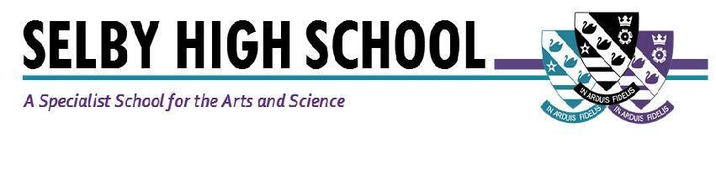

Teacher of Science
Required: September, 2021, (1 year maternity cover)
Salary: MPS/UPS
Are you ready for an exciting role as part of our successful Science Faculty? This is a superb opportunity for a year-long maternity cover in an established, forward thinking department, which achieves results well above the national average. There may well be further opportunities within the school at the end of the year for the right candidate. Our supportive ethos and superb teaching resources make this an ideal opportunity, whether you are looking to undertake your NQT training year, or you are a more experienced practitioner. The successful candidate will work in a supportive school where students achieve and make sustained progress as a result of our ‘can do’ ethos.

If successful, we offer you the opportunity to work with a highly-motivated group of students and colleagues, where your contribution to the Science Faculty and the school as a whole, will be valued. Working in a friendly school community, we invite you to join us in our commitment to inspire every student with the skills, resilience, independence and confidence they need to achieve their potential. As a school, we have an extensive CPD programme- including a very thorough package for NQTs and RQTs- to support you in your career. We also provide all our staff with a laptop computer.

Excellent learning and teaching is at the heart of all that we do and is supported with an outstanding induction programme.

We can’t arrange visits to the school at the moment, but the Principal would be delighted to talk through the role with you if you are interested. Selby is located in picturesque North Yorkshire and benefits from good commuter links with York and Leeds.

Selby High School is an equal opportunities employer. We have a robust child protection policy and are committed to safeguarding the welfare of our children and young people.

Full details and an application pack are available from the school website: www.selbyhigh.co.uk. Conversations with the Principal can be organised by contacting the SLT PA, Caroline Airth on 01757 244833 or admin@selbyhigh.co.uk.

Closing date: Noon on Monday, 19th April, 2021.

Selby High School
Leeds Road, Selby, North Yorkshire, YO8 4HT.

