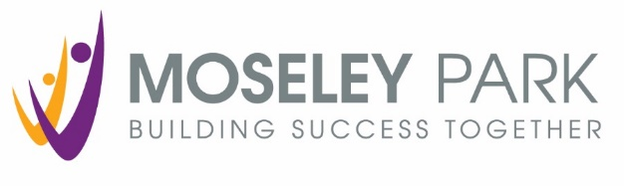

Moseley Park School
Teacher of Science
(Applications from NQTs are welcome)

We are looking for a dynamic and inspiring Teacher of Science to join our highly successful school. The candidate should have a record of outstanding practice, either in post or in training, knowledge of course specifications and a capacity to excite students with a range of innovative teaching and learning strategies.
Applications from newly qualified teachers are welcome and development/responsibility opportunities are available for interested candidates with relevant experience.
This is an additional position within the department, bringing greater flexibility and further capacity to the team. The successful candidate will have the opportunity to teach across all three Key Stages. You will be joining a progressive and forward-thinking department with a wealth of opportunity for professional development. We pride ourselves on our pupil-centric nature of working which consistently leads to excellent outcomes for the young people we teach. We are continually looking to develop our ability to lead enrichment activities outside the classroom through trips, external visitors and extra-curricular clubs. All staff within the department have the opportunity to lead on these, we look forward to welcoming you!
Moseley Park is one of the top performing non-selective schools in the City. We are unrelenting in our determination to provide the highest quality learning experiences for our students and so this is an exciting opportunity if you are an ambitious, high calibre professional.
If you share our vision and determination, possess strong ambitions for learners, and want to have a positive impact on young people, families and the community, then we would be delighted to hear from you. For more information and further details about this exceptional opportunity, please find the information on the school website (www.moseleypark.org) or contact Mrs Jane Elwell. Tel: 01902 553901 E-mail: jelwell@moseleypark.org
Moseley Park is committed to safeguarding and promoting the welfare of children and young people and expects all staff and volunteers to share this commitment. The successful candidate will be subject to an enhanced DBS check.

Closing date for applications: Monday 1 February 2021, 9.00am

