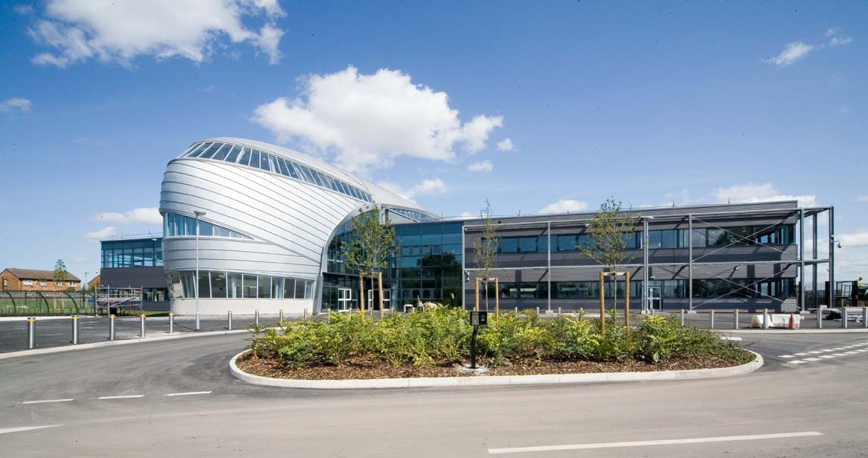

Aspire, Community, Experience

Welcome from the Principal Team
We live in exciting times – our great city of Liverpool is currently undergoing an amazing renaissance, with new jobs, investment and opportunities. We are proud to tell you that North Liverpool Academy is also undergoing its own renaissance. Our most recent Ofsted inspection has graded us as a ‘good’ school in all areas. Our exceptional academic results and reputation continue to confirm us as one or the fastest improving schools in Liverpool.
NLA lies at the heart of the local community. It is our task to prepare our young people for the exciting challenges and opportunities ahead. Our curriculum inspires a lifelong passion for learning and equips our students with the confidence and skills to take advantage of the tremendous opportunities on our doorstep and further afield.
Our ethos and core values are built around a culture of enjoyment and achievement. We believe that when joining our team as a student, parent, member of staff or a member of the local community, by embracing our values of high aspiration, transformational experience, community engagement and excellent achievement we will deliver outstanding educational outcomes for all.
We believe it is our job to ensure that our students take pride in all they do and graduate from North Liverpool Academy with the confidence to take on the competitive and ever-changing world around us. This is a truly exciting time for the North Liverpool Academy as we establish a world class academy with excellence for personal development, leadership, teaching and learning.
If you have any questions, would like a conversation or if you wish to come and see the outstanding work happening across our academy please feel free to contact us.
Phil Lloyd, Executive Principal Emily Vernon, Principal
History of NLA

North Liverpool Academy opened in 2006 as one of the first Academies in the country and has benefitted from the various advantages that brings. The Academy is well resourced both in terms of facilities and staff. It is housed in a superbly equipped building, erected in 2009 and enjoys an excellent reputation within the local community.

The Trust

Northern School Trust is a not-for-profit education charity. It is a well-developed MAT (Multi-Academy Trust) held in high regard by the DFE. There are currently four schools in the Trust including an innovative Studio School and a Life Sciences UTC in the centre of Liverpool and a UTC based in Wigan.

The Trust is proud of its collaborative way of working and is developing into a nationally recognised and trusted academy sponsor with an excellent reputation. The Trust has a wide range of expertise and specialised experience to call upon, having access to the FE, University, private and voluntary sectors as well as partner schools and consultant expertise drawn from across the UK.

The Trust has a central team that provides best value and an efficient service delivery in areas of HR, Finance, Enterprise & Marketing, Governance, Strategic ICT Development, Data and Facilities Management to all NST schools.

Latest Ofsted

North Liverpool Academy’s recent Ofsted inspection from March 2022 rated the school officially as a Good School, along with the improving trend in academic results confirms the school as one of the most improved in Liverpool.

Some takeaways from the report include:

“Pupils including those with special educational needs and/or disabilities (SEND) achieve well. This is because leaders have high expectations of pupils’ behaviour and learning. Teachers know their pupils and students in the sixth form in detail. Pupils appreciate the respectful relationships that they forge with staff. They said that they feel valued as individuals and that they trust the staff.”

“Students in the sixth form, benefit from a well-designed careers programme. This helps to raise pupils’ ambitions and improves their employability. A high proportion of pupils continue into further education and training. An increasing number of students from the sixth form continue their education at university.”

“Trustees and governors have a clear vision for the school and enact it capably. They
provide effective support and challenge to leaders. Their actions have led to improvements in the quality of education for all pupils including for disadvantaged pupils.
Leaders are considerate of staff ’s workload and well being. Staff said that they are proud to work at North Liverpool Academy describing the school as an extended family.”

Latest published results:

https://www.compare-school-performance.service.gov.uk/school/131065/north-liverpool-academy/secondary

Progress:
- Progress 8 Score = 0.20
- English Progress 8 Score = -0.20
- Maths Progress 8 Score = -0.05

Attainment:

- Average Attainment 8 Score 48.55
- 70.2% gained grade 4 or above in English
- 65.1% gained grade 4 or above in Maths
- 58.8% gained grade 4 or above in English and Maths
- 49.2% gained grade 5 or above in English
- 46.4% gained grade 5 or above in Maths
- 37.8% gained grade 5 or above in English and Maths
- 10.5% of students entered for EBacc
- 3.4% of students achieved an EBacc Standard Pass
- EBacc Average Point Score 3.66

KS5 Data:

Overall Value Added Score 0.79

Progress Scores by Qualification Category

A Level 0.92
Academic 0.91
Applied General 0.61

You can find the official evaluation Gov.uk evaluation of the school here https://www.compare-school-performance.service.gov.uk/school/131065/north-liverpool-academy/16-to-18

Our Amazing Facilities:
North Liverpool Academy moved into a purpose built state of the art building in September 2009 and has the following outstanding facilities to name a few:
- 7 Technology classrooms
- 13 state of the art Science classrooms which are fully supported by 2 full-time Science Technicians
- Outstanding Drama Theatre which includes movable walls and bleacher seating to accommodate 220
- High quality dance studio with 2 designated teaching spaces
- Music practice and performance rooms
- Designated sixth form provision with LRC, classrooms and space for study or research
- Library
- ICT facilities including banks of I-Pads, Chromebooks and laptops
- Multi-purpose media suite
- Teaching & learning hub
- Sports hall and fully equipped Gym and Fitness Centre
- Full size Astro pitch
- On site Scoot 66 Scooter supplies shop
- Secure car parking with spaces for up to 140 cars
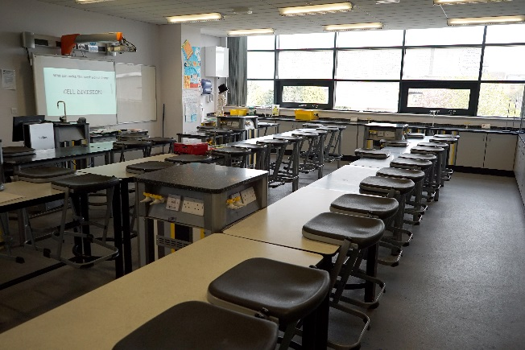

So why choose North Liverpool Academy?
All Staff
- Excellent opportunities for advancement & promotion
- Bespoke training as part of our talent management programme and online accredited CPD courses
- Well lead and managed teams
- Employee Assistance Programme offering staff (& their family members over 16) support through counselling & CBT therapy
- Inclusive induction programme
- Designated reprographics support & ICT helpdesk
- Staff discount scheme including cinema vouchers, days out, shopping and dining out
- Proactive approach to mental health and wellbeing including a supportive HR Department who can provide access to wellbeing services & referrals to Occupation Health
- Free on-site secure parking
- Free access to Fitness suite
- Complementary tea & coffee facilities
- Duke of Edinburgh
- Extended opening hours to promote a better quality of work/life balance
Teachers
- Fast track UPS/Leadership progression
- Training and support for middle or emerging leaders and access to NPQML/SL programmes
- Comprehensive ECT/School Direct/Teach First programme
- Paid Development post opportunities
Support Staff
- 35 days paid annual leave
- Support for staff wishing to progress into teaching through School Direct
- Membership into the local Government pension scheme, where we as employers pay an additional 11% of contributions
- Time off in lieu when available
- Non contractual discretionary leave during school closure periods

Dear Applicant,
Thank you for requesting further details about the position of Teacher of Science.
This is an exciting opportunity to join an ambitious, enthusiastic and energetic department, with a thirst to continue to improve the outcomes and prospects for all of the students in our care.
The department consists of nineteen members of staff, which includes a Head of KS5, Head of KS4 and Head of KS3, as well as a STEM co-ordinator. Our curriculum is based on a thematic approach to real life memorable science. These themes are centred around seasonal topics eg. Fireworks unit at Bonfire night, reproduction during spring and car crash investigation during the winter months. These have revolutionised how the science curriculum is taught and delivered and has ultimately improved engagement and motivation within science across the academy. We continually strive to improve ourselves and our teaching, so opportunities for CPD are vast, as are opportunities for promotion. We also have 2 very hard-working science technicians who will demonstrate and prepare all practical activities.
As a teacher of Science, you would have the opportunity to teach across the key stages and ability ranges. The department currently teaches the AQA specification and offers A Levels in Biology, Chemistry and Physics. We also offer Level 3 BTEC in Applied Science.
The Science department is housed in its own section of the school, with 13 specialist laboratories an ICT room and a very large prep room. We aim for each member of staff to have their own classroom, with interactive whiteboard and desktop PC.
You would be joining a hardworking, fully supportive and well-respected team who work within a wider staff of helpful, friendly colleagues.
Should you have any questions, wish to discuss the position further or if you would like to visit the Academy prior to your application, please feel free to contact me either by email omeara.n@nla.uk.com or by telephone.
I look forward to receiving your application.

Yours sincerely
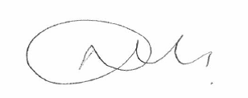

Mrs N O’Meara
Curriculum Leader of Science

The Science Department
The Department consists of 17 full time teachers with a range of experience and levels of responsibility both within the department and across the Academy. We also have two full time technicians. The science curriculum, as well as delivered using specialist teachers at Post-16 level as North Liverpool Academy strives to support its students to develop into the Scientists of the future.
“Science sits at the heart of everything we do. Every element of our lives is impacted by the rapid developments and real world application of science. The Science team at North Liverpool Academy are passionate about developing and delivering an innovative curriculum that will prepare our students to be successful, well informed citizens within an ever changing world.
The city of Liverpool is fortunate to be the home of some of the leading lights in the world of science. At North Liverpool Academy, we have developed a wide range of industry partners that work closely with our team to ensure that our students get to experience the real-life application of science beyond the classroom. We strive to raise the aspirations of our students by encouraging them to consider a career in science, technology, engineering or mathematics and to apply the skills of scientific enquiry to their everyday lives.
We are committed to recruiting teachers who share the enthusiasm of the team and are excited by the uncertainty that is created by the daily developments in the scientific world. As we continue to develop as one of the leading educational providers within Liverpool we are determined to add to our team of practitioners to ensure science education remains at the cutting edge of developments”

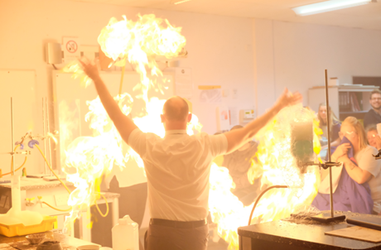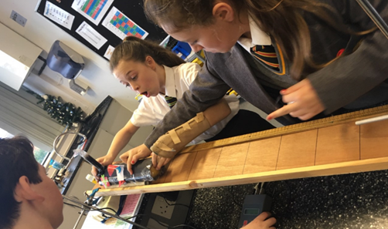

Curriculum
Our team of experienced, specialist science teachers have designed an inspiring programme of study to deliver the Key Stage 3 National Curriculum to allow students to master the fundamental knowledge, understanding and skills needed for GCSE-level success. This programme has been developed by incorporating the AQA schemes into a theme based approach to enthuse and challenge pupils to learn and achieve in their first three years.
At key stage 4 we teach AQA separate science and trilogy combined science. We have a two year key stage 4. Before this there is an interim year nine transition module and this allows time to continue with the thematic approach as an introduction to GCSE content and the remainder of the curriculum time is used to complete the specification, required practicals and have revision built in to embed the knowledge. Our students are taught content through practical science where possible and have timetabled skills lessons to embed the necessary skills to become competent scientists at key stage 5.
Our key stage 5 curriculum consists of A-levels with AQA in Biology, Chemistry and Physics running alongside the Edexcel BTEC Applied Science course. Working within all key stages, our leaders are developing a scheme of extracurricular opportunities with both universities and industry to ensure our science scholars develop skills and experiences outside of the classroom environment.

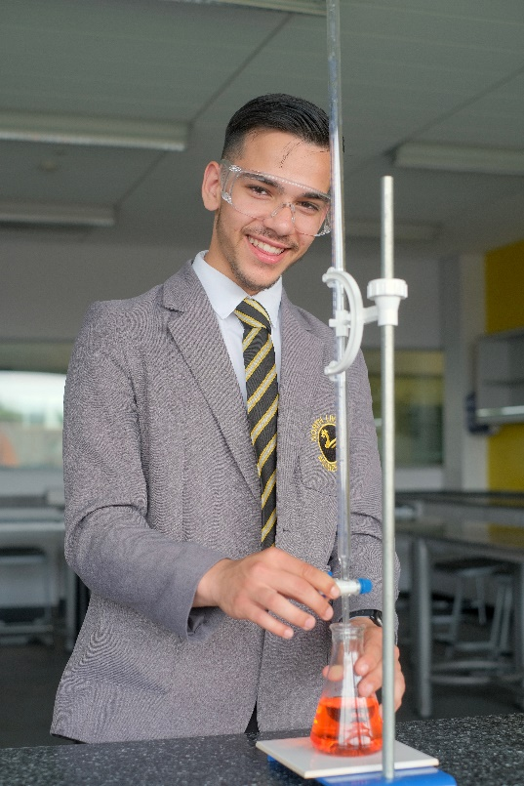

Staff Profiles
Nicki O’Meara, Subject Leader of Science
“I joined the academy in 2008 as long term supply and have never left. I was permanently employed quickly after starting and successfully completed my NQT year with lots of support. During my NQT year I swiftly recognised the need to show students the importance of science in our everyday lives and the need to make science relevant and contextual was paramount. The enjoyment and progress made by students during practical lessons using the fantastic facilities and equipment available has made teaching science here a joy.
After completing my NQT year I was asked to be part of a teaching and learning development team that provided CPD for all staff to improve their teaching practice, this involved providing them with strategies to improve student engagement and attainment. After this recognition from SLT to join the team I applied for KS4 co-ordinator and was successful in this application.
While undertaking the role of KS4 co-ordinator I received extensive support and guidance that has both improved my teaching and my leadership skills. This led to a successful promotion to KS4 leader in Science and more recently following a successful application to a middle leaders training programme I have achieved a promoted post as head of department.
I have grown up at NLA and it has shaped me to be very successful in my career so far. I see a long future for our team by driving a successful department forward to become the leading science provider in the city. Every day is different at NLA and it is the challenges and triumphs that we as a group face that make us a family of science teachers striving to improve our professional development.”

Graeme Erickson, STEM Lead
“I joined the North Liverpool Family in 2010 and was originally employed as a Chemistry Teacher. The day after my PGCE finished I started my teaching career at NLA. My main role was to increase the number of students taking part in separate chemistry at GCSE and A-level.
I was promoted to STEM Co-ordinator in 2016. This involved me taking a lead on encouraging students into STEM pathways using both internal and external school activities. I was chosen to take part in a Master’s in excellence in education alongside other colleagues. We use the knowledge gained from this qualification to deliver training to the staff body. The master’s qualification really helped me to clarify what is excellent practice in education and I am thankful that the school chose me to take part in it.
I am excited for what the rest of my career here at North Liverpool Academy will be as this is an exciting and dynamic place to work. From car crash investigations to chicks hatching in your classroom, no day is ever just an ordinary day. It is a special school to work in, it is a special area of Liverpool to work in and I hope I get to work here with the people I love working with for as long as possible.

Faye Cannon Key Stage 4 Leader in Science
“I joined the academy in 2019 to start a new role as Key Stage 4 coordinator in science. My first year at NLA was a huge learning curve. During this year I received a huge amount of support, training and guidance in which I developed lots of new skills and attributes in order to enable me to fulfil my new role as key stage lead.
The fantastic facilities and well thought out themed curriculum make teaching science fun and engaging. The students love for science can be seen in each and every lesson and is something each member of the science department is extremely proud of. The department is well-resourced and led by forward-thinking practitioners who are keen to ensure all students not only achieve well, but develop an enjoyment of science while doing so.
Since starting at NLA my development not only as a teacher but also as a key stage leader has been outstanding and NLA has been and will continue to be a huge part of my professional development. As part of my role I am accountable for securing the highest standards of pupil achievement across key stage 4 by monitoring and evaluating pupil achievement. I have learned how to improve student outcomes by developing monitoring and reviewing interventions.
I was fully immersed into life at NLA from the moment I started and realised that relationships with both staff and students was going to be paramount to my success here at NLA. Both the students and staff made me feel extremely welcome and supported and I instantly felt part of the NLA family. Every day I look forward to coming to work and I am lucky to be surrounded by a fantastic team of science teachers who go above and beyond every day to help students exceed expectations.”

Anne-Marie Binks, Key Stage 3 Leader in Science
“I joined the academy in 2015 to be part of a team that was all about improving life chances for the students and ensuring that all students are supported to achieve their full potential. I started as an experienced teacher and within a short time I was promoted to KS5 science coordinator. In 2018 I became KS3 science coordinator to assist in embedding our new themed KS3 curriculum.

Part of my role involves monitoring the progress of our students at KS3. The KS3 curriculum that we have developed ensures that our learners are able to successfully progress onto KS4 with a high level of science practical skills and knowledge. The academy’s professional development programme has supported me to continue to develop my teaching and leadership skills.

The department is enthusiastic in their approach to collaboratively plan sequences of lessons that will engage our learners and to inspire them to become passionate and young scientists of our future. We have grown to become one big NLA family and work hard to ensure that staff and students well-being is at heart that everything we do.”

Dr Alistair Bargery, Lead Teacher of KS5 & Physics
I have 10 years’ experience teaching, including three years in New Zealand. When I relocated back to the UK in 2020, I was looking for a school that gave opportunities for its students to pursue activities beyond the science laboratories, as well as providing a productive environment for learning in the laboratories.
NLA aims for thorough academic success for each pupil through a system of regular assessment cycles coupled with thorough data analysis. This is balanced with a pastoral system of houses and forms, where the pastoral staff are always on hand to help our pupils with their emotional needs, making our learners some of the happiest I’ve taught in any of the five schools in which I have worked.
The science department is a strong team and is led with drive, understanding and total commitment by our head of department. She is supported by a team of three key stage leaders and a STEM coordinator, who all collaborate to produce a curriculum that flows throughout the key stages. Our team work tirelessly to ensure that everyone in the department is supported and we have the full range of experiences within our teaching ranks, from trainees and ECTs to those with many years’ under their belts. All big tasks are shared and everyone is willing to give a helping hand if the need arises.
One of my favourite aspects to working within the NLA science department is the drive to ensure that our learners are intrinsically-motivated and enquiring learners. Our schemes of work are devised to bring out passion and enthusiasm for Science via a range of real-world links and frequent practical work. We aim to make sure the pupils are asking big questions about the topics they are studying.
My first degree was a master’s in Geophysics, with my master's project on reversals of the geomagnetic field, from the University of Liverpool and my PhD was in Environmental Science (fluid dynamic modelling, applied to flows on different planets) from Lancaster University. I am most interested in the way that the laws of Physics are universal and can be applied to any place in time and space in the universe, and that we are always finding out about new laws from continued experimentation, so it is an ever-developing science. I'm fascinated by every branch of Physics and have studied various applications, but at the moment my main interests are reading about quantum physics and how this theory brings into question the deterministic, classical view of the world.

Job Description
Post Title: | TEACHER
Purpose: | - To contribute effectively to the work of the Academy and to the achievement of its mission.  - To facilitate and encourage a learning experience which provides students with the opportunity to achieve their individual potential.  - To contribute to the provision of an appropriately broad, balanced, relevant and differentiated curriculum for students.  - To actively safe guard and promote the welfare of students in the Academy
Reporting to: | Curriculum Leader.
Responsible for: | The provision of a full learning experience and support for students.
Liaising with: | Support staff other teachers’ other professionals
Salary/ Grade: | The appropriate point on the STPC scale for teachers.
MAIN (Core) DUTIES
Operational / Strategic Planning | - To contribute to the whole Academy's planning activities.  - To assist in the development of appropriate syllabuses, resources, schemes of work, marking policies and teaching strategies in the Curriculum Area.  - To plan and prepare courses and lessons.
Curriculum Provision | - To assist the Curriculum Leader to ensure that the curriculum area provides a range of courses which will complement the Academy’s strategic objectives.
Curriculum Development | - To assist in the process of curriculum development and change so as to ensure the continued relevance to the needs of students, examining and awarding bodies and the Academy's Mission and Strategic Objectives.
Staffing  Staff Development  Recruitment / Deployment of Staff | - To take part in the Academy's staff development programme by participating in arrangements for further training and professional development.  - To continue personal development in the relevant areas including subject knowledge and teaching methods.  - To participate in the Performance Management process.  - To work as a member of a designated team and to contribute positively to effective working relations within the Academy.
Quality Assurance | - To help to implement Academy quality procedures and to adhere to those.  - To contribute to the process of monitoring and evaluation of the curriculum area/department in line with agreed Academy procedures, including evaluation against quality standards and performance criteria. To seek/implement modification and improvement where required.  - To review from time to time methods of teaching and programmes of work.  - To take part, as may be required, in the review, development and management of activities relating to the curriculum, organisation and academic mentoring functions of the Academy.
Management Information and Administration | - To maintain appropriate records and to provide relevant accurate and up-to-date information for MIS.  - To complete the relevant documentation to assist in the tracking of students.
Communication | - To communicate and consult with the parents of students.  - Where appropriate, to communicate and co-operate with internal/external individuals and bodies as appropriate.  - To follow agreed policies for communications in the Academy.  - To show an active and personal commitment to safeguarding students by communication any issues that may arise
Marketing and Liaison | - To take part in marketing and liaison activities such as Open Evenings and liaison events with primary schools.  - To help with the interviewing of prospective students.  - To contribute to the development of effective subject links with external agencies.
Management of Resources | - To contribute to the process of the ordering and allocation of equipment and materials.  - To assist the Curriculum Leaders to identify resource needs and to contribute to the efficient/effective use of physical resources.  - To co-operate with other staff to ensure a sharing and effective usage of resources to the benefit of the Academy, department and the students.
Academic Mentoring System | - To promote a safe environment for all students as part of the safeguarding agenda  - To promote the general progress and well-being of individual students.  - To register students, accompany them to assemblies, encourage their full attendance at all lessons and their participation in other aspects of Academy life.  - To undertake regular personal review interviews with students to assist in evaluating their progress and development and in identifying and monitoring personal action plans.  - To evaluate and monitor the progress of students and keep up-to-date the individual student progress file and other records as may be required.  - To contribute to the preparation of Records of Achievement/ profiles and other reports, including the drafting of references.  - To alert the appropriate Curriculum Leader to problems experienced by students and to make recommendations as to how these may be resolved.  - Monitor course work and targets and report any falling off of performance  - Monitor merits rewards and sanctions and undertake appropriate actions  - To support the activities of the House and take part in events.  - To deliver the Academic mentoring programme.  - To contact the parents, via the Head of House curriculum leader or House manager to keep them informed of any difficulties and problems experienced.
Teaching | - To teach, according to their educational needs, including the setting and marking of work to be carried out by the student in the Academy and elsewhere.  - To assess, record and report on the attendance, progress, development and attainment of students and to keep such records as are required to provide, or contribute to, oral and written assessments, reports and references relating to individual students and groups of students.  - To undertake a designated programme of teaching.  - To ensure a high-quality learning experience for students which meets internal and external quality standards.  - To prepare and update subject materials.  - To use a variety of delivery methods which will stimulate learning appropriate to student needs and demands of the syllabus.  - To make extensive use of the ICT facilities that are available to enhance teaching and learning.  - To contribute to the development of the materials on the VLE  - To maintain discipline in accordance with the Academy's procedures, and to encourage good practice with regard to punctuality, behaviour, standards of work and homework.  - To undertake assessment of students as requested by external examination bodies, departmental and Academy procedures.  - To mark, grade and give written/verbal feedback as required.  - To ensure that all cross curricular aspects such as Citizenship are delivered according to the academy’s plan and that these are assessed and recorded.
UPS 1,2,3 It is the role of post threshold teachers to support others younger in the profession to gain the necessary skills to pass through the threshold or to move higher in expertise. It is therefore expected that each member of staff will contribute towards the development of the practice of colleagues and be supportive of them so that that the base of knowledge is shared and our expertise as an academy grows. UPS 1,2 and 3 are deemed to be good and very good practitioners and the quality of their work should be always commensurate with that expectation

Enhanced DBS for all roles

OTHER SPECIFIC DUTIES
This job description is current at the date shown but, in consultation with you, may be changed by the Principal.

Person Specification

TEACHER
QUALIFICATIONS
Essential
- Relevant professional qualifications - Degree level or equivalent
- Has up to date knowledge of relevant legislation and guidance in relation to working with, and the protection and safeguarding of children and young people
- Displays commitment to the protection and safeguarding of children and young people
- Teaching Certificate

SKILLS / KNOWLEDGE / QUALITIES

Teaching

To be a very good or excellent teacher

Management of Learning
Essential
- Commitment to and ability to support the distinctive ethos of the Academy
- An excellent record of enthusiastic and successful teaching of History.
- Very good communication skills
- Planning and organisational skills
- Ability to relate well to staff, students and parents
- Values and respects the views and needs of children and young people
- Has good ICT skills which can be used in teaching for learning and good presentational skills
- Is resilient and demonstrates ability to work well under pressure. Manages time effectively
- Ability to be a fully integrated team member and be adaptable and flexible in approach to meet the needs and aspiration of the students.
- Is committed to personal and professional development. Is reflective and learns form past experiences.
- Is willing to work within the organisational procedures and processes to meet the required standards for the role
- Has problem solving analytical and negotiating skills

Curriculum
Essential
- Good understanding of the relevant curriculum area
- Willingness to keep up-to-date on issues concerning curriculum development
- Clear understanding of how the KS3 curriculum supports skills and knowledge needed for KS4 History.
- Ability to plan and deliver inspiring lessons for students.
- Ability to teach KS4 GCSE History
- Willingness to participate in the evaluation and monitoring of the relevant curriculum area(s) and quality assurance procedures
- Willingness to identify and implement action points for improvement
- Ability to maintain confidentiality where appropriate

Desirable
- Experience of delivering KS5 A Level History
- Understanding of the new KS4 specifications.
- Experience of planning long and medium terms schemes of work.

Staff
Essential
- Willingness to participate in Personal Development Review and Staff Development procedures.
- Commitment to equality of opportunity and fair treatment for all staff and students.
- Appreciates the significance of safeguarding and interprets this accurately for all individual children and young people whatever their life circumstances
- Willingness to undertake training to complete individual training needs.
- Willingness to contribute to the design and delivery of staff development programmes.

The Academy is committed to the safeguarding of its students and the promotion of the welfare of children and young people and expects all staff and volunteers to share this commitment.

Liverpool and Mersey region
Whether you are a native to Merseyside or looking at relocating, it’s clear that Liverpool and Merseyside as a whole has a lot to offer. Being European Capital of Culture in 2008 it’s evident why.
Here in Liverpool, there is something for everyone to enjoy, whether it’s visiting one of the many museums for a spot of history and culture, to experiencing a taste of the orient – Liverpool has the biggest Chinese arch outside of mainland China!
Here are some other reasons to enjoy our City
- 2 amazing Cathedrals
- Amazing parks and gardens
- 2 top premier league football clubs – both of which are located within walking distance of the Academy
- House prices in the North West are far cheaper than anywhere else in the UK
- Excellent transport links
- Top tourist attractions
- Fantastic range of shopping, restaurants and nightlife

Why not visit www.visitliverpool.com to see why Liverpool is great!

