Teacher of Science (Physics)
Required for either a September 2024 or January 2025 start
Salary: MPR/UPR

We are an 11-18 Catholic College with 1,600 students on roll, including 220 in the Sixth Form. GCSE and A level results have been consistently excellent over several years and we are determined to make ourselves an exceptional educational provider. Our college is highly popular with parents/carers, and we are oversubscribed every year.

We are looking to appoint an enthusiastic teacher of science, preferably with a specialism in physics, who is committed to ensuring student enjoyment, engagement and progress within the Science department. This is an exciting opportunity for a highly motivated and ambitious person to develop their career in a forward-thinking college with high standards of achievement and care.

Our college cherishes the individuality of Biology, Chemistry and Physics while weaving them together to offer a curriculum that is both distinct and interconnected across all key stages. With a focus on expert teaching, particularly at KS4 and KS5, we ensure that students benefit from high-quality instruction that sets consistently high expectations.

We follow AQA at GCSE and at KS5, where we currently offer Biology, Chemistry and Physics. We are currently exploring offering a BTEC from 2025. Year 7 and 8 are taught general science predominantly by a single teacher, and from Year 9 onwards, students are taught Combined Science: Trilogy as Biology, Chemistry and Physics by subject specialists. Some students choose to study Separate Sciences from Year 10.
We are a fortunate team in that we have a good balance of subject specialists, some of whom are part time. For the next academic year, the leadership of the department will include Lead Teachers of Biology and Chemistry, who will work closely with the Head of Science (who is a physicist), to focus on developing subject specialist curriculum and pedagogy. This new focus on teaching within specialism from Year 9 onwards has been very beneficial for students, who are now receiving more innovative and tailored learning experiences, something that we will build on in the coming years.

We have weekly departmental meetings and regularly discuss pedagogy in subject teams. This collaborative planning has led to some new innovative teaching ideas; we are trialling new teaching techniques across Year 7 to see how well it fits our team and students. The department has a bank of shared teaching resources, but all staff have the autonomy to experiment and fit their lessons to fit their individual teaching styles and student needs.
The department is well supported by two experienced, full-time, science technicians. A love of learning is encouraged through exposure to meaningful practical and modelling and to facilitate this, our department uses LabLogger to track and share practical.
The department is going through a rolling program of lab refurbishments we have 4 newly refurbished labs, the most recent was completed during October 2023. Most staff have their own laboratory or teach in one classroom for the entire day. This ongoing renovation is helping to raise the profile of the department across the college and alongside our other changes we are hoping this will further increase the numbers of students opting to take Separate Science in Year 10.
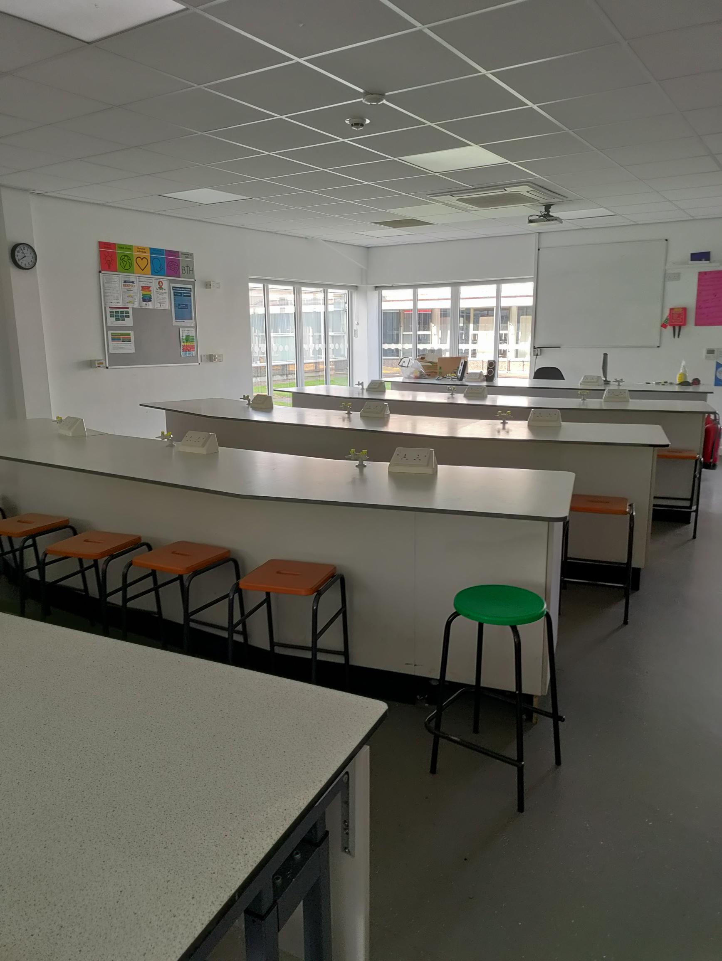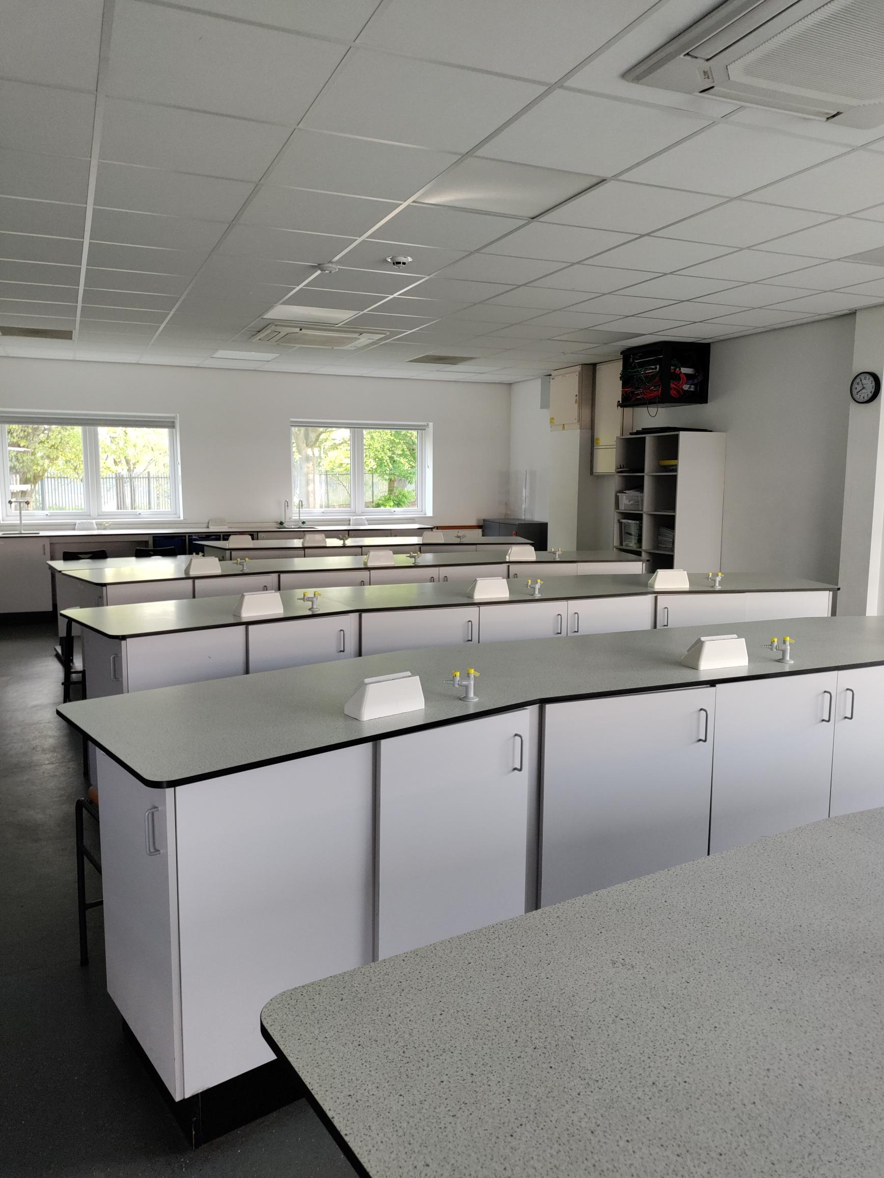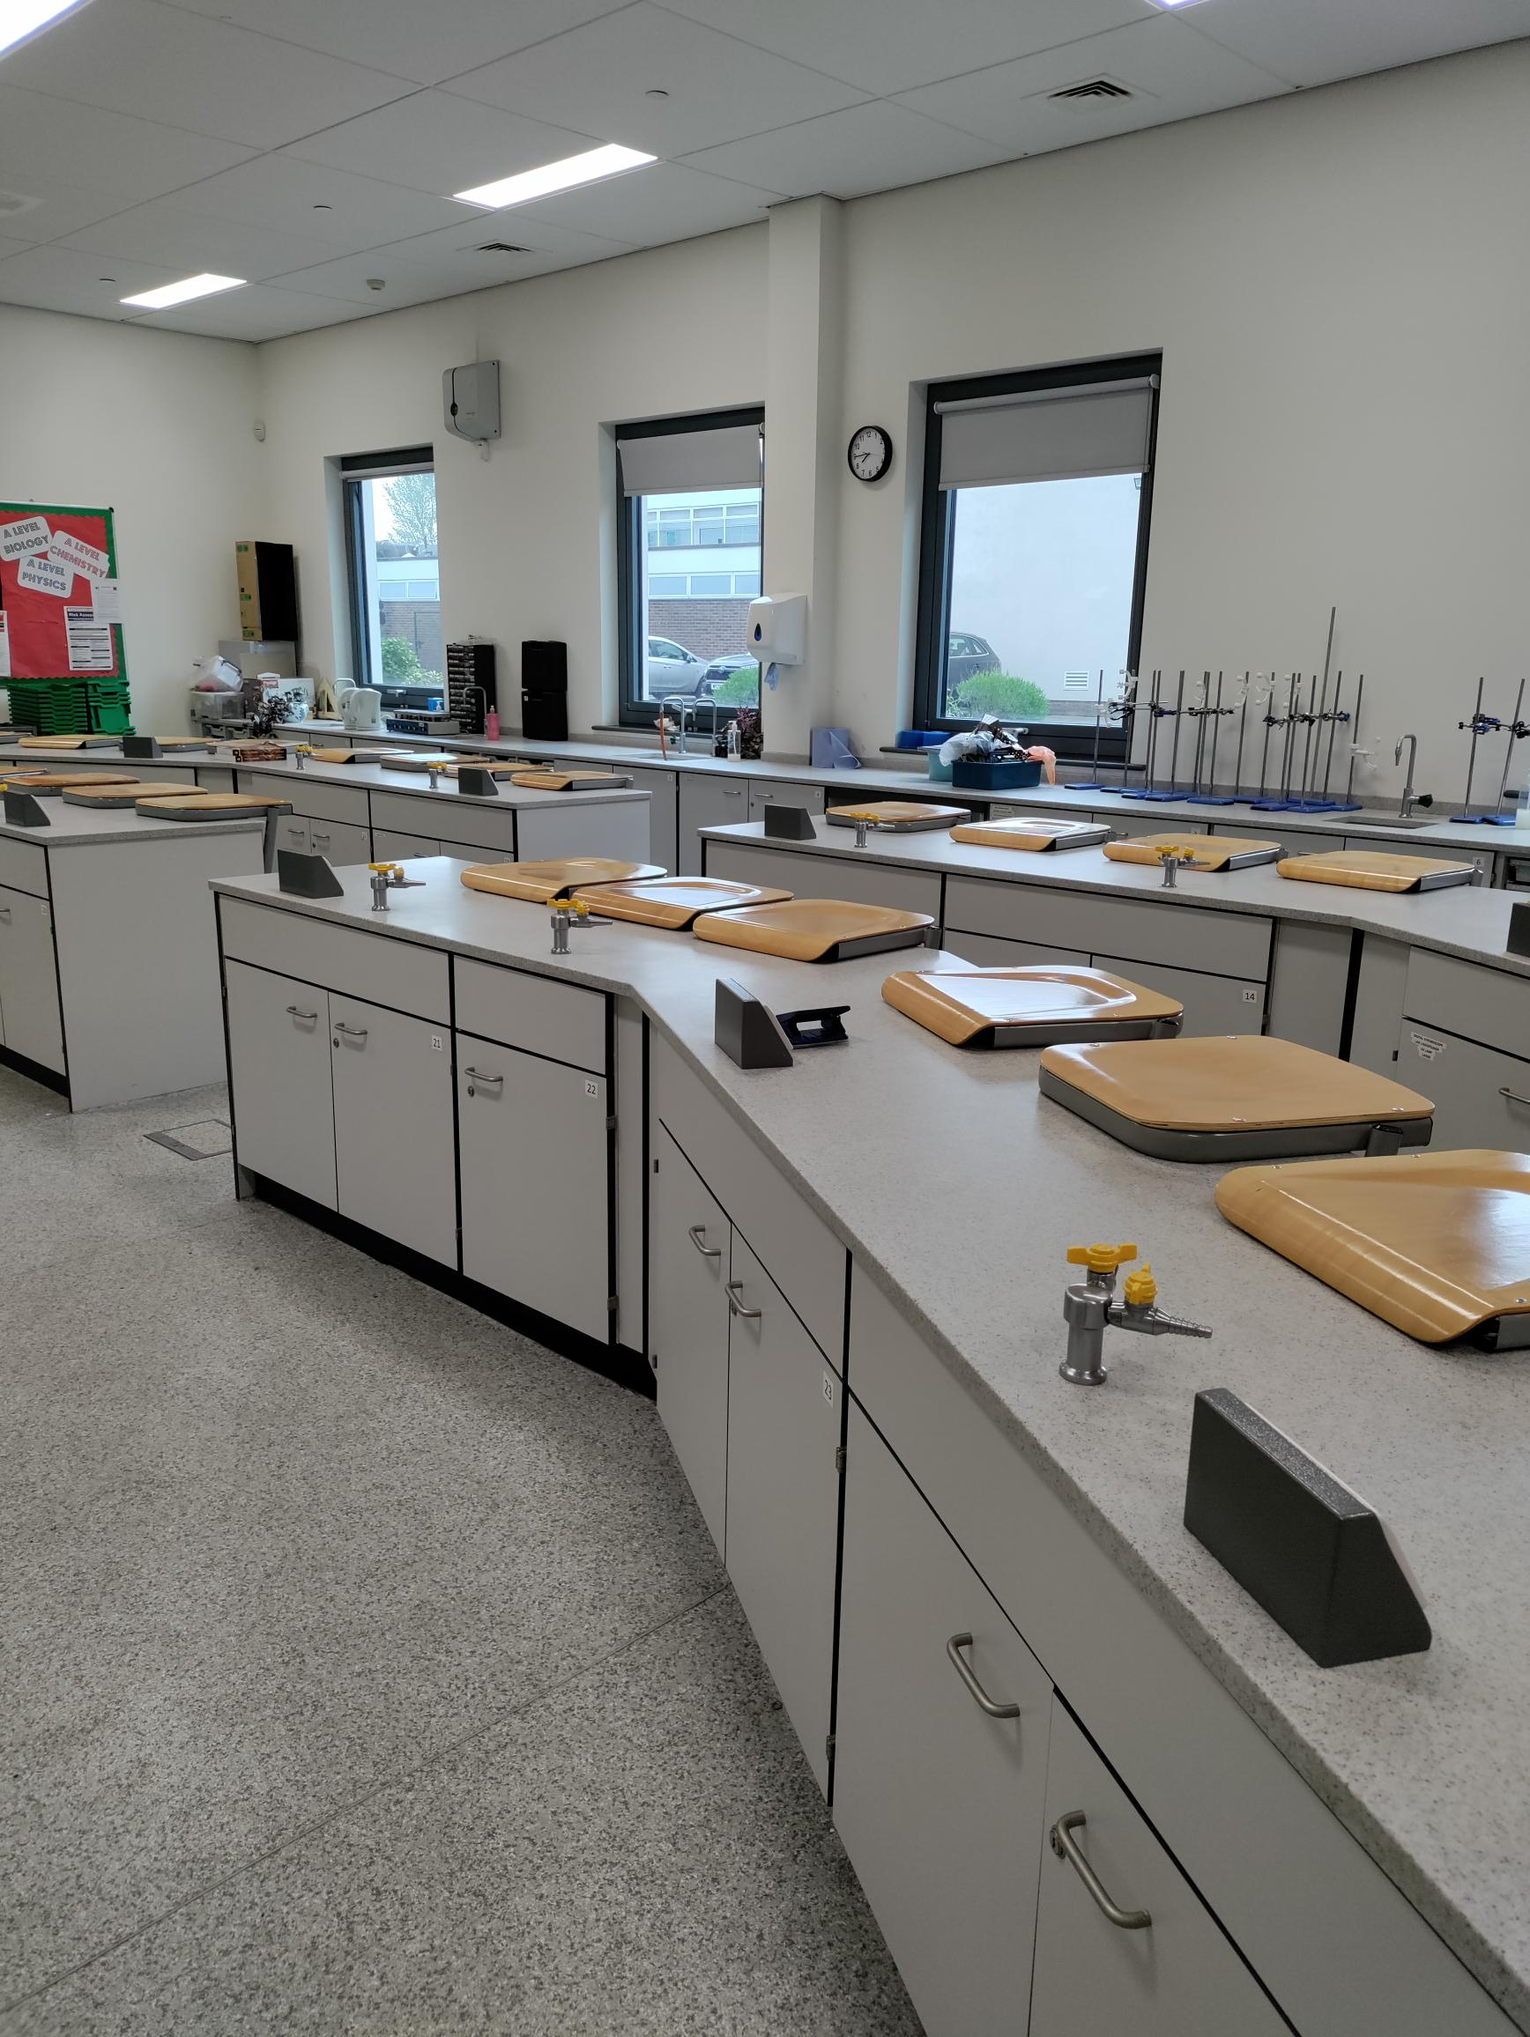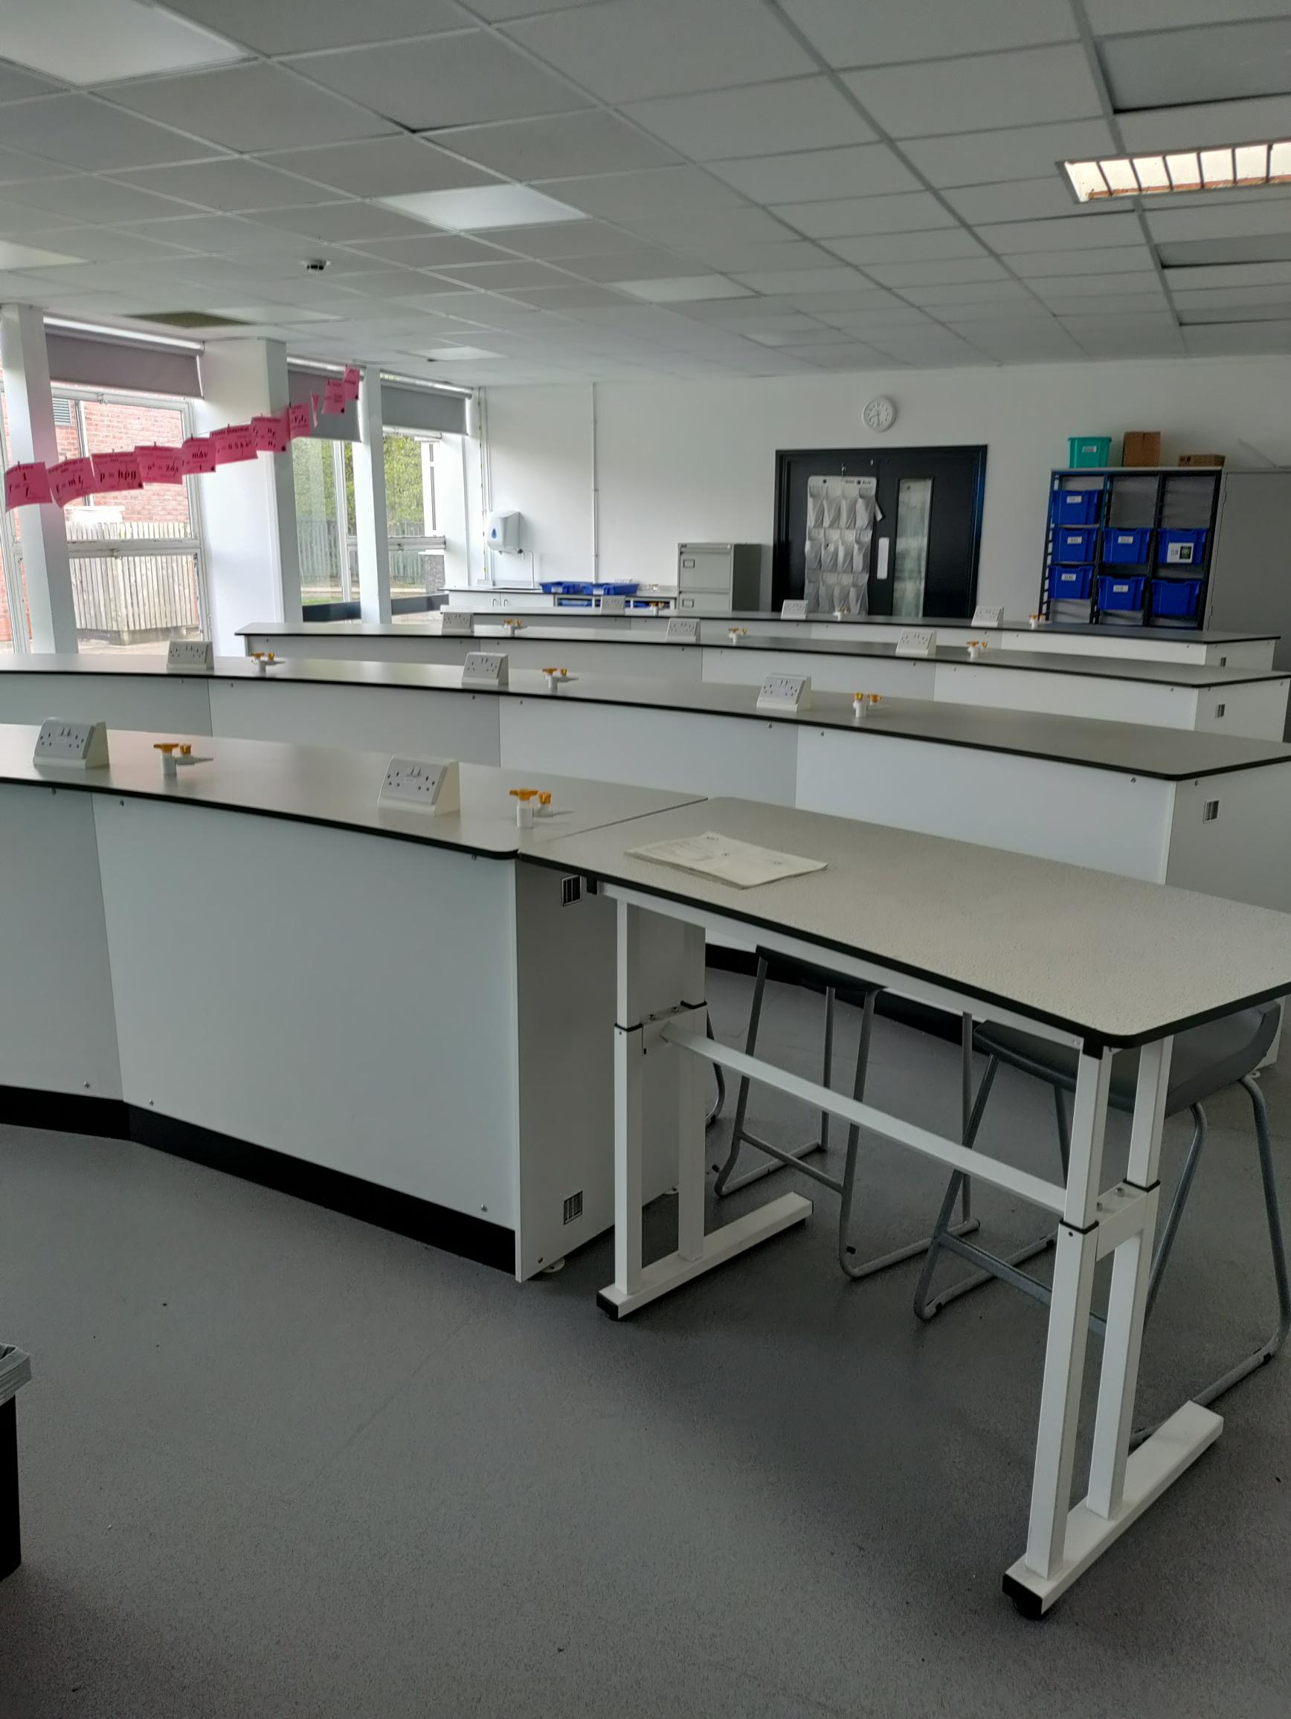

We welcome applications from ECTs and more experienced candidates. Sixth form teaching may be available based on experience, and subject training, CPD and support is available for those that wish to teach KS5 in the future.

The successful candidates will have:
- A love of their subject
- A sound and detailed knowledge of science
- The ability to inspire, engage and enthuse students

We offer:
- A supportive and committed college family
- Continuous Professional Development and formation
- Opportunity to teach A-Level

To Apply and for further information:
The job description and application forms are available on the college website: https://www.bthcc.org.uk/vacancies

Applications should be made using the CES application form
Applicants must have the Right to Work in the UK to be considered for the role.

Completed application forms should be sent to: recruitment@bthcc.org

Closing date for applications is: Monday 10th June 2024

