Our Vision:
To develop aspirational learners who strive for excellence academically, creatively and culturally, benefitting from a wide range of opportunities led by inspirational educators.

Shirley High School
Performing Arts College

Striving for Excellence

Job Description:

Post: Classroom Teacher
Line Manager: Department Leadership Team

Areas of responsibility and guidance:

- To follow syllabus and scheme of work devised by the Head of Department;
- To support the department in the teaching of the subject throughout the school at all phases;
- To work with department and school leadership to support high quality teaching and learning, and the implementation of the subject curriculum;
- To support in the monitoring and evaluation of teaching within the department;
- To promote the ethos of inclusion and challenge within the vision and mission statement of the academy;
- To maintain the standards, expectations and polices of the school and the department at all times;
- To ensure that the environment for learning within the department is in line with the school expectations;
- To support the pastoral life of the school including behaviour within the department and the role of a form tutor;
- To support and encourage school and extracurricular opportunities, especially those that enhance the cultural capital of students;
- To maintain the teacher standards assigned to this role;
- To teach lessons at all phases that consistently meet and exceed the expectations of the school;
- Strong knowledge of curriculum, appropriate syllabuses and national curriculum requirements;
- To ensure that home work is set in line with school expectations within their identified phase;
- To ensure that marking and feedback meets the expectation of the school within their identified phase;
- To exhaust all strategies, styles and initiatives to help ensure all students achieve at least expected progress and the majority make more than expected;
- To support the overall aims of the academy by teaching subjects other than where reasonably required and suitable time given;
- To complete tasks in line with school expectations with regards attendance, data collection and reports.

Personal Qualities:

- Reliable and conscientious teacher with high expectations in line with the school;
- Great communication skills with all within the school community;
- Neat appearance in line with the school policy;
- Ability to work as part of a successful team and work effectively under pressure;
- Have the determination and resilience to ensure that all students are challenged in all aspects of school life.

Think Green:

- Support the school in demonstrating good environmental practice (such as energy efficiency, use of sustainable materials, recycling and waste reduction) wherever possible in day-to-day work.

Safeguarding and Child Protection:

- To reinforce and enforce the school commitment to safeguarding and promoting the welfare of children and young people.
- Uphold the duty of care to ensure that if there are any concerns relating to the welfare or safety of a child they are immediately relayed to the Designated Person(s) with responsibility for safeguarding children.

Essential | Desirable
Qualified Teacher Status | Graduate status in subject area or related subject – Physics Specialist
True commitment to high standards | Experience of 11-18 education
Strong classroom management skills | Additional teaching qualifications or training
Relentless drive for student and personal progress and success | Sound knowledge of current educational developments, including the use of IT
Passion for learning and inspiring others | Ability to teach Key Stage 5
Respect for all | Strong analytical skills with regards leadership and getting the best out of colleagues
 | Track record of improving student performance

We want all at SHS to believe in and maintain the values of our school:

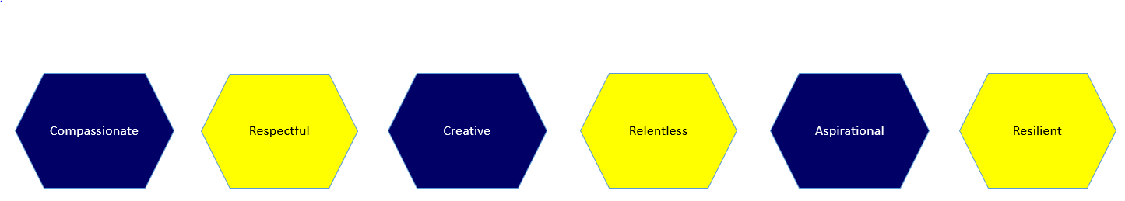

Signed: ………………………………………………………………………………. Dated: …………………………………………………….

