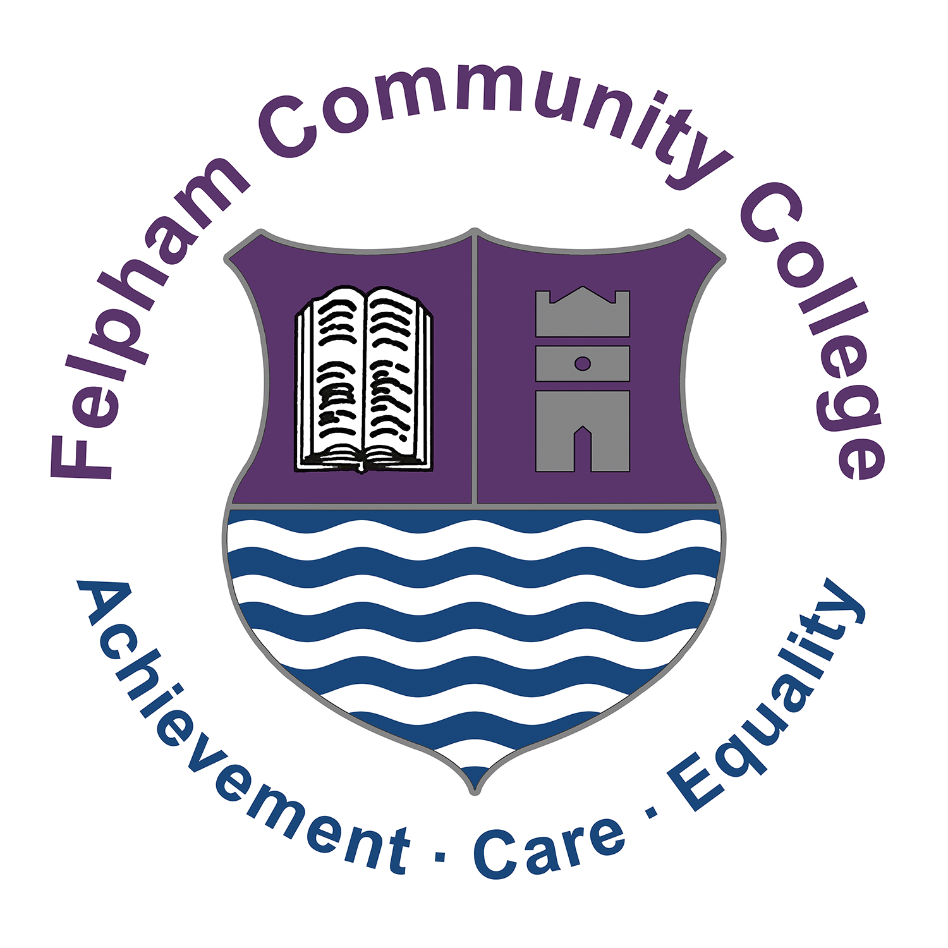

Headteacher: Mark Anstiss

Headteacher: Mark Anstiss

January 2022

Dear Applicant | Headteacher: Mark Anstiss

Teacher of Science (Physics) – TMS/UPS
Required from 25th April 2022
Permanent, full-time

Thank you for your interest in the post of Teacher Science (Physics) at Felpham Community College.

FCC is an 11-18 local authority, mixed comprehensive with 1430 students on roll and a successful sixth form. In March 2019, our one day, short OFSTED inspection confirmed our OFSTED ‘Good’ status originally achieved in January 2016.

The school has a good record of academic outcomes and pastoral support and our core values of achievement, care and equality underpin our work, creating a happy and vibrant school.

Despite recent changes to the curriculum and assessment in schools, Felpham remains in a strong position. Our exam results have been strong and we anticipate this continuing with our current year 11 and year 13 students. The commitment and support from staff and governors in partnership with students and parents led to this success.

However, we recognise that great schools are about more than just exam results and we have worked hard to create an exciting, engaging and broad curriculum for all students. At Felpham, we believe in getting the basics right so we have also focussed on developing a safe, calm and purposeful learning environment with excellent student behaviour and a smart school uniform.

In 2019, the school saw the completion of significant building work costing £11.5M. Students now benefit from fantastic modern facilities in our new three-storey block that replaced all of our older classrooms. Whilst great schools are about the people in them and not just the buildings, the enhanced facilities at Felpham will be a massive boost.

The school has made significant progress over the last five years. I started at Felpham as Headteacher in April 2010 with an initial focus on getting the basics right and developing a positive learning environment. Visitors to our school now regularly comment on our happy and enthusiastic students, excellent school uniform and good behaviour. This does not happen in a school by accident and requires constant attention and commitment from all staff. The quality of teaching and learning was our next focus and as that improved so did exam outcomes.

We are not complacent at Felpham and know we must continue to improve. In summer 2017 we became one of only 22 secondary schools in England to achieve the UNICEF Rights Respecting Schools Level 2 (Gold) Award. Student leadership is a strength of the school and continues to be an area we wish to enhance further.

Our strong pastoral system is based around linear tutor groups and year groups led by Year Leaders (who are teachers) and Year Managers (who are non-teaching associate members of staff). We are an inclusive school and benefit from a successful on-site Learning Support Unit.

In order to find out more about our school please explore our website (http://www.felpham.com)
which provides links to our OFSTED report, details about the school, recent newsletters, our prospectus and other information.

I hope that having looked at our website and reviewed the information provided you will be interested in applying. Completed application forms should be posted or emailed to my HR Manager & PA, Michelle Goodenough, at jobs@felpham.org.uk In addition to your application form you should include a letter of application of no more than two sides of A4 (size 11 font min.) which clearly addresses the following points:

- Your personal educational values and philosophy
- Professional experience and achievements (supported by data) as appropriate
- What you will bring to Felpham Community College

If you would like any more information on the post please contact Martin Vugler, Science Curriculum Leader, on the school number or email mvugler@felpham.org.uk. Visits to the school are welcomed.
The closing date for applications is 10.00am Friday 4th February 2022
Interviews will be held w/c 7th February 2022

This is an extremely exciting time to join Felpham Community College and to play a vital role in continuing our success.

I look forward to hearing from you.

Yours sincerely

Mark Anstiss
Headteacher

Please ensure that you complete your full employment history on the application form (including any study, voluntary work and with explanations for any periods not covered). Any employment gaps will be investigated. Because of the nature of this job, if you are successful in your application you will be subject to a criminal record check from the DBS before the appointment can be confirmed. This will be done by means of applying for an Enhanced Disclosure. Disclosures include details of cautions, reprimands or final warnings as well as convictions, spent or unspent.

Felpham Way, Felpham, Bognor Regis
West Sussex PO22 8EL
College Tel: 01243 826511
College Fax: 01243 841021
Email: fcc@felpham.org.uk
Website: www.felpham.com

