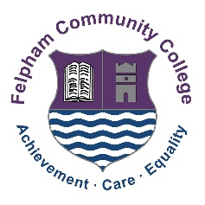

Teacher of Science (Physics)
Mainscale/UPS
Permanent contract
Required from 25th April 2022
Full Time

Felpham Community College is an 11-18 local authority, mixed comprehensive with 1430 students on roll and a successful sixth form. In March 2019, our one day, short OFSTED inspection confirmed our OFSTED ‘Good’ status originally achieved in January 2016. This is an exciting time to join Felpham following the completion of our £11.5M building project in October 2019, providing outstanding facilities for our students and staff.

We are looking to appoint a Teacher of Science (Physics) to join our team of 12 staff. The department has 10 laboratories with detailed, well-resourced schemes of work for every key stage and well planned and structured lessons. Teachers regularly share ideas and work collaboratively to develop and improve these schemes of work and lessons to ensure high standards of teaching and learning.

The ability to deliver KS5 Physics would be desirable but is not essential and this post would suit an ECT or more experienced colleague. A desire to build strong, effective relationships with students and staff to create a cohesive, inclusive and positive school environment is also sought.

Please visit our website (www.felpham.com) for more information and an application pack.
Alternatively, please contact Michelle Goodenough (HR Manager & Headteacher’s PA) on 01243 838026 or by email at jobs@felpham.org.uk

Visits to the school are welcomed.

Closing date for applications is: 10am Friday 4th February 2022
Interviews will take place w/c 7th February 2022

We ask that candidates submit their application to jobs@felpham.org.uk as soon as possible as some interviews may take place before the closing date.

FCC is committed to safeguarding and promoting the welfare of young people. This post is subject to an enhanced DBS check.

