The Holy Family
Catholic School

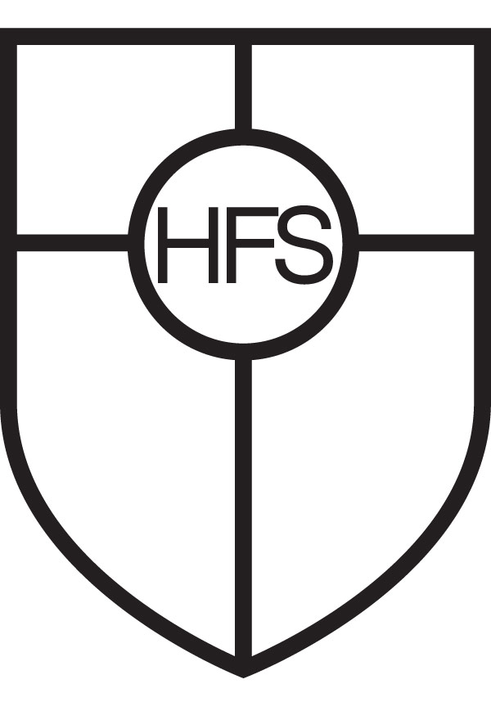

Diocese of Leeds - Bradford M.D.C
Mixed 11 – 18 Catholic Comprehensive School
906 on roll (including 127 6th form)

REQUIRED FROM September 2021

Science Teacher (Physics specialism preferred)

Contract type: Full time, permanent (suitable for NQT or experienced teacher)

We are seeking to appoint a creative and inspirational Teacher of Science (Physics specialism preferred) to join a supportive team who are committed to promoting high aspirations and excellent achievement in Science across the school.

The successful candidate will be able to teach KS3, KS4 and KS5 (A level) and to engage and enthuse students through high quality teaching and effective classroom management, which will lead to outstanding outcomes for all students.

Our new appointment will also contribute to the wider school mission of ensuring that we awaken minds, achieve dreams and serve others.

The Holy Family Catholic School is a consistently oversubscribed Catholic School serving the town of Keighley and surrounding villages in pleasant semi-rural surroundings.

We offer an excellent platform for enhanced career development and whole school leadership opportunities in a supportive and caring community.

We are committed to safeguarding and promoting the welfare of children and young people and expect all staff a volunteers to share this commitment. Safer recruitment practice and pre-employment checks will be undertaken before any appointment is confirmed. This post is subject to an enhanced Disclosure Barring Service (DBS) check.

Further details and an application form are available by contacting Mrs Michelle Clare mclare@holyfamilyschool.uk

Telephone: 01535 210212

Closing date: Monday, 12 April 2021 at 9.00 am

