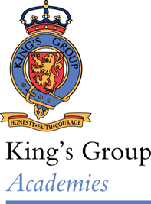
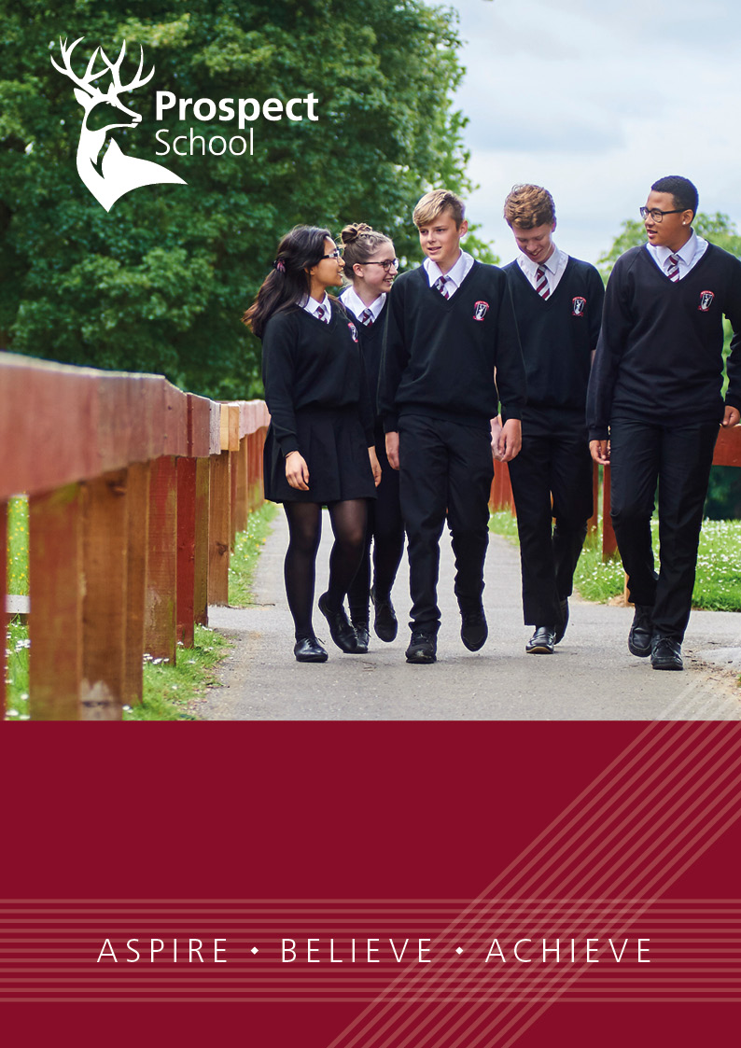
Dear Candidate,
Teacher of Science
Science Faculty

Thank you for your interest in joining us at Prospect School.
I am extremely proud to be Headteacher of this school. Our ethos is ‘Aspire, Believe, Achieve’, and you will see that this is very much more than a simple tag line. I expect every member of staff here to demonstrate these values in everything that we do with our students. It is my aim that every student will leave Prospect School fully equipped to make a positive contribution as young citizens in the twenty-first century.
We have high expectations for all; we are clear that our students need well-planned, challenging and exciting lessons that stretch and develop their skills, knowledge and understanding. In return for being an outstanding teacher, we will offer you the opportunity to develop your career beyond your own expectations, through a supportive working environment, excellent CPD opportunities, and collaboration with a range of partner schools and colleagues.
We are fortunate to have a truly inspiring site – our facilities are expansive and among the best in the region. We offer specialist classrooms that are well equipped, a balance of planning, preparation, teaching and development time, and a genuine commitment to staff well-being and work-life balance.
I do hope that our accompanying literature will help you to make the decision to apply to Prospect. If you would like to visit the school in advance of this, we would be delighted to show you round. Please contact our recruitment officer, Abi Davis, to make an appointment.
With very best wishes,

David Littlemore
Headteacher

About our school

Every student is treated as an individual and is encouraged to develop as a confident independent learner

From the Sixth Form to the lower school Prospect School encourages respect, resilience and rapport

“Leaders and those responsible for governance are taking effective action to provide education in the current circumstances” – Ofsted 2021

“Systems for remote learning are well established. Pupils who have to work from home are able to access remotely the same lessons as their peers” – Ofsted 2021

Our School
Welcome to Prospect School. We are a large, diverse and inclusive school, rightly proud of our students, whom we welcome from a wide range of backgrounds. We enable all our students, whatever their ability, background or heritage, to make excellent progress and achieve more than they believe to be possible. Our core values of ‘Aspire, Believe, Achieve’ are at the heart of everything we do, preparing our young people to be successful, fulfilled and great assets to their community in whatever they choose to do in the future.
We value educational excellence very highly and strive to ensure that we recruit the very best teachers to enable our students to progress onto the next stage of their educational journeys. We want our students to become young adults who understand the importance of respect and responsibility and who want to make a positive contribution to their school and the wider community. Equally important is our students' social and emotional wellbeing. We provide a supportive and nurturing environment, with a wide range of extracurricular activities, school trips and experiences to broaden their horizons. We work closely with our local community and enjoy mutually supportive relationships with students and their parents, as well as with our neighbours and wider networks.
We are extremely proud of our fantastic site - one of the largest sites in Berkshire - with its excellent facilities and well resourced, specialist classrooms. We offer a broad and balanced curriculum, allowing students to follow individual pathways that best meet their needs, whether academic, vocational or a mix of both.
However, don’t just take our word for it! We’re on a really exciting journey at the moment and we want you to be a part of it. Come and meet us, our students and our teachers to see the great opportunities that await you, we are always happy to offer tours in advance of applications.

Curriculum
“Leaders are determined to ensure that all pupils receive a challenging and aspirational diet of learning throughout the school” – Ofsted 2021
We offer a broad and balanced curriculum that really meets the needs of our students. We believe that a 3-year Key Stage Three is right for our students, allowing them the opportunity to study a broad range of subjects in Years 7, 8 and 9 before making a guided choice about the right pathway to follow in Key Stage Four.
We offer a wide range of subjects at all key stages. At Key Stage Four, students are able to make the choice from an offer of both academic and vocational qualifications, preparing them for further study or training post-16. Our curriculum has been carefully designed to ensure that they have a rich experience throughout their time at Prospect School.
We are well resourced and have excellent facilities. All subjects teach in dedicated and specialist accommodation, with the vast majority of teachers teaching in their own rooms. A strong foundation in literacy and numeracy underpins the curriculum, with dedicated support available for students with additional needs. More Able students are provided with stretch and challenge through a range of initiatives enabling them to make excellent progress.

Professional Development
“Newly qualified teachers are supported effectively”
“Leaders at all levels identify the school’s strengths accurately. They know which aspects of the school need to improve most urgently and are taking useful steps to tackle them. This has led to helpful bespoke training and support” – Ofsted 2019
We offer a wide-ranging and highly regarded programme of professional development for all our teachers and support staff. For those joining us as NQT’s, we offer a comprehensive programme of support and development, including professional studies sessions and a dedicated in-school mentor. Time for training is found using INSET days and Monday meeting times. Through our performance management and appraisal system, we identify and match individual needs and requests to the many training and development opportunities that we offer. These include both internal and external CPD programmes, which run continuously throughout the year. Our in-house sessions and workshops take place during dedicated training time and are planned and delivered by a highly effective teaching and learning team in the school. We encourage teachers at all stages of their careers to participate in external programmes, and many of our teachers have completed the NPQM/SL qualifications. We are proud of the number of our support staff who have also completed further training to develop their roles, including teacher training and other professional qualifications.

Facilities
We are fortunate to have a wonderful school site – extensive school fields and well-maintained purpose-built accommodation. All our subjects are taught in specialist classrooms, including recently refurbished science labs, a sports hall and gym, and a fantastic space for vocational courses including a construction yard, a hair and beauty salon and an engineering workshop.

Sixth Form
“Teaching in the Sixth Form shows many strengths” – Ofsted 2019
Our vibrant and successful sixth form is an excellent place for students to continue their learning with us. We offer a broad range of qualifications at Level 2 and 3, allowing students to follow both academic and vocational pathways. We are rightly proud of our successes in getting our students into the best universities and apprenticeships. Our Sixth formers are also leaders in the school, leading a broad range of enrichment activities across the school and providing leadership and role models to younger students.

Support for Students
“Pastoral care is a strength of the school. Pupils feel well supported and cared for. Strong relationships with staff help pupils feel safe and secure” – Ofsted 2019
We want our students to be resilient and independent young people, able to take responsibility for their own learning and well-being. We recognise that all students need a supportive and caring environment in order to fully succeed and rise to the academic challenges we set them. Students are led by their Head of Progress, and supported by a team of people in our dedicated Student Services area who are accountable for the academic and personal growth of all their students. The school works with a wide range of additional and external providers, employing a full-time counselling team as well as working with alternative provision and specialist services. The vast majority of teachers are also form tutors, which is a key role in our school, providing a link between home and school.

Behaviour and Attitudes
“Pupils genuinely care about each other and are respectful of the diversity within their school community” – Ofsted 2019
We have a distinctive school culture which all staff and students understand and buy in to. We have committed and highly visible school leaders who are ambitious for the future success of the school. All stakeholders share a clear understanding of the school culture – ‘this is how we do things here and these are the values we hold’. This ambitious and supportive school culture expects attention to detail and thoroughness in all that we do – from students, staff and all stakeholders, and a core belief that all students matter equally.

Staff Well-being
“Leaders place a commendable emphasis on support for mental health and emotional well-being” – Ofsted 2019
We take the well-being of our staff very seriously. We recognise the importance of all staff having a sound work-life balance, and we aim to achieve this through the removal of unnecessary meetings, data collection and other tasks that do not contribute to the effective teaching and learning of our students. In addition, we have a vibrant staffroom culture with free tea and coffee daily, free gym membership, and a range of staff led clubs and activities.

King’s Group Academies
Prospect School is part of the King’s Group Academies MAT led by a team of former and current Ofsted ‘outstanding’ head teachers and Her Majesty’s Inspectors (HMI). Please note link to King’s Group Academies Vision and Mission - https://kingsacademies.uk/aboutus/vision-and-mission/

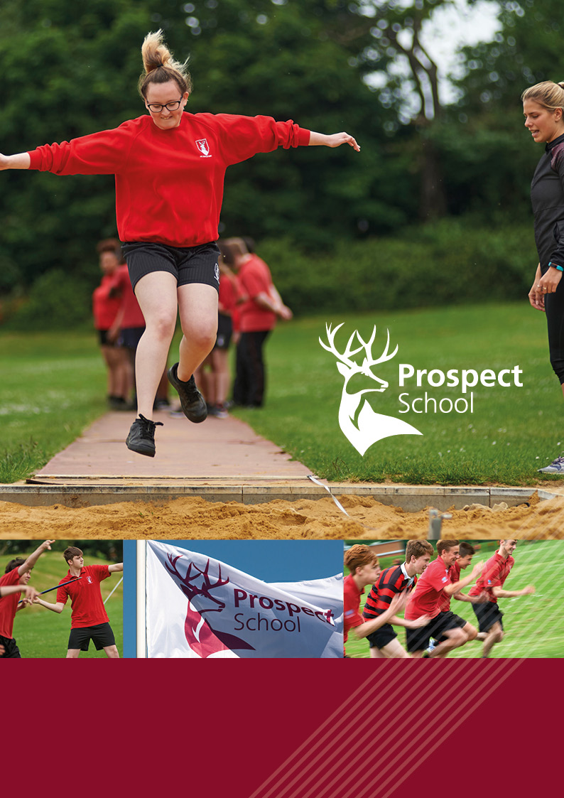
The Science Faculty
The Science Faculty
We believe that through a varied programme of activities that are enjoyable, fulfilling, demanding and challenging, students can see the benefit studying all Sciences. The curriculum will engage all learners so that they have a desire to succeed and achieve their potential whilst inspiring them to take their Science studies further.

Staffing | A Stent – Head of Faculty  L Welch – 2nd in Faculty  C Humphreys – Head of Biology  N Bennett – Head of Chemistry  A Russell – Head of Physics  L Demiri – Teacher of Science  T Dowling – Teacher of Science  I Lyddon – Teacher of Science
Curriculum Hours | At Key Stage 3, all students receive 7 hours per fortnight of combined science.  At Key Stage 4, the sciences are split into separate disciplines with Biology receiving 4 hours per fortnight and Chemistry and Physics each receiving 3 hours per fortnight.  At Key Stage 5, each discipline receives 9 hours per fortnight, subject to the number of students recruited.
Examination Qualifications | At Key Stage 4 we deliver the AQA qualification for Biology, Chemistry and Physics with the majority of students studying these as separate sciences. Where this approached is not deemed suitable, students will follow the AQA Combined Science (trilogy) qualification.  At Key Stage 5, we deliver the AQA qualifications for Biology, Chemistry and Physics.
Resources & Facilities | All teachers have access to their own teaching lab, with each subject having a designated technician and a specialist prep room.
Enrichment | Key Stage 3 Science Club  Key Stage 4 STEM Club  Subject-specific trips and enrichment activities organised by Heads of Subject, including a KS5 Biology field trip

Job Description – Teacher of Science
Job description
This job description forms part of the contract of employment of the successful applicant. The appointment is subject to the conditions of employment of Teachers contained in the School Teachers’ Pay and Conditions document and other current educational and employment legislation.

Responsible to: Head of Faculty (Science)

Purpose of Role: To support the Head of Faculty in establishing and developing a distinct vision for the subject which:
- Challenges, motivates and inspires students.
- Develops appreciation of the subject matter.
- Provides a transition between Key Stages and ensures excellent academic progress for students of all abilities.

Scale: MPS/UPS

Accountable for the delivery of the specified curriculum
- To prepare appropriate material in order to deliver the curriculum effectively, using a variety of styles and approaches, with regard of the individual students
- To contribute to the development of schemes of work
- To implement relevant school policies in relation to the subject
- To mark work using assessment for learning techniques so that students make progress.

Accountable for maintaining a well-managed classroom.
- To have regard for the safety of students in line with the school’s Health & Safety policy and routines, such as fire drill
- To maintain firm but clear discipline using the school behaviour policy
- To ensure that the learning environment is stimulating through the display of students’ work and other appropriate materials.

Accountable for keeping records on individual students.
- To keep a register of attendance at each lesson and to follow up non-attendance and lateness.
- To set and mark homework in line with the school’s policy.
- To contribute to the school’s assessment policy through the completing of grade sheets, student profiles, regular marking, attendance at Parent’s Consultation meetings and any other reports necessary

Accountable for Health & Safety and safeguarding of Students.
- To contribute to the safeguarding of students and to child protection using the procedures outlined in school policies.
- To ensure that the Health & Safety policy and Risk Assessments are followed.

Accountable for having a professional commitment to teaching and professional development.
- To attend regularly and punctually
- To update subject knowledge through external and school-based training
- To contribute to own professional development through performance review/observation.
- To attend school meetings as required

Upper Pay Scale
Teachers on the Upper Pay Scale need to demonstrate:
- that they are highly competent in all elements of the relevant standards; and
- that their achievements and contribution to the school are substantial and sustained.

Notes:
The above duties are subject to the general duties and responsibilities contained in the Statement of Conditions of Employment. The job description allocates duties and responsibilities but does not direct the particular amount of time to be spent on carrying them out and no part of it may be so construed. This job description is not necessarily a comprehensive definition of the post. It will be reviewed at least once a year and may be subject to modification or amendment at any time after consultation with the holder of the post. The duties may be varied to meet the changing demands of the school at the reasonable discretion of the Headteacher. This job description does not form part of the contract of employment. It describes the way the post-holder is expected and required to perform and complete the particular duties as set out in the foregoing.

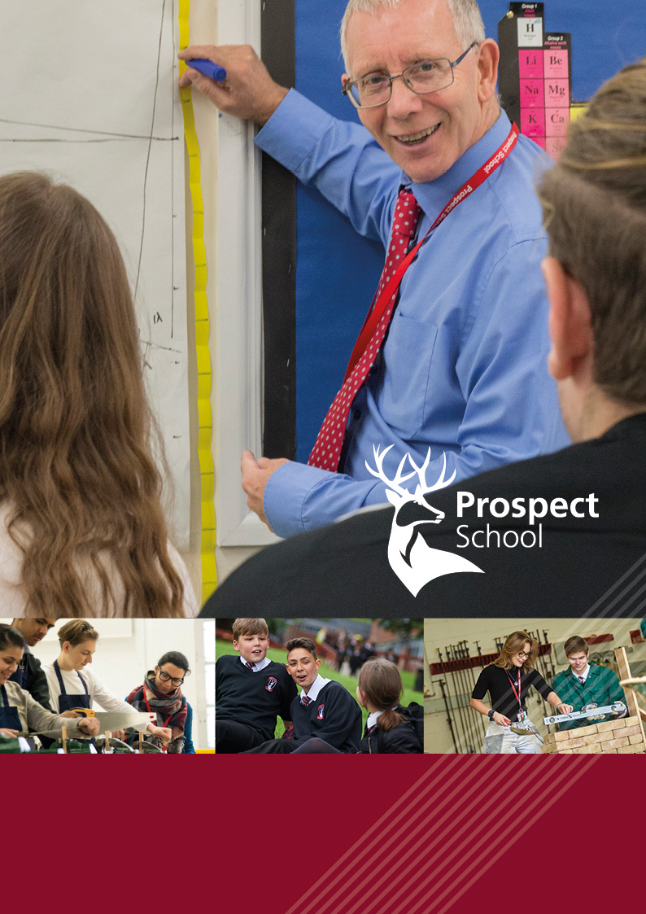
Person specification
Person specification

Essential | Desirable
Qualifications  - Qualified teaching status (or evidence that this is being worked towards)  - A good Honours degree qualification | - Higher Degree
Experience  - Responsive to students’ learning needs  - Evidence of recent professional development  - Excellent subject knowledge  - Demonstrates a range of teaching skills  and strategies.  - Competence in assessment for learning  - Confidence in ICT skills related to specialist subject(s)  - Awareness of current national trends in  specialist subject(s)  - Keen to try out, develop and share new ideas and practices.  - Successful teaching experiences throughout Key Stages 3 and 4  - Maintains high standards and expectations.  - Maintains positive relationships with students and parents.  - Commitment to positive behaviour  management. | - Evidence of successful examination results  - Confidence in ICT skills related to  document and data management.  - Awareness of current national trends  in education  - Successful teaching experiences at Key Stage 5.  - Awareness of progression in specialist subject(s) from Key Stage 2 to Key Stage 5.
Abilities, Skills and Knowledge  - Able to work with/build teams.  - Organised and systematic  - Clear thinker and communicator | - Experience of collaborative learning and coaching
Philosophy & Ethos
- An understanding of how students learn and an indication of how to meet their needs
- Commitment to high standards and continuing improvement
- An understanding and commitment to equality and inclusion principles and practice
- High expectations of student progress,
personal development and conduct
- Relentless personal drive and ambition
anchored in success

Appointment will be subject to enhanced DBS check, qualifications and experience checks and satisfactory references.
We are not looking for the impossible! If you think you have at least some of these attributes, we would very much like to hear from you.
Applications should be made directly via the School website or through TES; we are unable to consider applications without the correct form.
Visits to the school ahead of application are warmly welcomed, please contact our recruitment officer, Abi Davis (adavis@prospect.reading.sch.uk) to make an appointment.

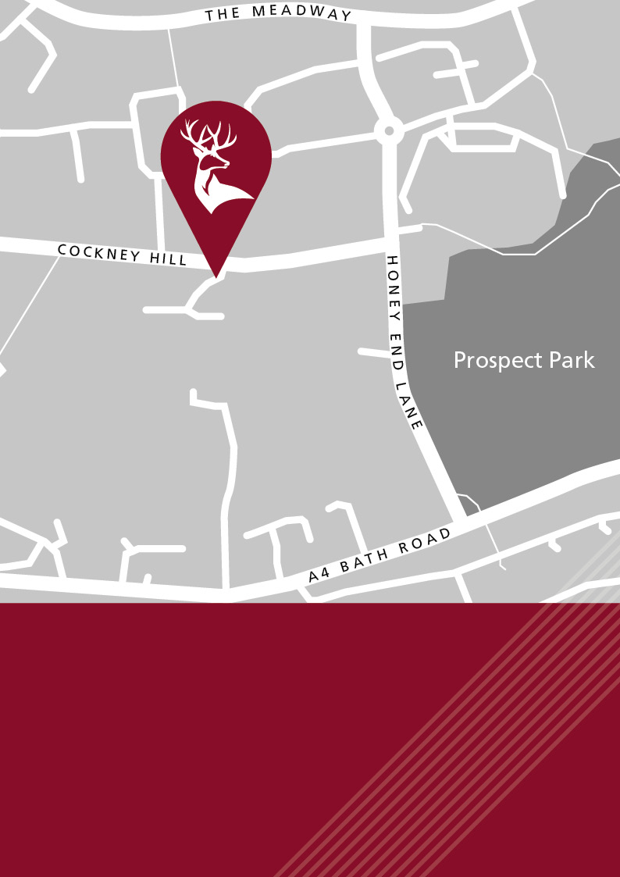
Cockney Hill, Tilehurst, Reading
Berkshire RG30 4EX
Tel: 0118 959 0466
enquiries@prospect.reading.sch.uk
www.prospect.reading.sch.uk

