
Teacher of Science
Recruitment Pack
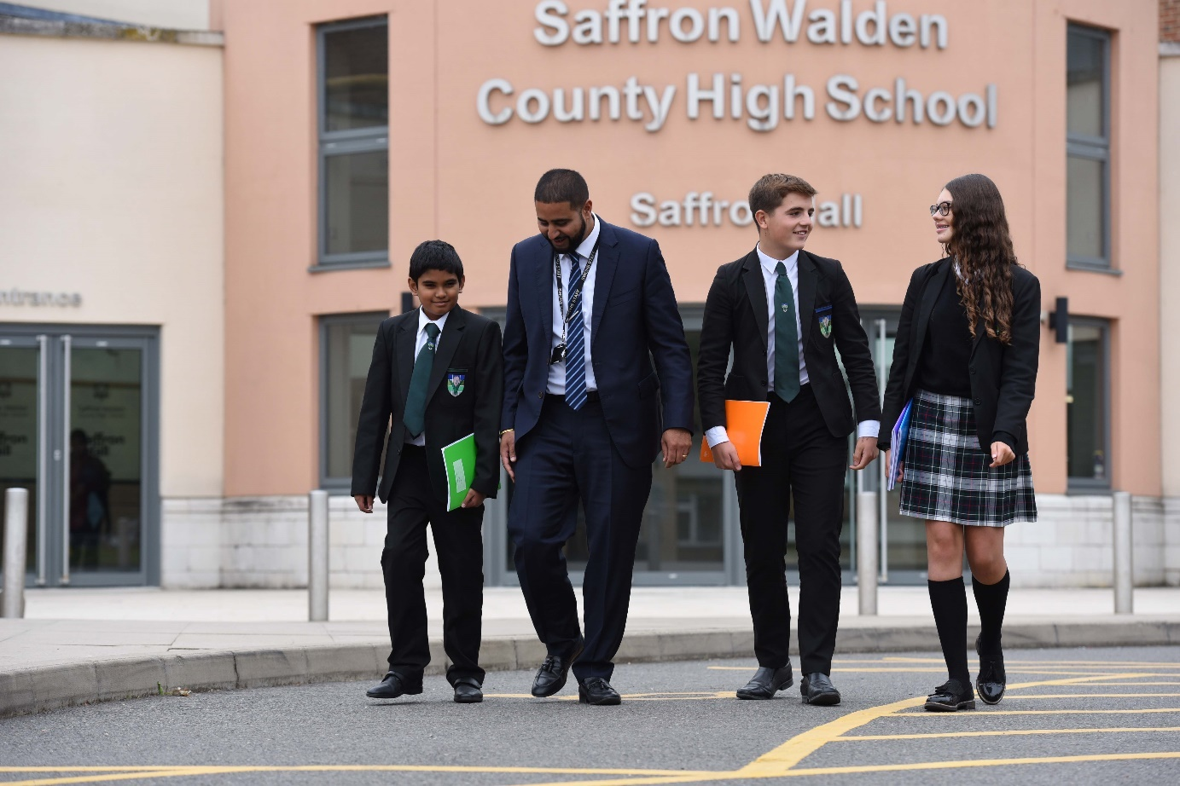

Saffron Walden County High School

Audley End Road
Saffron Walden
Essex
CB11 4UH
Tel 01799 513030
www.swchs.net
applications@swchs.net

Content

Welcome from our Headteacher 3

A brief history of our Trust 4

Our Aims 5

Why work for us 5

How to apply 6

Area details 7

Job description and Person Specification 9-14

Welcome from our Headteacher, Polly Lankester


Thank you for your interest in joining Saffron Walden County High School. This is a wonderful school to work in and I would encourage you to take the next step and complete the application form.
What makes this school such a great place for the next step in your career? I think it is a truly special place to work as we are one of the largest schools in the country, but also the only secondary school in Saffron Walden, and so we are a truly comprehensive school.
We believe in the transformative power of education. We are committed to providing an exceptional and exciting education for all young people in our community, preparing them to be caring, capable and well-informed adults. Not only do our students work hard in their classrooms, in addition we have an exceptional extra-curricular programme that inspires our students and makes school life well-rounded and culturally rich.
The team here works hard to provide both great teaching and great pastoral support. We invest in our staff team to ensure that we can all deliver for students and enjoy working in this school. We trust our department teams, which are truly collaborative, and value our staff, prioritising development and wellbeing.
I hope this gives you a flavour of life at this school and I would urge you to also have a look at our website.
Best wishes,

A Brief History of Saffron Academy Trust (SAT)

Mark Guest, CEO
ABOUT US
Saffron Academy Trust (SAT) was formed in 2011 when its founder school, Saffron Walden County High School, converted to academy status.
Since then SAT has grown and, in order of joining, comprises
- Saffron Walden County High School
- Alec Hunter Academy
- Katherine Semar Infant and Junior Schools
- R A Butler Infant and Junior Schools
- Honywood School
- Beckers Green Primary School
- Helena Romanes School and Sixth Form Centre
In addition, through an extensive range of collaborative partnerships, the Trust provides support to a number of other primary and secondary schools. One key aspect of the support we provide is to deliver high quality CPD focused both on classroom practice and leadership development.

AIMS OF THE TRUST
The educational aims of SAT are to support and promote
- An education which enables pupils and young people, aged 3-19, of all abilities to fulfil their academic potential and achieve their personal best.
- A broad curriculum across all key stages which promotes excellence.
- Teaching and learning which is highly engaging and geared to students making excellent progress through the key stages.
- Transition between key stages which delivers outstanding continuity of learning.
- A focus on developing all professionals to deliver the highest quality of teaching and support to all our learners.
- Schooling which is outward looking and allows students to interact with ideas and people from around the world.
- Educational research into factors underpinning successful schools and highly effective learning.
- Involvement with the local area in a way which promotes community cohesion and cultural excellence.
SAT BELIEVES:
1. That every child deserves to go to a great school
2. That we are preparing young people for life in a 21st Century world
3. That learning in our schools must inspire and lead to achievement and progress for every child
4. That learning opportunities must be broad and of the highest quality
5. That we should respect the unique character and context of the schools in our partnership, while maintaining high expectations of performance
6. That we are all learners and that we embrace evidence-based research and value teamwork
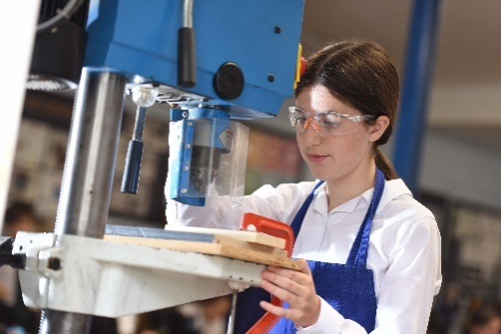
Our aims as a school:
- Ensure all students make excellent progress and attain their full academic potential.
- Deliver excellent teaching of subject knowledge and develop the learning skills, habits and attitudes necessary to enable students to value, enjoy and further their learning.
- Promote the outstanding personal and cultural development of all students through a rich and varied programme including trips, extra-curricular activities and community engagement.
- Maintain a secure and caring community which encourages academic ambition alongside respect and responsibility for all.
- Provide students with facilities that encourage great learning, whilst being aware of the school community’s responsibility for its impact on the wider environment.
- Be motivational leaders of education at a school, regional and national level, inspiring all to achieve high standards, to be personally ambitious and mindful of well-being.

Why work for us
The mission of Saffron Walden County High School is to be 'a local school of exceptional quality'. What this means in practice is that we constantly strive to provide the highest quality education to young people in the Saffron Walden area. It is the kind of quality that is demonstrated by outstanding achievement at all levels, high expectations of behaviour, excellent teaching and learning and a broad and rich curriculum.
Benefits:
Working with us brings with it a range of attractive benefits, including
- A Trust which puts staff well-being at the heart of everything it does
- Bespoke CPD programmes as well as access to national programmes
- Support for Early Career Teachers as an accredited Appropriate Body for ECT’s
- Occupational Health
- Employee Assistance Programme
- Free on-site parking/4 EV charging points
- Onsite early years Nursery
- Free access to onsite Fitness Suite
- Onsite dog day care available
- Cycle to work scheme
- Generous employer contributions to Local Government or Teacher Pension Scheme
- Further recruitment incentive may be available

Aspiring Leaders Programme.
This is a bespoke CPD opportunity designed and run internally which has proved extremely successful with those teachers who are considering their career progression in education who would like support to explore their career options and develop their leadership skills.
As a school we are keen to invest in our staff who are considering career progression, and many have gone on to secure a TLR post after this course.

What will the programme include:
- A choice of routes – either Pastoral or Curriculum/Teaching and Learning
- 1 period a cycle time allocation in the first year of the programme.
- A bespoke leadership training package with regular sessions that develop the skills and knowledge needed to be a superb middle leader
- A bespoke programme that gives you opportunities to experience and lead key aspects of pastoral or curriculum leadership
- An opportunity to carry out a leadership project that will give you the experience you need to move in to a promoted role - all aspiring leaders will be expected to make a significant contribution to their chosen team and to undertake an agreed leadership development task
- Opportunities to visit different schools and reflect on your learning from that
- Opportunities to attend selected Pastoral/Curriculum Leaders meetings.
- HR sessions to equip you with the knowledge to manage recruitment and handle staff situations.

.

How to apply
To apply, please complete the online form found on our website www.swchs.net
Your supporting statement should address and evidence the selection criteria detailed in the Person Specification.

We are committed to ensuring that recruitment and selection is conducted in a manner that is systematic, efficient, and effective and which promotes equality of opportunity. Selection will be on the basis of merit and ability, assessed against the qualifications, skills and competencies required to do the job. We will uphold obligations under law and national collective agreements to not discriminate against applicants for employment on the grounds of age, sex, sexual orientation, marital status, disability, race, colour, nationality, ethnic origin, religion or belief. We seek to be a diverse workforce and welcome applications from all.

Closing Date:
9am on Tuesday 5th May 2026

Interviews:
Week beginning 11th May 2026

Applying:
For any questions about the application process please contact our HR Administrator, Mrs Sykes: applications@swchs.net

Area details
Our Vision:

We will foster a lifelong enthusiasm for Science. We will equip students with the science knowledge, understanding and skills that they need for future study and work, to understand the world around them and to make informed choices throughout their adult lives. We will engage and challenge all students through excellent teaching in an exciting, positive and well-resourced environment.

All staff and students will be valued and respected and given the opportunities to develop within the department and school.

Our Aims:

At SWCHS, we aim to do the following for all students, regardless of aptitude, ability or any other characteristics:

- Deliver a curriculum that is engaging, challenging and enjoyable for all students
- Develop student's knowledge and understanding of scientific Ideas
- Support the development of numeracy by teaching students to apply mathematical skills to solve scientific problems
- Develop students' ability to carry out practical work safely, both independently and when working in a small group
- Develop skills in recording, analysing, presenting and evaluating data
- Help students to appreciate the importance of science in society by making links between the science they study in the classroom and their everyday lives
- Encourage a lifelong interest in science and technology
- Ensure that students who choose to pursue a science after leave SWCHS are fully equipped for further study or work through gaining necessary qualifications and skills

Management and Staffing

- The area is managed by a collegiate team consisting of the Director of Science, two Deputies Directors and heads of subjects / key stages. All members of the collegiate team have specific responsibilities within the area, including curriculum, teaching and learning, student achievement and behaviour support.
- 20 well-qualified, talented and committed teachers deliver the curriculum. We have a good balance between physics, chemistry and biology specialists
- We offer a warm and supportive working environment in which teachers support each other, both formally through area meetings and coaching, and informally through friendly discussion
- Teachers teach almost exclusively in specialism from Year 9 onwards
- Teachers are supported by a team of skilled and efficient science technicians
- We have 3 committed teaching assistants who work predominantly in the science department and are supported by other teaching assistants who work with specific students and groups.
- We have support from a curriculum assistant
- Two science engagement leads run a series of engagement and enrichment activities throughout the year including Science Club, Science Week and other trips and visits.

Accommodation and Resources
- Fourteen fully-equipped laboratories in a self-contained area of the school
- Five well-stocked preparation rooms
- Large staff office with individual working spaces
- A smaller workroom which is used for small meetings
- A huge range of resources available to order for classes including scientific equipment, electronic devices and books.
- A laptop given to every member of staff

Curriculum
- Our science curriculum has been designed and resourced to support all learners
- We have centralised, resources, but also allow flexibility to meet the needs of staff and students.
- Homework is set on an online platform (self-marking) using centrally prepared tasks and quizzes
- Feedback is given using centralised systems that have been developed to benefit students while supporting staff workload
- Our Year 7 and 8 course has been written both to meet the National Curriculum and to build the knowledge and skills required to be a successful scientist.
- Year 9 students complete Key Stage 3 Science and indeed are extended beyond that. They start to gain the preparatory skills and knowledge for GCSE Science. All students follow an internally designed and resourced Year 9 curriculum.
- At Key Stage 4 (Yrs 10 & 11) We follow the Edexcel (9-1) GCSE qualifications. The majority of students do Combined Science, with 2 classes doing Triple Science. A small group of students complete the Entry Level Science in addition to GCSE Combined Science
- At Key Stage 5, the Area offers AQA A-Level Biology and Chemistry and OCR A A-Level Physics. In addition, we offer an Applied Science Level 3 diploma and an A-level in Environmental Science.
Job Description and Person Specification
Job Title: | Teacher of Science
School/Academy: | Saffron Walden County High School
Salary: | MPS/UPS
Responsible to: | Headteacher

Role: | Class teacher with expert subject knowledge.
Purpose of job: | To secure excellent progress for all students through high quality teaching, learning and assessment in an atmosphere in which students feel challenged, valued and secure.

To be an excellent classroom practitioner and committed to becoming an expert in the relevant subject specialism.

In addition to the responsibilities listed below, there is an expectation that those paid on Upper Pay Scale:
Will be expected to demonstrate that their level of competence and performance is:
- highly competent in all elements of the relevant professional standards; and
- achievements and contributions to the school are substantial and sustained.

Responsibilities and Accountabilities:

Set high expectations which inspire, motivate and challenge pupils:
- Establish a safe and stimulating environment for pupils, rooted in mutual respect.
- Set goals that stretch and challenge pupils of all backgrounds, abilities and dispositions.
- Demonstrate consistently the positive attitudes, values and behaviour which are expected of pupils.

Promote good progress and outcomes by pupils:
- Be accountable for pupils’ attainment, progress and outcomes.
- Be aware of pupils’ capabilities and their prior knowledge, and plan teaching to build on these.
- Guide pupils to reflect on the progress they have made and their emerging needs.
- Demonstrate knowledge and understanding of how pupils learn and how this impacts on teaching.
- Encourage pupils to take a responsible and conscientious attitude to their own work and study.

Demonstrate good subject and curriculum knowledge:
- Have a secure knowledge of the relevant subject(s) and curriculum areas, foster and maintain pupils’ interest in the subject, and address misunderstandings.
- Demonstrate a critical understanding of developments in the subject and curriculum areas.

Plan and teach well-structured lessons:
- Impart knowledge and develop understanding through effective use of lesson time.
- Promote a love of learning and children’s intellectual curiosity.
- Set homework and plan other out-of-class activities to consolidate and extend the knowledge and understanding pupils have acquired.
- Reflect systematically on the effectiveness of lessons and approaches to teaching.
- Contribute to the design and provision of an engaging curriculum within the relevant subject area(s).

Adapt teaching to respond to the strengths and needs of all pupils:
- Know when and how to adapt teaching appropriately, using approaches which enable pupils to be taught effectively.
- Have a secure understanding of how a range of factors can inhibit pupils’ ability to learn, and how best to overcome these.
- Demonstrate an awareness of the physical, social and intellectual development of children, and know how to adapt teaching to support pupils’ education at different stages of development.
- Have a clear understanding of the needs of all pupils, including those with special educational needs; those of high ability; those with English as an additional language; those with disabilities; and be able to use and evaluate distinctive teaching approaches to engage and support them.

Make accurate and productive use of assessment:
- Know and understand how to assess the relevant subject and curriculum areas, including statutory assessment requirements.
- Make use of formative and summative assessment to secure pupils’ progress.
- Use relevant data to monitor progress, set targets, and plan subsequent lessons.
- Give pupils regular feedback, both orally and through accurate marking, and encourage pupils to respond to the feedback.

Manage behaviour effectively to ensure a good and sage learning environment:
- Have clear rules and routines for behaviour in classrooms and take responsibility for promoting good and courteous behaviour both in classrooms and around the school, in accordance with the school’s behaviour policy.
- Have high expectations of behaviour and establish a framework for discipline with a range of strategies, using praise, sanctions and rewards consistently and fairly.
- Manage classes effectively, using approaches which are appropriate to pupils’ needs in order to involve and motivate them.
- Maintain good relationships with pupils, exercise appropriate authority, and act decisively when necessary.

Fulfil wider professional responsibilities:
- Make a positive contribution to the wider life and ethos of the school.
- Develop effective professional relationships with colleagues, knowing how and when to draw on advice and specialist support.
- Deploy support staff effectively.
- Take responsibility for improving teaching through appropriate professional development, responding to advice and feedback from colleagues.
- Communicate effectively with parents with regard to pupils’ achievements and well-being.

Support for School:
- Participation in staff events by arrangement.
- Attend Staff Meetings.
- Contribute and participate in Trust events and activities where possible.
- Develop and maintain effective working relationships with other staff and parents/carers.
- Adhere to the Trust values.
- Follow school policies, practices and procedures.

Data security:
- Act in accordance with legal provisions regulating confidentiality and security of data and information in accordance with GDPR regulations.

Health and Safety:
- Be aware of the responsibility for personal Health, Safety and Welfare and that of others who may be affected by your actions or inactions.
- Co-operate with the Trust on all issues to do with Health, Safety & Welfare.
- To work/operate all equipment within Health and Safety and other legal regulations, including risk assessments.
- Contribute to the maintenance of a safe and healthy environment.

Continuing Professional Development:
- In conjunction with the line manager, take responsibility for personal professional development, keeping up to date with research and developments related to school efficiency, which may lead to improvements in the day-to-day running of the Trust.
- Undertake any necessary and identified professional development taking full advantage of any relevant training and development available, particularly when related to the use of ICT, for data management and record keeping.
- Maintain a professional portfolio of evidence to support the Performance Management process – evaluating and improving own practice.

Child Protection and Safeguarding
- The post holder will have a shared responsibility for the safeguarding of all children and young people. The post holder also has an implicit duty to promote the welfare of all children and young people.
- To inform the Designated Safeguarding Lead (DSL) or Deputies of any issues relating to the safety and well-being of students using relevant systems (CPOMS)

The post holder will undertake any other duties commensurate with the grade of the post, in consultation with line manager.

This job description is subject to review and may be changed following consultation with the post holder. It is not a comprehensive statement of procedures and tasks but sets out the main expectations of the Trust in relation to the post holder’s professional responsibilities and duties.

The Trust is committed to safeguarding and promoting the welfare of children and young people and expects all staff and volunteers to share in this commitment.
All staff will be subject to an enhanced check with the Disclosure & Barring Service.

Updated: February 2026

Person Specification – Teacher |  |  | Assessment Key:  A = Application Form  I = Interview  RE = Reference  AS = Assessment(observation)
Education and Qualification |  |  | Essential | Desirable | Assessment
1 | Qualified Teacher Status. |  | ✓ |  | A
2 | Good educational background including a good relevant Honours Degree or equivalent. |  | ✓ |  | A
3 | Evidence of continuing professional development. |  |  | ✓ | A/I
Experience |  |  | Essential | Desirable | Assessment
4 | Excellent classroom practitioner. |  | ✓ |  | A/I/RE/AS
5 | Excellent subject knowledge. |  | ✓ |  | A/I/AS
Knowledge and Skills |  |  | Essential | Desirable | Assessment
6 | Understanding of and commitment to teaching standards. |  | ✓ |  | A/I/RE
7 | Ability to foster and promote good relationships with all stakeholders. |  | ✓ |  | A/I/RE
8 | Ability to contribute to team meetings and contribute ideas. |  | ✓ |  | A/I/RE
Personal Qualities |  |  | Essential | Desirable | Assessment
9 | High personal standards in terms of attendance, punctuality and organising workload. |  | ✓ |  | I/RE
10 | Willingness to undergo further training and development. |  | ✓ |  | I
11 | Excellent interpersonal and communication skills. |  | ✓ |  | I/RE/AS
12 | Think creatively and collegiately to solve problems and identify opportunities. |  | ✓ |  | I/RE/AS
13 | Positive and enthusiastic approach towards work. Including sustained commitment to achieving team goals |  | ✓ |  | I/AS
14 | Professional approach when dealing with all issues, students and staff. |  | ✓ |  | I/AS
15 | Clear, fully inclusive, educational philosophy. |  | ✓ |  | A/I/RE
16 | Commitment to continual improvement and challenging norms. |  | ✓ |  | A/I/AS
17 | Evidence of showing sustained commitment to a team |  | ✓
Child Protection |  |  | Essential | Desirable | Assessment
18 | Support the Academy policies on safeguarding and child protection. |  | ✓ |  | A/I
Other |  |  | Essential | Desirable | Assessment
19 | Willingness to make a positive contribution to the wider life and ethos of the school |  |  | ✓ | A/I

