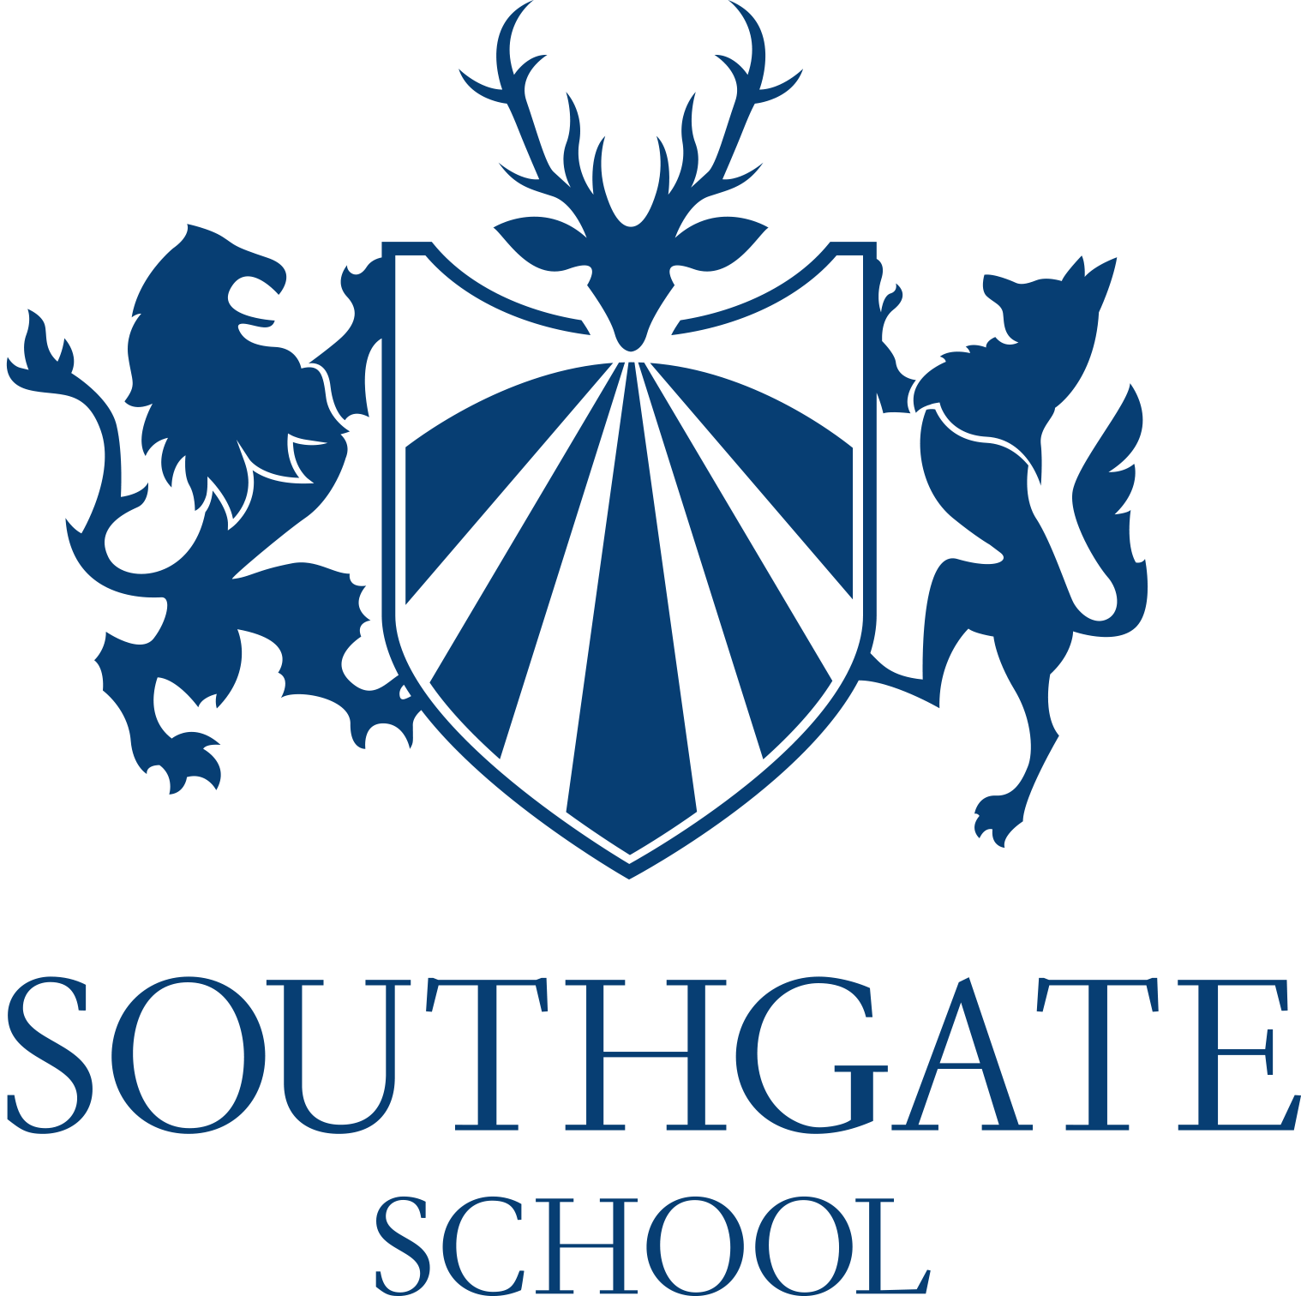
Vacancy – Teacher of Science
School: Southgate School
Address: Sussex Way, Barnet, EN4 0BL
Telephone: 020 8449 9583
Fax: 020 8441 6424
Email: hr@southgate.enfield.sch.uk
Type: Teaching
Salary: MPR
Contract type: Permanent
Vacant from: September 2021
Closing date: Midday on Friday 21st May 2021 - Please note that we reserve the right to close this vacancy early should we receive an overwhelming response. We encourage applicants to apply asap
Do you want to work in a vibrant and friendly school, as part of our dynamic and successful Science Team? Are you ambitious, dedicated and passionate about teaching? If so, then you might be just the right person for us.
We are looking for a qualified Teacher of Science who is able to teach all the Sciences up to GCSE level and any of Biology, Chemistry or Physics at A level, to join a strong department in a very successful school. All KS4 pupils study either Separate Science or Combined Science. Physics, Chemistry and Biology are particularly popular options in the Sixth Form.
We are looking for the right person; age and experience are less important than your vision, ideas and passion!
Why apply for this job at Southgate School?
- We are a member of Middlesex Learning Trust alongside The Compton School, an outstanding school with a national profile. Together we are leading edge in our approach to ensuring excellence for all.
- We are consistently the most over-subscribed school in Enfield
- You will work in a school that has exceptional students from all walks of life and staff who truly care about the impact of their work.
- You will be joining a school that is buzzing with life, energy and opportunities for your own continued professional development.
- Leaders’ work has been sharply focused on making sure that all subjects are
planned and taught effectively. As a result, pupils achieve well in their GCSEs. (Ofsted
2019)
- ‘There is never a day that I don’t want to come to school’. All the pupils we spoke to held this view.’ (Ofsted 2019)

We are a mixed comprehensive school (1500+ on roll including the Sixth Form) dedicated to academic achievement and the maintenance of very high standards.
Training
At Southgate School we offer a comprehensive training package for NQTs. For aspiring middle and senior leaders, we provide financial and professional support and wider CPD including the NPQML and NPQSL. These programmes are delivered as part of our partnership with the Institute of Education
Location
Southgate School has excellent transport links. We are five minutes away from Oakwood Tube Station (Piccadilly Line). Central London is only 20 minutes away.

Further Information
An application form can be downloaded from the school website and should be submitted to the Headteacher’s PA/Office Manager Mrs Jane Theobald by Midday on Midday on Friday 21st May 2021 by email to hr@southgate.enfield.sch.uk
All schools and services in Enfield are committed to safeguarding and promoting the welfare of children and young people. Therefore, all workers and employees in Enfield are expected to share this commitment.

