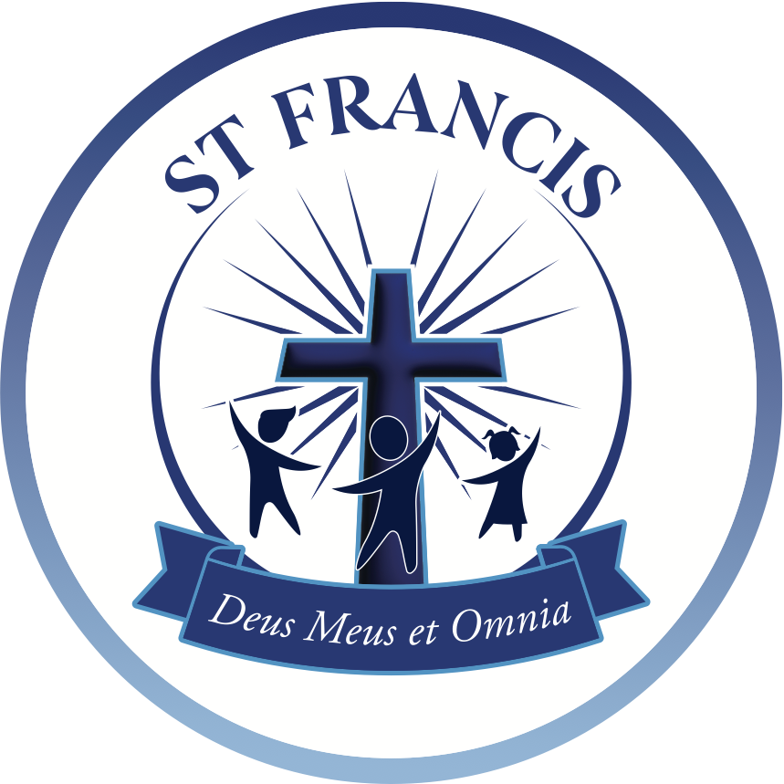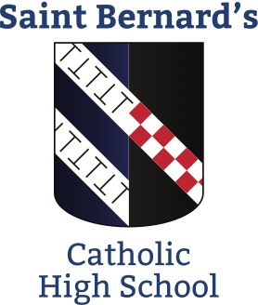



# Teacher of Science

**Saint Bernard's Catholic High School**

Herringthorpe Valley Rd, Herringthorpe,

Rotherham S65 3BE

Tel: 01709 828183

www.sbch.org.uk

**Full Time, Permanent ● Salary: MPS/UPS**

**Start date: September 2023**

St Bernard’s Catholic High School is an outstanding, popular and over-subscribed 11-16 academy in Rotherham. We are a Catholic Voluntary Academy, part of the St Francis MAT, with a wide catchment area, welcoming students of all faiths and denominations.

We are seeking to appoint a Teacher of Science. Ideally, we are seeking a Chemist but welcome applications from all Science disciplines. As a creative and motivated teacher, you will have a commitment to academic excellence through progressive teaching and learning styles. This post is also suitable for ECTs.

**We are looking for a teacher who:**

* has the highest expectations of teaching and learning
* is passionate about Science
* is creative and can inspire in the classroom
* has the desire and ability to help children of all abilities and backgrounds reach the highest levels of attainment and progress
* is supportive of the school’s Catholic ethos **(however you do not need to be a practicing Catholic)**

**We will offer you:**

* a wonderful, vibrant staff family
* a supportive and hard working department and leadership team
* benefits and opportunities through St Francis MAT
* an ongoing CPD programme, tailored to individual requirements
* a calm, well-disciplined learning environment
* an opportunity to contribute to School Direct

For an application pack please visit [www.sbch.org.uk/about](http://www.sbch.org.uk/about) us/vacancies or contact Vivienne Smith, Clerk to Governors on 01709 828 183. Completed application forms should be returned to Mrs V Smith, St Bernard’s Catholic High School, Herringthorpe Valley Rd, Rotherham, S65 3BE or email [jobs@sbch.org.uk](mailto:jobs@sbch.org.uk). Please note that **only** completed Catholic Education Service application forms will be accepted. Interested applicants are invited and encouraged to visit the school. Please contact Vivienne Smith to arrange an appointment.

The closing date for receipt of completed application forms is: **Friday 9th June 2023 at 9.00am.**

Interviews will be held on: **Thursday 15th June 2023**

*NB if successful for interview, references will be required prior to this date.*

St Bernard’s Catholic High School is committed to safeguarding and promoting the welfare of children and young people and expects all staff and volunteers to share this commitment. The successful candidate will be required to complete a DBS form in line with Section 115 of the Police Act 1997.