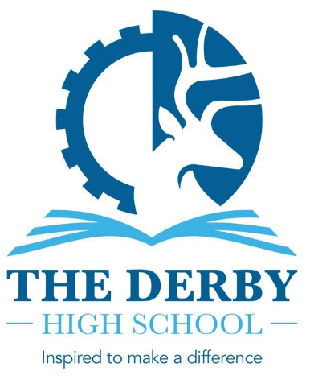

THE DERBY HIGH SCHOOL
RADCLIFFE ROAD
BURY BL9 9NH

Tel: 0161 764 1819
Email: derby@bury.gov.uk

Headteacher: Ms C H Hubert
11-16 mixed comprehensive NOR approx. 940

TEACHER OF SCIENCE
We are seeking to appoint a well-qualified, enthusiastic and highly motivated Science Teacher to join our forward-thinking Science Department
Salary: MPS/UPS
Apply by: 27th February 2026 at 9am
Required for: September 2026

The Derby High School is the highest performing school in Bury, Greater Manchester and has sustained this position for many years. We are seeking to appoint a well-qualified, enthusiastic and highly motivated teacher to join our successful Science Department. We are passionate about delivering a high quality and engaging Science curriculum and aspire to be a beacon for practice in Science education. Significant investments into the Science Department have been made in recent years to deliver on our vision for excellence. This is a great opportunity to join a dedicated, hardworking and forward-thinking department where you will be supported to develop your practice.

We are an over-subscribed 11-16 Co-Educational School situated in the heart of Bury, Greater Manchester. Year on year our students make exceptional progress and we are currently the highest performing school in Bury for Progress 8 (most recent validated Progress 8 measure stands at +0.35). We are an inclusive school serving a diverse student population who are a joy to be around. The leadership of the school at every level is a key strength and this was recognised by Ofsted in our most recent full inspection. We boast a talented staff with a commitment to delivering the highest standards and who are overwhelmingly proud to belong to the school. All who visit The Derby High School are impressed by the warm and welcoming environment that we work in.

We believe that The Derby High School is a great place to work. This post offers you the opportunity to work in/with:

- A successful school with a strong will and determination to continue to improve
- A school that has high expectations of all who work here
- A school that places teaching and learning at the heart of school improvement
- A school that is driven by strong values, invests in its staff and students and has a high regard for their welfare
- A supportive and cooperative teaching staff who are committed to their roles
- A school that works effectively with all stakeholders
- A caring school where you can make a real difference to the lives of young people
We will encourage you to be innovative and creative and provide professional development that will support you in your future career plans.

In line with our commitment to safeguarding and promoting the welfare of our students, appointment will be subject to a full DBS check and references. To apply for this post, please download and complete the application form and provide a letter of application and email to Mrs Silgram-Clynes, at ssilgram-clynes@thederbyhighschool.co.uk

CLOSING DATE: 27th February 2026 at 9am

Completed electronic applications can be emailed to the Headteacher’s PA: ssilgram-clynes@thederbyhighschool.co.uk

Posted applications should be sent FAO Mrs Silgram-Clynes at the school address.

