

Walshaw Road, Bury, BL8 1RN E-mail: eltonhigh@bury.gov.uk
Tel: 0161 763 1434 Fax: 0161 761 3849

General Information for Applicants

The Elton High School is a significantly oversubscribed school where the students are a real strength; visitors regularly comment on the calm and purposeful working atmosphere throughout the school. Relationships between staff and students are excellent and there is a relentless focus on reinforcing high standards of teaching and learning across the school.

In September 2016 we moved into the first new secondary school building to be built in Bury for many decades. The new build offers fantastic teaching facilities including state of the art classrooms, a four court Sports Hall and separate Activity Studio.

The success of our school is built on the expertise of our high-quality staff. We have a strong system of staff training in place aimed at developing the very best practice. Moreover, we have a constant focus on ensuring that all our team feel supported to give of their best and to have a work life balance.

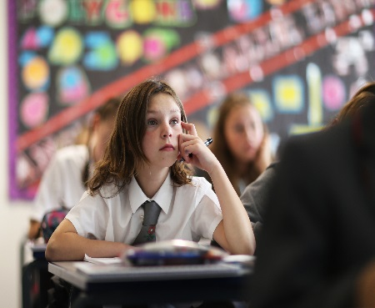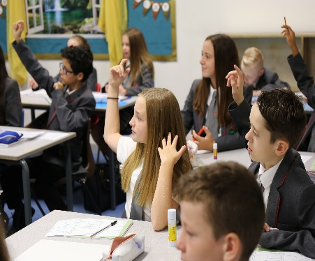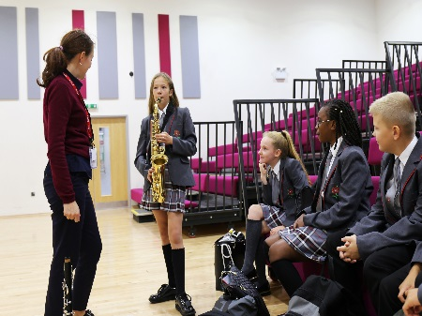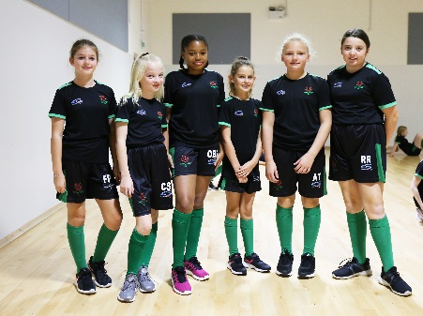 | 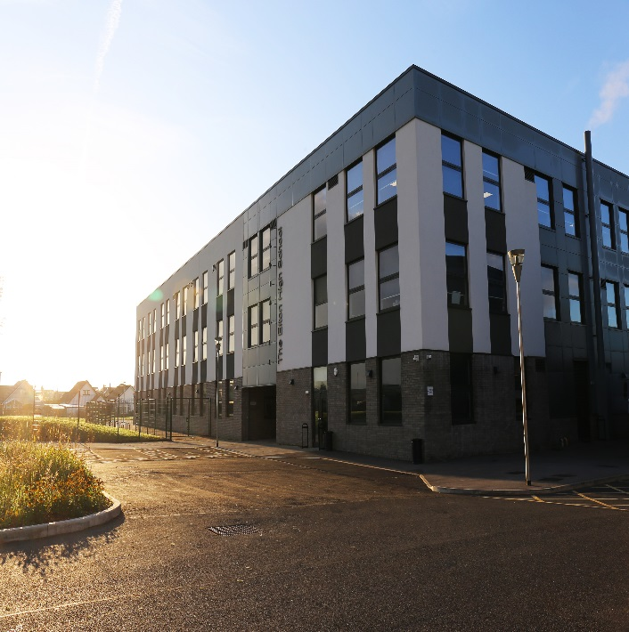

The school has excellent transport links with the M60, M61, M62 and M66 Motorways crossing the area, plus the Metrolink Light Rapid Transit system with a fast and frequent service from Bury centre through Manchester city centre to East Didsbury.

Students and social environment
The school normally admits 200-210 students from approximately 27 primary schools every year and we are oversubscribed in all Year Groups. We are a proudly comprehensive school with a range and mix of abilities. Students come from varied social backgrounds and approximately 12% of the school population are from ethnic minority groups, mainly Asian or Chinese heritage. Approximately 25% of the student population is eligible for pupil premium funding. The immediate vicinity of the school is composed of private detached, semi-detached and terraced housing, although students are admitted from other areas in the Borough of Bury and Bolton.

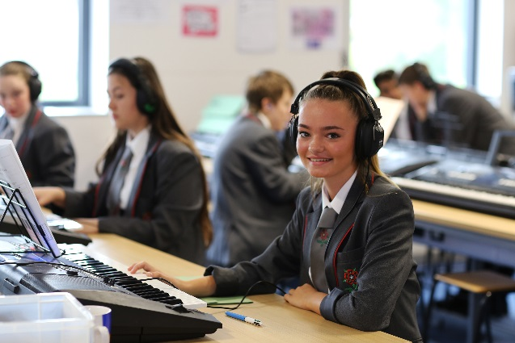 | 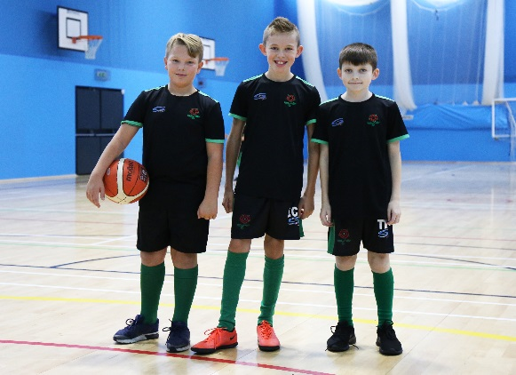 | 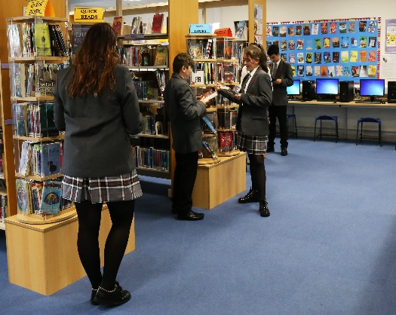

Chair of Governors Leadership Team
Mr Iain MacKay Headteacher: Mr Jonathan Wilton
Deputy Headteacher: Mrs Kate Johnson
Deputy Headteacher: Ms Sarah Warden
Assistant Headteacher: Miss Vicky Helme
Assistant Headteacher: Mr Daley Thompson
Assistant Headteacher: Mrs Donna Rooks
Assistant Headteacher: Mr David Wilson
School Business Manager: Mrs Joanna Filkins

Number on roll: 1047 Staff: 70 Administrative/Support: 52

Academic Structure
The management structure for the academic work of the school is based on a Subject Departmental system.

Staff meet regularly at whole school and subject team level. Staff and student groups meet every fortnight for the purpose of developing learning and teaching.

Subject teams work under the leadership and direction of the Head of Subject. In large subject teams there are additional responsibility roles. Additional responsibility allowances are made to reflect whole school curriculum and learning issues. Heads of Subject for 2023-2024 are:

- English – Lana Ali
- Mathematics – Amanda Butterworth
- Science – Simon Yorke-Robinson
- Technology – Robert Murphy
- Modern Foreign Languages – Rhian Bardsley
- Physical Education – Maria Leech
- SENDCO – Jo Leighton
  - RE/PD – Nicola Parkinson
  - Art & Design – Greg Thomas
  - Geography – Zoe Windsor
  - History – Helen Ryder
  - Music – Kristen Stopford
  - Computing – Waseem Arshad

All Heads of Subject are responsible to Ms Sarah Warden, Deputy Headteacher (Curriculum).

Student Support Structure
The system for student care is based on the work of Form Tutors, Learning Co-ordinators, the Student Support Leader, the Assistant Headteacher and the Deputy Headteacher for student support.
Deputy Headteacher: Kate Johnson Assistant Headteacher: Vicky Helme
Student Support Leader: Nina Alexander Student Support Administrator: Hannah Sikorski

Learning Co-ordinators
Year 7 Megan Waltham Year 10 Ben Dolata
Year 8 Paul Woolliscroft Year 11 Charlotte Walkden
Year 9 Paul Aldred

Behaviour Mentors
Nicola Scholfield, Jo Sutcliffe, Emma Wilcox, George Vickers and Natacha Darnell
Learning Co-ordinators fulfil duties at a specific Year Group level remaining with their Year Group throughout the school. The Learning Co-ordinators are focussed on providing quality support so as to maximise the achievement and develop the personal well-being of every student. They provide the normal point of contact in school for parents with regard to the student’s learning and development.

