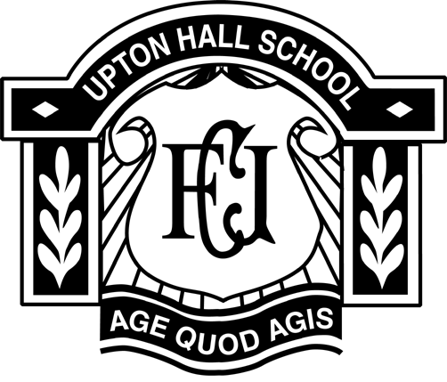

Upton Hall School, FCJ

Person Specification:
Teacher of Science

The minimum level of experience and skills are outlined below as essential. Applicants that can offer any of the desirable indicators in addition to the minimum requirement will be at an advantage. It is unlikely that candidates unable to demonstrate the essential criteria will be selected for short-listing.

Qualifications | Essential | Desirable | Stage Identified
Good Honours Degree in Science or equivalent | ✓ |  | AR
Post Graduate Certificate in Education | ✓ |  | AR
A second degree or additional qualification |  | ✓ | AR

Experience
A proven track record of achieving excellent results |  | ✓ | AIR
Evidence of successful teaching of Advanced Level Courses |  | ✓ | AR
Experience of teaching able pupils at Key Stages 3 and 4 |  | ✓ | AR
Evidence of promoting Science through competitions or extra curricular activities |  | ✓ | AR
Experience as a Form Teacher |  | ✓ | AR

Knowledge & Skills
Detailed knowledge and understanding of all three key stages in the teaching of Science | ✓ |  | AIR
The ability to teach Advanced Level Science | ✓ |  | IR
Knowledge and understanding of teaching and learning styles | ✓ |  | IR
Knowledge of how to make Science accessible and enjoyable for the most and the least able | ✓ |  | IR
Excellent communication skills | ✓ |  | AIR
Excellent ICT skills | ✓ |  | I
An ability to generate self-confidence in pupils | ✓ |  | I
An enthusiasm for Science that is contagious | ✓ |  | I
The ability to teach Chemistry |  | ✓ | AIR

Special Requirements
Good inter-personal skills | ✓ |  | AIR
The ability to manage time demands and ensure deadlines and priorities are met | ✓ |  | AIR
A commitment to offering a rich variety of extra curricular activities | ✓ |  | AIR
A willingness to contribute to the school ethos | ✓ |  | AI
Enhanced DBS check | ✓ |  | AI
KEY : A = APPLICATION, I = INTERVIEW, R= REFERENCE

