

SEND Teacher
Candidate Information Pack
2025-2026
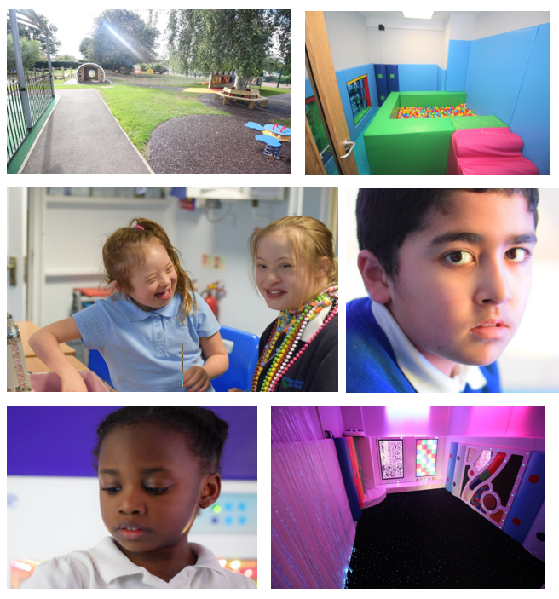
Contents
Within this pack you will find both information and advice on applying for a role within Brackenfield SEND School.
- Welcome from the Executive Headteacher & information about Brackenfield SEND School

- Job Advertisement

- Job Description and Person Specification

- How to Apply

- Outline of Selection Process

- Safeguarding and Checks

executive headteacher

trish turner

Thank you for your interest in applying for the post here at Brackenfield SEND School. The school has expanded over the last 9 years from 62 pupils to 284 at this current time. Within this time our designation has also been changed from 4yr-16yrs to 3yrs-19yrs. We continue to expand as a school, as our Post 16 which opened in Sept 2025 grows to capacity over the next two years. Our school is based over two sites The Grove and The Orchard located 300yards apart on Bracken Road. We are excited to recruit an experienced and enthusiastic teacher to our Outstanding team.

As a school we meet the needs of children from our local community and surrounding areas. Pupils attend the school from Derbyshire, Derby City and Nottinghamshire, Nottingham City, Leicestershire and Rutland local authorities.

Brackenfield is an oversubscribed local authority maintained special school. Over the last 9 years we have streamlined our offer to become a specialist school for pupils with severe and complex learning needs and we have a growing population of children with profound and multiple learning needs and disabilities. All our pupils are significantly cognitively impaired operating developmentally between 0 – 6 years of age. We support pupils’ learning and journey into adulthood through a curriculum based on life skills and skill generalisation. The school benefits from a dedicated Children’s Services Team which oversees safeguarding and family support, a Health Care Team, including registered nurses, which support the medical and care needs of our pupils and a Therapies Team, including onsite Speech and Language Therapists (SALTs) and Occupational Therapists (OTs) which support with assessment and interventions. These teams work with our highly skilled teaching team to shape the provision around our young people.

Our vision is to support our pupils to reach their potential and become functionally and emotionally literate young adults. Through a curriculum with functional life skills at its core, we are developing our pupils to become young adults who can safely navigate and contribute to society- with independence appropriate to their needs. We are fully committed to the safeguarding of all pupils, this is embedded through all aspects of school life, with strong home-school links. We are committed to developing pupil voice to enable our students to make positive choices, share their opinions and preferences whilst demonstrating an understanding of British Values. We have strong belief and ethos of character education, which is used to support our pupils development a self-recognition of character, alongside providing a curriculum that is ambitious and designed to give our young people the knowledge, self-belief and cultural capital they need to succeed and be happy in life. Pupils leave Brackenfield being the best version of themselves. We work with pupils and families to ensure that pupils are happy, safe and reach their potential during their time with us.

Brackenfield was last inspected November 2024 by Ofsted in a graded inspection. Inspection findings showed that Brackenfield SEND school is Outstanding in all 5 areas of the Education Inspection Framework. Please read out latest Ofsted report https://reports.ofsted.gov.uk/provider/25/113031

The East Midlands SEND Training Hub is an integral part of Brackenfield Special School and has been created to support and formalise our outreach work to schools, (both mainstream and special). The hub provides and brokers high quality training and provides work experience and professional placements for education and health professional/students/graduates.

Job advert

SEND teacher

Brackenfield is a successful and expanding special school in the South of Derbyshire. The Executive Headteacher and Governors are looking to appoint a passionate and committed Teacher to join our established, experienced team. The successful candidate will work with our Teaching Team, including Specilaist teaching and Learning Assistants and Learning support Assistants, our Leadership Team and our extended support team to meet the needs of our children with profound and multiple, severe and complex needs.

We are a school for children with complex learning and communication needs ranging from 3-19yrs. Brackenfield is a research based school and we work with external partners to ensure that our approaches reflect best practice in preparing young people with complex needs for adulthood.

We are looking for someone to join our highly skilled team, who can build excellent relationships with our children and is committed to high standards in the classroom as part of a highly motivated and hardworking team. You should have knowledge and understanding of specialist education and early childhood development. Successful applicants will need an understanding of the issues and support strategies relating to children with complex special educational needs.
Applicants are encouraged to come and meet the Executive Headteacher and Head of Site and have a tour of the school (please see contact below).

Brackenfield SEND School is committed to the safeguarding of all children. Due to this post having access to children and/or vulnerable adults, the successful candidate will be required to undertake a Disclosure and Barring Service check. The possession of a criminal record will not necessarily prevent an applicant from obtaining this post, as all cases are judged individually according to the nature of the role and information provided. Brackenfield SEND School is committed to promoting equality of opportunity, preventing unlawful discrimination in all of its activities and to valuing diversity.

If you would like more information please contact recruitment@brackenfield.derbyshire.sch.uk

Job description

send teacher

Duties and responsibilities of the post:
Teaching and Learning

- Lead and manage a class team
- Identify and adopt the most effective teaching approaches for pupils with a range of complex SEN
- Monitor teaching and learning activities to meet the needs of pupils with SEN
- Plan and deliver effective sequences of lessons and generate medium and long term plans to support this
- Identify and teach skills that will develop pupils' ability to work independently
- Identify and teach skills that will develop pupils' ability to communicate
- Identify and teach skills that will develop pupils' social independence
- Lead a subject(s) or identified area within the School Improvement Plan and ensure progress is at least Good.
- Report progress to relevant stakeholders

Behaviour and Safety

- Lead the class team in responding to behaviour policies, protocols and plans and with regards to individual students
- Establish a safe, purposeful and stimulating environment for pupils, rooted in mutual respect and establish a framework for discipline with a range of strategies, using praise, sanctions and rewards consistently and fairly
- Manage the class effectively, using approaches which are appropriate to pupils’ needs in order to inspire, motivate and challenge pupils
- Maintain good relationships with pupils, exercise appropriate authority, and act decisively when necessary
- Be a positive role model and demonstrate consistently the positive attitudes, values and behaviour, which are expected of pupils
- Have high expectations of behaviour, promoting self-control and independence of all learners
- Carry out playground and other duties as directed and within the remit of the current School Teachers’ Pay and Conditions Document
- Be responsible for promoting and safeguarding the welfare of children and young people within the school, raising any concerns following school protocol/procedures
- Be responsible for writing and updating personal risk assessment for pupils within the class
- Work in line with schools attachment best practise model

Team Working and Collaboration

- Participate in any relevant meetings/professional development opportunities at the school, which relate to the learners, curriculum or organisation of the school including pastoral arrangements and assemblies
- Work as a team member and identify opportunities for working with colleagues and sharing the development of effective practice with them
- Ensure that colleagues working with you are appropriately involved in supporting learning and understand the roles they are expected to fulfil
- Take part as required in the review, development and management of the activities relating to the curriculum, organisation and pastoral functions of the school

Recording and Assessment

- Accurately access pupil progress
- Set effective and detailed targets for raising achievement among pupils within class group
- Collect and interpret specialist assessment data
- Complete quality annotation and/or marking to support accurate assessment
- Update the SLT on the impact of the curriculum on pupil progress
- Cross moderate work with subject leads and the other Primary Teachers
- Have a firm understanding of complex learning needs and the importance of raising achievement among pupils
- Attend meetings and consultation evenings and keep parents informed about their child's progress

Standards and Quality Assurance

- Support the aims and ethos of the school
- Set a good example in terms of dress, punctuality and attendance
- Attend and participate in open evenings and school events
- Uphold the school's Behaviour management policy
- Participate in staff training and development
- Attend team and staff meetings
- Develop links with Governors, LEAs and neighbouring schools

Other Duties and Responsibilities
- An area of responsibility as designated by the Headteacher e.g. EVC, SCITT, FOBs, ISA etc

- Other duties that the Headteacher may from time to time ask the post-holder to perform and which fall into fall into school teachers terms and conditions

Person SPECIFICATION

SEND Teacher

Key expectations of the role
- A clear and precise understanding of how children with special needs and complex behaviour learn
- To have an ability to secure high standards of teaching and learning
- To ensure progression of pupils in own class is at least Good
- To work collaboratively with the other teaching staff, Phase Leads and SLT
- To develop an effective coherent curriculum, offer for students with complex SEN
- To carry out any other responsibilities reasonably required by the Head teacher

SEN Teacher Person Specification
Attributes | Essential | Desirable
Education/Qualifications | - Relevant Degree  - QTS  - Relevant CPD Record | - Further SEN qualification
Experience | - Proven track record of excellent teaching  - Proven track record of successful intervention strategies to improve outcomes for underachieving pupils. | - Experience of leading whole school initiative with measurable impact on pupil progress
Knowledge and Understanding | - Thorough knowledge of the requirements of the National Curriculum  - Ability to plan for, monitor and assess pupils’ work, especially for pupils with a range of learning difficulties – collect and analyse data  - Ability to work within a team and effectively communicate with others  - An ability to lead and manage classroom assistants  - Ability to work in a variety of teams  - Ability to organise training opportunities for other staff/share practice  - Knowledge and experience of working with pupils who may have challenging behaviours  - Ability to work in liaison with parents and a variety of professionals  - Ability to promote the vision and aims of our school | - Experience in augmented alternative communication systems e.g. Signs and Symbols, PECs  - Experience of team and or department leadership
Skills | - Outstanding classroom practitioner  - ICT Literate  - Ability to use Data intelligently to improve pupil progress | - Motivated to engage in action research
Personal Qualities | - Inspirational teacher  - Manage change effectively  - Resilient, calm and emotionally intelligent  - Willingness to participate in training and development  - Excellent organisation and communication skills  - A willingness to learn  - A professional attitude and demeanour  - A sense of humour and a positive outlook  - Ability support others wellbeing through co-regulation, whilst recognising own co-regulation/self-regulation needs | - Aspirant Leader

how to apply

SEND teacher

Please apply for this post via the Derbyshire Local Authority website: Derbyshire - Jobs and careers
Online applications
There are a number of benefits for you from applying online which include:
The information you give us when you register on the job site, and before you apply for a job such as in the 'employment history' section, is automatically included in your online application, saving you time - you can update the information held in these sections whenever you need to.
You can part complete an application form, save it and come back to it, and work on it and submit it later or on another day - you can also print off a copy at home. Applying online gives you access to your application form, advert, and any other recruitment documents throughout the recruitment process, even after the job has closed.
You can track the progress of your application online, for example, to see if you have been shortlisted. You'll receive communications about the recruitment process more quickly, by email rather than letter, including any invitations to interview.You'll be able to view any communication as soon as it is sent to you by logging into your account.
You can search for specific types of jobs and then set up a job alert which will ensure you receive an email anytime a similar post is advertised
Other ways to apply
There are still ways to apply if you're unable to do so online. If you do apply offline, please provide your email address if you have one, as this will ensure we send you any communication by email so you receive it as quickly as possible. You can complete either a PDF or Word version of our online application form. These are attached to: Ways to apply - Derbyshire County Council
This form can be printed out, completed by you and then sent by post to:
Derbyshire County Council
Shared Services Centre
John Hadfield House
Dale Road
Matlock
Derbyshire
DE4 3RD
Or completed as a Word document and emailed to jobs@derbyshire.gov.uk
If applying by post or email please make sure that:
- the vacancy reference number is entered on the form
- we receive your application before the closing date
You can request an application pack by telephone.
You can also request an application pack by contacting Call Derbyshire tel: 01629 533190, quoting the reference number of the vacancy.
Please make sure there is enough time between you requesting an application pack and the closing date as it will take a minimum of 2 working days to receive your pack through the post.
Completed applications should be returned to:
Derbyshire County Council
Shared Services Centre
John Hadfield House
Dale Road
Matlock
Derbyshire
DE4 3RD

Help to complete your application
If you have any problems filling in either your registration or your application form, email recruitment@derbyshire.gov.uk or tel: 01629 535118 and select option 1.
Help if you're disabled
We are a Disability Confident Employer. If you're disabled and looking for employment with us, we're keen to hear from you. If you meet the essential criteria for a job, we guarantee to give you an interview.
If you need advice or support with your application or need the recruitment documents in another format such as audio, Easy Read or braille, or wish to discuss related issues, please contact the Disability Employment Service email disabilityemploymentservice@derbyshire.gov.uk
They offer general help with job searches, applications and reasonable adjustments.

selection process

brackenfield send school
Shortlisting
All shortlisting is completed by a panel; with at least one person holds safer recruitment training. Shortlisting is completed by RAG rating against the following criteria:
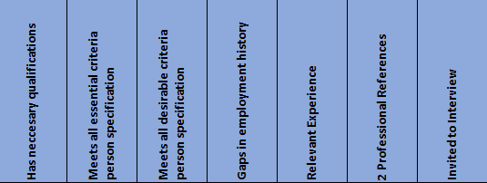
After shortlisting, successful applicants will be invited to interview. In the case of a large field of successful applicants there might be an informal discussion via Microsoft Teams before being bought forward to interview at the school. References will be requested prior to applicants being bought forward to interview.
Interview Process
The same panel members from shortlisting also take part in the interview day. This day may include:
- Tour of the School
- Pupil Panel
- Staff Panel
- In Tray Tasks
- Formal Interview
- Time in classes / Teaching (for Teaching and Learning based posts)
During the interview process each question is RAG rated by each panel member using the below RAG.
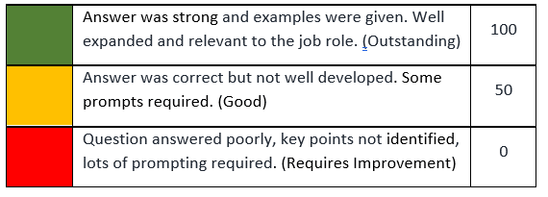
All elements of the day are taken into consideration as well as the application form and references prior to decisions being made.

safeguarding and checks

COMPULSORY checks for all applicants

Brackenfield SEND School and Derbyshire County Council are committed to safeguarding and promoting the welfare of all its pupils. We expect all staff, volunteers and agency staff to share this commitment.

Digital Checks after shortlisting:
As part of Brackenfield’s commitment to safeguarding pupils and the school, there will be pre-employment checks online, including:
Hr Admin to complete online searches Checklist:
- Google search of full name, maiden name/ previous name and name/, job title
- Google search on news tab of full name, maiden name/ previous name and name/, job title
- Use Brackenfield social media account to search Facebook, Instagram, Twitter, LinkedIn, YouTube, TikTok
- Screen shot evidence/ save hyperlinks, looking for: any relevant evidence which suggests that the individual may not be suitable to work with children should be identified. Relevant evidence may include offensive or inappropriate behaviour, jokes or language, discriminatory comments or inappropriate photos etc. Affiliation with certain online groups, or the responses to posts made by others may also indicate that the individual is unsuitable to work with children.
- Record date and time or search completed
- Findings will be reviewed by a Designated Safeguarding Lead
- Questions related to content will be added to interview questions to be queried with interviewee

The successful candidate will be required to undertake a Disclosure and Barring Service (DBS) check. The possession of a criminal record will not necessarily prevent an applicant from obtaining this post, as all cases are judged individually according to the nature of the role and information provided.

Brackenfield SEND School’s Safeguarding Policy applies to all adults, including volunteers and agency staff, working in or on behalf of the school. Each pupil’s welfare is of paramount importance. We recognise that some children may be especially vulnerable to abuse e.g. those with special educational needs and disabilities, those living in adverse circumstances. We recognise that children who are abused or neglected may find it difficult to develop a sense of self-worth and to view the world positively. We recognise that some children who have experienced abuse may harm others. We will always take a considered and sensitive approach in order that we can support all students within our academies.

The school pays full regard to the latest DfE ‘Keeping Children Safe in Education’ guidance. We ensure that all appropriate measures are applied in relation to everyone who works for the school who is likely to be perceived by the students as a safe and trustworthy adult including volunteers and agency staff.

As part of our safer recruiting practises, we scrutinise applicants; verify their identity, academic or vocational qualifications, obtain professional and personal references, check full employment history and ensure the applicant’s health and physical capacity is suitable to undertake the role. Interviews and DBS checks are also undertaken. This post is exempt from the Rehabilitation of Offenders Act 1974 and therefore all convictions, cautions and bind-overs, including those regarded as “spent” must be declared.

If you are currently working with children, either paid or voluntary, your current employer will be asked about disciplinary offences, including those related to children or young people (whether disciplinary sanction is current or time-expired), and whether you have been the subject of any child protection allegations or concerns and, if so, the outcome of any investigation or disciplinary proceedings.

If you are not currently working with children, but have done in the past, that previous employer will be asked about these issues.

Where neither your current or previous employment has involved working with children or young people, your current employer will be asked about your suitability to work with children and young people, although it may be answered “not applicable”, where appropriate, if your work has not brought you in to contact with children or young people.

