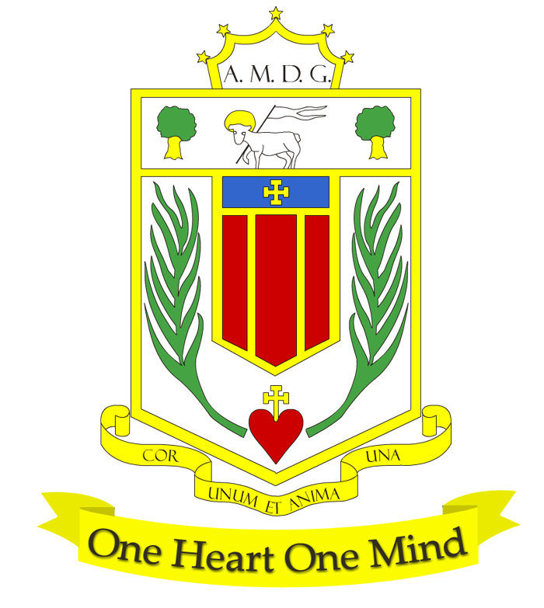

Broughton Hall Catholic High School

Science Department
Departmental Descriptions
The Science Department is led by Mr Roberts and is presently comprised of 11 full time teachers and 3 technicians. Miss Skiming has responsibility for KS4 and Chemistry, Mrs Williams has responsibility for Biology and KS3 matters are coordinated by Mrs Lofthouse. Broughton Hall Science is an improving and forward thinking department to work in, recently celebrating the best set of Science results in recent years. The department offers help and support to new staff whether they are trainees or experienced teachers.

August 2019 Results
- BIO: 75% of students achieved grades 7-9, Average grade 7+
- CHEM: 50% of students achieved top grade 9, Average grade 8-
- PHY: 58% of students achieved grades 7-9, Average grade 7-
The Science Department offers courses at KS3 which deliver a national programme of study in preparation for studies at KS4 where both GCSE Separate Sciences and Trilogy combined Science qualifications are studied. At KS5 A-level courses in Biology, Chemistry, Physics and a BTEC Vocational Qualification in Applied Science have proved both popular and successful.

Our aims are to:
- Develop and maintain students’ interest in Science and related disciplines.
- Develop in our students a wide and relevant body of scientific knowledge and understanding.
- Help students to develop investigative skills across Biology, Chemistry and Physics.
- Continue to develop both literacy and numeracy within a scientific context.
- Develop transferable skills such as problem solving within our students.

The department has always believed that education is continually evolving and as teachers we need to keep developing our skills and practice. The department works closely with the Local Authority and Diocese networks to ensure that staff receive the most up to date training in new developments and approaches. The department is also benefitting from the Stimulating Physics Partnership with bespoke training being available for staff. As part of the Triple Science Support Programme Broughton Hall Science has access to resources and funding designed to increase uptake of the 3 separate science GCSE’s a national target.
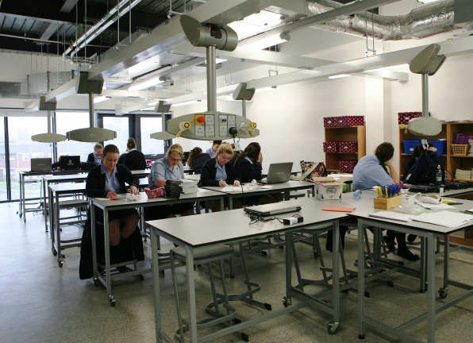
As with all departments science is also looking within itself for developments and improvements by sharing good practice via Triad teaching and learning groups and an openness to share ideas at department meetings which are regular within Broughton Hall.

Accommodation and Resources
The Science department is mainly based in 8 new purpose-built Labs with NAWIS gas and electric facilities. There are 3 science preparation rooms and a shared preparation area for use by teachers and technicians.

All laboratories benefit from Promethean interactive boards and 2 of these are apple enabled. The Science department also has access to 45 laptops for use solely within Science lessons, and two sets of interactive handsets. Practical equipment is well maintained by our experienced technicians and covers most standard practicals and topics. Excellent technical support from our technicians has allowed Broughton Hall to respond quickly to the emphasis on required practicals and a practical endorsement at both KS4 and KS5.

Key Stage 3
Year 7 & 8, follow an in house National Curriculum based scheme focusing on Core Scientific skills, which is fully resourced. Assessment is via tests at the end of each topic and an end of year exam. These assessments and the data they provide are used to give guidance on courses at KS4. We are now starting our Science GCSE’s in Year 9. The two year KS3 is currently under review.

Key Stage 4
Year 10 students all study for a GCSE qualification in AQA Trilogy Combined Science or AQA Separate Sciences.
In year 11 we offer separate GCSE qualification in Biology, Chemistry and Physics, this is offered as an elective over the three years.
The successful completion of these courses leads to students pursuing level 3 courses in Biology, Chemistry, Physics and Applied Science.

Key Stage 5
In years 12 and 13 students enjoy quality teaching and learning towards AQA A-levels in Biology, Chemistry and Physics and a BTEC Qualification in Applied Science. Students studying A levels in Biology, Chemistry and Physics typically have grades 6 or better in GCSE qualifications in Science and Maths. Students with GCSE grade 4 or better qualifications in Science and grade 4 in GCSE Maths will be offered a course leading to a BTEC in Applied Science. Students who study A levels in science continue their studies at Further education level with the majority of students going on to science-based degrees in medicine, dentistry, radiography, chemical, civil and mechanical engineering, pharmacy and others at Universities that in 2018 included Oxford, Cambridge, Liverpool, Manchester, and Lancaster.
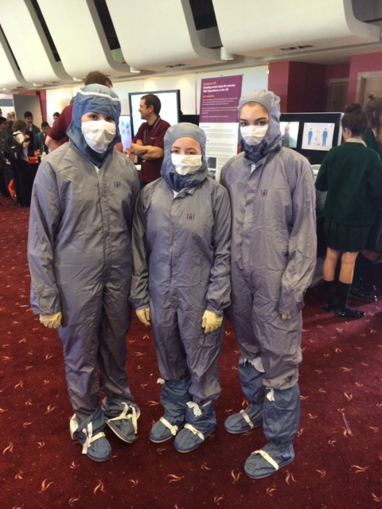

Extra-Curricular Activities
Intervention classes in Science are offered both before and after school to KS3/KS4 and KS5 students. There is also ‘Science Wednesday’s available to all year 10 and year 11 students on Wednesdays 3.05 – 4.05. KS3 students enjoy investigative work done within our STEM Club run after school. There are also intervention and general preparation classes at KS5 in all subjects. Numerous trips out add interest and enthusiasm to the science curriculum at Broughton Hall and recently there have been visits to Daresbury Laboratories for their ‘Chemistry at work day’, The Blood Transfusion Centre at Speke, the Blue Planet Aquarium, the Big Bang Event at Aintree, a Robotics Challenge Days at Liverpool University and Hugh Baird College, and an alien experience visit to Jodrell Bank. The 6th Form trip to Cern, Geneva proved exceedingly popular and proved to be an excellent opportunity to see cutting edge Science research up close.

