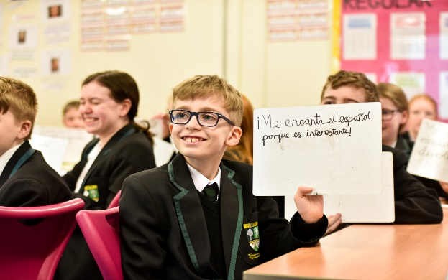

**Teacher of Spanish**



“Life in all its fullness” (John 10:10)

We are seeking to appoint an exceptional and inspiring teacher of Spanish.

The Languages Department at Altwood is a forward-looking team who work collaboratively to create a positive and practical learning environment. We aim to inspire confident and capable communicators who approach their work with enthusiasm, dedication, and confidence. We develop all our students’ individual talents so that they can learn a practical skill and gain a wider understanding of the world. Our Languages curriculum for French and Spanish aims to prepare students for adult life by giving them an awareness of and respect for other people and cultures, and enhanced language skills which also link to and support their use of English.

The department consists of a team of subject specialists who share a passion for both achieving the best for our students and instilling a love of their subject. We pride ourselves on our strong commitment to students both academically and in becoming well-rounded global citizens. The department has a very positive and energetic atmosphere and continues to develop in new and exciting ways. Teachers’ expectations of our students are high, and we encourage them to challenge themselves in lessons. We use a variety of innovative, dynamic, engaging, and collaborative teaching and learning methods in the classroom, including the teaching of phonics.

Languages are a key element of our school community; our curriculum is designed to inform and inspire our students with a desire to challenge themselves to go above and beyond what they believed was possible. All our rooms have audio-visual equipment and interactive whiteboards. The department also makes regular use of DVDs, websites, online resources, and other authentic materials. Our aim is to provide our students with lifelong language learning skills and create a stimulating and structured atmosphere where the students genuinely want to use the target language at every opportunity. We work to make them more responsible for their personal developments as linguists and inspire them with a love of languages.

Our KS3 curriculum has been designed to develop key skills and fluency so that students are proud of their language learning skills. Our classroom teaching is based on the Dynamo and Viva coursebooks, supplemented by the Linguascope resources, and extended by online homework activities. Our students then have a secure foundation for continuing to GCSE; students have gained creditable results at GCSE over several years. At KS4 and A level we follow the AQA specification.