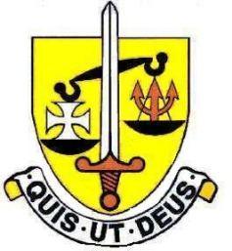

The Modern Foreign Languages Department

This is a very successful and lively department. We offer French, Spanish and Italian courses and we have a large number of students taking MFL in the Sixth Form. We also attract new students from other schools into Year 12 to take Languages at A Level.

Staff
There are currently 8 staff in the MFL Department. There are Teaching and Learning Responsibility posts for Head of MFL, Teacher in Charge of Italian and Teacher in Charge of Spanish.
We are well supported by Modern Foreign Language Assistants in each department.

Accommodation
We have 3 language classrooms suitable for teaching class groups of 32. We also have a Language Lab with 18 positions and a smaller Italian classroom suitable for GCSE and A Level classes. All classrooms are equipped with Interactive Whiteboards. In Sixth Form we have 2 additional teaching rooms.

The Curriculum
Key Stage 3 - French is compulsory in years 7, 8 and 9. In Year 7 the students also have the opportunity to experience Italian and Spanish on a carousel basis. This allows the students to make an informed decision at the end of Spring Term in Year 7 as to their choice of 2nd language which they commence in the Summer Term. The study of the second language is continued through Years 8 and 9. In Year 9 the students make their option choices and decide which language(s) they wish to continue into Year 10.
Key Stage 4 - Most students study one modern foreign language, but may study two. We follow the AQA specification.
A Levels – Students can continue with any of their GCSE languages. French and Spanish are following the AQA specification, whilst Italian is following Edexcel specification.

Trips and Exchanges
Key Stage 3 – The Year 8 four-day cross-curricular residential trip to Kent involves a day in Boulogne.
Key Stage 4 – We run a linguistic and cultural visit to Nice for students in Year 10. In the morning the students participate in language lessons and, in the afternoon, trips are organised by members of the Department.
The Spanish Exchange is open to students in Year 11.
The Italian Trip is open to students in Year 10.
Key Stage 5
We provide European Work Experience for students in Year 12. Destinations include France and Spain.

February 2024

