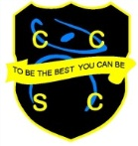**Chesterton Community**

**Sports College**

**‘To be the best you can be’**

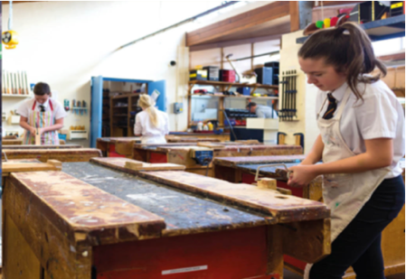

**Technology at CCSC**

The Technology Department at Chesterton Community Sports College is an engaging and creative department where students develop their knowledge and understanding at KS3 through designing and making. Pupils have the option to choose GCSE Design and Technology, GCSE Food Preparation and Nutrition and Creative iMedia at KS4. The department has two full time members of staff who are subject specialists and two technicians who assist with the day-to-day running of the department.

The Technology Department currently has one food room, one very large workshop and a large classroom with a computer area containing iMacs. All rooms have Apple TV which connects to your personal MacBook and iPad provided by the school. In addition to this, all students enjoy the use of their own iPads, which can be incorporated into your lesson planning, whether it be researching existing products, taking photographs of the stages of manufacture or making a workplan. The pupils and teachers use Microsoft Teams as their teaching and learning platform.

The department has always been a popular choice at GCSE with groups oversubscribed. As a department, we believe that organisational and planning skills gained by doing a technology-based subject are invaluable and can help with many other subjects around school.

The department runs extra-curricular clubs, including prep. sessions for coursework in both Food and Design and Technology, and we link with other subject areas for our CCSC Gardening Club and History Club. We also assist in school productions with set design and construction when needed.

