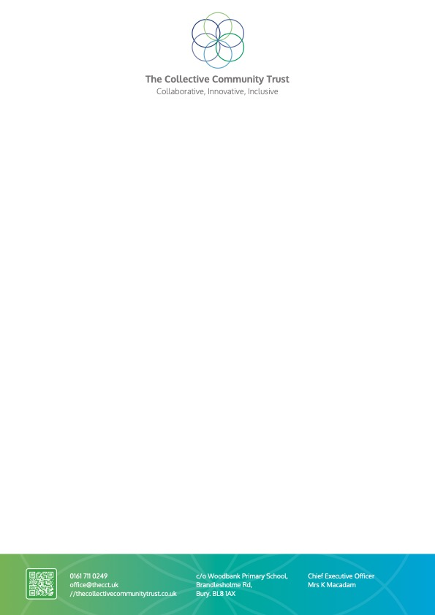
Dear Candidate,

Thank you very much for considering applying for a job within our Trust. I hope this pack provides you with enough information for you to consider whether you have the right qualities, skills and experience to apply.

I feel very proud and privileged to be the CEO of The Collective Community Trust. We are a group of seven community primary schools that serve the children within the Bury borough. Our Trust was established on 1st April 2024.

Our Trust values are Innovative, Inclusive and Collaborative. We very much believe in each individual school maintaining its own ethos, culture and individuality, whilst working collaboratively with each other. The children are at the heart of all we do, and we are extremely proud of the inclusive nature of all of our schools.

As a Trust we are very innovative and forward thinking, and one of our aims is about providing lifelong learning opportunities for all, and this includes our staff. If you are successful in your application we will ensure you are fully supported in your role and have opportunities to access a range of training and professional development to both benefit you and the Trust.

If you feel you can support us in our Trust vision and values then we would be delighted to hear from you.

Good luck with your application.

Kelly Macadam

KL Macadam

CEO of The Collective Community Trust

