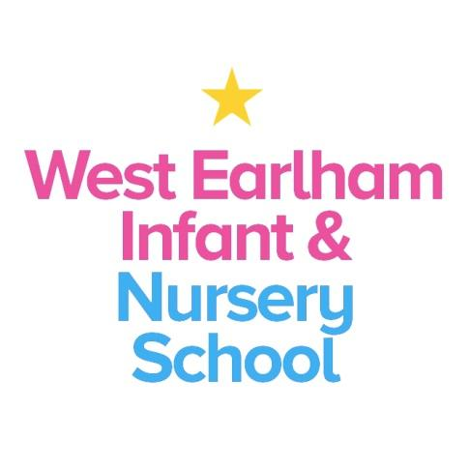

West Earlham Infant & Nursery School
Scarnell Road
Norwich
NR5 8HT
Tel 01603 451299
Email office@westearlhaminfant.norfolk.sch.uk

SEMH/Nurture Teacher
Full Time – Main Pay Range
Required from September 2022 - start date flexible for the right candidate
Governors are seeking to appoint an outstanding teacher to join our school, set in the dynamic neighbourhood of West Earlham in Norwich.
We are proud to be a local authority maintained school who has developed our own on-site alternative provision for children with Social, Emotional and Mental health needs. Mulberry class has its own purpose-built classroom with a well-established team and support network which strives to achieve excellent outcomes for the children.
The post holder will be a qualified teacher with experience of working with young children and a strong desire to work inclusively within an emotionally literate environment, supporting children who have encountered adverse childhood experiences and trauma.
We are looking for someone who:
- Can support the SLT in leading, planning and delivering the curriculum to a small group of children with a range of social, emotional and mental health needs
- Understands how young children develop and learn and is aware of the impact early childhood trauma and attachment impacts on this
- Can use highly skilled behaviour strategies to engage and nurture children
- Understands that children’s wellbeing is increased when connected to nature and has a commitment to incorporate outdoor learning into their planning
- Knowledge and understanding of SEND
- Has knowledge and experience of using social, emotional and mental health interventions (e.g. Boxall Profile, ELSA).
- Is reflective and innovative with a commitment to self-improvement
- Has experience of using RWI and Talk for Writing
- Has the ability to build strong and positive relationships with colleagues, families and outside agencies
- Has resilience and the moral drive to narrow the gap for children from disadvantaged backgrounds
- Has experience of leading a subject e.g. PSHE, RSHE
- Is solution focussed

You can expect:
- To work with a happy, forward thinking and a highly committed team
- To be welcomed and supported by staff, governors, children and families
- To be supported by our expert ‘resident’ Speech and Language Therapy team and Educational Psychologist
- To work closely with the school SENCO and Inclusion manager in shaping provision to reflect current needs
- To develop as a teacher and receive appropriate support and opportunities to enable you to do this
- To contribute to school improvement and development
- To receive relevant and appropriate CPD
- Group supervision every half term from a specialist consultant

How to Apply
Applicants should access more information about our school via our website www.weins.co.uk. For an informal discussion about this post, please contact the school office 01603 451299
You can find an application form by clicking on the orange “Apply for Job” button.
Please return your application to us via email to office@westearlhaminfant.norfolk.sch.uk or by post to the school address.
Closing date: 12 noon Thursday 16th June 2022
Interviews to be held on: Tuesday 21st June 2022
Our school is committed to safeguarding and promoting the welfare of children and young people and expects all staff and volunteers to share this commitment. An Enhanced DBS check will be carried out before the post begins.
This post is likely to come under the requirements of the Childcare (Disqualification) 2009 Regulations and the successful applicant will be required to complete a declaration form to establish whether they are disqualified under these regulations

