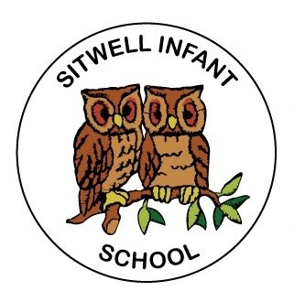
Class Teacher
Person Specification

Personal Skills Characteristics |  | Essential | Desirable | Method of Assessment
1. | Experience  Successful EYFS/KS1 teaching experience | ✓ |  | AF/I/R
2. | Qualifications and Training  QTS qualification | ✓ |  | CQ
3. | Special Skills and Knowledge  Knowledge and understanding of KS1 curriculum and assessment  Knowledge and understanding of EYFS curriculum and assessment  Knowledge and understanding of effective behaviour management strategies and the ability to put these into practise  An understanding and experience of effective teamwork  Ability to work with and deploy staff and resources effectively | ✓  ✓  ✓  ✓  ✓ |  | AF/I  AF/I  AF/I  AF/I/R  I
4. | Personal Qualities  An understanding of and commitment to equal opportunities issues  Conscientious, honest and reliable  Ability to motivate and engage with children  Ability to communicate effectively in verbal and written form  Flexible and adaptable  Sense of humour | ✓  ✓  ✓  ✓ | ✓  ✓ | AF/I  I/R  T/R  AF/I  R  I/R
5. | Personal Circumstances  Willingness to participate in the full life of the school | ✓ |  | AF/I
6. | Physical Requirements  No serious health problem which is likely to impact upon job performance; (that is, one that cannot be accommodated by reasonable adjustments)  Good attendance record in current employment (not including absences resulting from a disability) | ✓  ✓ |  | I/R  I/R

Key: AF – Application Form R – References I – Interview QC – Qualification Certificate

