

**KEY STAGE 2 TEACHER**

**Needed: 1st September 2025**

**Main Scale/Upper Pay Spine (Min £36,051 – Max £46,525)**

**Full time and permanent**

**Closing date Friday 6th June 2025**

**Location**

St John CE Primary School Farnworth  
Church Road, Farnworth, Bolton BL4 8AP Tel: 01204 333101  
School website: www.st-johns-kearsley.bolton.sch.uk  
Roll: 169

**Information**

**“For I know the plans I have for you, plans to prosper you, plans to give *you hope and a future”***

Jeremiah 29:11

The Governing Board of St. John CE Primary School Farnworth is seeking to appoint a highly motivated and experienced class teacher to join our ‘National Nurturing School’ that was again judged ‘GOOD’ by Ofsted in June 2022. We became an Ambassador School for Nurture UK in July 2023.

At St John CE Farnworth we believe God has a plan for each and every one of us and with and God’s love through the teachings of Christ and our Christian school values of Forgiveness, Respect, Encouragement, Kindness, Love and Equality we will all achieve our full potential.

‘The Parable of the Lost Sheep’ illustrates God’s profound love for each and every one of his children. God deeply loves and cares personally for us as individuals. We are valuable to him and he will seek far and wide to bring us back home to him. When the one who was lost returns, the Good Shepherd receives him back with joy, and he does not rejoice alone.

The successful candidate will:

* Be a nurturing and forward thinking, excellent class teacher
* Be able to demonstrate highly effective teaching and learning
* Be part of a committed staff team, focused on continuing to raise standards within teaching and learning
* Have high expectations of pupils, achievement and behaviour
* Be a highly organised individual who can communicate effectively with parents, staff and outside agencies
* Have vision, enthusiasm and good team values
* Bring new ideas to the school which will build on existing good practice
* Have a commitment to support the wider aspects of school life  
    
  We will offer you:
* A friendly, welcoming school with accredited National Nurturing status
* Motivated and engaged children who love to learn
* Excellent career development and training opportunities
* A forward thinking team
* A strong and supportive leadership team and Governing Board
* A strong whole school community that values parents as partners

Rehabilitation The post you are applying for is covered by the Rehabilitation of Offenders Act 1974 (Exceptions) Order 1975 (as amended in 2013). If successful you will be required to apply to the Disclosure and Barring Service (DBS) for a 'disclosure'. Information provided by you or the Disclosure and Barring Service will be dealt with in a confidential manner in accordance with the DBS's Code of Practice. You may view the Code of Practice on the DBS website at www.gov.uk/dbs or alternatively a copy is available on request. Bolton Council has a Handling of DBS Certificate Information Policy this is available from the recruiting manager to applicants who are asked to complete a DBS application.  
  
Bolton Council has a Policy Statement on the Recruitment of Ex-offenders this is available to all applicants upon request.  
  
Please note that in line with Keeping Children Safe in Education 2023, an online search will be carried out as part of our due diligence on shortlisted candidates.  
  
More Information can be found at  [www.st-johns-kearsley.bolton.sch.uk](http://www.st-johns-kearsley.bolton.sch.uk)

**Essential Qualifications**

* Qualified Teacher Status

**Proposed Interview Date:**

13/6/2025

For an informal discussion please contact:

Visits to the school are warmly welcomed and encouraged. Please contact the school to arrange: 01204 333101 or [office@st-johns-kearsley.bolton.sch.uk](mailto:office@st-johns-kearsley.bolton.sch.uk)

Application forms and job descriptions can be obtained from the “Greaterjobs” website.

**CLOSING DATE**: Please return completed forms to Mrs Kirsty Diggle (Finance/HR Officer) at the Archbishop Temple Trust by midday on the closing date by **Friday 6th June 2025**

Email: digglek@archbishoptempletrust.co.uk

Post: St John’s CE Primary School, Church Road, Farnworth, BL4 8AP

*This school is committed to safeguarding and promoting the welfare of children and young people and expects all staff and volunteers to share this commitment. Successful candidates will be subject to an Enhanced Disclosure by the Disclosure and Barring service.*



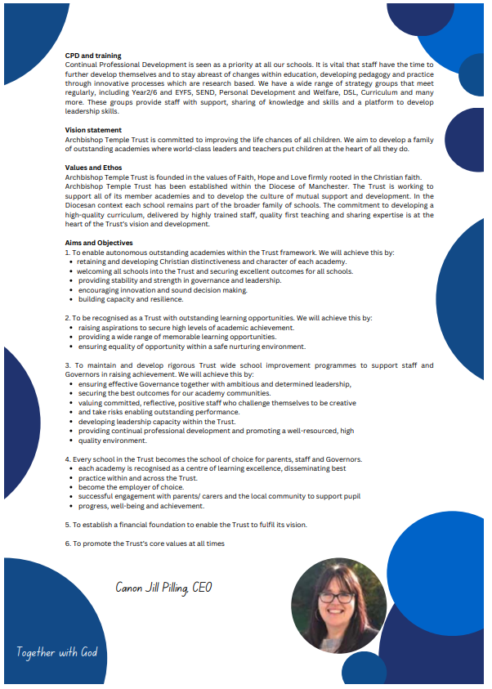

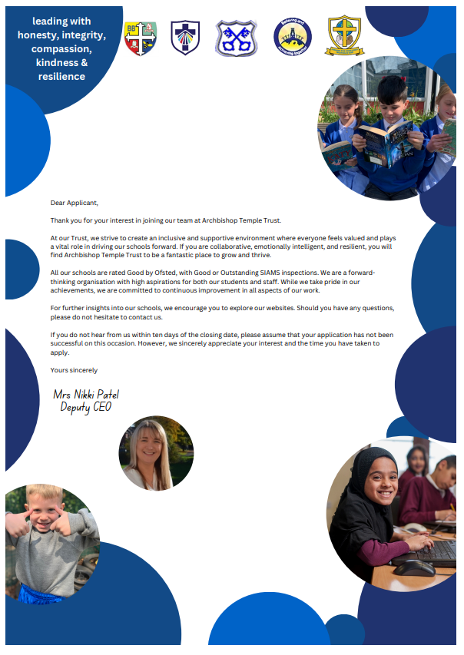



**JOB DESCRIPTION**

**St John CE Primary School Farnworth**

**Class Teacher**

The appointment is subject to the current conditions of employment for teachers as contained within the School Teachers’ Pay and Conditions Document, the 1998 School Standards and Framework Act, the required standards for Qualified Teacher Status and the Standards for all Teachers 2012.

This job description may be amended at any time following discussion between the Headteacher and the member of staff. It will be reviewed annually as part of the appraisal process.

Teachers at this school make the education of their pupils their first concern and are accountable for achieving the highest possible standards in work and conduct. They must act with honesty and integrity; have strong subject knowledge; keep their knowledge and skills as teachers up to date and are self-critical; forge positive professional relationships; and work with parents in the best interests of their pupils.

**TEACHING**

A teacher must:

**Set high expectations which inspire, motivate and challenge pupils:**

• Establish a safe and stimulating environment for pupils, rooted in mutual respect;

• Set goals that stretch and challenge pupils of all backgrounds, abilities and dispositions;

• Demonstrate consistently the positive attitudes, values and behaviour which are expected of pupils.

**Promote good progress and outcomes by pupils:**

• Be accountable for pupils’ attainment, progress and outcomes;

• Plan teaching to build on pupils’ capabilities and prior knowledge;

• Guide pupils to reflect on the progress they have made and their emerging needs;

• Demonstrate knowledge and understanding of how pupils learn and how this impacts upon teaching;

• Encourage pupils to take a responsible and conscientious attitude to their own work and study.

**Demonstrate good subject knowledge and curriculum knowledge:**

• Have a secure knowledge of the relevant subject(s) and curriculum areas, foster and maintain pupils’ interest in the subject and address misunderstandings;

• Demonstrate a critical understanding of developments in the subject and curriculum areas and promote the value of scholarship;

• Demonstrate an understanding or, and take responsibility for, promoting high standards of literacy, articulacy and the correct use of Standard English, whatever the teacher’s specialist subject;

• If teaching early reading, demonstrate a clear understanding of systematic synthetic phonics;

• If teaching early mathematics, demonstrate a clear understanding of appropriate teaching strategies.

**Plan and teach well-structured lessons:**

• Impact knowledge and develop understanding through effective use of lesson time;

• Promote a love of learning and children’s intellectual curiosity;

• Set homework and plan other out-of-class activities to consolidate and extend the knowledge and understanding pupils have acquired;

• Reflect systematically on the effectiveness of lessons and approaches to teaching;

• Contribute to the design and provision of an engaging curriculum within the relevant subject area(s).

**Adapt teaching to respond to the strengths and needs of all pupils:**

• Know when and how to differentiate appropriately, using approaches which enable pupils to be taught effectively;

• Have a secure understanding of how a range of factors can inhibit pupils’ ability to learn, and how best to overcome these;

• Demonstrate an awareness on the physical, social and intellectual development of children, and know how to adapt teaching to support pupils’ education at different stages of development;

• Have a clear understanding of the needs of all pupils, including those with special educational needs; those of high ability; those with English as an additional language; those with disabilities; and be able to use and evaluate distinctive teaching approaches to engage and support them.

**Make accurate and productive use of assessment**

• Know and understand how to assess the relevant subject and curriculum areas, including statutory assessment requirements;

• Make use of formative and summative assessment to secure pupils’ progress;

• Use relevant data to monitor progress, set targets and plan subsequent lessons;

• Give pupils regular feedback, both orally and through accurate marking and encourage pupils to respond to the feedback.

**Manage behaviour effectively to ensure a good and safe learning environment**

• Have clear rules and routines for behaviour in classrooms, and take responsibility for promoting good and courteous behaviour both in classrooms and around school, in accordance with the school’s relationship policy;

• Have high expectations of behaviour, and establish a framework for discipline with a wide range of strategies, using praise, sanctions and rewards consistently and fairly;

• Manage classes effectively, using approaches which are appropriate to pupils’ needs in order to involve and motivate them;

• Maintain good relationships with pupils, exercise appropriate authority and act decisively when necessary.

**Fulfil wider professional responsibilities**

• Make a positive contribution to the wider life and ethos of the school;

• Develop effective professional relationships with colleagues, knowing how and when to draw on advice and specialist support;

• Take responsibility for improving teaching through appropriate professional development, responding to advice and feedback from colleagues;

• Communicate effectively with parents with regard to pupils’ achievement and wellbeing;

• Deploy support staff effectively.

**PERSONAL AND PROFESSIONAL CONDUCT**

A teacher is expected to demonstrate consistently high standards of personal and professional conduct. The following statements define the behaviour and attitudes which set the required standard for conduct throughout a teacher’s career.

• Teachers uphold public trust in the profession and maintain high standards of ethics and behaviour, within and outside the school, by:

• Treating pupils with dignity, building relationships rooted in mutual respect, and at all times observing proper boundaries appropriate to a teacher’s professional position;

• Have regard for the need to safeguard pupil’s well-being, in accordance with statutory provisions;

• Showing tolerance of, and respect for, the rights of others;

• Not undermining fundamental British values and mutual respect and tolerance of those with different faiths and beliefs;

• Ensuring that personal beliefs are not expressed in ways which exploit pupil’s vulnerability or might lead them to break the law.

• Teachers must have proper and professional regard for the ethos, policies and practices of the school in which they teach, and maintain high standards in their own attendance and punctuality;

• Teachers must have an understanding of, and always act within, the statutory frameworks which set out their professional duties and responsibilities.

**Classroom Teacher**

**Person Specification Form**

|  |  |  |
| --- | --- | --- |
| **Personal Attributes required**  **(on the basis of the job description)** | **Essential (E)**  **or**  **Desirable (D)** | **To be identified by:**  **(e.g. application form, interview, reference, etc.)** |
| **Qualifications**  Qualified Teacher Status  Primary trained  Degree  Recent participation in a range of in-service training | E  E  E  D | Application  Application  Application  Application |
| **Experience**  Recent experience of teaching within Key Stage 2  Experience of successful leadership of a range of subjects (Please state curriculum expertise)  Experience of working with children with SEND  Experience of teaching and assessing Phonics  Experience of teaching in Early Years and Key Stage 1 | E  E  E  D  D | Application, interview, reference |
| **Knowledge, skills and abilities**  An understanding of the importance of nurture on child development and practice  Have high expectations of all pupils  Engage the interests of learners  Effectively manage support staff in the classroom Outstanding classroom management and organisation  Outstanding behaviour management  Plan sequences of lessons with clearly differentiated learning objectives, linked to prior attainment which meet the needs of individual learners  A clear understanding of how assessment for learning practices support teaching and learning  Use a range of strategies to provide feedback to pupils  Closely assess, track, record and report pupils’ progress  **Professional knowledge and understanding**  National policies, priorities and statutory frameworks  Assessment and tracking of pupil progress  Application of ICT to teaching and learning  Ability to create and promote a stimulating learning  environment for all learners  Ability to coordinate a subject area  Good understanding of and commitment to inclusion, Child Protection and safeguarding  **Personal Skills and attributes**  Good communication skills  Interpersonal skills  Ability to prioritise time effectively  Flexibility  Personal impact and enthusiasm  Self-confidence and presence  Commitment and integrity  Ability to work as part of a team  A commitment to further professional development  A willingness to participate in the wider life of the school, including extra-curricular activities  **Other**  1. Commitment to safeguarding and protecting the welfare of children and young people  2. Commitment to equality and diversity  3. Commitment to health and safety  4. Commitment to attendance at work | D  E  E  E  E  E  E  E  E  E  E  E  E  E  E  E  E  E  E  E  E  E  E  E  E  E  E  E  E  E  E | Application and interview, reference  Application, interview and reference  Application, interview, reference  Interview, reference |

**These core competencies are considered essential for all roles within Bolton Council. Please be prepared to be assessed on any of these during the interview process and, for the successful applicant, throughout the probationary period.**

**Developing Self & Others**

Promote a learning environment to embed a learning culture.  Support others to develop their skills and knowledge to fulfil their potential. Actively pursue your own development. Support and promote the principles of Investors in People.

**Civil Contingencies**

Bolton Council has a statutory duty under the Civil Contingencies Act to respond in the event of an emergency. If Bolton Council’s Emergency Management Plan is activated, you may be required to assist in maintaining key Council services and supporting the community.  This could require working outside of routine working hours and working from places other than your normal place of work.

**Equality & Diversity**

Uphold the principles of fairness and the Equality Act in all undertakings as a Bolton Council employee, including providing a fair, accessible service irrespective of customer’s race, religion, gender, sexuality, disability or age.

**Customer Care**

The ability to fully understand, assess and resolve the needs of all customers including those who present with complex situations, in a manner that respects dignity and expresses a caring & professional image.

**Health & Safety**

Take responsibility for the health and safety of yourself and others who may be affected by your acts or omissions, and comply with all health and safety legislation, policy and safe working practice, including participating in training activities necessary to your post.

**Data Protection and Confidentiality**

Ensure that any personal data or confidential data you hold is kept securely and is not disclosed, whether electronically, verbally or in writing, to any unauthorised third party. Follow Council policies and procedures on dealing with personal information and information assets, including The Code of Conduct, Data Protection, Acceptable Use and Information Security policies. Personal or confidential data should only be accessed or used for council purposes.

**Fluency Duty**

Should you be required, as a regular and intrinsic part of your role, to speak to members of the public in English, you must be able to converse at ease with customers and provide advice in accurate spoken English, as required byThe Immigration Act 2016.

**Working Hours**

The nature and demands of the role are not always predictable and there will be an expectation that work will be required outside of normal hours from time to time.

**Safeguarding**

This Council is committed to safeguarding and promoting the welfare of children, young people and vulnerable adults and expects all staff and volunteers to share this commitment. Should the role involve working with the above groups, you will be subject to an Enhanced Disclosure and Barred List check by the Disclosure & Barring Service.

**The values of an organisation are those key principles by which people are expected to work to day to day. They’re our culture and help define what is expected of each and every one of us**.







**How to apply**

We hope that you have enjoyed reading about the Archbishop Temple Trust and our school and that you will feel able to apply for this post.

Please complete the **downloadable** **application form.** Please do not send CVs or open references as part of your application as these will not be considered.

It is important that you provide a complete employment history from when you left full time education. If the application form is not fully completed or has unexplained gaps in your employment history, your application will not be considered. Copies of your qualifications will be required at the interview stage; please do not send these with your application.

Please also write **a letter of no more than two sides of A4** to explain why you want to work within our Trust, why you are the best candidate for the post and what you would contribute to our schools, with examples from your recent work if possible.

Please let us have both the supporting letter and the application form by **noon** on **Friday 6th June 2025** as we will not be able to consider applications received after that.

In accordance with the Data Protection Act, the details provided in the application form will be used for selection and interview procedures, and for employment records if your application is successful.

If you are disabled, please give details of how we can ensure that you are offered a fair selection and interview process.

Successful candidates will be asked to provide, prior to taking up the appointment, documentary evidence (including National Insurance number) showing their entitlement to work in the UK. We will also carry out an enhanced DBS and declaration of health check. References will also be required in line with Keeping Children Safe in Education 2019.