Class Teacher
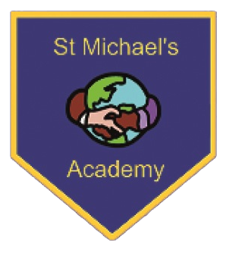
St Michael’s Academy
2x Full time Permanent Positions
Salary: MPS
Are you a driven and enthusiastic teacher who is passionate about making a difference to children’s lives? Do you have what it takes to engage and inspire our curious and eager young learners?
We are looking to recruit two ambitious and dedicated teachers to provide the highest standards of teaching and learning. The ideal candidate will be committed to inclusive practices and promote success for all learners, regardless of barriers.
This post is suitable for an experienced teacher looking for a fresh, exciting opportunity, or a newly qualified teacher looking for their first teaching role. The successful candidate must be a person with energy, passion and commitment who can instil a love of learning by delivering inspirational and fun lessons to enthused children from a diverse range of backgrounds.
We ask a great deal of our staff and in return we offer an outstanding opportunity for the right person to make a real impact on children’s lives and the community we serve, as well as developing their own career in our successful and innovative school. You will have access to first class training and mentoring which will enable you to enhance your practice quickly and develop as a leader should you wish to do so.
You will join our vibrant and forward looking team of highly dedicated, collaborative and supportive colleagues who have the drive to make a real difference to our pupils and the wider community.
If you share our vision of delivering a high quality and distinctive education, where no child is left behind, it would be great to arrange a visit prior to application. We welcome applications from people of all faiths and are dedicated to promoting equal opportunities for all.
Please contact the school office (see below) and let us know the dates and times when you can visit. We look forward to hearing from you.
We are committed to safeguarding and promoting the welfare of children and applicants must be willing to undergo Child Protection screening, including checks with past employers and the DBS. References will be taken up before interviews are offered.
Early application is encouraged as we review applications throughout the advertising period and reserve the right to close the advert earlier than the stated deadline.
Visits to the school are highly recommended and encouraged.
Please apply by letter, outlining your skills and experience relevant to the post and complete the teaching application form available from the school website.

www.stmichaelsacademy.co.uk

Closing date: Friday 21st April (12 noon)

Interview date: Week commencing Monday 24th April

St Michael’s Academy, Grass Royal, Yeovil. BA21 4JW

NOR: 250 Age range 7-11 01935 423863
Email: office@stmichaelsacademy.co.uk

