 **Appointment**

**Information Pack**

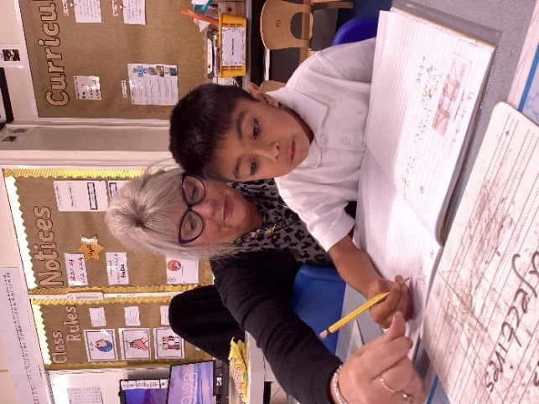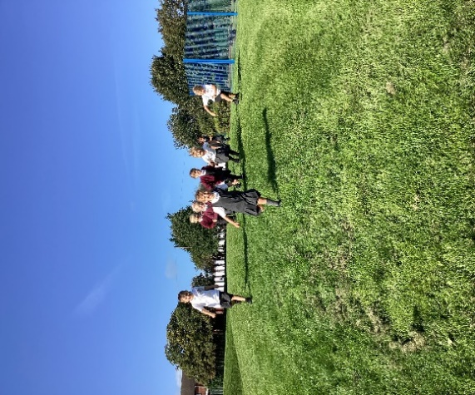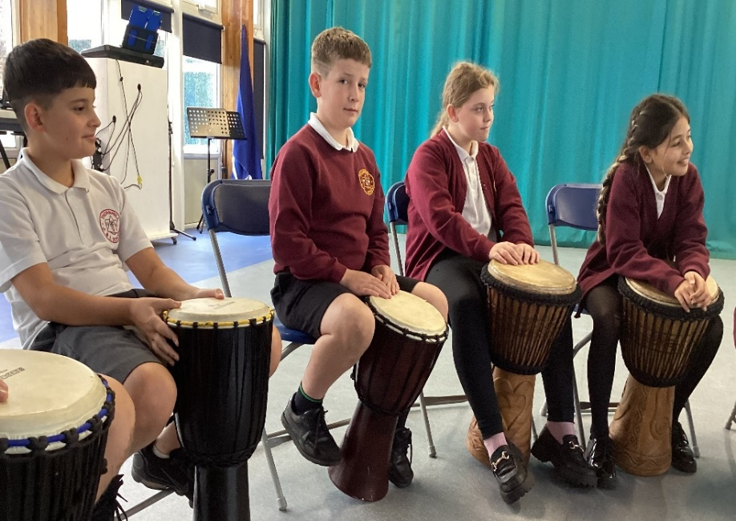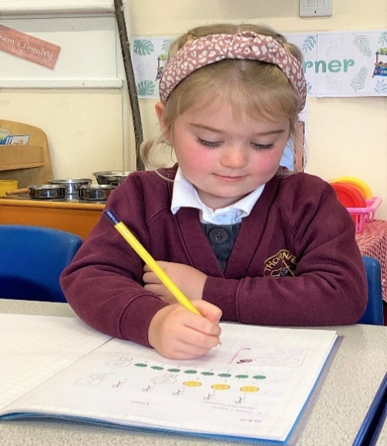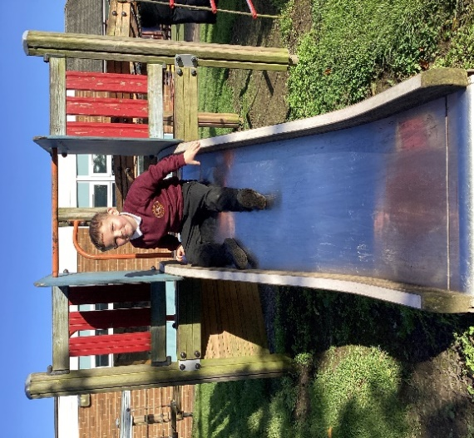

|  |  |
| --- | --- |
| **Vacancy** | Class Teacher |
| **Location** | Thornhill Junior and Infant School |
| **Start date** | September 2024 |
| **Closing date** | Friday 26th April 12 noon |
| **Salary** | MPS |
| **Contract** | Fixed Term – Maternity Cover |
| **Return application to** | *thornhill@focus-trust.co.uk* |

**Welcome from Jen Rylance, the Headteacher, Thornhill Junior & Infant School.**

**Dear applicant,**

Thank you for taking an interest in the Deputy Headteacher vacancy at Thornhill Junior and Infant School.

Our popular School is situated in the village of Thornhill, Dewsbury, West Yorkshire, serving a large residential area of private and local authority housing.  The school's planned admission number is 420 and the school’s admission limit is 60 per year group.  The number of children on roll currently stands at 360. Approximately 36% of our children are entitled to free school meals, 18% have Special Educational Needs and 7% come from homes where English is not their first language.

Our school is popular with local families and has a reputation for being friendly and welcoming. There are good links with the local community through various activities and we enjoy positive relationships with neighbouring schools as part of the Dewsbury Learning Partnership.

Key messages from our most recent Ofsted report in 2019:

* Leaders have established a warm ethos in the school, based on respect for all. This is underpinned by the wealth of opportunities leaders have put in place which promote effectively pupils’ spiritual, moral, social and cultural development.

|  |
| --- |
| * Leaders have ensured that the quality of teaching is good. Professional development for teaching staff in subjects such as phonics and writing has ensured that pupils typically make strong progress. |
| * Leaders have placed reading at the heart of pupils’ learning. Consequently, pupils are enthusiastic readers and show a secure understanding of what they have read. * Teachers ensure that pupils’ learning is purposeful by making well considered links between a range of subjects within a topic. Pupils often decide which aspects of a topic they would like to explore. This stimulates pupils’ curiosity effectively. They regularly reflect on what they have learned and think about their next steps. Pupils are enthused by this approach and, hence, show positive attitudes to learning and take pride in their work. * The curriculum is well designed and, hence, captures pupils’ interest and feeds their motivation to learn. As a result, pupils demonstrate positive attitudes in lessons. * The well-developed music curriculum plays a crucial part in supporting pupils’ spiritual and cultural development. Pupils benefit from a range of musical experiences, such as an opera visit during Year 4, opportunities to perform in the school band and to compete in musical contests with pupils from other schools. Pupils also learn about other cultures through a focus on different musical genres, significant artists and musicians. * The behaviour of pupils is good. Pupils rise to adults’ high expectations of them and, hence, they conduct themselves well. They are polite, welcoming and respectful. This creates a calm atmosphere in the school. |

I am extremely proud to be the Headteacher at Thornhill Junior and Infant School and believe it is a rich and vibrant place to learn and work. I would be very happy to answer any questions that you may have.

We hope that you will find this information pack helpful in finding out more about this post. You are very welcome to make an appointment to visit the school and meet with me.  Please contact the school office on 01924 453259, to make an appointment.

If you would like a further conversation about any aspect of this post or about working as part of Focus-Trust, please do not hesitate to email [thornhill@focus-trust.co.uk](mailto:thornhill@focus-trust.co.uk) or contact the school office who will arrange a telephone call.

Please contact us if you require any further information.

Please return all completed documents to thornhill@focus-trust.co.uk by

**12 noon on 26th April 2024.**

Jen Rylance

Headteacher

**Academy details**

|  |  |
| --- | --- |
| **Address** | Edge Lane, Dewsbury, WF12 0QT |
| **Telephone** | 01924 453259 |
| **Email** | [thornhill@focus-trust.co.uk](mailto:thornhill@focus-trust.co.uk) |
| **Website** | [www.thornhilljischool.co.uk](http://www.thornhilljischool.co.uk) |

**Welcome from Paul Spencer, Chair of Governors**

Dear applicant,

Thank you for taking the time to consider applying for the post of Deputy Headteacher at Thornhill Junior and Infant School.  As Chair of the Governing Body, I would like to take this opportunity to tell you a little bit about the context of our school.

Thornhill Junior and Infant School is a two-form entry school, situated in Thornhill on the outskirts of Dewsbury, West Yorkshire. We have PAN of 420 primary aged pupils with an admission limit of 60 pupils per year group. A small percentage of pupils come from homes where English may not be the first language.

We are proud to be part of the Focus Academy Trust and recognise the value of support, ethos, challenge, and collective efficacy embodied within the trust.

This is a very friendly school where children are happy, and staff work exceptionally well as part of a team. The large staff of teachers and teaching assistants are led by a dedicated, highly respected Senior Leadership Team.

There are 15 spacious and well-equipped classrooms. The school has a large hall which is used as a gymnasium, dining room and assembly hall. Our school is surrounded by secure playgrounds and a large, grassed area which includes an orchard. The building is a mixture of old and new and there has been much renovation and interior development over the last five years.

We offer a wide range of extra-curricular activities and clubs, and the school is renowned as a lead in music provision.

Parents are made very welcome in the school and provide much valuable support; they run the ‘Friends of Thornhill’ group which organises social and fund-raising activities.

Our school is popular with local families and has a reputation for being friendly and welcoming. There are good links with the local community through various activities and positive relationships with neighbouring schools, including the local High School.

I hope I have given you a flavour of Thornhill Junior and Infant School and that it makes you feel that you would like to become a part of our school community.

Yours sincerely,

Paul Spencer

Chair of the Governing Body

**Job Description**

|  |  |
| --- | --- |
| **School/Academy** | Thornhill Junior and Infant School |
| **Job title** | Teacher |
| **Accountable to** | Headteacher |
| **Line manager** | Key Stage Leader/Assistant Headteacher |

**Introductory statement**

The responsibilities and professional duties of the post are to be performed in accordance with the provisions of the most recent version of the Teachers’ Standards.

Teachers make the education of their pupils their first concern, and are accountable for achieving the highest possible standards in work and conduct. Teachers act with honesty and integrity; have strong subject knowledge, keep their knowledge and skills as teachers up-to-date and are self-critical; forge positive professional relationships; and work with parents, colleagues and external agencies in the best interests of their pupils.

**Purpose of the role**

To ensure all pupils achieve high standards of learning and well-being.

**Main duties**

**Set high expectations which inspire, motivate and challenge pupils**

* Establish a safe and stimulating environment for pupils, rooted in mutual respect
* Set goals that stretch and challenge pupils of all backgrounds, abilities and dispositions
* Lead by example and demonstrate consistently the positive attitudes, values and behaviour which are expected of pupils

**Promote good progress and outcomes by pupils**

* Be accountable for pupils’ attainment, progress and outcomes.
* Plan teaching to build on pupils' capabilities and prior knowledge.
* Guide pupils to reflect on the progress they have made and their emerging needs.
* Demonstrate knowledge and understanding of how pupils learn and how it impacts on teaching.
* Encourage pupils to take a responsible and conscientious attitude to their own work and study.

**Demonstrate good subject and curriculum knowledge**

* Have a secure knowledge of all curriculum areas, foster and maintain pupils’ interest in the subject, and address misunderstandings.
* Demonstrate a critical understanding of developments in curriculum areas, and promote the value of learning and scholarship.
* Demonstrate an understanding of and take responsibility for promoting high standards of literacy, articulacy and the correct use of Standard English, whatever the teacher’s specialist subject.
* Demonstrate a clear understanding of the teaching of systematic synthetic phonics, reading and the teaching and application of basic skills.
* Demonstrate a clear understanding of the teaching of mathematics and the application of basic skills.

**Plan and teach well-structured lessons**

* Impart knowledge and develop skills and understanding through effective use of lesson time.
* Promote a love of learning and children’s intellectual curiosity.
* Set and assess homework and plan other out-of-class and enrichment activities to consolidate and extend the knowledge and understanding pupils have acquired.
* Reflect systematically on the effectiveness of lessons and approaches to teaching.
* Contribute to the review, design and provision of an engaging curriculum.

**Adapt teaching to respond to the strengths and needs of all pupils**

* Know when and how to differentiate appropriately, using approaches which enable pupils to be taught effectively.
* Have a secure understanding of how a range of factors can inhibit pupils’ ability to learn, and how best to overcome these.
* Demonstrate an awareness of the physical, social and intellectual development of children, and know how to adapt teaching to support pupils’ education at different stages of development.
* Make effective use of resources (including other adults) to impact on pupil learning and progress.
* Have a clear understanding of the needs of all pupils, including those with special educational needs; those of high ability; those with English as an additional language; those with disabilities; and be able to use and evaluate distinctive teaching approaches to engage and support them.

**Make accurate and productive use of assessment**

* Undertake formative, summative and statutory assessments in line with the Academy’s policy and assessment calendar.
* Make use of formative and summative assessment to plan for and secure pupils’ progress.
* Use data to monitor progress, set targets, and plan subsequent lessons.
* Give pupils regular and timely feedback, both orally and through accurate marking, and encourage pupils to respond to the feedback.
* Prepare and present written and verbal reports for parents and carers.

**Manage behaviour and resources effectively to ensure a good and safe learning environment**

* Have clear rules and routines for behaviour in classrooms, and take responsibility for promoting good and courteous behaviour both in classrooms, around the academy and when learning off-site, in accordance with the Academy’s behaviour policy.
* Have high expectations of behaviour, and establish a framework for discipline with a range of strategies, using praise, sanctions and rewards consistently and fairly.
* Manage classes effectively, using approaches which are appropriate to pupils’ needs in order to involve and motivate them.
* Maintain good relationships with pupils, exercise appropriate authority, and act decisively when necessary.
* Ensure the learning environment is kept well ordered, tidy and free from hazards.

**Fulfill wider professional responsibilities**

* Make a positive contribution to the wider life and ethos of the Academy and the Trust.
* Develop effective professional relationships with colleagues, knowing how and when to draw on advice and specialist support.
* Deploy support staff and other adults in a support role effectively.
* Liaise with external agencies with regard to pupil progress, safety and welfare.
* Take responsibility for improving teaching through appropriate professional development, responding to advice and feedback from colleagues and external advisers.
* Work with other staff across the Trust and in other maintained schools.
* Communicate effectively with parents with regard to pupils’ achievements and well-being.
* Lead an area or strand of school improvement (excl NQT).

**Personal and professional conduct**

A teacher is expected to demonstrate consistently high standards of personal and professional conduct. The following statements define the behaviour and attitudes which set the required standard for conduct throughout a teacher’s career.

* Teachers uphold public trust in the profession and maintain high standards of ethics and behaviour, within and outside the Academy, by:
* treating pupils with dignity, building relationships rooted in mutual respect, and at all times observing proper boundaries appropriate to a teacher’s professional position;
* having regard for the need to safeguard pupils’ well-being, in accordance with statutory provisions;
* showing tolerance of and respect for the rights of others;
* not undermining fundamental British values, including democracy, the rule of law, individual liberty and mutual respect, and tolerance of those with different faiths and beliefs; and
* ensuring that personal beliefs are not expressed in ways which exploit pupils’ vulnerability or might lead them to break the law.
* Teachers must have proper and professional regard for the ethos, policies and practices of the Academy and the Trust, and maintain high standards in their own attendance and punctuality.
* Teachers must have an understanding of and always act within, the statutory frameworks which set out their professional duties and responsibilities; and within the policies, handbooks and guidelines of the Academy and of the Focus-Trust.

**General**

The post holder will:

* Be expected to actively support work and values of the Focus-Trust;
* Be expected to undertake such additional duties as may reasonably be requested by the Principal or their representative.
* Respect confidentiality of staff, pupils, families and visitors and not breach this trust. Any breaches of confidentiality must be reported to the Principal immediately.
* Comply with the requirements of all policies, procedures & handbooks of the Focus-Trust and individual academy.
* Participate in arrangements for appraisal and in the identification of areas in which s/he would benefit from training and undergo such training.
* Proactively keep abreast of developments in relation to the post, and whenever possible and appropriate, attend professional development opportunities.
* Comply with and support all requirements related to equal opportunities and safeguarding children.

This job description is neither exhaustive nor exclusive, and it may, after consultation with the post holder be subject to modification and amendment in accordance with the needs of the academy.

Post holder: Signed ………………………………………… Name …………………………………..

Principal: Signed ………………………………………… Name …………………………………..

Dated: …………………………………………………..

**Class Teacher**

**Personnel specification**

**Key;**

**App**- Application form

**Ref**- Reference

**SP**- Selection process. This could include a range of exercises, including an interview

|  |  |  |
| --- | --- | --- |
| **Knowledge, experience and skills** |  |  |
|  | Essential/  Desirable | How identified |
| **Experience** | **E/D** | **App/SP** |
| Ability of raising attainment of all pupils | E | APP/SP |
| Ability to reflect on practice and improve teaching methods to increase pupils achievements | E | APP/SP |
| Ability to continually improve teaching and learning through schemes of work, assessment and extra curriculum activities etc | E | APP/SP |
| **Knowledge** |  |  |
| Up to date knowledge in the primary curriculum | E | APP/SP |
| Ability to use strategies needed to establish consistently high aspirations and standards of results and behaviour | E | APP/SP |
| **Skills** |  |  |
| Able to play a full and active role in a team | E | APP/SP |
| Clear understanding of expectations, accountabilities and consistency | E | APP/SP |
| Aligned with the Trusts values | E | APP/SP |
| Motivated to continually improve standards and achieve excellence | E | APP/SP |
| Commitment to the safeguarding and welfare of all pupils | E | APP/SP |
| Excellent classroom practitioner | E | APP/SP |
| Effective and systematic behaviour management, with clear boundaries, sanctions, praise and reward | E | APP/SP |
| Excellent communication, planning and organisational skills | E | APP/SP |
| **Fulfil wider professional responsibilities** |  |  |
| Understand when and how to seek advice and support. | E | APP/SP |
| Able to develop and maintain good relationships with staff, parents, pupils, governors and the community | E | APP/SP |
| Committed to own development as a professional. | E | APP/SP |
| Able to reflect on own practice and identify areas for improvement | E | APP/SP |
| **Qualifications and training** |  |  |
| Qualified Teacher Status or other educational qualification | E | APP/SP |
| Qualified to degree level and above | E | APP/SP |
| Evidence of further professional development. | E | APP/SP |
| **Personal qualities and attributes** |  |  |
| Moral purpose (Equality, children and adults treated with respect) | E | SP |
| Excellent communicator (Listening, putting a message across) | E | SP |
| Child centred | E | SP |
| Resilient | E | SP |
| Integrity | E | SP |
| Self-motivated and able to motivate others | E | SP |
| Enjoys challenge | E | SP |
| Works to deadlines | E | SP |
| Enthusiastic and optimistic | E | SP |

**About Our School**

**Thornhill Junior and Infant School vision:**

**‘Together we will make the difference’.**

Thornhill Junior and Infant school aims to nurture: happy, confident, inquisitive, responsible citizens with high aspirations for themselves and others.

We seek to achieve this through:

* Working together to create a happy school full of learning, laughter and friendship where individual contributions and opinions are valued.
* Promoting each pupil’s self-esteem by building and developing individual strengths and talents so that children feel able to take risks within a safe, positive environment.
* Providing opportunities to explore, investigate and question the world around them through a broad and balanced curriculum enabling children to develop their natural inquisitiveness.
* Creating a stimulating environment, with high quality teaching, where children are encouraged to think for themselves, express their opinions and take responsibility for their learning.
* Supporting children to make the right choices for themselves and others, enabling them to make a valuable contribution to society and become responsible citizens.

**Our pupils**

The very large majority of pupils are of White British heritage and some have a first language other than English. The proportion of pupils known to be eligible for free school meals is above average. The proportion of disabled pupils or who are supported on the SEND register are above average. Attainment on entry is broadly in line with age-related expectations.

**Our staff**

Our leadership team comprises the Headteacher, Deputy Headteacher, two Assistant Headteachers and two senior leaders. In addition to teachers and teaching assistants, we have behaviour and pastoral leads who work with children and families, staff and outside agencies to offer support for wellbeing and develop parental engagement. The running of the school is also supported by admin, site, kitchen and lunchtime teams.

**Our facilities**

Thornhill is a two-form entry school. The classrooms are light and spacious and well equipped to ensure the children have a learning environment conducive to the 21st century. We are extremely fortunate to have large grounds which have been designed and developed to support children’s learning.

**Our school organisation**

Our pupil admission number is 420 and there are two classes for each year group, from Reception to Year 6. In addition to class teachers, learning is supported in classes by teaching assistants – the number of these depends on needs within classes and year groups.

**Our curriculum**

We offer a broad and balanced curriculum which gives the children a wide range of experiences to develop the whole child. Our curriculum is geared to giving children a firm grounding and the necessary skills to succeed in an ever-changing world as well as providing them with the solid foundations of Reading, writing and Maths. We are very proud to be an Arts Mark School as well as having achieved the Platinum Sing Up Award.

**Our extra-curricular activities**

As well as our extensive range of music clubs we have lots of other extra-curricular activities that run throughout the year including; football, cooking, Scalextric, board games, homework, Lego and arts and crafts. We have an After School and Holiday Club to provide affordable childcare and to meet the needs of our working parents.

|  |  |
| --- | --- |
| **Academy Quick Facts** | |
| **Type of school** | Primary |
| **Age range** | 4-11 |
| **Location/LA** | Kirklees |
| **Number of children** | 353 |
| **Number of teaching staff** | 21 |
| **Number of support staff** | 40 |
| **% FSM** | 36% |
| **% SEN** | 18% |
| **% EAL** | 7% |

Background to the Trust

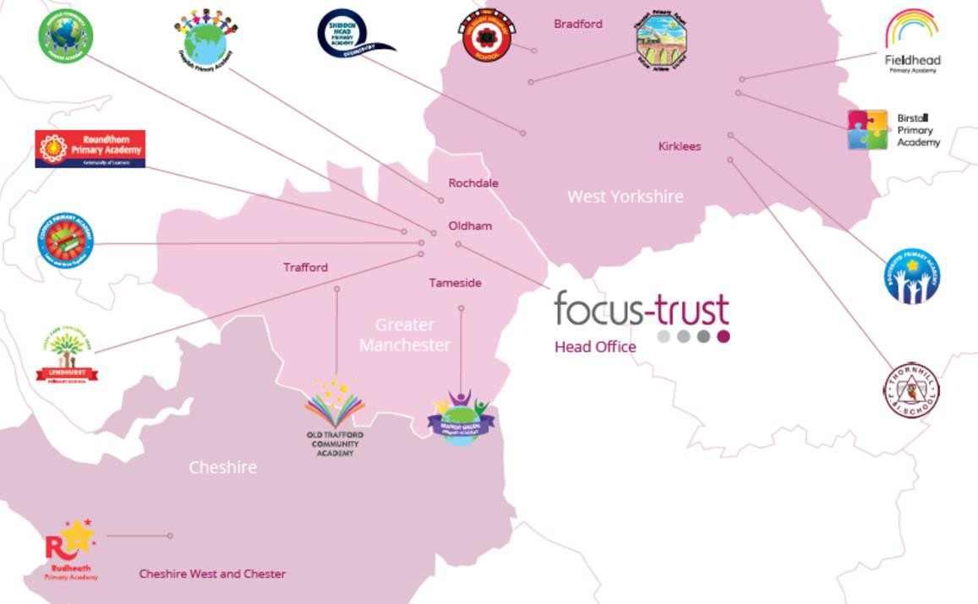Focus-Trust was incorporated in May 2012 as a primary trust. The Trust has links with the sponsor, Focus Education, but is an entirely separate legal entity. As with all academy trusts, the Trust is a company limited by guarantee and an exempt charity. The Trust’s offices are situated in a newly converted historic mill conversion in Chadderton, Oldham with excellent motorway networks to access our schools.

The defining feature of Focus-Trust is that it is a specialist primary phase trust. This means that the work of the Trust is driven by the distinctive needs of primary schools. Whilst the Trust has robust systems for accountability, each school has their own distinctive identity, ethos and culture, and this is a commitment to every school when they convert and join the Trust.

Focus-Trust currently has a small centrally employed team. The members of the team are highly skilled and committed to the vision, culture and values of the Trust.

All the schools within the Trust are willing partners who have actively chosen to join Focus-Trust and there is a very high degree of consensus, cooperation and commitment from within the group.

The Trust has robust policies and systems in place to govern and guide its work. These have been gradually implemented as the Trust has grown. The Trust has well-established productive relationships with trade unions and meets half termly with a group of national trade union representatives to discuss policy development. This has enabled us to introduce and change a range of policies in a streamlined and cooperative way.

# **Our Vision**

‘Great schools at the heart of our communities’ - with our Community Champions and colleagues, we strive to ensure we are being civic leaders making a difference in the local and national communities and the community is supporting us.

## **Focus-Trust Mission**

‘Learning together, making the difference’

## **Collective Efficacy**

We have a well-developed and securely embedded culture of Collective Efficacy. By this we mean we have, ‘A shared commitment to work together on the things that matter to improve outcomes for all.’

## **The Focus-Trust Values**

Professional honesty is at the heart of everything we do. The Trust knows the schools well because of the strong working partnership between academy leaders and the Trust Central Team. It is only by being honest and transparent with a balance of credible challenge and effective support, that we can move forward and get the best for all children and staff. Our work is underpinned by our values:

**Care** for children, adults and the learning environment  
**Dare** to do things differently and have a go  
Be **fair**, honest and inclusive – demonstrating integrity  
**Share** concerns, expertise and best practice for the benefit of all learners

**Our Moral Purpose**

**Our People Strategy**

**What you might want to know about Focus Trust**

**Pensions**

Focus-Trust contributes to Teachers’ Pensions and Local Government pensions in the same way and with the same level of contribution as local authorities.

**Employer Relations**

Focus-Trust has a Trade Union agreement which recognises the teacher and support staff unions. This is further supported by an ongoing and productive relationship with key trade union officials.

**Equality of opportunity**

Focus-Trust is an equal opportunity employer, dedicated to a policy of non-discrimination in employment on any basis including age, gender, race, colour, nationality, ethnic origin, disability, gender, religion, age, marital status, sexual orientation and/or medical condition.

**Safeguarding**

Focus-Trust is committed to safeguarding and promoting the welfare of all children and young people. There is an explicit expectation that all employees share this commitment and adhere to all safeguarding policies and procedures. Applicants should be aware that the recruitment process will include an assessment of your suitability to work with children.

**Dress code**

We expect all staff to dress professionally and appropriately for the roles undertaken. We pride ourselves on the high standards of dress of both our pupils and staff; these standards are led by our staff who we expect to set an example.

**Policies**

Focus-Trust and the schools have a range of policies and handbooks that help to make clear our expectations and ways of working. These are always shared openly with staff and are accessible to everyone. There are several policies that prospective employees should be aware of when making an application. These can be found on the Trust website [www.focus-trust.co.uk](http://www.focus-trust.co.uk) and school websites. All members of staff will be asked to sign a declaration as part of the induction process to acknowledge that they have read and understand the Code of Conduct and some of the key policies, e.g. Safeguarding and Child Protection, Health and Safety, Acceptable use of IT.

**Right to work in the UK**

Under the Asylum and Immigration Act 1996, it is a criminal offence to employ anyone who is not entitled to live or work in the United Kingdom. Applicants can expect us to ask for proof of this at interview stage, where you will be asked to provide some original documentation to confirm that you are eligible to work within the UK. Photographic proof of identity will also be required.

**Validation of qualifications and identity**

All shortlisted candidates will be asked to bring original certificates or relevant qualifications and identity documents to interview. These will be photocopied and kept on file and, if appropriate, may be confirmed as genuine with the relevant awarding bodies. The copies of the successful candidate will be retained on their personnel file. The copies of unsuccessful candidates will be treated as confidential waste and disposed of appropriately.

**References and Social Media Checks**

If you are shortlisted, we will take up references before the interview date. One of your referees must be your current or most recent employer. Two satisfactory references must be received before we can confirm any offer of an appointment. The information we request will relate to salary, length of service, skills and abilities, suitability for the job, disciplinary record and suitability to work with children. Copies of references or open references will not be accepted. On receipt of references, your referees may be contacted to verify any discrepancies, anomalies or relevant issues as part of the recruitment verification process.

In line with our safer recruitment policy, social media checks will be undertaken if you are shortlisted. This social media check is designed to complement the range of standard recruitment checks and allows us to identify a candidate’s online presence which potentially could damage the organisation’s reputation.

**Knowledge and skills profile**

This is an important part of your application and is your opportunity to explain how you meet the person specification for the post. You should demonstrate your skills, knowledge and experience and give short examples. Describe how you match the requirement of the job; include experience gained from previous jobs, community or voluntary work. Ensure that the information you give is well organised, relevant and brief. You may find it helpful to use sub-headings in order to keep your statement well focused. If you do not submit this profile, you will not be considered for short listing.

**Disability**

To comply with the Equality Act 2010, we are legally required to consider making reasonable adjustments to ensure that disabled people are not disadvantaged in the recruitment and selection process. We are therefore committed to meeting, wherever possible, any needs you specify on the application form. Please contact Natalie Harris if you need to discuss this in any detail. We will consider any reasonable adjustment under the terms of the Act to enable an applicant with a disability (as defined under the Act) to meet the requirements of the post.

**Disclosure of a criminal record**

Employment in this role is subject to an enhanced check with the Disclosure and Barring Service (DBS). Checks will also be made against the lists showing people barred from working with children. All checks must be satisfactory before any offer of employment can be confirmed and before commencement of work can take place.

Please return all completed documents to [thornhill@focus-trust.co.uk](mailto:thornhill@focus-trust.co.uk) by **12noon Friday 26th April 2024.**

Thank you for taking the time to read this information pack. We wish you every success in any application you may make.