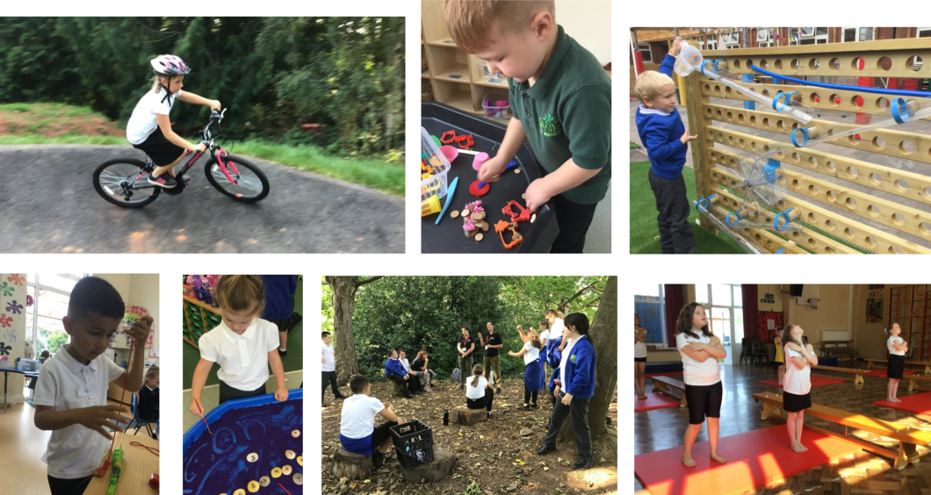
Specialist SEN
Teacher

Whipton Barton Federation

Letter from the Headteacher

Dear applicant
Thank you for taking the time to consider applying for the post of Teacher (with SEN experience preferable) in our federation.

Our federation is fast gaining a reputation as a place where pupils with additional needs are supported in an exemplary way. Led by an outstanding SENDCo, we have built a team of SEND professionals who work very effectively alongside children, teachers and parents to deliver the very best provision for those pupils with SEND. We are now expanding this provision, having been selected by DCC to provide an eight-space resource base for children with communication and interaction difficulties. We expect this to be operational from January 2022. For the successful candidates, we can offer a dynamic working environment, excellent training, wide ranging career development opportunities and a real opportunity to make a difference to the lives of our pupils. We also pride ourselves on our welcoming and inclusive ethos.
We are proud to be a member of the Ted Wragg Multi Academy Trust and its reputation for successful school improvement. The trust is committed to further improve standards of education for all children no matter what their starting point or their background. The Trust board is highly ambitious and committed and we are looking for individuals who share the same values.
Please download an application pack from our website www.whiptonbarton.org In your supporting statement, we would like you to draw on the job description below but also flag up any specific areas of expertise or experience you have. For more details or enquiries please contact Andrea Gambie on admin@whiptonbarton.org.
The closing date for applications is midday on 29th October 21 and applications should be submitted to recruitment@whiptonbarton.org by the deadline. Interviews will be held on 5th November 21.
We look forward to receiving your application.
Best wishes
Georgina Reid
Headteacher

TRANSFORMING LIVES THROUGH LEARNING
Ted Wragg Multi Academy Trust

1938 - 2005
Professor Ted Wragg, in whose memory the Ted Wragg Trust is named, was passionate about education in general, and Exeter in particular, and about how education can transform young people’s futures.
The Trust shares Ted Wragg’s passion for education and the difference it can make to social mobility, progression, self-esteem and ultimately success, in an increasingly competitive education and jobs market.
The Ted Wragg Multi Academy Trust’s ambition is to raise the aspirations of young people and enable them to become fulfilled, life ready, confident and motivated citizens, able to contribute actively to a democratic society. All pupils within the Ted Wragg Multi Academy Trust, regardless of social or cultural background, are motivated to succeed and make outstanding progress because their needs are met through creative, relevant and innovative provision.
THE AIMS OF THE TED WRAGG TRUST ARE TO:
- Work in genuine partnership to strengthen schools and their communities.
- Foster a culture of positive challenge and continual school improvement.
- Provide a common sense of purpose with a focus on outstanding teaching and learning.
- Offer an excellent educational experience so that every pupil fulfils their potential.
- Encourage a rich, dynamic and purposeful range of learning opportunities for all pupils.
- Develop life-enhancing values so that pupils leave school with a sense of self-worth and determination to succeed.
The Ted Wragg Multi Academy Trust currently has eleven school members, Isca Academy, St James School, the Cranbrook Education Campus, St Luke’s Church of England School, West Exe School, Exwick Heights Primary School, Whipton Barton Federation and Queen Elizabeths School in Greater Exeter and Marine Academy Plymouth, Marine Academy Primary and All Saints Academy in Plymouth plus a new Exeter Creative School which is shortly commencing construction. We have trustees from the University of Exeter and Exeter College, as well as from local businesses.
The key aspect that makes our Trust exceptional, is that with the ‘Members’ we have an inspirational progression route from an Outstanding Primary, through an Outstanding FE College, to a world-class, Russell Group University.
Website: http://www.tedwraggtrust.co.uk
Job Description
Job Title: | Teacher (with SEN experience preferable)
Multi Academy Trust: | Ted Wragg Multi Academy Trust
School: | Whipton Barton Federation
Responsible To: | SENDCo
Salary Grade: | UPS 1-3

- Key Purpose of Job
Context: Our federation does not see SEND and disadvantage as barriers to learning. We are preparing to expand our already successful SEND team under the direction of our SENDCo, having been selected by DCC to run an eight-place resource base for children with communication and interaction difficulties.
Key purpose of the job: To work under the guidance of the SENDco to provide high quality education and personalised provision for pupils with specific leaning difficulties linked to communication and interaction. This will be a lead role with line management responsibility for a team of SEND teaching assistants operating from the resource base and within our personalised provision.

- List Key Duties and accountabilities of the post
List of key duties and accountabilities of the post:
- Develop a clear understanding of the learning needs and the importance of raising achievement among pupils and use the knowledge to plan effective teaching and learning.

- Identify and adopt the most effective teaching approaches for pupils.

- Monitor teaching and learning activities to meet the needs of pupils

- Manage the EHC plans and evaluate the outcomes of provision, intervention work and support for pupils.

- Teach skills that will develop pupils’ ability to work independently, manage social interactions and improve emotional understanding in context of the individual needs of the pupils.

- Complete referrals and liaise with other agencies to understand barriers to learning and provide additional support for pupils.

- In consultation with the SENDco, class teacher and parents set targets for raising achievement among pupils.

- Collect, interpret and share assessment data. Use this to inform planning and provision.

- Update the SENDco on the effectiveness of provision and progress of pupils.

- Regularly liaise with parents/carers to keep them informed of their child’s progress.

- Supervision / Line Management Responsibilities of the post
The post-holder will report directly to the SENDCo.

- Working Environment & Conditions of the post
The post will be working across either the Infant and Nursery school or the Junior school. The role is class based.

- Other Duties
Other Duties
- To undertake additional duties as required, commensurate with level of the job.

- To contribute to the effective working of the school.

- Maintain positive, professional relationships with pupils, parents / carers, teachers and other school staff.

- Maintain a presence around the school within which you are working to ensure the highest standards of behaviour, following school policy and practices.

- To participate in induction training, incremental coaching, our staff appraisal process and professional development opportunities.

- The post holder will be expected to commit to Equal Opportunities and familiarise themselves with and adhere to all relevant school policies and procedures, including safe guarding and health and safety.

- The post holder will be expected to have an agreed working pattern to ensure that relevant functions are fulfilled through direct dialogue with the executive head teacher, SENDco and SLT.

- The duties of this post may vary from time to time without changing the general character of the post or level of responsibility entailed.

- Other Information

All staff must commit to Equal Opportunities and Anti-Discriminatory Practice.
- The Trust operates a Smoke-Free Policy and the post-holder is prohibited from smoking in any of the Trust buildings, enclosed spaces within the curtilage of buildings, and Trust vehicles.
- The post-holder will be expected to have an agreed working pattern to ensure that all relevant functions are fulfilled through direct dialogue with employees, members of other agencies and community members.
- The post-holder is expected to familiarise themselves with and adhere to all relevant Trust and School Policies and Procedures.
- The post-holder must comply with the Trust’s Health and Safety requirements specifically for the school they are working at
- This post is based at Whipton Barton Federation but the post holder may be required to move their base to any other location within the Trust upon request.
- As this post meets the requirements in respect of exempted questions under the Rehabilitation of Offenders Act 1974, all applicants who are offered employment will be subject to an Enhanced Disclosure and Barring Service Check (DBS) before the appointment is confirmed. This will include details of ALL cautions, reprimands or final warnings as well as convictions, whether “spent” or “unspent”. Criminal convictions will only be taken into account when they are relevant to the post.

Person Specification | Essential / Desirable | Evidence
Qualifications and Experience:
Qualified Teacher Status | Essential | A,C,
Proven track record of CPD | Essential | A,C,I
Further specialist qualification/s in an aspect of SEN e.g ASD, SpLD | Desirable | A,C,
Evidence of sound knowledge of effective quality first teaching and intervention strategies | Desirable | A,C,I
Demonstratable experience in working collaboratively with parents, colleagues, governors and the local community | Essential | I,R
Experience of monitoring and evaluating effective teaching and learning. | Essential | A,I,R
Proven experience in effective liaison with a range of outside agencies | Essential | A,I,R
Teaching experience within a primary age range | Essential | A,I,R
Professional Knowledge and understanding
Knowledge and understanding of the expectations within the EYFS and National Curriculum | Essential | A,I,R
Knowledge and understanding of current developments and best practice in SEND legislation and all aspects of inclusion and pastoral care | Desirable | A,I,R
Knowledge of the range and types of interventions available and their relative effectiveness | Desirable | A,I,R
Confident use of ICT, including classroom technologies | Desirable | A,I,
Understanding of child protection procedures and safeguarding children | Essential | A,I,R
Abilities and skills
Ability to use performance data to inform provision mapping and planning | Essential | A,I,R
Ability to lead and manage people to work effectively, both individually and in teams | Desirable | A,I,R
Ability to deal sensitively but confidently with people, including parents, teachers and the SEND team | Essential | A,I,R
Ability to communicate effectively, taking into account the views of others, including effective oral and written communication and excellent presentation skills | Essential | A,I,R
Ability to organise work effectively, prioritising and managing time, working under pressure to meet deadlines and setting personal goals | Essential | A,I,R
Ability to promote the learning ethos of the federation, supporting our vision for inclusion | Essential | A,I,R
Ability to ensure environments within the school are welcoming, inclusive and fully supportive of all children achieving their very best | Essential | A,I,R
Personal qualities
A commitment to inclusive education and a willingness to respond to the needs of all learners | Essential | A,I,
Ambition, energy, enthusiasm, determination and drive to develop your role | Essential | A,I,R
Reliability, professionalism and integrity | Essential | A,I,R
Independence and initiative – the ability and enthusiasm to suggest and drive change | Essential | A,I,R
Key to Evidence:
A – Application Form & Letter
C - Certificates
I - Interview
R – Reference

