
Kirkby High School
Recruitment Pack
Teaching Assistant


MAXIMISING OUR POTENTIAL


CONTENTS
Letter from Headteacher
About us
Continuous Professional Development
Job Description
Person Specification
How to Apply
Application Form
Welcome
Dear Applicant,
Thank you for your interest in the Teaching Assistant position at Kirkby High School required as soon as possible, temporary until 17th July 2027, in the first instance, subject to funding
We are seeking to appoint a dedicated and enthusiastic individual who is ambitious and has an excellent work ethic to start as soon as possible.
Our vision is a community driven by high expectations and mutual respect providing all individuals with the belief and opportunities to succeed now and in the future.
To help you decide if the job would suit you, please find enclosed some details, which we hope will give you a flavour of what Kirkby High School and The Rowan Learning Trust are about.
If your values and ambitions mirror ours and you believe you can deliver that vision, then we would be delighted to receive an application from you.
If you have any specific queries please contact my PA, Jo Barrett j.barrett@kirkbyhighschool.net
We are committed to safeguarding all members of our community; therefore, all posts are subject to enhanced disclosure procedures and pre-employment checks.
Yours faithfully,
Mrs A Dobson
Headteacher

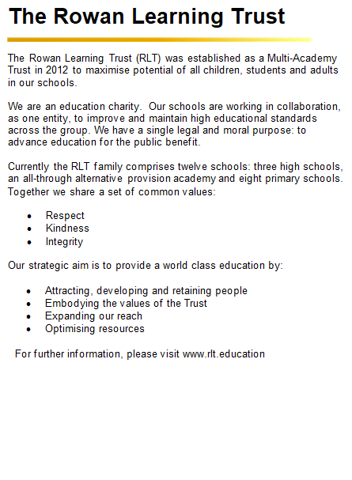
Kirkby High School
Kirkby High School is an 11-16 mixed comprehensive. All staff at Kirkby High School fully embrace our vision: “A community driven by high expectations and mutual respect providing all individuals with the belief and opportunities to succeed now and in the future”.
Kirkby High School stands at the centre of our local community and we believe that we offer our young people guidance and aspiration to be the best they can be in all aspects of life. Quality teaching and learning, supported by reliable pastoral systems, ensure that students are preparing well for later life.
We believe in building a culture of resilience and tolerance in which our students can thrive. Our aim is to increase our students’
self-belief and to show them that they can be what they want to be.
Confidence Kindness Aspiration Respect Resilience

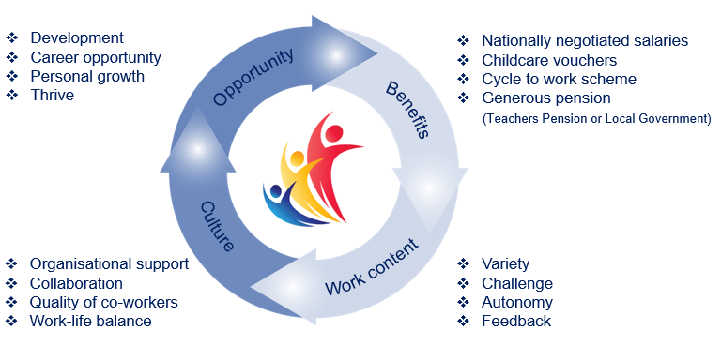

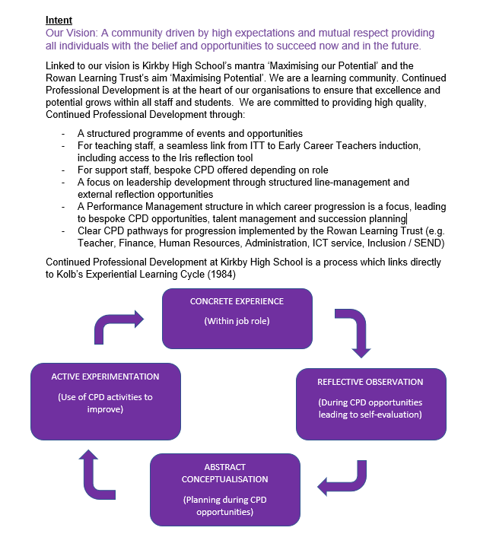

Continued Professional
Development Framework

Support for the Teacher

- Prepare the classroom as directed for lessons including the preparation of resources and tidying away.
- Assist with the movement around the school environment and during school activities.
- Assist with the display of children’s work.
- Provide clerical/admin support e.g. photocopying, typing, filing, collecting money.
- Manage student behaviour in line with school policy and ensure reports are made in agreed school format.
- Gather/report basic information from/to parents/carers as directed.
- Undertake pupil record keeping as required.
Support for the Curriculum
- Support students to process instructions.
- Support students in respect of local and national learning strategies e.g. Early Years, Primary National Strategy, KS3 as directed by the teacher.
- Support students in using basic ICT equipment as directed by the teacher.
- Prepare and maintain classroom equipment/resources as directed by the teacher and assist pupils in their use in accordance with the lesson plan.
Support for the School
- Be aware of and comply with school policies and procedures relating to child protection, health, safety and security, confidentiality and data protection, reporting all concerns to an appropriate person.
- Contribute to the school ethos, aims and development/improvement plan.
- Be aware of and support difference and ensure all students have equal access to opportunities to learn and develop, respecting their social, cultural, linguistic, religious and ethnic backgrounds.
- Work as part of a team, appreciating and supporting the role of other people in the team.
- Attend and participate in meetings as required.
- Assist with the supervision of students out of directed lesson time, including before and after school, if appropriate and within working hours.
- Undertake personal development through training and other learning activities including performance management as required.
- Undertake personal development through training and other learning activities including performance management as required.
- Assist with the organisation, routines and upkeep of the wider learning environment.
- Accompany teaching staff and pupils on visits, trips and out of school activities as required.

Job Description

Overall Purpose of the Post
- To work and supervise individual and groups of children under the direction of the teacher, inclusive of physical/social needs general care and basic classroom management techniques to support their learning.
Support for Students
- Support students to access the curriculum in line with appropriate lesson plan/teacher direction.
- Provide support and meet the needs of students in relation to welfare, health, hygiene, toileting, dressing, feeding, mobility and administering of medicines as required.
- Establish good working relationships with students, acting as a role model.
- Encourage students to act independently as appropriate.
- Be aware of and respond appropriately to individual student need.
- Encourage students to interact with others and engage in activities led by the teacher.
- Promote inclusion and acceptance of all students.
- Promote self-esteem and independence.
- To accompany students on visits.
- To administer basic first aid where appropriately trained.

Teaching Assistant
Reports to: Head of Inclusion Faculty
Location: Kirkby High School, Bracknell Avenue, Kirkby, L32 9PP
Salary: NJC Grade C/Grade D (depending on experience) scale
points 3–4 / 5-6 (pro-rata) plus SEN allowance

Grade C SCP 3-4 £25,614 - £26,016 plus SEN Allowance £1,590 pro rata
(Actual salary: £16,255 - £16,510 plus SEN allowance £1009)

Grade D SCP 5-6, £26,427 - £26,847 plus SEN Allowance £1,590 pro rata
(Actual salary: £16,770 - £17,037 plus SEN allowance £1009)

Hours: 27.5 hours per week, (9.10am-3.10pm), term time only
Person Specification
The successful candidate will possess the following personal attributes:

A commitment to safeguarding and equality

Communication & Influence
Conveys basic messages using a variety of media. Appears confident when communicating with others. Writes in a clear, factual and logical way. Avoids jargon, keeping to everyday language. Is able to provide constructive feedback on day-to-day issues in an appropriate manner.
Team working
Shows an interest in others, taking time and effort to get to know people and a willingness to help others. Does not work in isolation, sharing information and keepings others up to date. Takes time out to listen, explain and provide constructive feedback.
Organisational Awareness
Understands how own job contributes to the schools activities. Stays up to date with developments in school and discusses with colleagues their activities to gain a broad understanding.
Adaptability
Understands the need for, and the effects of, change and is able to adjust style and way of working taking others into account. Learns from experience.
Use of technology
Has knowledge of, and is able to use, the range of technology within own workplace (e.g. PCs including standard software, printers, photocopiers etc.) Has a willingness to remain proficient as the technological needs of the school change.
Professional Values and Practice
Demonstrates high expectations for all students.
Ability to build and maintain successful relationships with students, treat them consistently, with respect and consideration and demonstrate concern for them development as learners.
Ability to improve your own practice through observations, evaluation and discussion with colleagues.
Experience & Knowledge
Experience of working with and or caring for children.
Awareness and basic understanding of school curriculum.
Basic knowledge of First Aid.
Basic awareness of inclusion, especially within a school setting.
Qualification & Training
Have achieved or working towards a Level 2 (qualification in Numeracy/Maths and Literacy
Requirement to complete DfES Teacher Assistant Induction Programme
Please submit the enclosed application form and a supporting statement of no more than two sides of A4 outlining why you are interested in the opportunity and how your application addresses the requirements of the role.
Applications should be returned electronically to j.barrett@kirkbyhighschool.net
Alternatively, send a hard copy to:
Mrs A Dobson
Headteacher
Kirkby High School
Bracknell Avenue
L32 9PP

Closing date: 12noon, Friday 25th September 2026

How to Apply


The Trust will make any necessary reasonable adjustments to the job and the working environment to enable access to employment opportunities for disabled job applicants or continued employment for any employee who develops a disabling condition.
All appointments are subject to satisfactory references, proof of qualifications and eligibility to work in the UK.
The Trust is committed to safeguarding and promoting the welfare of all children and young people and expects all staff to share this commitment. An enhanced DBS check will be required.

The Trust will make any necessary reasonable adjustments to the job and the working environment to enable access to employment opportunities for disabled job applicants or continued employment for any employee who develops a disabling condition.
All appointments are subject to satisfactory references and eligibility to work in the UK.
The Trust is committed to safeguarding and promoting the welfare of all children and young people and expects all staff to share this commitment. An enhanced DBS check will be required.


The Rowan Learning Trust
Registered Office: 18 Beecham Court, Goose Green, Wigan, WN3 6PR
Company Number 8010464



KIRKBY HIGH SCHOOL

JOB APPLICATION FORM FOR SUPPORT STAFF IN SCHOOLS

The School and Governing Body are committed to equal opportunities in employment and welcome applications from all sections of the community.

KIRKBY HIGH SCHOOL

BRACKNELL AVENUE,

KIRKBY, MERSEYSIDE, L32 9PP

TELEPHONE: 0151 477 8710

- POST APPLIED FOR

Post Applied For:
School: | Kirkby High School
As advertised in: |  | On date:

2. PERSONAL DETAILS

SURNAME: |  | FORENAME:
TITLE:  (Optional) |  | Date of Birth:  (Optional)
Address:
POSTCODE: |  | Email:
Telephone No: |  | Mobile No:

3. CURRENT POST
CURRENT EMPLOYER AND JOB TITLE:
DATE OF APPOINTMENT: |  |  | SALARY:
NOTICE PERIOD:
MAIN DUTIES AND RESPONSIBILITIES
Reason for this application

4. EMPLOYMENT HISTORY
Post | Dates |  | Employer | Grade/Salary | Reason for Leaving
 | From | To

5. GENERAL EDUCATION
School | From | To | Qualifications – Grades, awarding bodies and dates

6. FURTHER AND HIGHER EDUCATION
Name of College/ University | From | To | Qualifications – Grades, awarding bodies & dates

7. ANY OTHER RELEVANT QUALIFICATIONS
Please give details of any other relevant qualifications you have for this post.

8. ADDITIONAL INFORMATION
Are you related to, or a close friend of, any member of the Trust or of the Governing Committee of the school? (If yes, please state relationship) | Yes / No
Have you left any previous job for the reason of redundancy or are you in receipt of an occupational pension?  (If yes, please give details) | Yes / No
Have you ever been dismissed from any previous employment on the grounds of misconduct or incapability?  (If yes, please give details) | Yes / No
Do you hold a current and valid driving licence?  (if yes, please state the category) | Yes / No
The Rowan Learning Trust is committed to providing equal opportunities and supporting all applicants. If you require any reasonable adjustments to allow you to participate in the application process, please let us know.
Do you require any reasonable adjustments? YES/NO

You should note that the disclosure of any offence will not necessarily prevent the Rowan Learning Trust from employing you, but we reserve the right to consider its significance in relation to working with children.

Work at the school is exempt under the Rehabilitation of Offender Act 1974. Any offer of appointment will be dependent upon the successful completion of the Disclosure and Barring Service (DBS) check at the Enhanced level.

Where serious concerns as to an individual’s suitability to work with children are expressed, the facts will be reported to the relevant authorities.
In line with Keeping Children Safe in Education (KCSIE) guidance, are you currently subject to any criminal investigation, police enquiry, arrest, charge, caution, conviction, or other matter that may be relevant to your suitability to work with children and young people?  If yes, please forward details (date, offence and sentence) with a covering letter, in a sealed envelope marked “Addressee Only – Headteacher”. | Yes / No
Do you have any adult cautions (simple or conditional) or spent convictions that are not protected as defined by the Rehabilitation of Offenders Act 1974 (Exceptions) Order 1975 (Amendment) (England and Wales) Order 2020? | Yes / No
In line with Keeping Children Safe in Education, The Rowan Learning Trust will undertake general online searches for all shortlisted candidates which may include social media and video platforms. Online searches will only examine data which is publicly available, and the aim is to identify any incidents or issues. Any areas of concern will be discussed during the interview process.

9. STATEMENT IN SUPPORT OF APPLICATION
Please include a supporting statement, indicating any matters which you feel may be relevant to this application. Please head additional documentation with your name and post applied for.

10. REFERENCES
Please state the names and addresses and telephone numbers of two persons from whom references may be obtained. One must be your current or most recent employer. In the absence of previous employment experience, a reference from your last place of full-time education will be a suitable alternative.

REFEREE 1 |  | REFEREE 2
TELEPHONE NO: |  | TELEPHONE NO:
EMAIL: |  | EMAIL:
Can this reference be taken up immediately  YES/NO |  | Can this reference be taken up immediately  YES/NO

11. FURTHER INFORMATION FOR CANDIDATES

- You will receive no further communication unless selected for interview. If you have therefore not been contacted within three weeks of the closing date for applications, you should conclude that, unfortunately, you have been unsuccessful on this occasion.
- In the interests of the protection of children, all posts are subject to enhanced criminal record and other relevant disclosures through the Disclosure & Barring Service (DBS). A criminal record will not necessarily prevent you from obtaining a position.
- Under the Data Protection Act, the Trust and the Governing Body will use the information given for the purpose of recruitment and selection. Strict confidentiality will be observed and if you become an employee, the information will be used for personnel, pay and pensions administrative purposes only.
- To comply with the Asylum and Immigration Act 1996 (as amended by S.147 of the Nationality, Immigration and Asylum Act 2002), all prospective employees will be required to supply evidence of eligibility to work in the UK. If you are appointed to the post you will be provided with further information detailing what documents will be required.

THANK YOU FOR YOUR INTEREST SHOWN IN THIS APPOINTMENT

12. DECLARATION

To the best of my knowledge and belief all the particulars I have given are true. I understand that any false statements may disqualify me from employment or render me liable for dismissal. I also understand that no offer of employment made to me will be binding unless confirmed in writing.

I also understand that this post is subject to a satisfactory enhanced Disclosure & Barring Service Disclosure, to satisfactory medical clearance and the provision of documentary evidence (e.g. NI Number) that shows I am entitled to work in the U.K.

Signature:……………………………………………………………………………Date:………………

