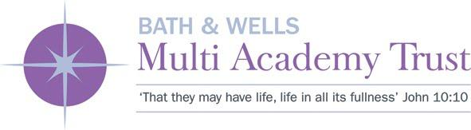**Bishops Lydeard Church School  
Mount Street, Bishops Lydeard, TA4 3AN**

01823 432582

enquiries@bishopslydeard.bwmat.org

Bishops Lydeard Church School and The Bath & Wells MAT is committed to safeguarding and promoting the welfare of children, young people and vulnerable adults and expects all staff and volunteers to share this commitment. The post is subject to an enhanced DBS and all relevant pre-employment checks.

NOR: 153, Age range: 4-11

**TEACHING ASSISTANT**

**Fixed Term until 31/08/2025**

**15 hours per week**

**Grade 15 £23,656 - £24,404 pro rata**

**£8,001.92 - £8,254.94 actual pay**

*Our vision of ‘Life in all its fullness’ runs through all that we do and seek to achieve. We have high expectations for the children’s progress and development both academically and emotionally. Our values of ‘Respect, Endurance and Friendship’ are also central to our culture and ethos and are a very much lived experience.*

We are an inclusive and caring school at the heart of a thriving local village community.

Is this the sort of school you would like to work in? If so, read on….

This post requires positivity, dedication, reflection, and a heart to see children live life in all its fullness. You should have the understanding of how to form good working relationships with children and have insight into developing social and emotional skills. You should have the ability to inspire and motivate children and be confident in using your own initiative within school policies and expectations.

The successful candidate will need to:

* show commitment to high standards for all pupils in both learning and behaviour
* be responsive to the children’s needs, socially and emotionally and academically
* hold safeguarding for all at the forefront of responsibilities
* work proactively and effectively within the wider school team and contribute to the wider life of the school
* get pleasure from and be enthused by seeing all around them succeed

We can offer:

* Welcoming children with eager minds
* Dedicated professionals who readily support each other (and all children)
* A commitment to your professional development
* Parents who are supportive of their children’s needs
* A strong Christian ethos

This post will commence as soon as possible

Benefits of working for the Bath & Wells MAT include; a generous pension scheme, enhanced sickness and parental benefits and a supportive working environment.

To apply please send completed application forms to Tracey Fillingham at enquiries@bishopslydeard.bwmat.org

For informal enquires please contact the school office

***Closing date*** ***Interview date***  
*9am on Friday 31 January 2025* *w/c Monday 3 February 2025*