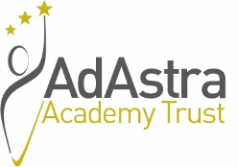
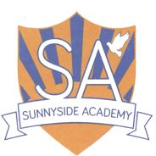

SUNNYSIDE ACADEMY

Manor Farm Way, Coulby Newham, Middlesbrough, TS8 0RJ

Teaching Assistant - based in the specialist Key Stage 2 Higher Needs Base (Band 6) Spinal Column Points 6 – 7 Salary £21,240.07 - £21,578.42 per annum. 35 hours per week, term time only including PD days (195 days per year). Permanent.

We are a large mainstream primary school situated in Coulby Newham with three support bases for children with a Deaf/Hearing Impairment, children with a Visual Impairment and children with moderate learning difficulties. The successful applicant will work alongside a dedicated team within the Higher Needs Base. This position will commence as soon as possible.

The successful candidate will work with teachers to support teaching and learning by working with individuals and/or small groups of pupils, adjusting activities within set parameters under the direction, guidance and supervision of teaching staff. The successful candidate will also have responsibility to provide short term emergency cover by supervising classes.

Candidates should be suitably qualified and experienced, possessing a NVQ level 3 or equivalent and having worked as a classroom or teaching assistant within a primary school, for a minimum of 12 months, together with having experience of supporting learners with SEND and be able to meet the criteria detailed on the person specification.

For an informal discussion about this position please contact Julie Sutton, Headteacher on 01642 596422 or via Julie.Sutton@sunnyside.adastraschools.org

Sunnyside Academy is committed to safeguarding and promoting the welfare of children and young people and expects all staff and volunteers to share this commitment. As such the successful candidate will be required to undergo an enhanced DBS check.

This post is exempt under the Rehabilitation of Offenders Act 1974 (Exceptions) Order 1975 (2013 and 2020).

Requesting an application form

Application forms and further details are available via the Ad Astra website:

https://adastraschools.org/careers/

Completed application forms to be emailed to recruitment@adastraacademytrust.com

Candidates must only apply using the application form provided; CV’s will not be accepted.

Closing Date – 9am on Monday 10th November 2025
Interviews to take place in the week commencing 17th November.

