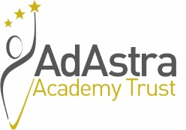
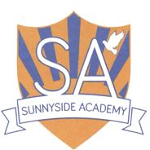

SUNNYSIDE ACADEMY

Manor Farm Way, Coulby Newham, Middlesbrough, TS8 ORJ

Teaching Assistant – Behaviour Support (Band 5) SCP 5, £15,988.09 per annum. 35 hours per week, term time only including PD days (195 days per year). Permanent.

Sunnyside Academy wishes to appoint an enthusiastic and committed Teaching Assistant to support positive pastoral provision. This position would be to start on 1st September 2022.

Sunnyside Academy is a large primary school situated in Coulby Newham with 317+ pupils from the surrounding area. The school also has special needs bases for children with sensory impairment and for children with moderate learning difficulties.

The successful candidate will work with teachers to support teaching and learning by working with individuals and/or small groups of pupils, adjusting activities within set parameters under the direction, guidance and supervision of teaching staff.

Candidates should be suitably qualified and experienced, possessing a NVQ level 2 or equivalent and having worked as a classroom or teaching assistant within a primary school, for a minimum of 12 months, together with experience of supporting learners with SEND and be able to meet the criteria detailed on the person specification.

Candidates must only apply using the application form provided; CV’s will not be accepted.

For an informal discussion about this post please contact Julie Sutton, Headteacher on 01642 596422.

Sunnyside Academy is committed to safeguarding and promoting the welfare of children and young people and expects all staff and volunteers to share this commitment. As such the successful candidate will be required to undergo an enhanced DBS check.

This post is exempt under the Rehabilitation of Offenders Act 1974 (Exceptions) Order 1975 (2013 and 2020).

Requesting an application form

Application forms and further details are available via the Ad Astra website:

http://www.adastraacademytrust.com/careers/

Completed application forms to be emailed to recruitment@adastraacademytrust.com

Closing Date – 9am on Wednesday 8th June 2022
Interviews to take place on Thursday 16th June 2022

