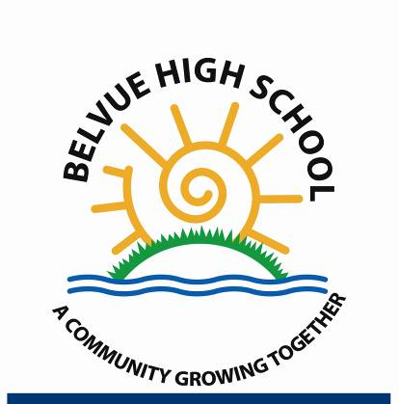

Rowdell Road Northolt, UB5 6AG
Tel: 0208 845 5766

Belvue School and Year 7 at Carr Road, Northolt (Roll: 230, secondary special school for young people aged 11-19 with MLD or SLD and a range of additional needs) Headteacher: Mrs Sana Bhopal www.belvueschool.com

5 x Teaching Assistants
Grade 5 Teaching Assistant (1 Year Fixed Term Posts)
32.5 hours per week term time only,
Grade 5 Scale point 12 - 15 (£31,665 -£33,072) pro rata salary of £26,123 - £27,284
Start Date: September 2025

Belvue School is a secondary special school for young people with moderate and severe learning difficulties. We also have Key Stage 3 Year 7 pupils situated in Carr Road, Northolt. We are committed to providing an outstanding and inclusive education for the young people and have a positive and stimulating environment with a range of wonderful learning opportunities. We offer a very broad and yet personalised curriculum in order to meet the needs of each learner and allow them to achieve their potential. The school has exceptional outdoor and woodland learning spaces and strong community partnerships.

You must be passionate about working with young people with special needs, an ability to relate well to children and adults, to be able to demonstrate ability to liaise with pupils sensitively and effectively, encourage with their learning and to work under the supervision, instruction and guidance of the class teacher and assist in creating a supporting learning environment. Have high levels of energy and enthusiasm to inspire and motivate young people to learn and thrive. You must possess excellent communication and personal skills, and be able to build supportive and trusting relationships with pupils, families and colleagues.

In return you will be joining a creative and professional staff team and you will find your role challenging, stimulating and rewarding. The school is committed to CPD which will ensure that you develop professionally. You will receive mentoring, professional support, effective feedback and opportunities for reflection.

Closing Date for applications: Friday 11th July 2025 at Noon
Interview Date: Wednesday 16th July 2025

You can find out more about working at Belvue School and how to apply at https://www.belvueschool.com/join-the-team

This post is advertised on our school website, Ealing Jobs Website and Government Education Vacancies website, all applications must be submitted to our HR Manager email: victoriaom@belvue.ealing.sch.uk CV’s will not be accepted.

Belvue School is committed to upholding the highest possible safeguarding standards and follows safe recruitment practices to protect children and vulnerable adults. This role involves safeguarding responsibilities. All staff at Belvue School must adhere to statutory guidance, or safeguarding policy and staff code of conduct in order to fulfil these responsibilities. The Successful candidate will be required to apply for an Enhanced Disclosure from the Disclosure & Barring Service. Further information can be found at www.gov.uk.

Also in line with KCSIE 2024 and safer recruitment practices, the school will conduct an online search for all shortlisted candidates. The online search is part of our safeguarding checks and will seek publicly available information on candidates’ suitability to work with children. Shortlisted candidates will be provided with further guidance and will be asked to clarify their online presence

This post is exempt from the rehabilitation of offender’s act 1974, which provides that when applying for certain jobs and activities certain spent convictions and cautions are protected so that they do not need to be disclosed. Shortlisted candidates are required to complete a self-declaration form. It is an offence to apply for this role if the applicant is barred from engaging in regulated activity relevant to children. For roles that involve regulated activity with vulnerable adults an adult barred list check is conducted. For further information for regulated activity with adults please look here

