Candidate Information Pack
Teaching Assistant

Contents
About the Trust | 1
About us | 2
Our vision and values | 3
Working at Bishop Alexander Academy | 4
Benefits of being part of L.E.A.D. Academy Trust | 6
How to apply | 8
Job description and Person specification | 9

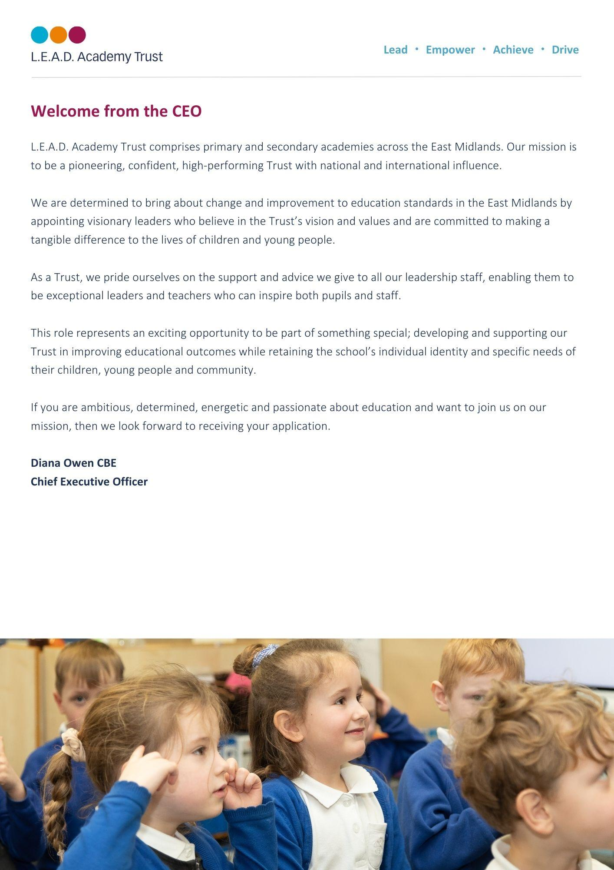
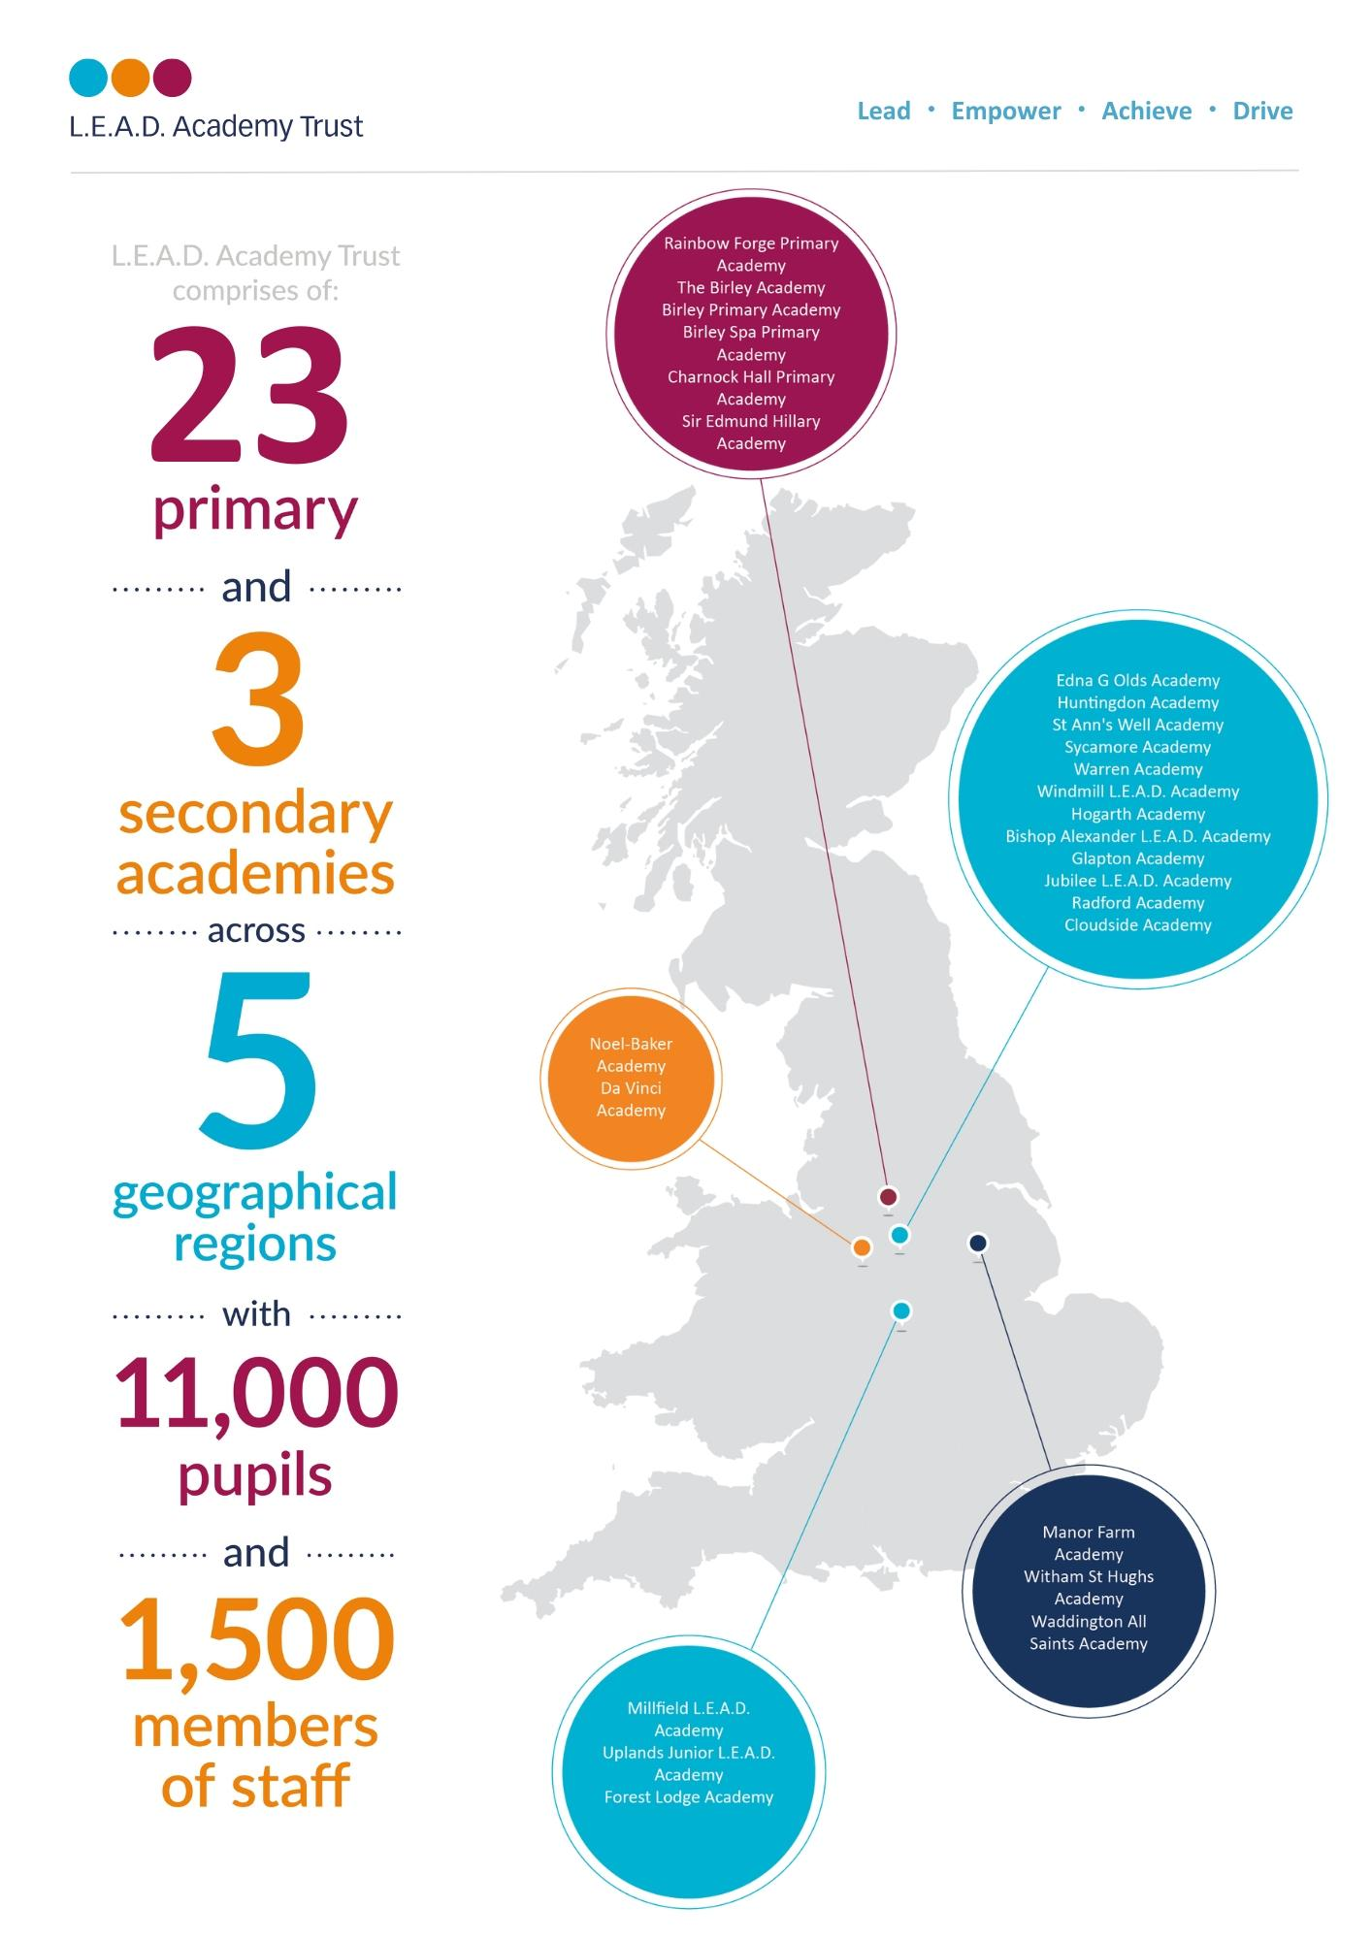
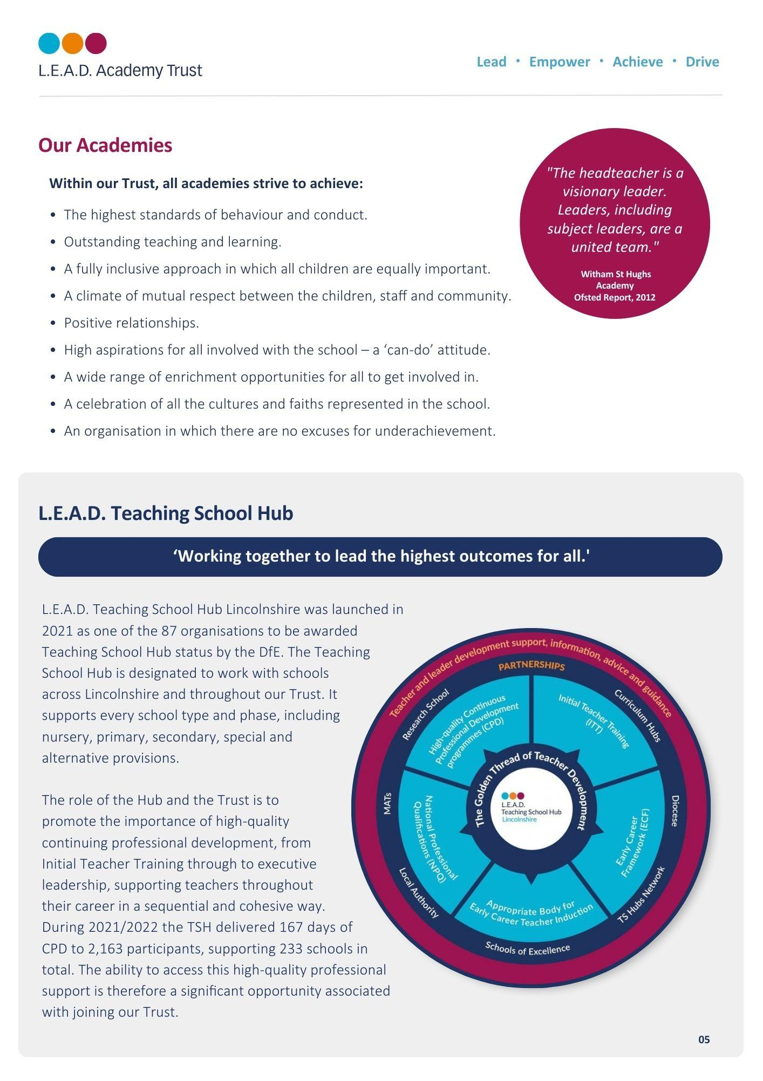

A message from the Headteacher
HEADTEACHER IN THIS SPACE.
YOU MAY NEED TO WRAP THE TEXT AROUND USING THE WRAP FUNCTION
Thank you for your interest in this role.
I am proud to have been the Headteacher of Bishop Alexander Academy for 10 years, and consider myself lucky to work with remarkable pupils, dedicated staff and supportive families. The people are what makes this academy special!
The pupils are enthusiastic and committed to their learning and show resilience and aspiration in all they do. They understand the importance of making mistakes and recognise these as learning opportunities. They show care for each other, but also for other members of the community. We firmly believe that this school belongs to the pupils’, and their voice plays an essential part in the development of the academy. Pupils also undertake roles of responsibility such as Subject Ambassadors, Lunchtime Leaders Headteacher Mrs Nicky Spencelayh
and Active Citizens.

We have a highly committed team of staff, who inspire and care for our pupils. Our parents say, ‘they are approachable staff’ and provide a place in which ‘their children flourish’. All staff are proud to be members of the Bishop Alexander team.
We believe that our pupils deserve the best education possible, and this is only possible through talented and well trained staff. They have a wealth of CPD opportunities both within the academy and through L.E.A.D Teaching School Hub. Staff say they value these opportunities to develop.
The school is fortunate to have a strong and supportive Governing Body, who share our commitment to further strengthen teaching and learning and ensure that all children reach their full potential. They also share a keen interest in the staff and their welfare.
I strongly encourage you to visit the academy, and see our caring, yet challenging, ethos in practice.
About Bishop Alexander Academy
We are a one-form entry academy with 220 pupils, which consists of a modern school building with extensive grounds. There is a diverse community, with 13 different home languages spoken, and pupils come from a range of backgrounds. We are passionate about pupils being able to ‘see’ themselves in our curriculum, and we pride ourselves on our inclusive ethos.
Our curriculum follows a two year cycle and starts literally ‘on our doorstep’, in that it is about our local community and Newark itself. We feel that the children need a sense of belonging and pride in where they live, before they learn and appreciate the wider world. Our curriculum themes are carefully chosen and
reflect the needs of our pupils. The whole school follow the same theme and come together
at the end for a common purpose.

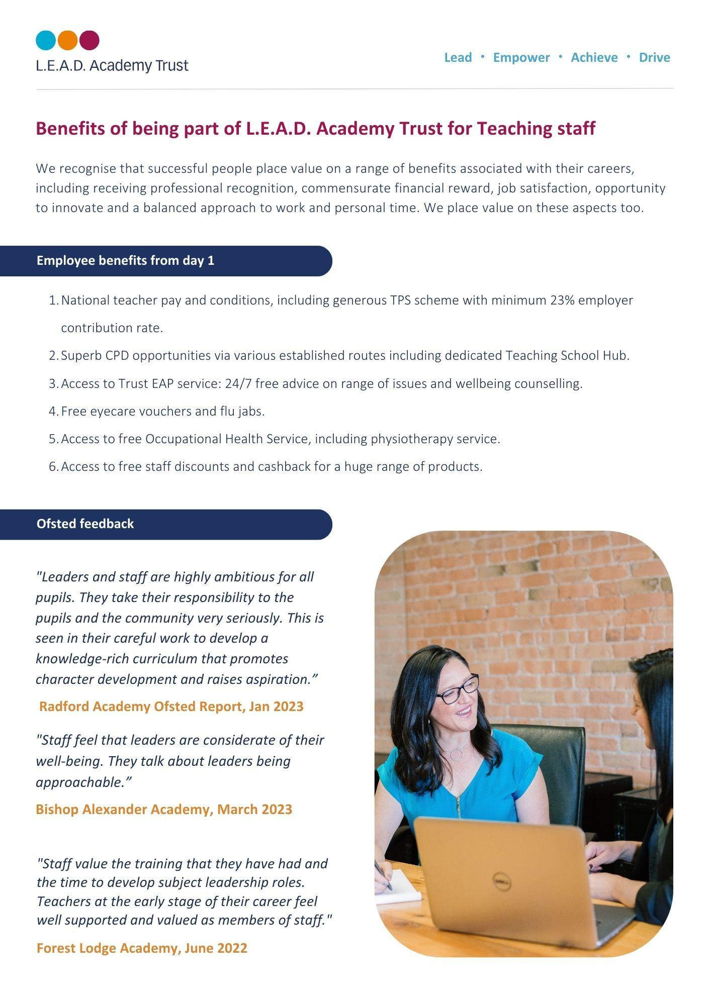

OFSTED March 2024:

“Pupils feel happy and safe at this school.
Parents who shared a view described a welcoming environment,
approachable staff and a place in which their children flourish.”

How to apply
Please send a completed application form and covering letter explaining your interest in the role and how you meet the person specification to : sallyh28@bishopalexanderacademy.co.uk
CLOSING DATE: Friday 5th July 2024
INTERVIEWS: We expect interviews to take place Tuesday 9th July 2024

Applications will be reviewed upon receipt, therefore shortlisted candidates may be contacted in advance of the closing date.
L.E.A.D. Academy Trust is committed to safeguarding and promoting the welfare of children and young people and we can expect all staff and volunteers to share this commitment. This post is subject to an enhanced DBS check.
For an informal, confidential discussion about this opportunity, please email: Mrs Sally Hade at sallyh28@bishopalexanderacademy.co.uk
Job description
Key responsibilities and accountabilities
Full Time Teaching Assistant

Working Hours: 37 hours per week

Salary: NJC 7-12

Start Date: September 2024

- To work with children as part of a team under the overall direction of the Headteacher who will be responsible for the policy and educational programme and for matters of control and discipline within National Curriculum Framework.
- To foster the participation of pupils in the social and academic processes of the school by recognising individual pupils’ needs and identifying and implementing appropriate responses under the overall management and guidance of the class teacher.
- To work independently in accordance within guidelines in order to encourage pupils to become more independent learners and help to raise the standard of achievement and attainment for all pupils.
- Activities undertaken by colleagues at this level would be monitored by the class teacher or more senior colleagues and the content of learning activities would be planned by the teacher/more senior staff, although there would be an expectation that the post holder would contribute to this process.
- To be aware of your responsibility for promoting and safeguarding the welfare of young persons whom you have contact with during the course of your duties.
Key Duties
- Assist the class teacher in the planning and evaluation of teaching and learning activities.
- Provide support to individuals and groups on teacher planned activities to enable them to access the curriculum, whilst monitoring progress and dealing with challenges as they arise.
- Through effective learning strategies, support all pupils to participate in learning activities. This will involve being aware of pupils’ needs, using appropriate equipment and materials and modifying resources as necessary to support pupils to participate and progress.
- Contribute to the implementation of an effective behaviour management strategy, applying it fairly and consistently within clear boundaries and reinforcing positive aspects of behaviour.
- Develop positive relationships with parents, carers and families by taking a partnership approach, maintaining and sharing accurate information where appropriate.
Support for the Pupil
- Support learning activities for all pupils by maintaining awareness of the stages of development and individuals’ specific needs and giving positive encouragement and feedback to ensure pupils are reaching their full potential.
- Care and support pupils by providing a safe and secure environment, responding appropriately to accidents, emergencies and following established procedures wherever appropriate.
- Contribute to the health and well-being of pupils through the support of safeguarding for pupils by ensuring a safe environment, and following policies & procedures at all times.
- Develop and promote positive relationships with pupils by communicating effectively, allowing them to feel valued and listened to and encouraging questions and ideas.
- Assist with the personal and intimate care of pupils.
- To support children and young people with SEND, supporting them to actively participate in learning activities. To liaise with parent/carers/outside agencies as required.
Support for the Teacher
- Contribute to the planning and evaluation of teaching and learning activities by being clear of own role in delivery, sharing realistic ideas, offering constructive suggestions and giving feedback where appropriate.
- Support with the delivery of learning activities in the absence of the teacher, e.g. when providing cover supervision or working with pupils outside of the classroom; however learning activities should take place under the direction and supervision of a qualified teacher in accordance with arrangements made by the Headteacher of the school.
- Working alongside the class teacher to ensure that learning resources and materials are ready for use in activities whilst recognising and minimising potential hazards and making adjustments where necessary.
- Escort and supervise pupils on educational visits and out of school activities.
Support for the Curriculum
- Support pupils in activities to develop their literacy and numeracy skills by having an awareness of individual needs, learning targets, and the relevant support required to assist pupils’ development, offering encouragement and feedback where appropriate.
- Prepare and effectively use ICT within the classroom environment to support and promote pupils’ learning in ways that are stimulating and enjoyable for pupils according to age, needs and abilities.
Support for the School
- Develop and maintain effective working relationships with other practitioners, drawing on their strengths and expertise in order to best support teaching and learning.
- Support children and young people through transitions that occur in their lives, enabling them to manage them in a positive manner.
- Willingness to keep up to date with professional practice by maintaining an up-to-date understanding of the requirements of the role and individual responsibilities.
- Contribute to maintaining accurate pupil records following relevant procedure and ensuring confidentiality at all times.
As job descriptions cannot be exhaustive, the post-holder may be required to undertake other duties which are broadly in line with above key responsibilities.
The Trust is committed to safeguarding and promoting the welfare of children and young people and expects all staff and volunteers to share this commitment and individually take responsibility for doing so.
At L.E.A.D we have a strong vision and four core principles, to lead, empower, achieve and drive, which you will be expected to demonstrate in your working practices.
- At L.E.A.D we have a strong vision and four core principles, to lead, empower, achieve and drive, which you will be expected to demonstrate in your working practices.
Person specification
The person specification listed below outlines the competences, knowledge and behaviour of candidates who would be suitable for this role. The two right-hand columns provide guidance as to whether these items are essential (E) or desirable (D) criteria.
Qualifications and Attainments | - GCSE pass level or equivalent qualifications in maths/numeracy & English/Literacy or significant demonstrable experience in a similar role  - Hold a relevant qualification as listed below or significant demonstrable experience in a similar role | E  E
Skills and Knowledge | - Knowledge of Teaching Assistants’ contribution to raising standards by the promotion of independent learning  - An appreciation of the National Curriculum and how it is applied to planning, preparation and delivery of learning activities  - Knowledge and understanding of pupil assessment, progress, evaluation and reporting of attainment  - Understanding and awareness of individual needs and ability to adjust communication methods accordingly  - Developed communication skills, both orally and in writing  - Ability to establish positive relationships with pupils, families and colleagues  - Awareness of techniques necessary to support individual learning needs and development  - Initiative in dealing with day to day issues  - Ability to contribute to the planning and delivery of learning activities  - Knowledge of stages of child development and individual needs  - Knowledge of appropriate behaviour management practices  - Knowledge of Health and Safety policies and procedures that contribute to the maintenance of pupil safety and security  - Knowledge of safeguarding procedures and protocols  - Ability to organise classroom resources and assist with the maintenance of pupil records | E  E  E  E  E  E  E  E  E  E  E | D  D  D
Experience | - Experience of working within an education setting or equivalent  - Direct experience of working with pupils to raise attainment through personal intervention  - Proven experience of working with children and young people, including children with individual needs and from a range of backgrounds  - Innovative use of resources and materials including ICT software and equipment  - Relevant experience of building positive relationships with all stakeholders  - Understanding the role of parents/carers and the wider community in education  - Experience of working with children or young people with SEND | E  E  E  E | D  D  D
Personal Attributes | - Have an openness to learning and change  - Have a positive attitude to personal development and training  - Be able to work in ways that promote equality of opportunity, participation, diversity and responsibility | E  E  E
Additional Requirements | - This role is subject to an enhanced DBS  - May be required to work out of school hours to support the Academy | E  E

Teaching Assistant Qualifications

Level 3 Certificate and Diploma in Supporting Teaching and Learning (STL)
Level 3 NVQ Supporting Teaching and Learning (STL)
Level 3 NVQ Childcare Learning and Development (CCLD)
Level 3 CACHE Diploma in Childcare and Education
Open University Certificate in Early Years Practice
Relevant Foundation Degree (relating to childcare and education)
QTS
Relevant degree in education studies accompanied by demonstrated practical experience as detailed in the person specification above.
National Nursery Nursing Board Award (NNEB)
BTEC National Learning Support
Children’s Care and Education Diploma (CCE)
NVQ Level 3 in Early Years and Childcare
NVQ Level 3 Caring for Children and Young People
Open University Specialist Teaching Assistant Certificate (STAC)
Specialist Teaching Assistant Award (STA)
City and Guilds Certificate in Learning Support combined with NCFE
3563 Special Needs Assistant Qualification
NVQ3 Teaching Assistant

Email address:
office2@bishopalexanderacademy.co.uk
Phone number:
01636 680040

