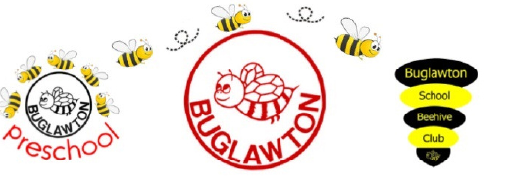
Buglawton Primary School
Job Specification for Teaching Assistant
Requirements | Essential | Desirable
Qualifications | - NVQ Level 3  - English and maths GCSE Grade C or 4 and above. | - SEN related courses.  - Evidence of further professional development.
Experience | - Classroom experience within primary education.  - Experience of working as a team. | - Experience of working in Early Years.
Curriculum | - Knowledge of the National Curriculum. | - Experience of adapting the curriculum and developing programmes for individual pupils.
Interpersonal | - Excellent interpersonal skills.  - Calm, warm, caring approach.  - A sense of humour.  - Ability to work within a team and encourage team spirit.  - Willingness to attend further training if required.  - Commitment to the ethos and life of the school.
Wellbeing | - Be able to demonstrate compassion and empathy with all children.  - Ability to supervise individuals or groups of pupils both in and out of the classroom to ensure their safety and facilitate their social and emotional development. | - Experience of providing children with programmes of social and emotional literacy.  - Experience of implementing a wide range of behaviour management strategies.
Parent/Carers/  Community | - Ability to communicate sympathetically with parents/carers. | - Experience of liaising with other agencies.  - Ability to foster interest and participation in the community.

