EAST SUSSEX COUNTY COUNCIL Danehill CE Primary
School Lane
Danehill
Haywards Heath
East Sussex
RH17 7JB

Headteacher: Lizzie Overton Tel: 01825 790388 Fax: 01825 790795
Email: office@danehill.e-sussex.sch.uk

29th September 2021

Dear Applicant

Thank you for your interest in applying for the post of Teaching Assistant at Danehill Primary School.

We are a small school set within the Ashdown Forest, an area of outstanding natural beauty.
We are looking for someone who is able to take on the above role to work for 18.75 hours a week Monday – Friday (term time only). The hours would be 08.30 – 12.15.

We are developing an innovative approach to Primary Education and would strongly encourage that you visit the school before applying in order to ascertain whether our ethos is one that you would be keen to support. Please contact the school office to arrange a convenient time for this.

Yours sincerely

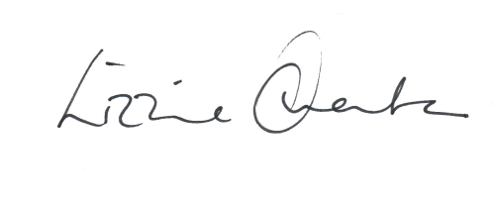

Lizzie Overton
Headteacher

