
Eldene Nursery & Primary School

We are an inclusive school based in the heart of the Eldene Community.

We treat staff with respect and invest in your career.

- We invest in your wellbeing – we want you to do well here.

Salary: Grade J/K (dependent on experience)
Contract: Permanent
Hours: 25 hours per week (9:00am to 3pm, Monday to Friday)
Start Date: As soon as possible
Application deadline: Friday 28th August
Interviews: w/c 7th September

We respect our staff: At Eldene you will be part of a friendly, supportive team that values collaboration, professional growth and staff wellbeing.

We prioritise wellbeing: We have a dedicated wellbeing team and actively encourage a healthy work-life balance, offering support, wellbeing initiatives and opportunities to connect with colleagues.

We celebrate diversity and inclusion: We are proud of our diverse school community and are committed to ensuring every child and adult feels valued, respected and able to succeed.

We prioritise wellbeing with a dedicated wellbeing team: The wellbeing of staff at Eldene is paramount to maintaining a successful and forward-thinking school. We believe that the best asset in school for children are staff who are happy, motivated and focused. Eldene recognises that staff are our most important resource and are to be valued, supported and encouraged to develop personally and professionally. We have a Wellbeing Team who champion staff mental health and togetherness. We promote staff events where we can mix, relax and support each other. From Wellbeing breakfasts to drop-in sessions - we've got it covered!

We celebrate Diversity, Equity & Inclusivity: Eldene is proud to be a richly diverse community where equity, inclusion and belonging are at the heart of everything we do. We celebrate the different cultures, languages, faiths and experiences of our families - this diversity is a strength that enriches learning for all. Our curriculum reflects the world our children live in, ensuring every child can see themselves represented and valued, while our inclusive practices support all learners to thrive. We are committed to fair opportunities, high expectations and mutual respect. We actively promote a culture where every voice is heard and everyone feels safe, welcomed and empowered to
succeed.
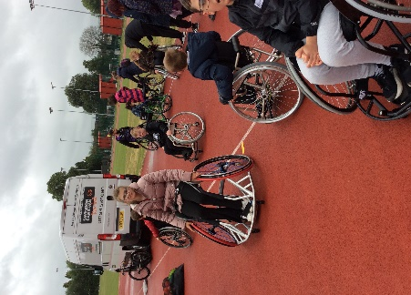
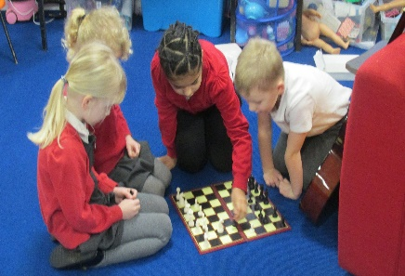
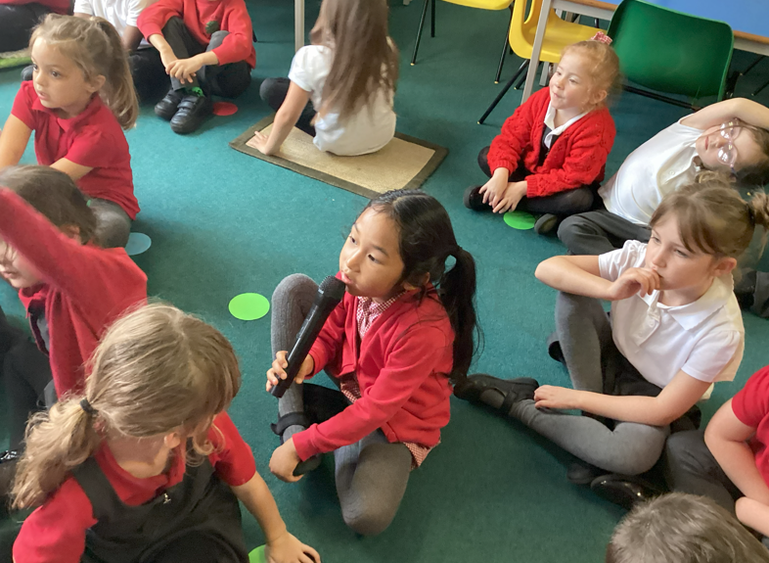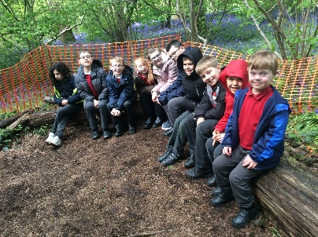



About the Role
We are looking for a caring, enthusiastic and adaptable Teaching Assistant to support pupils with a variety of needs. This rewarding role will involve supporting children both within the classroom and through targeted interventions, helping them achieve their full potential academically, socially and emotionally.
The successful candidate will be flexible and willing to work across Early Years, Key Stage 1 and Key Stage 2 according to the needs of the school. The role may involve providing 1:1 support for pupils with complex SEND needs, including children communication, Social, Emotional and Mental Health, sensory, physical and learning needs.
The postholder must also be willing to provide personal and intimate care where required, following appropriate training and school procedures.

Here’s what we are looking for someone:
- who enjoys working with children and is passionate about helping them succeed
- with high expectations for all pupils
- who can build positive relationships with children, families and colleagues
- who is patient, nurturing and resilient
- who is flexible and willing to work across different year groups
- who is confident supporting pupils with a range of additional needs
- willing to provide intimate care and support pupils with complex SEND needs
- committed to safeguarding, inclusion and equality

We can offer you in return…
- a supportive and welcoming team
- opportunities for training and professional development
- a wellbeing focused workplace
- a valued role contributing to pupil development

It’s worth looking at our website: Eldene Nursery & Primary School - Home

We look forward to welcoming you to Eldene!


Clare Pellew
(Headteacher)

Visits to the school are welcomed:
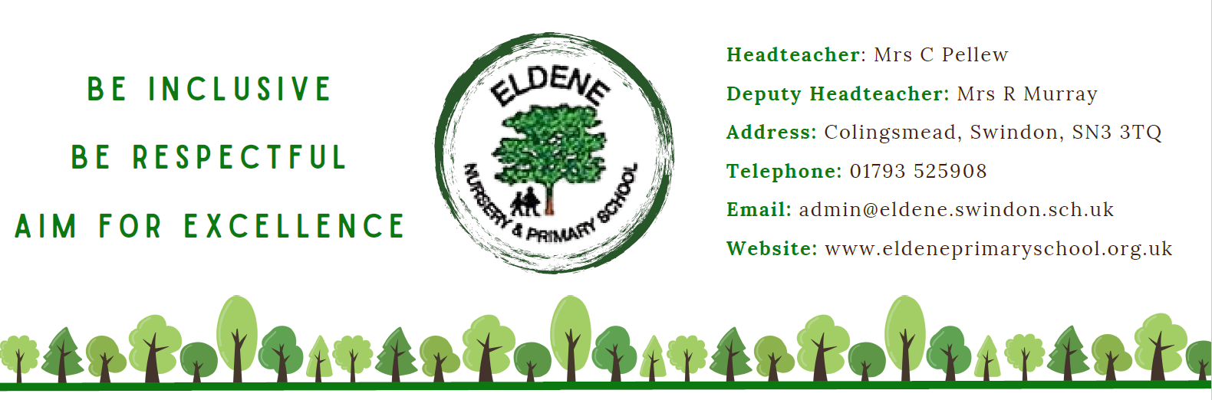
Please contact us on 01793 525908 or email admin@eldene.swindon.sch.uk

