Keighley St. Andrew’s CE Primary School
Fixed Term Teaching Assistant (KS2)
30 hours per week
To commence as soon as possible
Fixed term until 31st August 2022
Applicant Pack

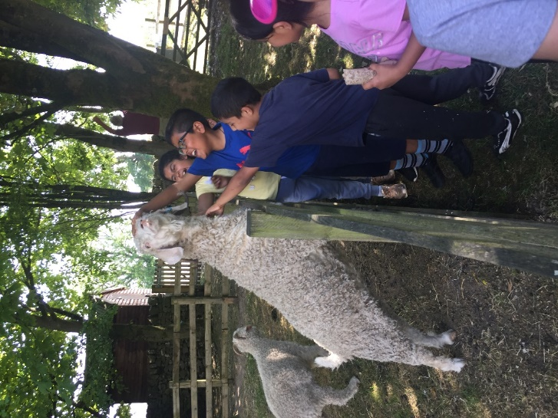

Contents
Head’s introduction
What’s it like to develop at Keighley St. Andrew’s
Our School
Our Curriculum
Recruitment / Application Details

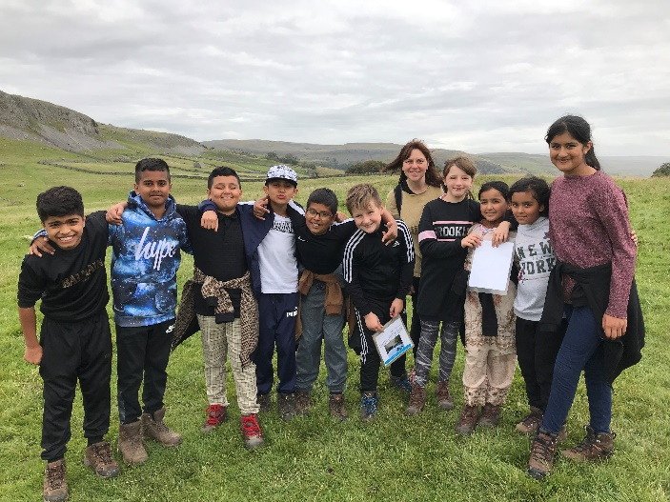
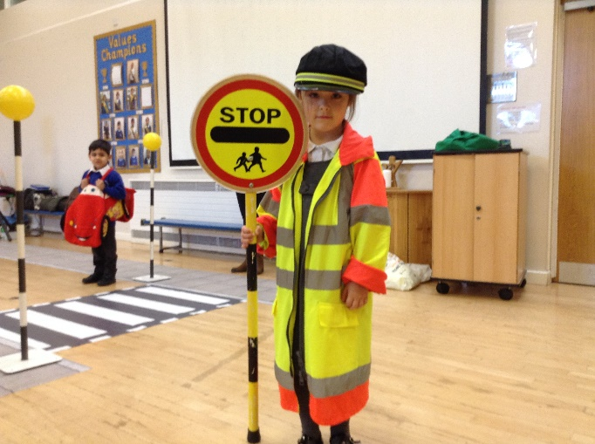

Introduction from the Headteacher
Thank you for showing interest in the role of teaching assistant at Keighley St. Andrew’s.
I am incredibly proud of our school community- Our children, staff (including governors) and parents. Together, we strive hard to create a wonderful place to learn and flourish. Our vision is rooted in our Christian ethos and shared school values of: Thankfulness, Peace, Community, Trust, Courage and Compassion.
Our School Vision: Guided by God, we will create a community of learners who will flourish and be filled with hope.
As a school community, we are committed to providing all learners with the skills, knowledge and experiences, which will enable them to flourish academically and personally. We value parent partnership and the contribution that parents can make to their child’s education.
Every day is a learning opportunity – whether child, parent or member of staff. We offer regular opportunities to develop home/school partnerships through a varied programme of events and courses to support learning and well-being (for both children and adults). Our staff also receive ongoing training and development so that they are also equipped with the skills to provide your children with the very best education and experiences.
We strongly encourage visits to school and are holding an open morning for prospective applicants on Tuesday 2nd November so that you can come along and find out more about us. If you wish to attend please email your name recruitment@standrews-primary.co.uk or telephone Mrs Eden / Miss Hanif on 01535 604656.

Email: recruitment@standrews-primary.co.uk
Phone: 01535 604656
Website: www.standrews-primary.co.uk

Mrs Rachel Whitham
Headteacher

What’s it like to Teach and Develop at Keighley St. Andrew’s?
Don’t take it from me… Here’s what our teachers and aspiring leaders say:

Keighley St Andrew’s has consistently and proactively supported me in my professional development. I began my teaching career here as a Teach First participant. I received amazing support throughout my unqualified and NQT years, invited to attend a wide range of training courses and actively encouraged to trial the techniques I learnt on them and share these with my colleagues, delivering my first staff meeting in my first year as a teacher – scary but immensely valuable for my confidence and professional development. This professional development is something that has continued throughout my time at KSA. Once qualified, I was fully supported to pursue a two-year Masters degree, and given the encouragement and flexibility I needed to complete this to my full potential. Taking into account my desire to move into middle leadership, I was encouraged by leaders to apply for a middle leadership programme, which I have been completing during this academic year. The support and engagement I have felt from my colleagues and leaders while on this programme has been incredibly encouraging and motivating, and has really made a difference to an area of our school curriculum. As part of this course, I was offered the opportunity to attend a 9-day residential at the STEM learning centre, an opportunity that has significantly contributed to my development as a subject leader. This year, I was also given the opportunity to transition from year 5 to Early Years, and although initially nervous about this significant change, the support I received has made the experience a really positive one. Overall, the support, encouragement and opportunities I have received at KSA have helped me develop both personally and professionally. I look forward to the future opportunities that working in this school holds for me.

I joined the Keighley St Andrews team in June 2018, since then I have flourished in both my self-confidence and my career development. With encouragement from Senior Leadership and the school Governors, I have been able to develop my career in education, enrolling in a part time university degree in teaching and learning. Regular opportunities to teach both small group and class sessions spanning several year groups, has allowed me to practice and develop my newfound skills, building my confidence and broadening my knowledge of teaching and how children learn.

The wealth of opportunities during my time at Keighley St Andrews has enabled me to flourish in my teaching career and on a personal level. The encouragement and motivation from the leadership team has given me the confidence and knowledge to take on new roles within school. As an RQT, I was enrolled onto an Implementing and Leading Lesson Study course at Sheffield Hallam University. Keighley St Andrew’s were one of the first schools in the country to work towards this qualification and I was thrilled to be a part of it. The training made me realise just how important ongoing research is to develop teaching and learning and this inspired me to continue to improve my practice.
After attending a range of courses over the period of a year, I became the oracy lead for our school. I worked alongside Parkwood Primary to gain knowledge and experience of a dialogic classroom, which has led me to deliver staff training and effectively disseminate these strategies to teachers and HLTAs across school. This development opportunity has also led me towards the role of developing vocabulary through dialogic strategies.
My recent CPD training with Noctua and Literacy Trust has provided me with further knowledge to support our school’s aim to improve vocabulary across the curriculum and I have thoroughly enjoyed sharing activities and strategies with my colleagues.
Over the past term, I have also worked alongside leaders from Primary and Secondary schools across Keighley. We have been working together to create a bespoke activity passport, tailored to the needs of Keighley children. I am looking forward to rolling this out into our school to provide our children with a variety of skills and life experiences that they will cherish forever.
I think it is fantastic that our school is enthusiastic about the continuous professional development of staff. We value the learning of both pupils and staff in school and I am grateful for the continuous support I have received during my time here.

Our School
Keighley St. Andrew’s Church of England Primary School sits just outside the centre of Keighley.
- 2 form entry with a 30-hour Nursery
- Class sizes between 24 and 30 pupils
- School is well resourced with Support Staff (teaching assistants) to support the learning and independence of our children with additional need
- Well stocked School Library
- ICT suite
- I-Pads and Net Books for pupils and staff
- Staff laptop
- Each class has a Visualiser to support feedback and teacher demonstration
- School minibus
- Active partnership and access to training (Northern Lights, Noctua and Bradford Birth to 19 Teaching School, English Hub, The Literacy Trust, Bradford Teaching Schools)
- Strong partnership with Initial Teacher Training Providers – Leeds Beckett University, Bradford Birth to 19
- Pupil School Council and Pupil Workforce
- Experiences such as: Visits to farms, outdoor learning, Residential Visits to the Yorkshire Dales (Ingleborough Hall and Halton Gill) – Pony Trekking, Caving, Gorge Scrambling
- Mental Health First Aider (to support adults with wellbeing and mental health)
- Mental Health Champion (to support children)

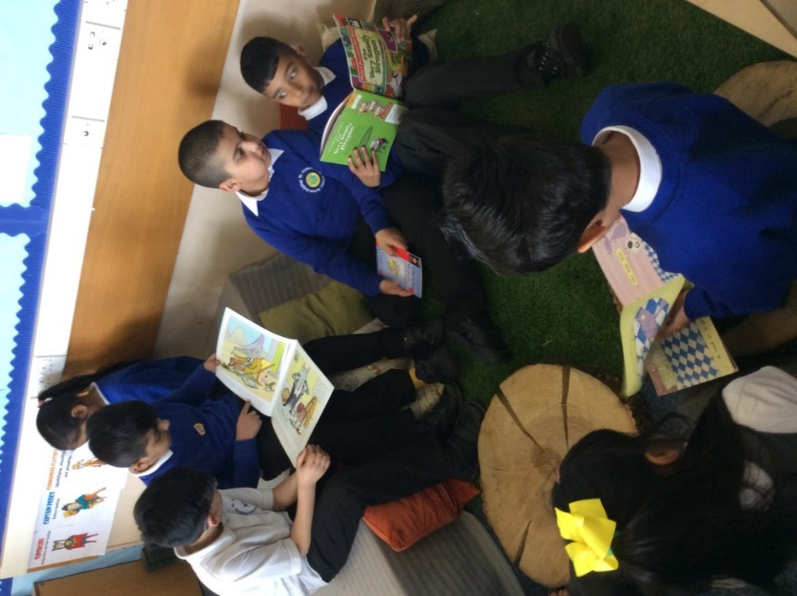

Our Curriculum
We know that it is essential that our children develop fluency and confidence in Mathematics and English so that they have the foundations to deepen their knowledge and learn across all subjects.
Vocabulary Development and Reading
It is crucial that children can develop a love of reading and wide vocabulary throughout their time at Keighley St. Andrew’s. School enjoys working with the Burley English Hub, National Literacy Trust and teaching schools across Keighley, Bradford and Leeds (Northern Lights and Bradford Birth to 19) to ensure that our training and development for both new and more experienced staff is the best it can possibly be. We are committed to developing teachers and aspiring leaders so that training and development can take place both within and outside of school.
School uses the ‘Read, Write, Inc’ programme for the teaching of Early reading and phonics, and all Early Years and KS1 staff receive dedicated training from our phonics lead. Our phonics lead provides regularly coaching and mentoring to all staff who teach phonics. All new members of the Key Stage One Team will receive full training in the implementation of our approach to the teaching of Early Reading /phonics.
In Key Stage 2 we use ‘Bug Club’ reading as a springboard for the development of comprehension skills and vocabulary. We have devised our own teaching sequence which ensures that the development and revision of new vocabulary and fluency are integral.
Daily story time using quality texts is a much-loved part of our curriculum and a chance for all to develop a love of reading and vocabulary through a broad diet of authors and genres throughout school.
Mathematics at Keighley St. Andrew’s
We use the White Rose Maths medium-term plans as a basis for our daily planning. The ‘Concrete, Pictorial, Abstract’ approach is one which really benefits our learners. That is also underpinned by a consistent diet of practising of number facts on a daily basis so that our learners have the fluency and confidence to work with larger numbers and multiple operations. Our maths lead and several members of staff have been developed by White Rose and the National Centre for Excellence in the Teaching of Mathematics (NCETM) so they are well placed to work alongside new and more experienced teachers to provide coaching, mentoring and be there as a source of advice and guidance.
Since 2016 standards in Mathematics have risen year on year. We believe that is due to our commitment to staff development and consistency of delivery which enables all our pupils to feel confident in grappling with new learning in maths.
Curriculum Intent and Development
We recognise that English and Maths help unlock potential in other subjects but also understand and value the role that other subjects play. We balance the acquisition of knowledge with opportunities for our children to develop their oracy skills, creativity and learn through experience.
Visitors, events and educational visits are important to us as they help our pupils make sense of the knowledge and also help them develop co-operation, empathy and resilience.
We are keen to develop our pupils’ creativity in the arts and have developed our Art Curriculum so that our children can build skills and knowledge relating to techniques, art forms and artists both traditional and contemporary. During our art lessons, our children develop vocabulary too, with enquiry relating to artists and art appreciation and practising the skills which our chosen artists use
We use the Charanga program to teach music and our Year 5 pupils have weekly Ukelele lessons.
Religious Education is taught using the Understanding Christianity resource and schemes from the Diocese and allows children plentiful opportunities to ask, explore and answer ‘Big Questions.’ Our children love RE lessons as they are engaged in lots of discussion and reflection.
Computing is taught using the Purple Mash scheme as a starting point, We also have i-pads, net books and a designated computer suite to support computing and learning using ICT. Staff receive training to support their computing knowledge.

Sustainable Development Goals / Environmental Awareness
We have developed our own curriculum units of work based around the United Nations Sustainable Development Goals. We understand that the knowledge which our children acquire will equip them with the skills and knowledge to make changes for a better world.
Pupils experience: Designing and making reusable shopping bags from recycled t-shirts and showing these off in a fashion show; visiting supermarkets to investigate where our produce comes from and waste. Growing vegetables in an aeroponic tower garden; designing, publishing and handing out leaflets about food waste in our shopping centre. Running a Pay as You Feel Stall at school and in the town centre and using supermarket waste produce in our Cooking Club and a local food kitchen.
During the pandemic we have still worked hard to provide our learners with experiences. In 2020 – 21 – these included:
- A visit from Zoolab where our EYFS pupils handled and obsenrved exotic insects and reptiles such as snakes, tarantulas and giant millipedes;
- A virtual visit / online demonstration of birds of prey;
- A live question and answer session with UK Parliament;
- A virtual reality headset experience (Earth and Space) themed;
- A Stone Age Explorer workshop;

Other things which make ‘Keighley St. Andrew’s:
- Values Champions – children and staff ‘spot’ when our values of ‘Thankfulness, Compassion, Trust, Courage, Community and Peace’ are put in to action by others. A weekly champion is chosen and celebrated.
- Year 6 Workforce: Our Year 6 pupils experience the World of Work by applying for in school jobs such as Play Leader, Eco-Crew, Reading Buddy. If successful they receive a special ‘CREW’ gilet and weekly pay tokens.
- Young Leaders – Our Year 5 children experience leadership at a school and local level; fund raise and complete tasks in the community both individually and in teams. Last year they worked with local churches and the council on community clear-ups, coffee mornings for parishioners. They also learn about influential leaders through history and research charities so that they can make informed decisions about fundraising.
- Collective Worship: Daily collective worship is planned by teachers, classes and pupils. Our pupils love being part of Worship Council where they plan and lead acts of collective worship.
- School Council: These are nominated and lead on fund raising and social projects in schools; they have: visited the London and the Houses of Parliament; represented school at a Gala Dinner in Leeds
- Outdoor Learning – Activities and experiences include: Archery, Nature Sculpture, Canal Visits, Den Building, Problem solving/team building and orienteering
- Inter Schools Sports Competitions: Football, triathlon, athletics and multi-skills
- Linking School Project: Year 3 students have partnered with Y3 students from a church School in Bradford to develop and understanding of the wider locality ; and build values/ attitudes such as empathy and tolerance
- Residential Visits to Ingleborough Hall and Halton Gill where children pony trek, go fishing, caving, gorge scrambling, orienteering, hill walking and much more.

How to Apply
Interested candidates are requested to apply online for these posts. Via https://prospectsonline.co.uk/
Please ensure you read the application details and check you meet the criteria before completing an application form.
Closing Date: Friday 5th November 2021 @ 9am
Interviews / tasks: Monday 8th November 2021
Safeguarding Statement
This school is committed to safeguarding and promoting the welfare of children and young people and expects all staff to share this commitment. The post is subject to an enhanced DBS check, stringent applicant checks and satisfactory references.

KEIGHLEY ST ANDREW’S C OF E PRIMARY SCHOOL & NURSERY

Outline Job Description

Post Title: | Teaching assistant
Grade: | SCALE 2 (SCP 3 & 4)

Generic Introduction:

The following information is furnished to assist staff joining the School to understand and appreciate the work content of their post and the role they are to play in the organisation. The following points should be noted:

- Whilst every endeavour has been made to outline the main duties and responsibilities of the post, a document such as this does not permit every item to be specified in detail. Broad headings, therefore, may have been used below, in which case all the usual associated routines are naturally included in the job profile.

- Employees should not refuse to undertake work, which is not specified on this form, but they should record any additional duties they are required to perform and these will be considered when the post is reviewed.

- This school is an Equal Opportunities Employer and requires its employees to comply with all current equality policies in terms of equal opportunity for employment.

- This school is committed, where possible, to making any necessary reasonable adjustments to the job role and the working environment that would enable access to employment opportunities for disabled job applicants or continued employment for any employee who develops a disabling condition.

Prime Objectives of the Post:

To complement, appreciate and support the role of teachers and other professionals by undertaking work/care/support programmes which enables access to learning in the community as part of a teacher planned approach.

To support the class teacher and other senior staff on a range of teaching and learning experiences which deliver an appropriately differentiated and suitably challenging creative curriculum for all pupils whilst meeting statutory requirements.

Work within school policies and procedures under the direction and guidance of senior staff and within an agreed system of supervision.

May from time to time be required to undertake other duties commensurate with the grade and level of responsibility defined in this job description.

To support and uphold School’s Christian Ethos.

Knowledge and Skills:

(See Personnel Specification)

Effort Demands:

- Will assist in maintaining the good discipline of pupils throughout school and be expected to use good common sense, as well as use initiative in all matters relating to the conduct and behaviour of individual pupils, groups of pupils and whole classes, the safety, mobility (if required), hygiene and wellbeing of the pupils; making decisions within established working practices and procedures.

- Will recognise and challenge any incidents of racism, bullying, harassment, victimisation and any form of abuse of equal opportunities, ensuring compliance with the relevant school policy and procedures.

- Will deal with any issues, immediate problems or emergencies that arise in line with school policies and procedures liaising with colleagues where necessary e.g. dealing with a sick, injured or distressed child.

- Acting as a role model, will establish productive and constructive working relationships with pupils, setting high expectations, motivating and interacting with them, being aware of their individual needs, supporting difference and ensuring all pupils have equal access to opportunities to learn and develop whilst responding appropriately.

- Will have the ability to cope with the requirements of the post, which may include working with pupils who have emotional/behavioural/physical difficulties.

- Will contribute to the overall ethos/work/aims of the school.

- Will engage with professional development.

- Will appreciate and support the role of other professionals.

- Be vigilant and sensitive to any child protection/safeguarding concerns that arise, reporting any concerns to the designated officer in line with school policy and procedure.

Responsibilities:

- Assist in the management of pupils in the learning environment.

- Undertake structured and agreed learning activities/teaching programmes appropriate to the pupil’s needs to ensure physical, social, emotional and intellectual development, taking into account diversity e.g. language, culture, ability, race and religion.

- Will supervise and support pupils consistently at all times; recognising and responding to their individual needs whilst ensuring their safety and education in the learning environment.

- For posts working with pupils who are physically less able, it may be necessary to be able to physically assist the pupil in line with school polices and good practice

- Will (where needed) and with training, assist with processes and procedures a pupil’s medical needs

- Attend to the pupils’ personal needs, implementing and maintaining related personal care programmes with the correct use of care materials including the safety and well-being of the pupils and first aid, paying attention to social, health, physical and welfare matters as well as high standards of cleanliness and hygiene, e.g. washing, dressing, toileting and, if applicable, mobility (including supporting intimate care where necessary

- Will occasionally be required to supervise the class for brief periods (of 30 minutes or less) in a lesson where the classroom teacher is not available

- Promote and reinforce the inclusion, acceptance and integration of all pupils, including those with specific and special needs and those from different cultures and/or with a different first language as appropriate.

- Set challenging and demanding expectations whilst promoting self-esteem and encouraging pupils to act independently as appropriate as well as interact and work co-operatively with others and engage in activities led by the teacher.

- Will prepare resources as directed to meet the lesson plans. Take responsibility for the care, preparation, maintenance and use of relevant equipment, assisting pupils in its use and clearing/storage afterwards.

- Will be aware of pupil progress, monitor/record pupil responses against pre-determined learning objectives as well as provide accurate, constructive and detailed feedback/reports to the teacher and pupils.

- Promote positive values, attitudes and good pupil behaviour and encourage pupils to take responsibility for their own actions whilst supporting the teacher in managing this. Deal promptly with conflict and incidents (including those involving restraint) and reporting challenging behaviour where appropriate in line with established policy.

- Will gather/report information from/to parents/carers as directed, taking into account parental/carer concerns, dealing with them sensitively under the direction of the teacher.

- Will provide clerical/administrative support as directed by the teacher.

- In respect of local and national learning strategies, will support pupils to achieve learning goals e.g. literacy, numeracy, KS3, early years as directed by the teacher.

- Will support pupils in the use of ICT in learning activities as directed by the teacher, and develop pupils’ competence and independence in its use.

- Will participate in own performance development, identify and address any training needs/other learning activities.

- Will assist with the supervision of pupils out of lesson times, including before and after school and at lunchtimes, accompanying teaching staff and pupils on visits, trips and out of school activities.

- Will assist in the supervision of students on work experience, trainees and voluntary helpers.

environmental demands/Working Conditions:

- Will have long periods of sitting or standing.

- Available to work during school hours during term time and a willingness to be flexible as may be required to attend staff meetings/training sessions outside of usual hours.

- Will have contact with members of the public/other professionals e.g. teaching staff, governors, parents/carers, community groups, local education authority, external providers etc.

- The post holder may occasionally be subjected to antisocial behaviour from members of the public/parents/site users.

- This post may include a degree of manual lifting and handling. You are expected to be aware of health and safety policies and procedures and frequently assess your ability to carry out the lifting tasks required of you.

- Report all concerns to an appropriate person.

Fluency Duty

In line with the Immigration Act 2016; the Government has created a duty to ensure that all Public Authority staff working in customer facing roles can speak fluent English to an appropriate standard.

For this role the post holder is required to meet the Intermediate Threshold Level

Intermediate Threshold Level

The post holder should demonstrate:

- They can express themselves fluently and spontaneously with minimal effort and,
- Only the requirement to explain difficult concepts may hinder a natural smooth flow of language.

Special Conditions of Service:

- No contra-indications in personal background or criminal record indicating unsuitability to work with children/young people/vulnerable clients/finance (An enhanced DBS check is required).

Other considerations

- To be aware of and comply with policies and procedures relating to child protection; being vigilant for signs that children may be being abused and to report any such suspicions to the school’s nominated Child Protection Co-ordinator or the Headteacher.

- To act in accordance with the Data Protection Act and maintain confidentiality at all times e.g. access to staff/student/parent and carers files.

- Accept and commit to the principles underlying the Schools Equal Rights policies and practices.

- Be able to perform all duties and tasks with reasonable adjustment, where appropriate, in accordance with the Equality Act.

- Must be legally entitled to work in the UK.

PERSONNEL SPECIFICATION:

 | ESSENTIAL (E)/DESIRABLE (D)
Experience: | - Experience of working with children of relevant age (E)  - Experience of working in a team situation (E)  - Experience of supporting children with additional need (D)  - Provide evidence of having previously spoken fluently to customers at an Intermediate Threshold Level (E)
Qualifications/  Training: | - GCSE English and Maths grade C or equivalent e.g. Adult Literacy/Numeracy at level 1/2 (D)  - Other relevant qualifications or working towards relating to the post e.g. Apprentice/BTEC/NVQ Level 1/2 or above in Supporting Teaching & Learning or equivalent (D)  - First aid qualification (D)  - Evidence of further training/development and/or willingness to participate in further training and development opportunities (E)
Knowledge/ Skills: | - Will possess knowledge of the School’s relevant procedures or practices  - Will have an outline understanding of relevant legislation (D)  - Will have some knowledge of some of the policies covering their service area (D)  - Problem solving skills (E)  - Good communication skills (E)  - Good numeracy/literacy skills (E)  - Basic ICT skills (E)  - An understanding of the issues relating to pupils who have additional learning needs, more able and special educational needs (E)  - Knowledge of childcare (E)  - Awareness of child development (E)  - Knowledge and commitment to schools Equality policy (E)  - Ability to relate well to pupils and adults (E)  - Ability to work constructively as part of a team (E)  - Ability to remain calm under pressure (E)  - Demonstrate a commitment to working with children of the relevant age (E)  - Demonstrate good co-operative, interpersonal and effective listening skills (E)  - Maintain confidentiality in matters relating to the school, its pupils, parents or carers (E)  - Ability to perform all duties and tasks with reasonable adjustments where necessary (E)  - Ability to cope with the requirements of the post, which will include working with pupils who have emotional/ behavioural/physical difficulties (E)  - In line with the Immigration Act 2016; you should be able to demonstrate fluency of the English Language at an Intermediate Threshold Level

