Aldermen Payne Primary School
Head teacher – Ms. S. Blyth
9 Main Road
Parson Drove
Wisbech
Cambs
PE13 4JA

Tel: 01945 700 275
Fax: 01945 701 401


A Part of Village Life

Dear Candidate,

Thank you for your interest in Alderman Payne Primary School. I am looking for an outstanding practitioner who can work with a pupil with additional needs in the Reception class. The hours are 15 hours per week and this comprises of 5 hours of a midday assistant supporting the pupil at lunchtime (12noon until 1pm), and 10 hours in the classroom (1pm – 3pm) every day. The candidate would not necessarily have previous experience of this role, but must have the capacity to quickly develop.

If you are shortlisted, please bring a copy of proof of your identity to the interview. The interview will include the following:-

- An opportunity for you to work with a small group of children for about half an hour.
- Interview questions. (up to half an hour)
- Unseen exercise. (half an hour)

Visits to the school are warmly welcomed and encouraged.

I look forward to receiving your application by Thursday 15th December by 2pm
Interview and observations:
Interviews will be during the week commencing Monday 19th December with work commencing from Thursday 5th January 2023 or as soon as possible thereafter.

Yours sincerely,

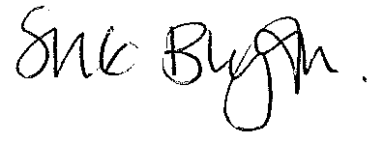
Sue Blyth
Headteacher


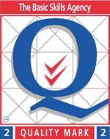



E-mail: office@aldermanpayne.cambs.sch.uk Web: www.aldermanpayne.co.uk

