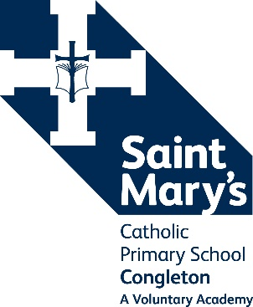“*My soul glorifies the Lord ….” Luke 1:46*

**Saint Mary’s Catholic Primary School, A Voluntary Academy**

Belgrave Avenue, Congleton, Cheshire, CW12 1HT Tel: 01260 274690

E-mail: [admin@saintmaryscongleton.co.uk](mailto:admin@saintmaryscongleton.co.uk)

*Our Lady Help of Christians Catholic Academy Trust part of the Diocese of Shrewsbury*

**Teaching Assistant - Grade 4**

**32.5 hours per week, temporary**

The Governors are looking to recruit an outstanding Teaching Assistant to support children both in class and on a one-to-one basis across the school. The postholder will use their skills to support and deliver activities to contribute to effective teaching and learning. The successful candidate will have a confident, calm and patient approach and have high expectations of behaviour and attainment.

The days of work will be Monday to Friday from 8:30am to 3:30pm during term time, plus INSET days. Applicants for this post are encouraged to have or be studying for a TA qualification or have relevant experience.

Saint Mary’s is a thriving Catholic Community with 180 children on roll, including a Nursery. We have happy children who are eager to learn and a dedicated, friendly and supportive staff team.

The school is committed to safeguarding and promoting the welfare and safety of children. The successful candidate will be required to complete an enhanced DBS disclosure and will follow a stringent vetting and induction process.

This position is temporary until July 2025. Applications must be submitted on a Catholic Education Service application form which is also available from the school website: www.saintmaryscongleton.co.uk

**Closing Date: Friday 11th October 2024 at 12 noon**

**Interviews: Week beginning Monday 14th October 2024**

**Start date: Tuesday 5th November**