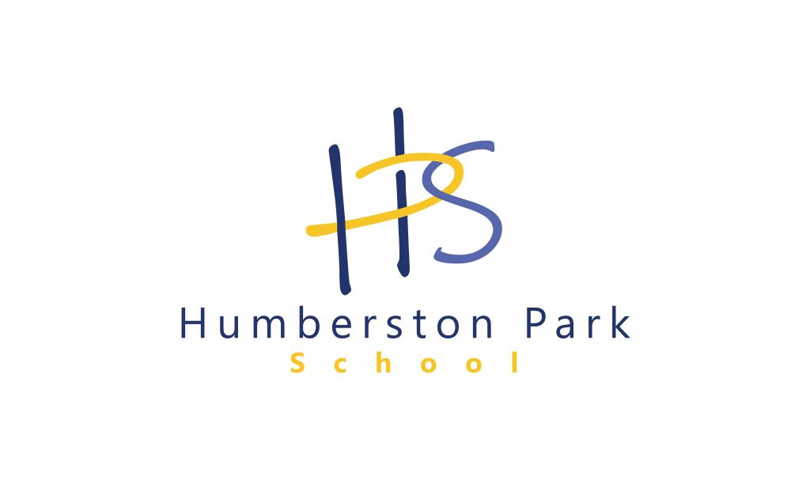 | JOB DESCRIPTION

POST TITLE: TEACHING ASSISTANT Special schools (Entry Level One)

GRADE/SPINAL COLUMN POINT: 3

REPORTS TO: Line Manager

- PURPOSE OF JOB:

Teaching Assistants are appointed to work with children over the whole age range as part of a team under the general direction of the line manager and the close supervision of a classroom teacher/senior staff.

To provide basic learning support for pupils identified as having severe learning difficulties including complex or multiple special education needs in a range of learning situations and settings. This will enable pupils to access an appropriate curriculum, enrich and enhance the learning experience and contribute to personal, social physical and emotional development under the close direction of a teacher or senior learning support staff.

- MAIN RESPONSIBILITIES
- Developing an understanding of the specific needs of the pupil(s)

- Carries out an individual personal care programme, for example Personal hygiene, toileting, eating and drinking to contribute to personal and social development.

- Provide practical assistance in relation to other identified physical needs e.g. transportation, dressing, meal times, and organisation of learning equipment to support Personal, Health, Social and Emotional development.

- Observes individuals and groups of pupil’s personal, social and learning achievements. Maintains appropriate records, monitor progression and attainment and provides reports and information to inform and support the assessment process.

- Maintain and clean personal care equipment and materials, clothing etc.

- Undertake routine activities with either individuals or small groups of pupils to facilitate their physical, emotional and educational development.

- Helping to promote pupils' good behaviour and discipline through positive interactions with pupils and participation in strategies.

- Assist all pupils where appropriate in the proper use of simple personal and learning aides and equipment and to ensure that they are available.

- Provide routine assistance and support to all pupil/pupils in physical/practical activities e.g. physical education, cookery, school visits, organised by the school to support PHSE.

- Carry out routine administrative tasks i.e. photocopying, basic record keeping, and basic IT skills.

- Provide basic regular feedback about pupils to the teacher and other colleagues.

- Prepare and clear up classroom materials and learning areas ensuring that they are available for use.

- Assisting in the presentation of displays in the learning environment to enhance the learning experience and celebrate the achievements of children and provide information.

- Record against a pupil’s objective in the manner prescribed by the class team leader in order to assist the review of pupil’s progress.

- Assist with lunch and break time supervision of pupils.

- Participate in and supports educational visits and outings to enhance the learning experience.

- Attend training courses to support ongoing professional development.

- Attend staff meetings to maintain an awareness and understanding of current issues within the school and to provide and receive basic information and contributes to discussions.

- Provide routine pastoral care for pupils who are sick.

- Monitor children’s and young people’s conduct and behaviour throughout the learning process and intervene to resolve routine issues using appropriate techniques and skills to de-escalate potential difficult situations or resolve simple conflict with individual and groups of pupils to establish and maintain a safe and calm atmosphere conducive to learning and ensure the safety and wellbeing of pupils, staff and visitors.

- Participates in the induction of children into specialist units, classes or schools for pupils with special educational needs.

- SUPERVISION/MANAGEMENT OF PEOPLE
No direct supervisory responsibility other than familiarisation of procedures to colleagues.

4. CREATIVITY AND INNOVATION
Learning is an environment where new situations will arise every day.
The post holder must seek to develop positive relationships with pupils.

The range of the pupils learning difficulties will require the post holder to be adaptive in approach to achieve individual learning objectives with each pupil.

Interpretation of individual personal care programmes to best support the child.

Contributes to the presentation of displays and learning resources

Guidance is readily available from teaching staff or other colleagues, school policies and procedures, I.E.P's and lesson plans etc.

5. CONTACTS AND RELATIONSHIPS
Teachers – to assist them in preparing materials reporting pupils’ routine progress and supporting learning activities.

Pupils – to support, assist and enable them to access the curriculum and develop social and independence skills to their fullest ability. To care for their personal needs.

Other staff – to work as part of a team with all pupil related staff to keep them informed of areas of concern and pupils needs, particularly when handing over at the end of a session or day.

Parents – to exchange routine information related to individual pupils.

- DECISION
Discretion - The degree of discretion for the post holder is minimal.

Actions taken outside the normal routine are discussed with the line manager.

Any areas of concern related to child protection issues must be immediately reported to the responsible person.

Consequences - The post holder works under the close direction and supervision of a teacher/line manager. Any decisions will have a limited short term effect for the pupil and on the education provision within the school.

Constructive and effective support of the pupil can be of assistance to the pupils' physical and academic development.

- RESOURCES
Shared responsibility for hygiene materials, teaching materials and equipment.

Responsible for handling small sums of cash up to the value of £50.

- WORK ENVIRONMENT

Work Demands
The post holder will normally work within an agreed routine which may be varied dependent upon the needs/behaviour of pupils.

Physical Demands
Physical effort will regularly be required in assisting pupils with daily routines, e.g. mobility, transfer, personal needs, lifting and handling of basic equipment, setting out classrooms and learning environments. There will be regular lifting of children or equipment. Some physical effort will be required in carrying out Positive Handling procedures within authorised school policies.

Working Conditions
The post holder will work within the School environment with some periods of outdoor activity when supervising children's' activities

Work Context
The post is predominantly classroom based and some risk is posed to the personal safety of the post holder. There will be regular lifting of children or equipment. In some instances there may be a risk of infection from exposure to pupils' bodily fluids.

- KNOWLEDGE AND SKILLS
- Ability to work with individual and groups of pupils with complex Special Educational Needs to support learning, personal, physical, emotional and social development having regard for each child’s differing levels of development and ability.
- Good standard of basic education particularly literacy and numeracy skills.
- Routine administrative, ICT skills and timely record keeping.
- An awareness of the education process and relevant curriculum.
- Awareness of the regulatory framework relevant to schools and pupils.
- Good communication and interpersonal skills.
- Ability to establish and maintain positive relationships with pupils and adults.
- Caring skills in terms of pupils physical and emotional needs
- Team worker – able to work positively with others as part of the team.

