

**Teaching Assistant L2 with SEN Responsibilities**

**Salary:** Grade D point 6 with SEN Allowance – pro rata

**Required From:** 1st September 2025

**Hours:** 30 hrs per week (Term Time plus 5 inset days)

**Contract:** Fixed term to 31st August 2026

The Governors of St James CE Primary School invite applications for the above post from suitably qualified or experienced people who enjoy working with children. The persons appointed will work for 30 hours/week (Monday to Friday) and will provide learning support in the classroom for children with EHCP’s.

To fulfil this very rewarding and valuable role you will need:

* Experience of supporting young children with learning, social and emotional difficulties
* Patience, resilience and an ability to nurture
* A calm, organised and flexible approach to team working
* An ability to build positive relationships.

In return we can offer a school with:

* Well behaved, friendly and motivated children who love to learn;
* A friendly and skilled staff;
* Commitment to the professional development of staff;
* A welcoming, caring atmosphere where everyone is valued.

Application packs are available from the Greater Jobs website and completed applications should be returned to Mrs Kirsty Diggle (Finance/HR Officer) at Archbishop Temple Trust.

Email: digglek@archbishoptempletrust.co.uk

Closing date: Friday 4th July 2025 at 12pm (Midday)

Observations/Interviews: Thursday 10th July 2025 – please note this date cannot be changed

*This school is committed to safeguarding and promoting the welfare of children and young people and expects all staff and volunteers to share this commitment. Successful candidates will be subject to an Enhanced Disclosure by the Disclosure and Barring service.*

Visits to the school are welcomed. Please contact Kirsty Diggle, digglek@archbishoptempletrust.co.uk



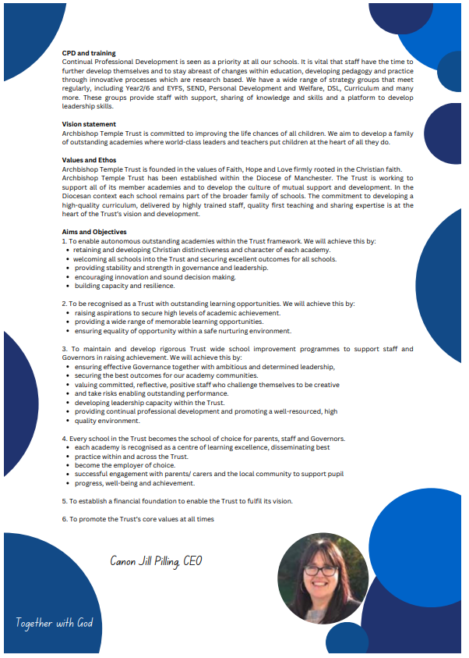

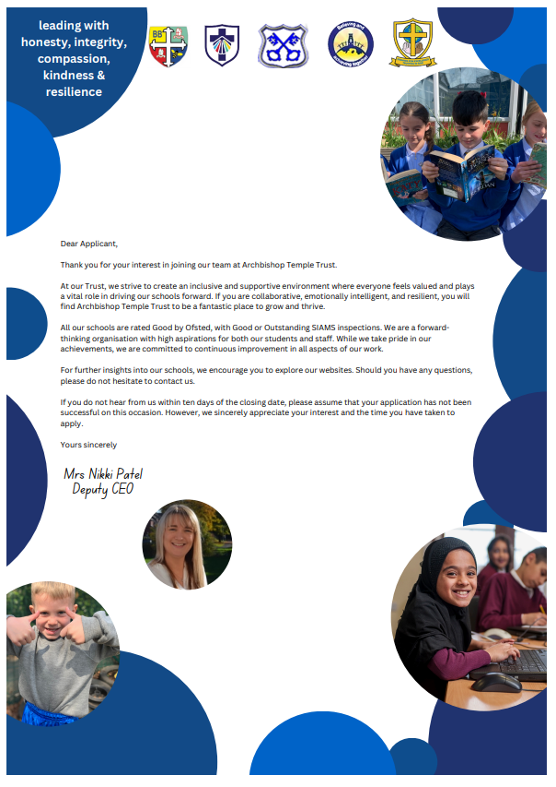

|  |  |
| --- | --- |
|  |  |
| Job Description | |

|  |  |
| --- | --- |
| Job Details | |
| **School Name** | St James CE Primary School |
| **Job Title** | TEACHING ASSISTANT LEVEL 2 (SEN) |
| **Grade** | GRADE D |
| **Primary Purpose of Job** | Provide effective support for teaching and learning in school, SEN responsibilities as per the advertisement |
| **Responsible to** | Line Manager/Head Teacher |
| **Responsible for** | N/A |
| **Principal Responsibilities** | Provide support for teaching and learning activities  Contribute to children’s development and safeguarding  Provide support to develop the learning environment |

|  |  |
| --- | --- |
| Main Duties | |
|  | Provide support for learning activities across a range of key stages and in a range of environments |
|  | Support children’s development (e.g. physical, emotional, social, communication and intellectual development needs) |
|  | Help to keep children safe, including maintaining a safe environment, dealing with accidents, supporting safeguarding. |
|  | Encourage children’s positive behaviour |
|  | Contribute to positive relationships with children and adults through communication and interaction |
|  | Provide effective support for colleagues |
|  | Support literacy and numeracy activities |
|  | Support the use of information and communication technology for teaching and learning |
|  | Use information and communication technology to support pupils’ learning |
|  | Observe and report on pupil performance |
|  | Provide displays |
|  | Escort and supervise pupils on educational visits and out-of-school activities |
|  | Contribute to maintaining pupil records |
|  | Contribute to monitoring and maintaining curriculum resources |
|  | Invigilate tests and examinations |

|  |  |
| --- | --- |
| Other duties for staff with responsibility for supporting play in settings | |
|  | Support children’s play and learning |
|  | Support children and young people’s play |
|  | The post holder may reasonably be expected to undertake other duties commensurate with the level of responsibility that may be allocated, at the discretion of the Head Teacher and to meet the needs of the school |
|  | Intimate care when necessary |

|  |  |
| --- | --- |
| Version Control | |
| **Job Description prepared by:** | School’s HR |
| **Job Description updated:** |  |

|  |  |
| --- | --- |
|  |  |
| Person Specification | |

|  |  |
| --- | --- |
| Job Details | |
| **School Name** | St James CE Primary School |
| **Job Title** | TEACHING ASSISTANT LEVEL 2 (SEN) |
| **Grade** | GRADE D |

## Stage One

The minimum essential requirements for the above post are as follows. Please try to show in your application form, how best you meet these requirements. Disabled candidates are guaranteed an interview if they meet the essential criteria.

|  |  |  |
| --- | --- | --- |
| Skills and Knowledge | | Method of Assessment |
|  | Ability to support the teacher in planning, delivering and evaluating learning activities to ensure effective teaching and learning. Ability to give feedback in a constructive manner. | Application Form/Interview |
|  | Ability to listen and observe children/young people and share observational findings effectively. | Application Form/Interview |
|  | Ability to keep children and young people safe during day-to-day work activities. Ability to assess the balance between safety and risk, challenge and protection, and adjust own behaviour and accordingly. | Application Form/Interview |
|  | Ability to praise and encourage children/young people according to their age, needs and abilities. Ability to deal sensitively with challenging behaviour (in line with setting/school policy and procedures). Act as a role model for positive behaviour. | Application Form/Interview |
|  | Ability to interact and respond positively to children, young people and adults. Ability to establish and maintain rapport with pupils. Ability to demonstrate verbal and non-verbal communication skills when dealing with children, colleagues, parents, carers, families and other practitioners. | Application Form/Interview |
|  | Ability to become an effective member of staff. Ability to work effectively with colleagues and other practitioners. Ability to take an active role in developing own skills and expertise. | Application Form/Interview |
|  | Ability to help pupils, under the direction of the teacher, to participate in whole class, group and individual literacy and numeracy learning activities. | Application Form/Interview |
|  | Ability to operate ICT resources safely and effectively as a learning resource. Ability to access and use learning programmes and information. | Application Form/Interview |
|  | Ability to encourage and support pupils in using ICT during learning activities and feedback on their progress and response. | Application Form/Interview |
|  | Value people equally, supporting an inclusive ethos | Application Form/Interview |
|  | Excellent numeracy and literacy skills | Application Form/Interview |
|  | Understanding of roles and responsibilities for supporting pupils’ learning and implications for the support you can provide. | Application Form/Interview |
|  | Knowledge and understanding of children and young people’s development in relation to the ages covered by the setting/school | Application Form/Interview |
|  | Awareness of safeguarding principles and safe working practices | Application Form/Interview |
|  | Displays commitment to the protection and safeguarding of children and young people. | Application Form/Interview |
|  | Knowledge and understanding of importance of consistent behaviour management | Application Form/Interview |
|  | Knowledge and understanding of the key features of effective communication. | Application Form/Interview |
|  | Knowledge and understanding of appropriate software packages | Application Form/Interview |
|  | CompetenciesPlease note the school’s competencies, which are considered to be essential for all roles, are in the attached Core Competencies document. | Interview |

|  |  |  |
| --- | --- | --- |
| Experience, Qualifications and Training | | Method of Assessment |
|  | Experience of working with and/or caring for children within specified age range/subject area | Application Form/Interview |
|  | Holder of, working towards or willing to work towards an NVQ Level 2, BTEC Level 2 **or equivalent** in Teaching Assistant or Supporting Teaching and Learning in Schools | Application Form/Interview |

|  |  |  |
| --- | --- | --- |
| Work Related Circumstances | | Method of Assessment |
|  | To attend staff training days, twilight training sessions and relevant out of hours training and events. | Application form/Interview |
|  | This post is subject to an enhanced disclosure and a barred list check from the Disclosure & Barring Service | Application Form / Interview |

## Stage Two

This will only be used in the event of a large number of applicants meeting the minimum essential requirements. Please try to show in your application form, how best you meet these requirements.

|  |  |  |
| --- | --- | --- |
| Skills and Knowledge | | Method of Assessment |
|  | Be familiar with and able to set in motion accident/emergency, safety, safeguarding and welfare procedures, according to school/setting policies and procedures | Application Form / Interview |
|  | Ability to adapt learning activities to individual pupils’ needs and abilities | Application Form / Interview |
|  | Ability to identify the purpose of learning displays and devise design and content accordingly. Ability to create the display with due regard for safety and future maintenance, and to evaluate its effectiveness. | Application form/Interview |

|  |  |  |
| --- | --- | --- |
| Experience, Qualifications and Training | | Method of Assessment |
| 1. | Holder of GCSE Mathematics and English qualification Grades A-C or 9-4 or the equivalent | Application form/Certificate |
| **2.** | Knowledge and understanding of ICT materials, sources of information and advice, and how to adapt the use of ICT for pupils of different ages, needs and abilities. | Application Form / Interview |
| **3.** | Knowledge and understanding of procedures and policies around confidentiality, data protection and sharing of information | Application Form / Interview |
| **4.** | Knowledge and understanding of literacy and numeracy strategies and resources | Application Form / Interview |
| **5.** | Knowledge of the practical application of special educational needs strategies | Application Form / Interview |
| **6.** | Knowledge and understanding of how to maintain the health, safety and well-being of pupils when outside the school setting | Application Form / Interview |

|  |  |
| --- | --- |
| Version Control | |
| **Person Specification prepared by:** | School’s HR |
| **Person Specification updated:** |  |

**These core competencies are considered essential for all roles within Bolton Council. Please be prepared to be assessed on any of these during the interview process and, for the successful applicant, throughout the probationary period.**

**Developing Self & Others**

Promote a learning environment to embed a learning culture.  Support others to develop their skills and knowledge to fulfil their potential. Actively pursue your own development. Support and promote the principles of Investors in People.

**Civil Contingencies**

Bolton Council has a statutory duty under the Civil Contingencies Act to respond in the event of an emergency. If Bolton Council’s Emergency Management Plan is activated, you may be required to assist in maintaining key Council services and supporting the community.  This could require working outside of routine working hours and working from places other than your normal place of work.

**Equality & Diversity**

Uphold the principles of fairness and the Equality Act in all undertakings as a Bolton Council employee, including providing a fair, accessible service irrespective of customer’s race, religion, gender, sexuality, disability or age.

**Customer Care**

The ability to fully understand, assess and resolve the needs of all customers including those who present with complex situations, in a manner that respects dignity and expresses a caring & professional image.

**Health & Safety**

Take responsibility for the health and safety of yourself and others who may be affected by your acts or omissions, and comply with all health and safety legislation, policy and safe working practice, including participating in training activities necessary to your post.

**Data Protection and Confidentiality**

Ensure that any personal data or confidential data you hold is kept securely and is not disclosed, whether electronically, verbally or in writing, to any unauthorised third party. Follow Council policies and procedures on dealing with personal information and information assets, including The Code of Conduct, Data Protection, Acceptable Use and Information Security policies. Personal or confidential data should only be accessed or used for council purposes.

**Fluency Duty**

Should you be required, as a regular and intrinsic part of your role, to speak to members of the public in English, you must be able to converse at ease with customers and provide advice in accurate spoken English, as required byThe Immigration Act 2016.

**Working Hours**

The nature and demands of the role are not always predictable and there will be an expectation that work will be required outside of normal hours from time to time.

**Safeguarding**

This Council is committed to safeguarding and promoting the welfare of children, young people and vulnerable adults and expects all staff and volunteers to share this commitment. Should the role involve working with the above groups, you will be subject to an Enhanced Disclosure and Barred List check by the Disclosure & Barring Service.

**The values of an organisation are those key principles by which people are expected to work to day to day. They’re our culture and help define what is expected of each and every one of us**.







**How to apply**

We hope that you have enjoyed reading about the Archbishop Temple Trust and our school and that you will feel able to apply for this post.

Please complete the **downloadable** **application form.** Please do not send CVs or open references as part of your application as these will not be considered.

It is important that you provide a complete employment history from when you left full time education. If the application form is not fully completed or has unexplained gaps in your employment history, your application will not be considered. Copies of your qualifications will be required at the interview stage; please do not send these with your application.

Please also write **a letter of no more than two sides of A4** to explain why you want to work within our Trust, why you are the best candidate for the post and what you would contribute to our schools, with examples from your recent work if possible.

Please let us have both the supporting letter and the application form by **noon** on **Friday 4th July 2025** as we will not be able to consider applications received after that.

In accordance with the Data Protection Act, the details provided in the application form will be used for selection and interview procedures, and for employment records if your application is successful.

If you are disabled, please give details of how we can ensure that you are offered a fair selection and interview process.

Successful candidates will be asked to provide, prior to taking up the appointment, documentary evidence (including National Insurance number) showing their entitlement to work in the UK. We will also carry out an enhanced DBS and declaration of health check. References will also be required in line with Keeping Children Safe in Education 2019.



|  |  |  |  |
| --- | --- | --- | --- |
| Dream | Believe | Learn | Achieve |

My name is Lisa Belfield and I am the very proud Principal of our special ‘St James Family’. Each day is an absolute pleasure, working with the staff and parents who are committed to make a difference to the lives of the pupils with whom we work. Our children are nurtured through the Christian values of respect, peace, love, forgiveness, honesty and hope. As a result, our pupils are kind, caring and polite; visitors always feel a warm welcome when they walk through our front door. The children of St James are utterly delightful, with exemplary behaviour and a real credit to the school and their families.

St James is situated in a very vulnerable catchment area, with above-average pupil premium and SEND figures. However, this does not stop our pupils from achieving what we set out for them, nor does it stop us as practitioners believing that our children CAN DO. I am very lucky to serve a staff who work incredibly hard to ensure the children in our care receive the very best that we can offer them. We are big advocates that ‘team work makes the dream work’ and we ensure that we are there to support, challenge and motivate each other. Staff new to school, or on supply, always comment on how helpful and friendly the staff team of St James are. We are always eager to grow our workforce with like-minded individuals, who have a passion to make a difference. Our children deserve a great education, with great professionals to ensure we achieve this.

Working within the Archbishop Temple Trust has opened many doors for school improvement and networking. Staff at St James have benefited from many CPD opportunities for training and sharing best practice. Strong and supportive relationships across staff flourish within our MAT. The impact for the children is also positive, with the opportunity to visit other schools in contrasting environments and to work on joined-up projects.



Thank you for considering our school and MAT to either start or further your career in education. I look forward to hearing from you.



Mrs Lisa Belfield

Headteacher