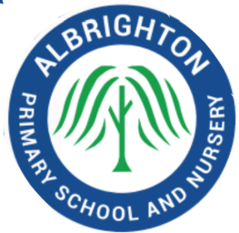
Only our best will do!
Newhouse Lane, Albrighton, Wolverhampton WV7 3QS
Tel: 01902 372558
Email admin@albrightonprimary

Vacancy for
Teaching Assistant
5 mornings per week
To start Autumn Term 2022

NVQ Level 3 or equivalent
Term time only (Permanent)

We are looking for an experienced, inspirational and creative teaching assistant to join our team. You should have experience of working in a Primary School setting; your ability to understand how children learn and skill to enable progress are more important than which phase you have experience in.

We are looking for someone who:
- is an exemplary practitioner who can inspire and motivate our children
- is dynamic, flexible and creative and has a clear understanding of effective practice
- has proven ability to improve outcomes for children
- is happy to take on whole class teaching cover including at short notice
- has excellent interpersonal skills
- is a keen team player
- is keen to participate in the wider life of the school

We can offer you:
- The chance to make a difference to our school community
- A wide range of CPD opportunities
- Happy, well-motivated and caring children
- Friendly and supportive staff
- An idyllic setting in which to work

Visits to the school are encouraged. Please contact the school for more details.
All applications should be returned directly to the school. Applications will also be accepted via email.

Closing Date: Monday 6th June, 2022 – 9.00am

Julie Bratt
Head Teacher

