

HIGH S
HASTINGS HIGH SCHOOL

Teaching Assistant /
Learning Support Assistant

Salary: Grade 5/6 (Actual salary £16755 - £17564)
39 weeks per year, 28.75 hours per week
To start: 20th August 2026
Application Deadline: June 12th 2026
Interview date: W/c – June 15th 2026

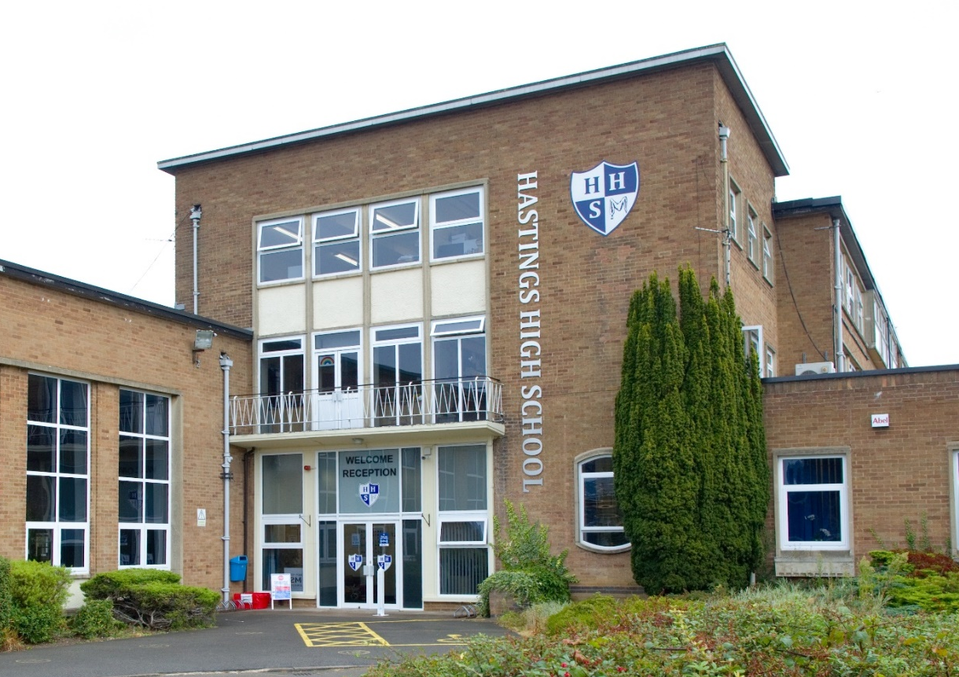

🌐 www.hastings.school 📞 01455 239414 St Catherine’s Close, Burbage, Leicestershire, LE10 2QE


LEARNING SUPPORT ASSISTANT
STARTING AUGUST 2018

HASTINGS HIGH SCHOOL
June, 2026

Why join the Hastings Family?
At Hastings, we live by our motto: Care and Excellence for All.
We are a thriving, oversubscribed community school with a strong academic record and a reputation for nurturing ambition, responsibility, and self-development in every pupil.
- Ofsted: Judged “Good” with outstanding pupil behaviour and relationships.
- Academic success: Progress 8 consistently above average (+0.40 last year).
- Facilities: Multi-million investment in 2025, including 8 new classrooms, a sports hall, and redeveloped pastoral and dining areas.
- Community: A supportive, ambitious, and enriching environment for staff and pupils alike.

What We Offer You

Comprehensive induction programme – tailored support for ECTs and new staff.

Professional development – ongoing training, appraisal, and opportunities to grow.

Wellbeing focus – a culture of care and respect for staff.

Collaborative team spirit – work alongside talented, reflective practitioners.

Enriching curriculum – access to a wide range of resources, facilities, and extracurricular opportunities.

How to Apply
Please submit:
- Completed application form
- Letter of application (max 2 sides of A4, font size 11)

Send to: Mrs. Sarah Brown – HR Manager 📧 sarah.brown@hastings.school

Closing date: 9am, 12th June 2026

Interviews: Week beginning 15th June 2026

(If you have not heard from us by 22nd June, please assume your application was unsuccessful.)
We love showing off our school! Prospective candidates are warmly invited to arrange a visit.
We very much hope you will apply and look forward to receiving your application.


Yours sincerely,


Miss C Bradley and Mr S Shipman

(Co-Headteachers)

HASTINGS HIGH SCHOOL
Care and Excellence for All

OUR HASTINGS FAMILY

All employees of Hastings High School are expected to live and breathe the school’s CARES

values so that they act as role models for our pupils and hold themselves and each other to

high standards.

Community: to demonstrate a collaborative, team working approach so that we can instil a sense of belonging to something that is greater than any one individual – the Hastings Family.

Ambition: to believe that every pupil deserves to be given the opportunity and the tools so that they may become the best version of themselves.

Responsibility: for personal professional growth and development, keeping up-to-date with national research and engaging with professional organisations.

Enriching: a commitment to helping our young people develop existing interests and try something new which will shape experiences and memories that will stay with them for life.

Self-development: demonstrates the capacity to be a self-reflective leader and practitioner and treats feedback as an opportunity to become even better.

A word from our pupils

💬 “Hastings is an amazing community of pupils and teachers who work together in striving for excellence.”

💬 “Hastings has helped me become ambitious and motivated to succeed.”

💬 “Relationships between staff and pupils are very positive. Staff are strong role models.”

HASTINGS HIGH SCHOOL
Care and Excellence for All

THE SEND DEPARTMENT

Hastings High School is a mainstream secondary school that meets the needs of all pupils, regardless of Special Educational Needs, to ensure that all pupils make the best possible progress.
SEND can be categorised by the 4 broad areas of need:
· Cognition and Learning
· Communication and Interaction
· Social, Emotional and Mental Health
· Sensory/Physical

At Hastings High School we recognise that all pupils must be given the opportunity to reach their full potential; “The best for every child”. We aim to provide “Care and Excellence for all” by supporting each and every person in our care. Our approach begins with quality first teaching in the classroom: all staff are given detailed information about SEND needs, which they use to provide differentiated support for pupils in lessons.
We are committed to continually re-evaluating the needs of our pupils, through formal and informal means, and we actively encourage a close partnership between the school, the pupil, parents and carers, working closely with other agencies where appropriate.
The SEND Department meet weekly to discuss the progress of SEND pupils and evaluate the effectiveness of current provision. In addition, specific pupils with special educational needs will have regular sessions with their keyworker, during which they will have the opportunity to discuss their progress and share their views.
We offer a Break and Lunchtime Club for pupils who need extra support during social times. This facility enables pupils to work for a short period in a quiet and calm area; accessing additional support when needed. Our programme of interventions help to improve speech and language development, handwriting skills, social and emotional development and literacy and numeracy skills. Our team is committed to supporting all pupils to develop, both academically and emotionally, ensuring that pupils learn the necessary life skills in order to prepare them for adulthood.
We are looking to recruit an enthusiastic and highly motivated teaching assistant to join our expanding support team. We have a clear understanding of what we are looking for in the staff we appoint. If you have a desire to work hard, want to transform lives, can use your own initiative, have a good sense of humour and want to be part of a dynamic team, then you could be the person that we are looking. You could be part of our Hastings family.

L Woodward

Head of SEND Provision



HASTINGS HIGH SCHOOL
Care and Excellence for All

PERSONNEL SPECIFICATION – TEACHING ASSISTANT / LEARNING SUPPORT ASSISTANT

Criteria | Essential | Desirable | Evidence
Qualifications & Professional Development | Good levels of Literacy and Numeracy  NVQ level 2 or equivalent  For Grade 6 – Level 3 TA qualification or equivalent | GCSEs or equivalent / ‘A’ Levels or equivalent  Supporting Teaching & Learning Level 2 | Application Form
Application | Well-constructed and well-presented application, addressing the specific requirements of this post |  | Letter
Experience | Experience of working with young people in the 11 – 16 age range | Working in a secondary school | Letter / References
Knowledge | Have sufficient understanding to support pupils’ learning, and be able to acquire further knowledge to contribute effectively and with confidence to the classes in which you are involved  Knowledge of a range of strategies to promote good behaviour | Behaviour Management training | Application Form
Professional Skills | Ability to work with and support other colleagues  Good oral and written communication skills  The ability to develop effective relationships with pupils and colleagues  A genuine enthusiasm for young people and an ability to engage them in learning | Ability to work with small groups of pupils under the guidance of a member of staff | Letter / Interview / References
Personal Qualities | Excellent attendance and punctuality record  Ability to work to deadlines  Understand and uphold the school’s policies and procedures  Awareness of the need for confidentiality  Evidence of a sense of humour, enthusiasm and commitment |  | References / Interview
Safeguarding | Evidence of knowledge of current child protection procedures  Commitment to promoting the welfare of our pupils |  | Interview
Extra-curricular activities | Understanding the importance of the extra-curricular dimension of our school  Willingness to contribute to our enrichment programme, including activities’ week and the alternative curriculum | Experience of participating in pupil residential trips | Letter / Interview


HASTINGS HIGH SCHOOL

JOB DESCRIPTION – TEACHING ASSISTANT (TA) / LEARNING SUPPORT ASSISTANT (LSA)

JOB SUMMARY:

Under the direction and supervision of the Head of SEND Support and classroom teachers, provide support for teaching and learning and associated activities in accordance with school policies and procedures. This may include providing general support for whole class learning activities, or supporting individuals or small groups of pupils.

MAIN DUTIES AND RESPONSIBILITIES

To assist with the planning, delivery and evaluation of whole class learning activities, including identifying how the pupils can best be supported.

To work under the supervision of a teacher to plan, deliver and evaluate learning activities for small groups or individual pupils, providing feedback on pupil engagement and their achievement of the desired learning objectives.

To help prepare, monitor and maintain a safe and secure learning environment in line with the teacher’s lesson plans.

To promote the development of pupil's self-reliance, self-esteem and emotional resilience.

To promote, observe and report on pupil performance and development, using assessment strategies to improve learning.

To support the physical, intellectual, emotional and social development of pupils, facilitating children and young people's learning and development.

To promote the development of positive relationships and acceptable behaviour in accordance with school/college policy.

To develop positive relationships with colleagues, providing consistent and effective support and working constructively as a member of the school staff team.

To support pupils to improve their numeracy and literacy skills through focussed learning activities and more generally across the curriculum.

To prepare and utilise ICT resources to support pupils learning.

To prepare and support the use of learning materials, monitor and maintain curriculum resources, and create visual displays in order to ensure a relevant physical learning environment.

To provide care and encouragement to children and young people with disabilities or special educational needs, supporting them to participate in activities and liaising, if required, with parents / carers / other professionals as appropriate.

To provide support for bilingual / multilingual pupils if required.

To invigilate internal and external tests and examinations under formal conditions.

To assist with the maintenance of pupil record keeping systems, including recording agreed updates to individual records.
To communicate as appropriate with parents and carers about the care and education of their children, as directed by the school.

To assist volunteers based in your work area, as appropriate.

To encourage participation in structured and unstructured learning activities, including play (timetabled and during breaks if required). (Primary and Special Schools)

OPTIONAL EXTRA RESPONSIBILITIES, NOT AFFECTING THE GRADE

To contribute to assessing and developing plans to meet the personal support needs of children and young people with additional requirements, and assist in the implementation and evaluation of the plans.

To monitor attendance to identify any patterns of absence and lateness and work with colleagues and parents to seek ways of helping the pupil to attend school more regularly.

To lead an extra-curricular activity under the direction of the school but with limited direct supervision.

To escort and supervise pupils on educational visits and out of school activities, ensuring their health, safety and well-being.

To undertake midday supervision duties.

To provide toileting support to pupils as necessary.*

To support, as appropriate, in instances where pupils are unwell whilst at the school.*

MISCELLANEOUS

To oversee the general tidiness and condition of furniture and fabric of, and equipment in, the teaching base, including where appropriate the display of pupils’ work, thus creating an environment conducive to learning (reporting to the Site Team any issues of health and safety or damage requiring repairs).

To carry out the duties placed on employees by the Health and Safety at Work Act 1974.

To adhere to all policies relating to Health & Safety and Equal Opportunities as determined by the Governors of the School.

Please note that these responsibilities are indicative rather than exhaustive. This job description sets out the duties and responsibilities of the post at the time when it was drawn up. Such duties and responsibilities may vary from time to time without changing the general character of the duties or the level of responsibility entailed. Such variations are a common occurrence and cannot themselves justify a reconsideration of the grading of the post.

* these duties only to be included by negotiation with individual employees, and after appropriate risk assessment and training have been undertaken.



HASTINGS HIGH SCHOOL

Care and Excellence for All

LOCATION AND CONTACT DETAILS

St Catherine’s Close
Burbage
Leicestershire
LE10 2QE
Telephone: 01455 239414
Email: reception@hastings.school
Website: www.hastings.school

HASTINGS HIGH SCHOOL


Reception:

