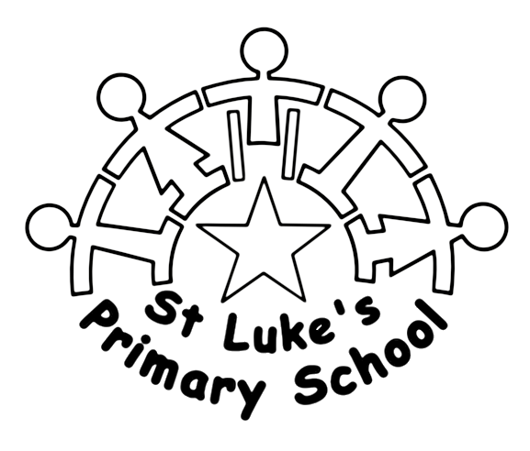
Champions for every child

St. Luke’s Primary School
Grange Lane North,
Scunthorpe,
DN16.1BN

Tel: 01724 844560 / Fax 01724 747740
Email: admin.stlukes@northlincs.gov.uk

Headteacher: Alastair Sutherland

Teaching Assistant (Level 1) – Required for November 2022

Permanent Contract

Thank you for your interest in the above post.

A Level 1 Teaching Assistant is required for November 2022 at St Luke’s.

The governing body is keen to appoint a person who may have substantial and recent experience of working with children in mainstream and/or special schools or early years settings. Experience of supporting children’s personal care needs is also desirable.

You will be required to support all aspects of personal care needs at lunch times and in other planned interventions throughout the school day. You must be prepared to work with pupils with a wide range of needs and with different age groups. You will be deployed according to the organisational needs of the school.

You must be prepared to participate in moving and handling children with physical disabilities. Appropriate training is provided.

The working hours are 11:30am to 1:30pm (Monday to Friday).

Please do not hesitate to phone for an informal discussion or to find out specific information. A visit to the school is strongly recommended before making an application.

About the school

St. Luke’s Primary School is a well-resourced, purpose built school for pupils aged 3 to 11 years with moderate to severe learning difficulties. Many of the pupils have profound learning difficulties and additional needs that arise from sensory and physical disabilities and medical conditions.

There is a well-established team of teachers and teaching assistants working at the school.

When you write your application please consider carefully the job description and person specification and demonstrate how you can meet the person specification and skills described. The governors who will be reading your application will be entirely dependent upon what you write when deciding whether to shortlist you for interview.

CLOSING DATE: Monday 3rd October 2022 (Applications received after midday will not be considered)

Interviews will be held before 15th October 2022. If you have not heard by this date then your application has been unsuccessful.

