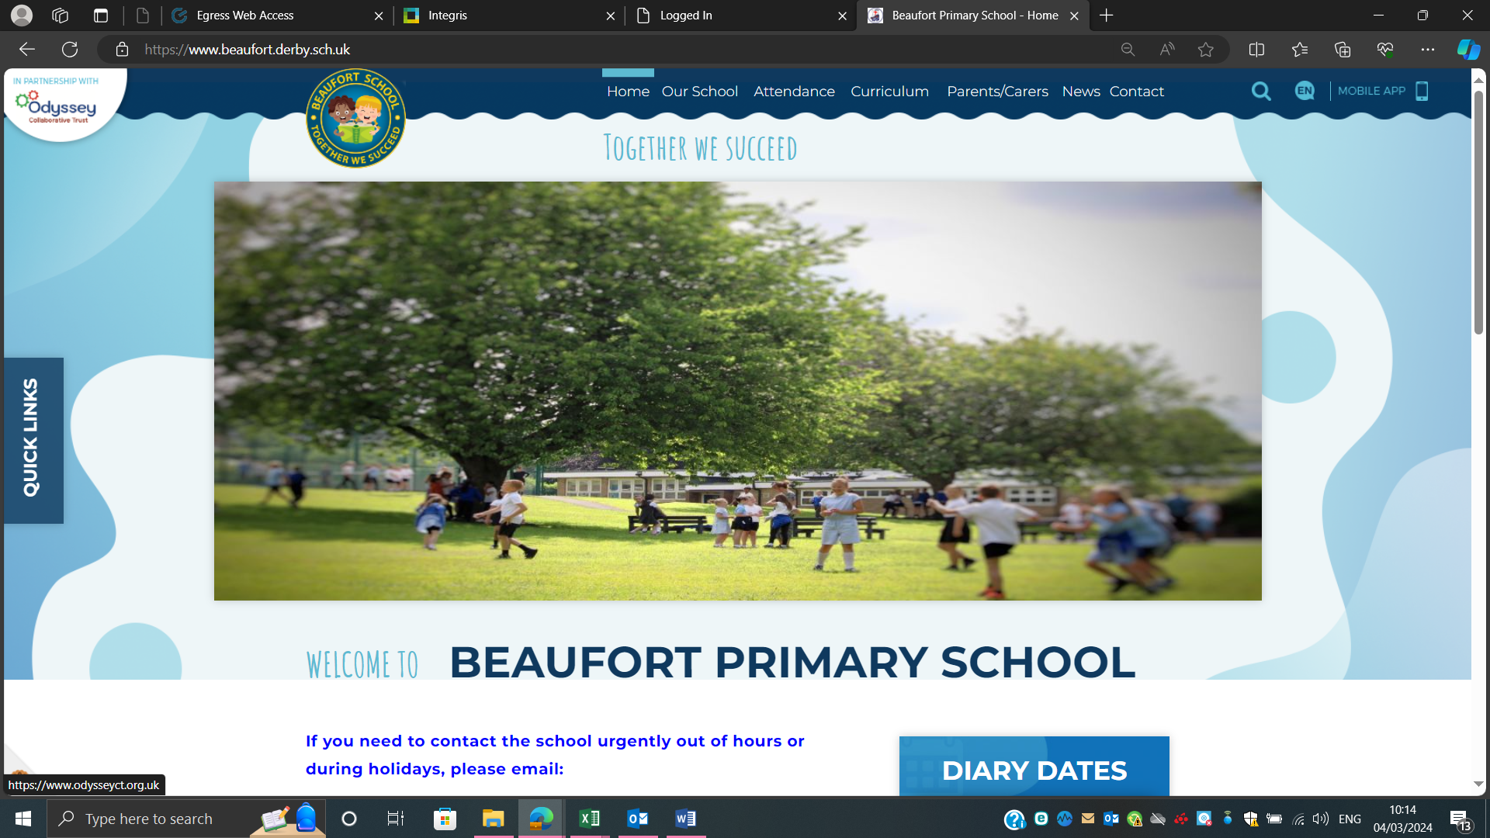

Job Application Pack

Beaufort Primary School

Teaching Assistant (TA)
Start Date: 1st January 2026
Hours per week: 32.5
Contract Type: Term Time Only, Permanent
Grade C, SP 5-6
Pay Scale: £25,583 – £25,989 pro rata (based on FTE).
Closing Date: Monday 8th December 2025 (10.30am)
Interview Date: Thursday 11th December 2025

Beaufort Primary School
‘BRAVE’
Brilliant Beaufort Minds, Respectful Relationships, Amazing Attitudes, Varying Vocabulary, Everyone is Equal

Welcome letter from Kate Beecroft, Head Teacher of Beaufort Primary School

Dear Candidate,
Thank you for showing an interest in the role of TA at our school. An exciting opportunity has arisen for a strong candidate to make a difference to our pupils at Beaufort Primary School in Derby. We are looking for a creative candidate who is dynamic and can cope with the occasional bump in the road!

We are looking for a candidate who will strengthen the team, who has good communication skills and will have our children’s best interests at heart.

Our school is part of the Odyssey Collaborative Trust. Our Trust is committed to supporting and delivering education of the highest quality across the trust. Here at Odyssey, we share one vision; ‘Our Children Thrive - Our Colleagues Thrive - Our community Thrives.’

Each of our academies is unique and has their own values to provide our children with the opportunities they deserve. At Beaufort our values are based on our ‘BRAVE’ Curriculum: Brilliant Beaufort Minds, Respectful Relationships, Amazing Attitudes, Varying Vocabulary and Everyone is Equal.

This is a tremendous opportunity to make a difference and to be part of a dynamic and innovative staff team.

We look forward to receiving your application and working with you on your own professional journey to excellence.

Best regards,

Kate Beecroft
Headteacher
Beaufort Primary School

Beaufort Primary School
‘BRAVE’
Brilliant Beaufort Minds, Respectful Relationships, Amazing Attitudes, Varying Vocabulary, Everyone is Equal

About the school

At Beaufort Primary School our vision is for every child to become a successful, independent, resilient, lifelong learner and a responsible member of the community, who can achieve and grow in a nurturing and creative environment prepared for our ever-changing world.

The strong sense of a learning community; working together and caring about each other, is felt throughout the school and leads to a commitment by all members to recognise the importance of having a positive impact on their school, local community and beyond.

The aims provide the overall direction in which Beaufort Primary School wishes to move and provide the essential context within which our school vision can develop the curriculum and the ethos of the school can be achieved. They are built on the values and vision and summarise how the vision can be realised.

We develop positive learning relationships with our children and recognise the importance of this. We are proud of our children, staff and school.

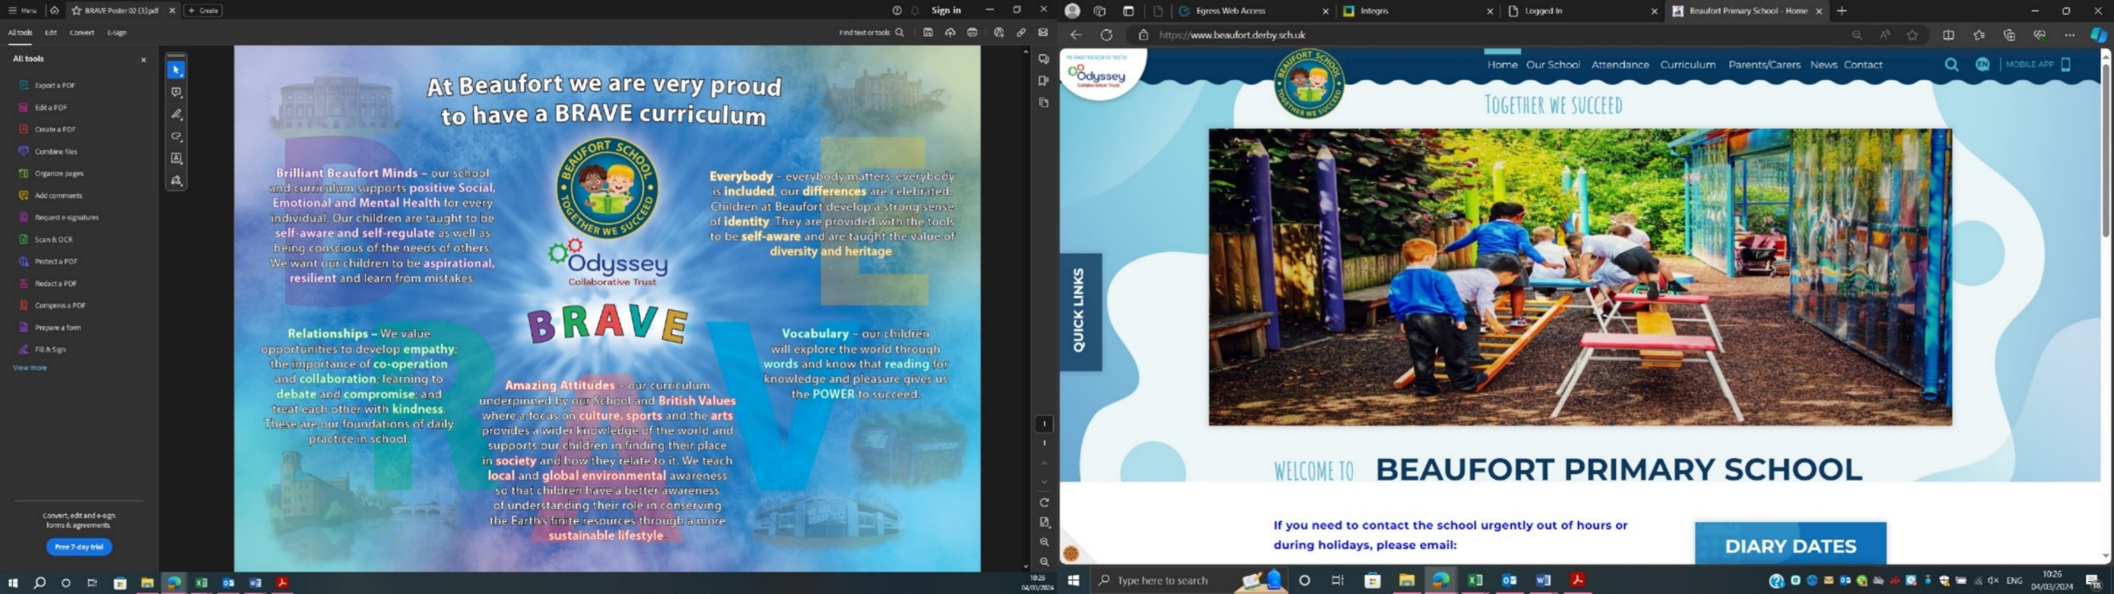

Beaufort Primary School
‘BRAVE’
Brilliant Beaufort Minds, Respectful Relationships, Amazing Attitudes, Varying Vocabulary, Everyone is Equal

Job Description – Teaching Assistant Level 1
Application Details
We are looking for an enthusiastic Teaching Assistant to join our team here at Beaufort Primary School. We need ambitious and driven candidates with a passion for helping children learn effectively. Everyone who visits our school comments on the calm atmosphere, the enthusiasm our children have for learning and the great sense of team amongst staff and children alike.

At Beaufort Primary we value every individual and put our children at the heart of everything we do. If you think this sounds like you then come and visit us to see for yourself. Visits are positively encouraged. Please contact Steph Baird (details below) to arrange a convenient date. Please phone or email to arrange a mutually convenient appointment. Find out if we’re right for you! Contact Steph Baird on 01332 347275 or email s.baird@beaufort.odysseyct.org.uk.

Odyssey Collaborative Trust is committed to safeguarding and promoting the welfare of children. We follow safer recruitment procedures and will require an enhanced DBS clearance and references from current and past employers. Further details of this post, the school and the Trust are included in this pack and details of how to apply can be found below.

How to Apply
Should you wish to apply for the post, please complete and return an application form along with a covering letter addressed to Beaufort Primary School which clearly demonstrates your suitability for this role. Applications can be submitted via email to s.baird@beaufort.odysseyct.org.uk or by post, for the attention of Steph Baird, to the following address: Beaufort Primary School, Hampshire Drive, Chaddesden, Derby, DE21 6BT.

Wherever possible, please provide work email addresses for your referees.

Closing Date
Please ensure your application form arrives by Monday 8th December 10.30am
Interviews for the role will be held on Thursday 11th December 2025
Our privacy notice can be found at https://www.odysseyct.org.uk/gdpr/

Beaufort Primary is committed to safeguarding and promoting the welfare of children and young people, and expects all staff and volunteers to share this commitment. As this post is regulated activity, successful appointments are subject to an enhanced Disclosure and Barring Service check and relevant recruitment checks that comply with guidance in the most recent version of Keeping Children Safe in Education.
We are committed to equality of opportunity in employment and services
Beaufort Primary is part of the Odyssey Collaborative Trust

All members of staff will receive training in line with our Safeguarding and Child Protection Policy.

Equal Opportunities
Odyssey Collaborative Trust welcomes applications from everyone and values diversity in our workplace. A commitment to promoting diversity and developing a workplace environment where all staff are treated with dignity and respect is central to our recruitment process.

Beaufort Junior School – L1 Teaching Assistant
Job Purpose
- Provide educational and pastoral support for students.
- Support individuals and groups of students to improve behavior and relationships.
- Implement strategies for managing challenging behaviour in the classroom and the wider school to enable access to learning.
Responsibilities
- Support with classroom and behaviour management, using appropriate restorative approaches in line with school policies.
- Contribute to creating a purposeful and supportive learning environment.
- Lead small group sessions and interventions as appropriate.
- Support children with modifying their behaviour managing self-regulation.
- Understand difficulties and barriers that pupils may face, and build trusting relationships to support success in school.
- Remain calm in challenging situations.
- Establish good relationships with students, acting as a role model and being aware of and responding appropriately to individual needs.
- Promote the inclusion and acceptance of all members of our community.
- Be aware of, and support difference and ensure all pupils have equal access to opportunities to learn and develop.
- Encourage students to interact with others and engage in activities led by the teacher.
- Set high expectations, promote self-esteem and independence.
- Undertake student record keeping as required
- Establish and maintain positive relationships with parents/carers, gathering and reporting information.
- Ensure the effective/efficient deployment of resources as appropriate.
- Act in accordance with school policies and procedures and relevant legislation particularly in relation to safeguarding, child protection and behaviour management.
- Participate with other team members in the development, planning, implementation and evaluation of learning programs for individuals and groups of pupils.
- Monitor and contribute to assessment and recording of children’s development, in any subject, and be involved in the sharing of this information where relevant.
- Monitor children’s achievements and contribute to school displays.
- Promote the ethos of the school and our Beaufort BRAVE values.
- Participate and support with residential trips if required.
- Promote development and learning – physical, emotional and educational and social.
- Implement physical interventions in order to safeguard individuals.

Professional Development
- Constantly improve own practice/knowledge through self-evaluation, appraisal and learning from/with others.
- This area of responsibility will be reviewed annually under Performance Management.

These above-mentioned duties are neither exclusive nor exhaustive, the post-holder maybe required to carry out other duties as required by the School or Trust.
As this job is designated as a ‘regulated activity’ an enhanced DBS with Barred list check is essential.

L1 Teaching Assistant

Person Specification Teaching Assistant | L1 Essential/ Desirable | L2 Essential/ Desirable
Qualifications
5 GCSEs including English and Maths 4+/C+ or equivalent | E | E
Meeting the National Occupational Standards (NOS) in Supporting Teaching and Learning Level 3 and NVQ Level 3 or equivalent relevant qualification. (TAs who have not completed will commit to doing so). | N/A | E
Knowledge
Knowledge and experience of SEND and other barriers to learning | D | E
Knowledge of social issues facing children from disadvantaged backgrounds and strategies for working with those displaying challenging behaviours. | D | E
An understanding of the national curriculum, relevant policies/ codes of practice and awareness of relevant legislation. | D | E
Knowledge and understanding of safeguarding, equal opportunities, health and safety, confidentiality, information sharing (GDPR) and ability to comply with these. | E | E
A good understanding of the learning process and child development. | D | E
Awareness of Zones of Regulation | D | D
Experience
Experience of working directly with children of a relevant age, in an education setting. | D | E
Ability to use ICT effectively to support learning. | E | E
Experience of establishing and maintaining positive working relationships with a range of stakeholders, at all levels | E | E
Experience of managing and prioritising tasks and being responsible for own workload. | E | E
Experience of de-escalation of conflict/emotion and application of systems to manage behavior. | D | E
Experience of safeguarding and supervision of children | E | E
Able to liaise and communicate effectively with others, including handling challenging conversations with a range of adults and students. | E | E
Personal qualities
Good organisational and communication skills both written and oral. | E | E
Commitment to safeguarding and welfare of pupils. | E | E
Team player who is confident at using their own initiative, and understands classroom roles and responsibilities and their position within these. | E | E
Commitment to school improvement, equality and social inclusion. | E | E
Flexibility to adapt and open to change | E | E
Pride, perseverance and problem-solving approach | E | E
Willingness to engage with appropriate professional learning and training | E | E

